Seismic Processing Workshop™

FlowChart™

V 2.2.11

Executor™

V 2.2.11



About This Manual

This manual is organized into two sections. The first section is a users manual for the FlowChart and Executor applications. The second section is a reference manual that describes each of the processing steps and associated parameters in the SPW Processing library.

Parallel Geoscience Corporation
PO Box 5989
Incline Village, NV 89450

Tel: +1-541-412-7793
E-mail: support@ parallelgeo.com

Web: http://www.parallelgeo.com

SPW, Seismic Processing Workshop, SPW Tape Utility, FlowChart, SPW Executor, SPW Vector Calculator and SPW SeisViewer are trademarks of Parallel Geoscience Corporation. All other products are trademarks of their respective companies.

This manual is proprietary information of Parallel Geoscience Corporation and is for the internal use only by licensed purchasers of SPW products.

© 2008 Parallel Geoscience Corporation

Seismic Processing Workshop™ 1
FlowChart™ 1
Executor™ 1
About This Manual 2
The SPW System 8
Product Support 10
FlowChart and Executor 11
The Executor 12
The Main FlowChart Window 14
The Tools Palette 15
The Selection Tool 16
The Linking Tool 17
The Processing List 18
The Console Window 19
The Icons 20
Menu Items 21
The File Menu 22
The Edit Menu 23
The Display Menu 26
The Flowchart Menu 27
The FlowItems Menu 29
The Help Menu 30
The Window Menu 31
Building a Flow 32
Setting Processing Step and Data Step Parameters 34
Displaying Data Spreadsheets and using the Spreadsheet Command 35
Spreadsheet Controls 37
Running the FlowChart 39
Naming and Saving a Flow 40
Compiling a Flow 41
Executing a Flow 43
Executing a Flow 43
Viewing the Statistics of an Executed Flow 46
Encountering Errors in Execution 49
File Database 51
Templates 52
Example Template: 2D Geometry Application 53
The Processing Library: 56
Overview 56
Amplitude Adjustment Steps 58
Amplitude Equalization 59
Amplitude versus Angle 61
Angle Gather 65
Apply Gain 68
Apply Trace Balance 70
Automatic Gain Control 72
Clip 74
Remove AGC 76
Sliding Window AGC 78
Spherical Divergence Correction 80
Surface Consistent Amplitude Corrections 82
Trace Balance 84
Trace Header Amplitude Math 86
Windowed AGC 88
Windowed Trace Balancing 90
Card Data Steps 92
Creating and Editing Card Data Files 94
Card Data Customization Dialog 99
Creating Card Data in Excel 103
Creating Card Data in Excel 104
Crooked Line Bin Definition 105
CMP Statics 108
Early Mutes 110
First Break Time Picks 113
Frequency Filter 116
GMG Source Card File 118
GMG Station Card File 119
Gain Curves 120
Horizon File 123
Line Definition File 126
Multicomponent Receiver Statics File 128
Observers Notes – SPS Format 131
Phase Matching Statistics File 134
Polygon Definition File 136
PP Nhmo Eta Function 138
PP Nhmo Gamma Function 141
Profile Geometry File 144
Receiver Gains 147
Receiver Locations – SPS Format 150
Receiver Statics 153
Receiver Statics List 156
Refractor Velocities 158
Residual NMO Analysis 161
Rotation Card File 164
Source Gains 167
Source Locations – SPS Format 170
Source Statics 173
Source Statics List 176
Streamer Definition 178
Surgical Mutes 181
Tail Mutes 184
Time Filter 187
Trace Kills 189
Trace Reversals 192
Trace Statics 195
Velocity Function 197
Editing Steps 200
Automatic Trace Edit 201
Coordinate Conversion 203
Data Difference 206
Data Divide 208
Data Multiply 210
Data Sum 212
Derivative 214
Design Vibroseis Sweep 216
Despike 219
Duplicate Trace 221
Integration 223
Kill Traces 225
Phase Rotation 227
Remove DC Bias 229
Reverse Traces 231
Trace Header Cell Math 233
Trace Header Column Math 236
Trace Header Logic 239
Trace Header Resequencing 243
Trace Math 245
Vibroseis Correlation 247
Filtering Steps 250
Adaptive Filter 251
Adaptive Radon Demultiple 254
Apply F-K Filter 257
Apply F-K Velocity Filter 260
Apply Frequency Filter 264
Apply Time Filter 266
Butterworth Filtering 268
Coherence Filter 270
Convolution 272
Design Frequency Filter 274
Design Notch Filter 277
Design Time Filter 279
Diffusion Filter 282
Dip Filter 284
F-K Spectrum 287
F-X Deconvolution 289
F-XY Deconvolution 291
Horizontal Median Filter 293
Median Filter 295
Notch Filter 297
Q Filter 299
Radon Demultiple 301
Radon Transform 304
Radon Inverse 308
Ricker Filter 311
Spatial Noise Filter 313
Swell Removal 315
Time Variant Bandpass 317
Time Variant Butterworth 319
Wave Equation Multiple Attenuation 321
Geometry/Binning Steps 323
Note Trace Header Geometry Application 324
Build Supergathers 328
CMP Binning 331
CMP Fold - Data 334
CMP Fold - Geometry 336
Crooked Line Binning 339
Crooked Line Fit 341
Extract Geometry 343
Flex Binning 345
Geometry Definition 347
Geometry Interpolation 354
PreStack Kirchhoff Partitioning 356
Simple Marine Geometry 358
Single Fold Profile Geometry 360
UKOOA P1/90 Geometry 363
Image data 365
F-T Frequency Slice Image 368
F-T Time Slice Image 370
Migration 372
2-D Dip Moveout 373
Create Simple Geometry from XY’s 375
Convert Time to Depth 378
Finite Difference Migration 380
Kirchhoff Dip Moveout 382
Phase Shift Migration 385
Post-Stack Kirchhoff Time Migration 387
Pre-Stack Kirchhoff Time Migration 390
Split-Step Migration 396
Stolt Migration 398
Multi-Component 400
Apply Horizontal Rotation 402
Apply PS Non-hyperbolic Moveout 404
Birefringence Analysis - 2C 407
Birefringence Analysis - 4C 409
CCP Binning 411
CCP Fold - Geometry 414
Constant Gamma Stacks 417
Convert PS Time Picks 420
Dual Summation 422
Horizontal Rotation 424
Select Component 426
Three Component Rotations 428
Two Component Horizontal Rotation 431
Wavefield Separation 434
Mutes 436
Mutes 436
Apply Early Mute 437
Apply Surgical Mute 439
Apply Tail Mute 441
Quality Analysis 443
Amplitude Analysis 444
Amplitude Spectrum 447
Autocorrelation 449
Compare Traces 451
Cross Correlation 453
Extract Dead Traces 455
F-T Cube 457
F-T Frequency Slice 459
F-T Time Slice 461
Frequency Analysis 463
Gabor Transform 466
Instantaneous Amplitude 468
Instantaneous Frequency 470
Instantaneous Phase 472
Phase Matching 474
Resolution 476
Signal to Noise 478
Source Energy Estimation 480
Trace Analysis Report 482
Trace Header Maps 484
Seismic Data 486
3D Radar File 487
ARAM SEGY File 489
Brick 2D Data 491
Copy Seismic File 493
Create Sine Waves 496
Create Spikes 498
F-X Trace Interpolation 501
I/O SEGY File 503
Interpolate Traces 505
Progress T2 SEGD File 507
Resample Seismic 509
SEG 2 File 511
SEG Y File 514
Seismic File 517
SPW Demo File 520
Seismic Merge 522
Sercel SEGD File 524
Signature Input 526
Sorting Steps 528
CMP Sort 529
General Trace Sort 531
Offset Sort 535
Receiver Sort 537
Select Traces 539
Source Sort 541
Source Sort 541
Stacking and Summing Steps 543
Diversity Stack 547
Horizontal Trace Sum 549
Median Stack 551
Receiver Order Stack 555
Source Order Stack 557
Trace Mixing 559
Variable Trace Mix 561
Statics Steps 563
Apply GMG Statics 564
Apply Static Shifts 567
Automatic Residual Statics 569
CMP Statics Separation 571
CMP Statics Summing 573
Flattening Statics 575
Floating Datum Statics 577
Receiver Statics Separation 579
Receiver Statics Summing 581
Refraction Statics 583
Source Statics Separation 585
Source Statics Summing 587
Stack-Power Optimization Statics 589
Surface Consistent Statics 593
Trim Statics 597
Velocities 599
Apply Linear Moveout 600
Apply NMO 602
Apply PP Non-hyperbolic Moveout 605
Azimuth Velocity Analysis 608
Calculate 3-D Residual NMO 612
Constant Velocity Stacks 615
Delta-T Stacks 618
Delta-T VelocitiesDix’s Equation 621
Dix’s Equation 622
PP Constant Eta Stacks 624
Supergather Velocity Analysis 627
Velocity Cube 630
Velocity Semblance 632
Velocity Smoothing 635
Wavelet Shaping Steps 638
Apply Deconvolution Operators 639
Deconvolution 641
Minimum Phase Compensation 644
Offset Deconvolution 647
Receiver Deconvolution 650
Source Deconvolution 653
Signature Deconvolution 656
Spectral Whitening 659
Surface Consistent Deconvolution 662
Time-Variant Deconvolution 665
Wavelet Estimation – Seismic Only 668
Wavelet Estimation – Seismic + Well 671

Introduction

The SPW System

Welcome to the Seismic Processing Workshop (SPW) system. SPW is a suite of applications written by Parallel Geoscience Corporation for processing seismic and/or GPR data. The SPW system was originally written for the Macintosh computer platform and has been redesigned and rewritten using a cross platform framework. SPW is currently available for the Windows NT, Windows XP, Windows 2000, Linux, and Macintosh PowerPC operating systems. The SPW system is composed of the following applications – FlowChart, Executor, SeisViewer, Tape Utility, and Vector Calculator. Each of these applications is also available separately.

The FlowChart allows you to build processing flows and set the parameters for processing steps. A simple graphical user interface reduces the learning curve and accelerates your processing time. An interactive tutorial of the SPW FlowChart can be viewed at:
http://www.parallelgeo.com/products/SPWFlowChartIntroduction.htm
The Executor is a standalone seismic job execution engine. The Executor is multi-threaded to take full advantage of modern multiple CPU systems. The output of the FlowChart can be run by the Executor on the same system as the FlowChart or sent to a separate computer on a network. A single high-end system running the Executor can service multiple FlowChart client systems. This client-server design enables large jobs to be run on more powerful systems while user interactive tasks can occur on inexpensive desktop or laptop PC systems.

The SeisViewer is a seismic data display and montage application. Seismic data may be displayed from either SEG Y format disk files or from the SPW internal processing format. Drawing tools are included to allow you to annotate your seismic display. You can also import bitmap graphics files in BMP format to build a montage of other information with your seismic display. SeisViewer utilizes the standard Windows print drivers commonly delivered with printers for generating hardcopy output. You can also generate a BMP output file for use by other graphics applications. An interactive tutorial of the SPW SeisViewer can be viewed at:
http://www.parallelgeo.com/products/SPWSeisViewerIntroduction.htm

SPW Tape Utility is a data reformat, analysis, copy and verify program. As the name indicates, tape data handling is included in the application. All standard and many non-standard seismic data formats are handled in the data reformatting portion of the application. The copy and verify functions allow you to quickly and easily duplicate tapes for archive and/or distribution. The analysis functions allow you to view the contents of a tape in multiple human readable formats and enable you to decode the contents of the tape. An interactive tutorial of the SPW Tape Utility can be viewed at:
http://www.parallelgeo.com/products/SPWTapeUtilityIntroduction.htm

The SPW Vector Calculator is a trace analysis tool that operates like a scientific calculator, using Reverse Polish Notation. It can operate using scalar numbers as well as one-and two-dimensional vector numbers. You may use it for simple mathematical functions, or to analyze seismic trace data. You can create plots of seismic trace analyses, scale and control the annotation of these plots, as well as print them for reports. An interactive tutorial of the SPW Vector Calculator can be viewed at:
http://www.parallelgeo.com/products/SPWVectorCalculatorIntroduction.htm

The SPW system is designed to be user expandable. Parallel Geoscience will release the programming API interfaces for the FlowChart and the Executor to all SPW users in the near future. This will allow you to add your own customized processing algorithms and data formats to the SPW system.

Product Support

For solutions to questions about FlowChart and Executor, first look in this manual or consult the release notes file accompanying every software release. If you cannot find answers in your documentation, contact Parallel Geoscience Corporation via E-mail (support@parallelgeo.com), or phone (+1-541-412-7793). Please be ready to provide the following information:

- Your name.
- Your company name.
- The FlowChart and Executor versions you are using.
- The operating system you are using.
- The type of hardware you are using.
- What you were doing when the problem occurred.
- The exact wording of any error messages which appeared on your screen.
- Any other pertinent data set information.

FlowChart and Executor

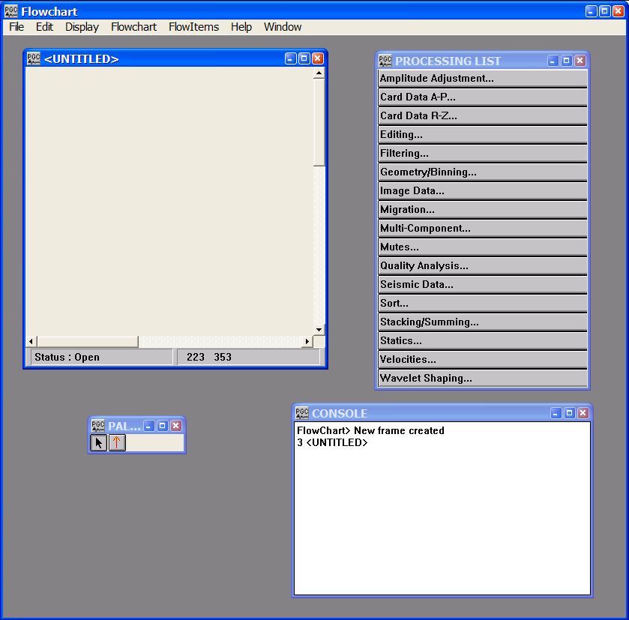
The FlowChart application in the SPW system allows you to build processing flows and set the parameters for processing steps. The FlowChart application contains four basic sub-windows: the FlowChart design window for creating a processing flow (<UNTITLED> below), the Processing List, the Tool Palette, and the Console. The FlowChart graphical user interface simplifies the process of building a processing flow to a few mouse clicks.

FlowChart User Interface

The Executor

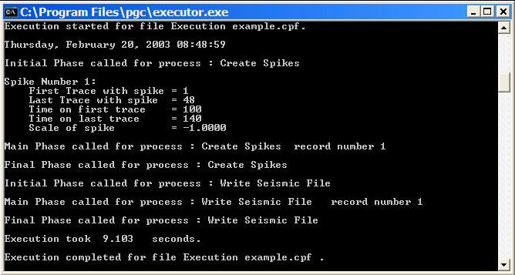
The Executor application is the part of the SPW system that runs the processing flow after it has been built in the FlowChart. It reports such things as processing activity, job errors, and job status. The Executor automatically opens files named with a .cpf extension that reside in the Executor program directory. Once the file is opened and execution starts, the file is renamed to have an extension of .act. After execution is complete, the file is renamed with an extension of .fini. The Executor has only a DOS type console window for a user interface. To stop the Executor, press the Esc key or use the X close box in the upper right corner of the Executor window.

The Executor User Interface

The Executor may be running on the same system as the FlowChart or may be run on a separate computer. The Executor takes full advantage of multiple CPUs and automatically multi-threads a processing flow. The Executor runs jobs sequentially.

The messages in the Executor window are written to a disk file in the Executor program directory. This file has the name of the executed job with an extension of .cpf.con.

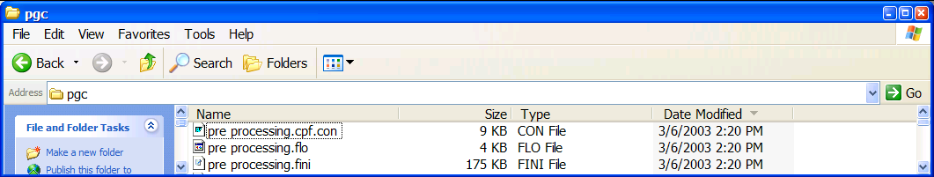
The Output Console File from the Executor

If you encounter problems in running a flow, this console file can greatly assist the Parallel Geoscience Corporation customer support staff in resolving the problem. It can easily be opened in a text editor for viewing, printed and faxed, or attached to E-mail.

The Main FlowChart Window

The FlowChart application is used for building and saving processing flows. The FlowChart application is a multi-document interface so multiple FlowChart windows may be open simultaneously.
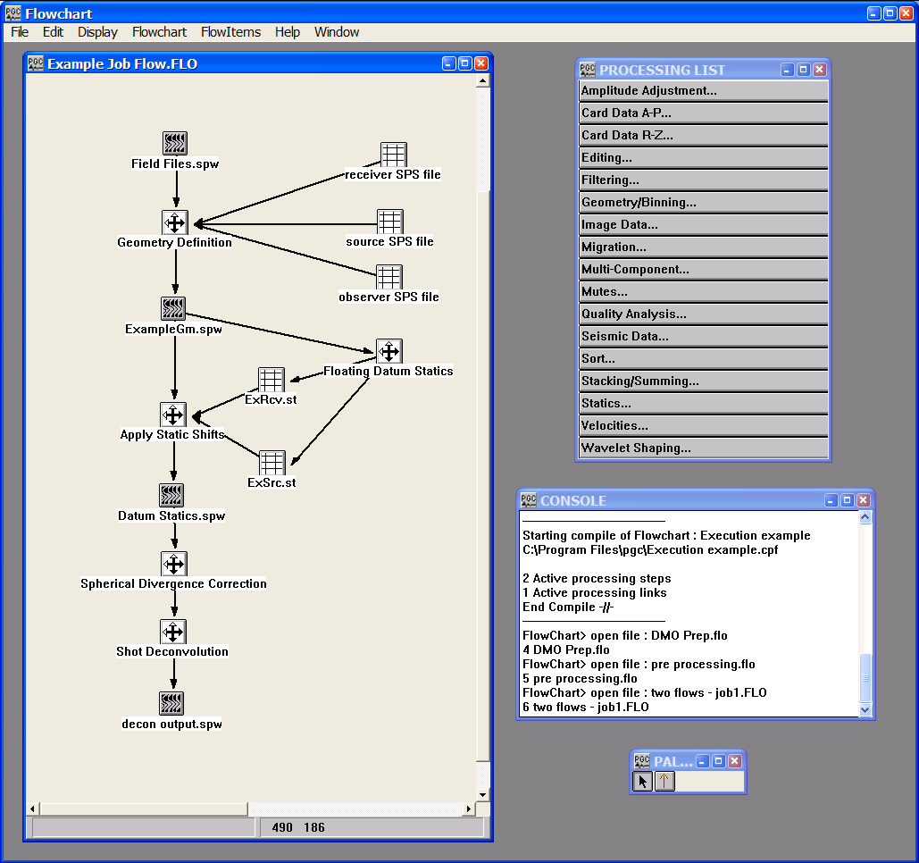
Example of a processing flow in the main FlowChart window

The Tools Palette

The Tools Palette contains the selection tool and the linking tool. The user may toggle between the selection tool and the linking tool with a click of the mouse, or with the use of the Tab key on the keyboard. The selection and linking tools are used in building a job flow.
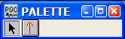
Tools Palette

The Selection Tool

The Selection Tool (i.e. the black diagonal arrow) can select either a processing step or the link between the processing steps. When selected, the Selection Tool button will appear depressed.
Selection Tool selected

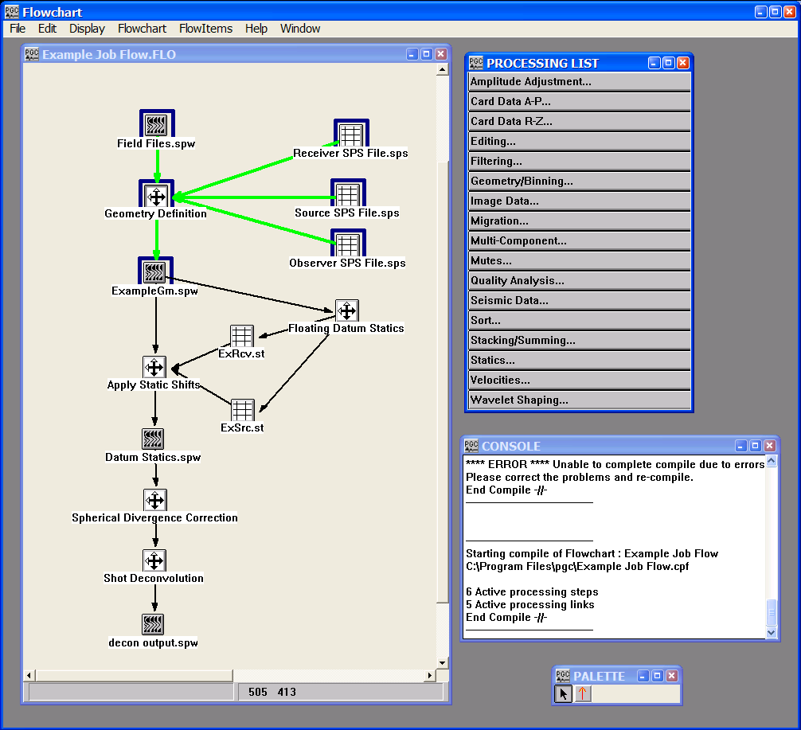
When using the selection tool, the items selected will be highlighted by color; the links will become bold green, and the flow items will be enclosed by a blue box.
Selecting a Link

Once selected you can remove an item or a link by choosing either the Clear command or the Cut command from the Edit menu. Alternatively, you can use the Delete key on the keyboard.

The Linking Tool

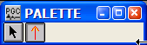
The Linking Tool (i.e. the red vertical arrow) allows you to define the data flow between steps on the chart. When selected, the Linking Tool button will appear depressed.

Link Tool selected

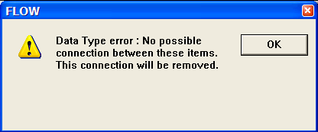
The data flow is type-checked for validity at the time you draw the link. If an improper association is made, either directionally or sequentially, the following error message will appear, and the link will not be completed.

Data Type Error Dialog

The Processing List

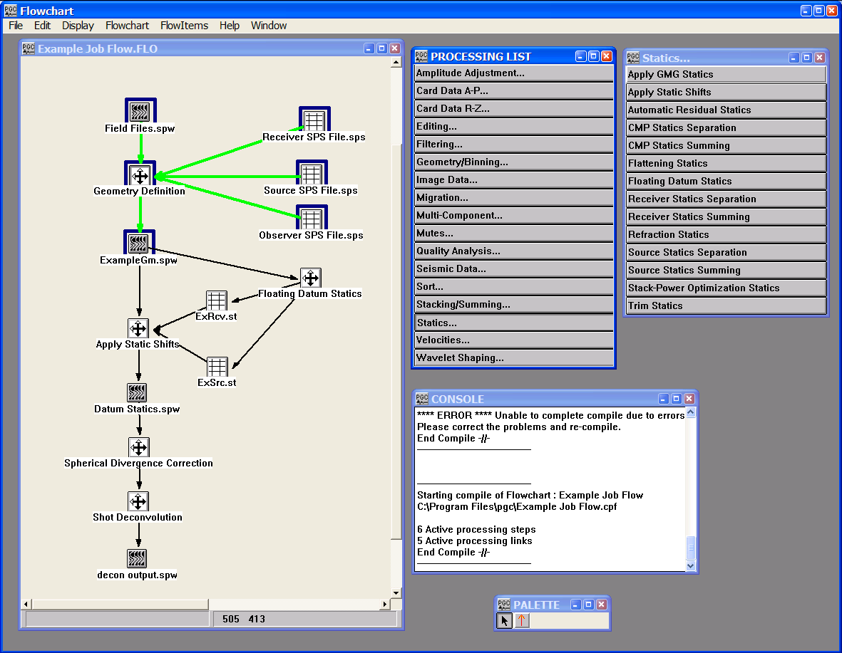
The Processing List sub-window contains the categories of processing steps available in the SPW system.

The Processing List sub-window…

When you click on a button in the Processing List, such as Statics... a sub-window extension will appear that contains each of the available processing steps in that category. However, only the steps available in your license will be shown in the selected sub-window.

When you click on the desired processing step button, it will appear depressed. You must then click in the FlowChart window where you wish the step to be placed before it will appear. The selected item may then be dragged for further positioning.

The Console Window

The Console Window contains various messages related to the building and compiling of processing flows. These messages may be helpful in finding errors or problems in the building, saving or compiling of processing flows.
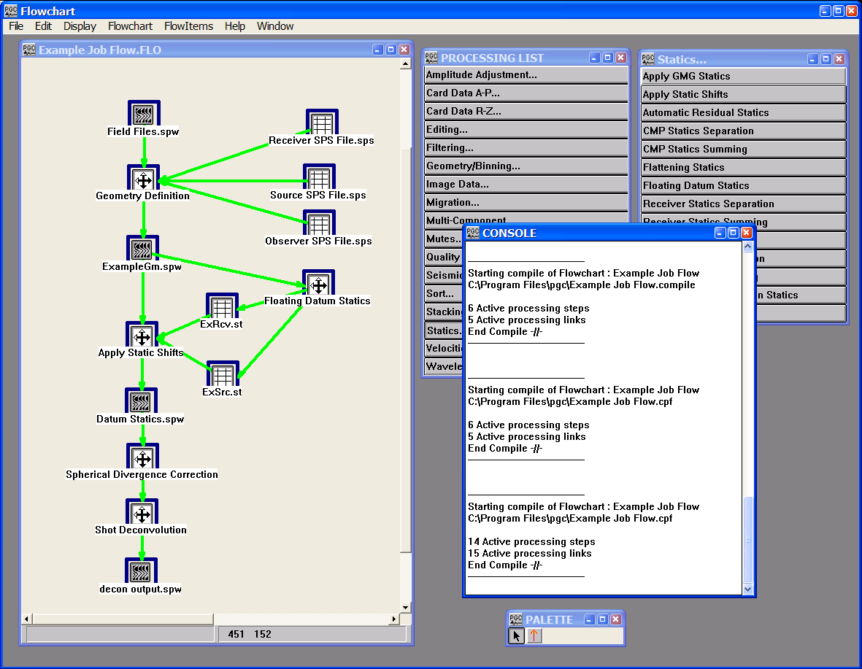
The FlowChart Console Window

The Icons

The FlowChart uses the following four distinct icons:

Processing steps are shown with an icon of:

Seismic data items are shown with an icon of:

Card data items are shown with an icon of:



Sorting steps, which require a disk data file, are shown with an icon of:

Menu Items

The FlowChart application menu contains the following items:

- File Menu
- Edit Menu
- Display Menu
- Flowchart Menu
- FlowItems
- Help
- Window

The File Menu

In addition to the standard File commands common to most applications, the File menu allows you to launch the Executor, the SeisViewer, the IO Utility, and the Vector Calculator applications.
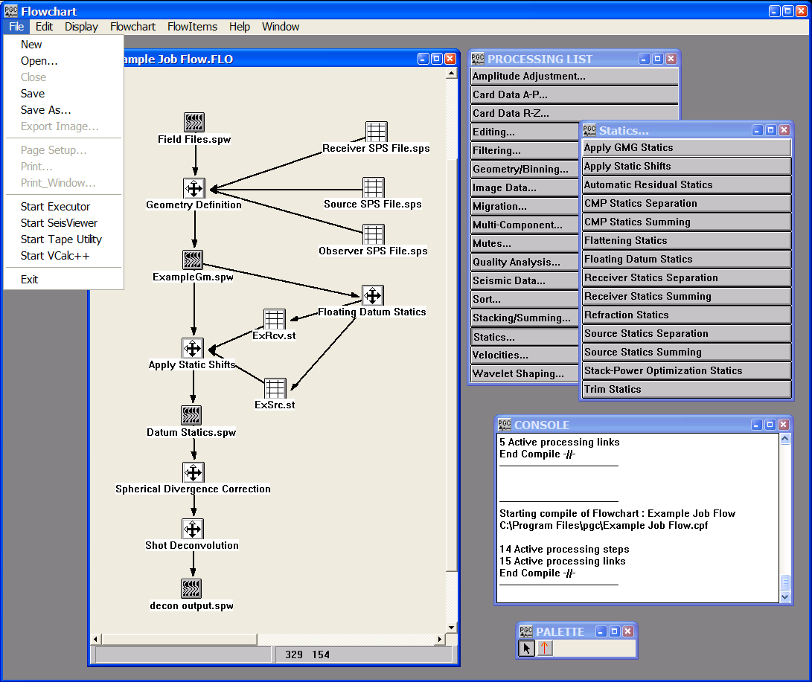

File Menu

The Edit Menu

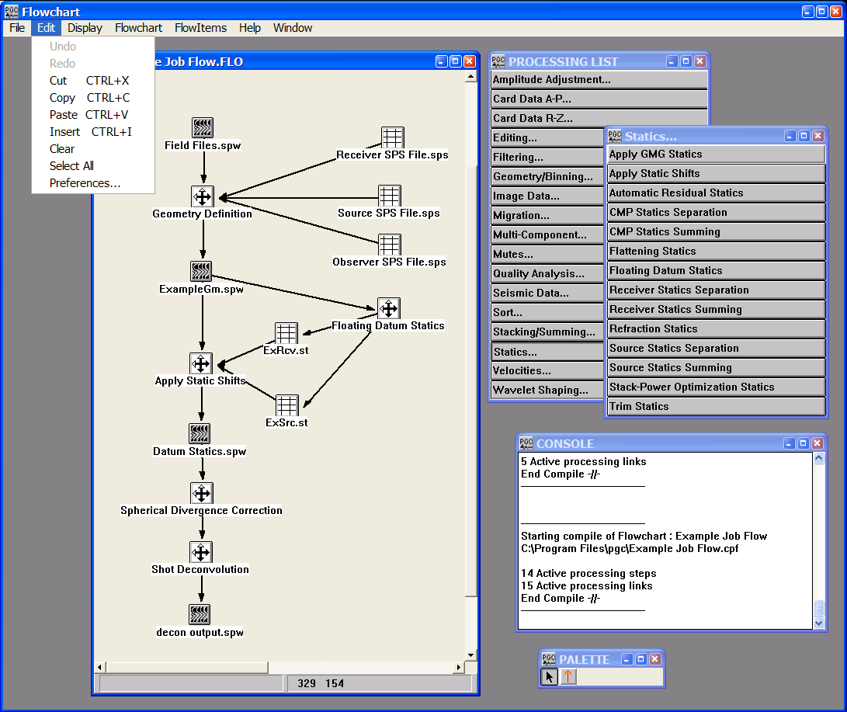
The Edit menu contains the edit commands common to most applications.

Edit Menu

Cut can be used to remove flow items or links between flow items that have been highlighted with the Selection tool.

Copy and Paste are implemented to copy portions of a flowchart from one flowchart window to another.

The Insert command is not active.

The Clear command removes the currently selected items from the flowchart window.

The Select All command selects all items on the active FlowChart canvas.
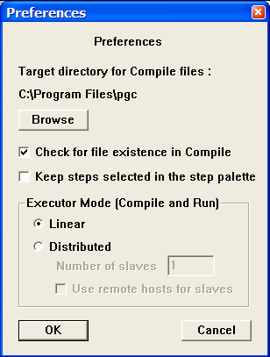
The Preferences command brings up the Preferences dialog.
Preferences Dialog

The Preferences dialog is used to set preferences for several execution-related processes. First, the Browse button allows you to set the target directory into which (1) compiled job flows are written prior to execution; (2) executed job flow console files are written following execution. This directory is selected through the use of the Browse button. By default, this directory contains each of the SPW executable files.

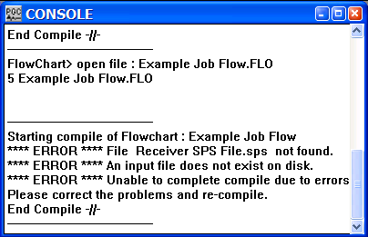
Check for file existence in Compile – If checked, this causes the compiler to verify the existence of all files required to execute the job flow. If path names have been incorrectly specified, or links point to non-existent files, the appropriate error message will be displayed in the Console window:
Compile error due to non-existent file(s)

Keep steps selected in the step palette – If checked, the processing step selected from the Processing List will remain active until another processing step has been chosen. As a result you will be able to place as many of the chosen processing steps in the FlowChart window, as you like.

Executor Mode (Compile and Run) – These options allow you to confine the execution of a compiled flow job to a single computer (i.e. Linear) or to distribute the processes among a network of computers (i.e. Distributed) and take advantage of SPW’s parallel processing capabilities.

Linear – If selected, the compiled flow chart will be executed on a single CPU.

Distributed – If selected, the compiled flow chart will be executed on a network of CPU’s consisting of a master and one or several slaves.

Number of slaves – Indicate the number of slaves on the network.

Use remote hosts for slaves – If checked, allows remote hosts to behave as slaves for the purposes of flow chart execution.

The Display Menu

The Display menu contains commands that allow the user to (1) display trace header spreadsheets; (2) display seismic, processing step, or card data parameters; (3) turn on or turn off the display of the console sub-window.
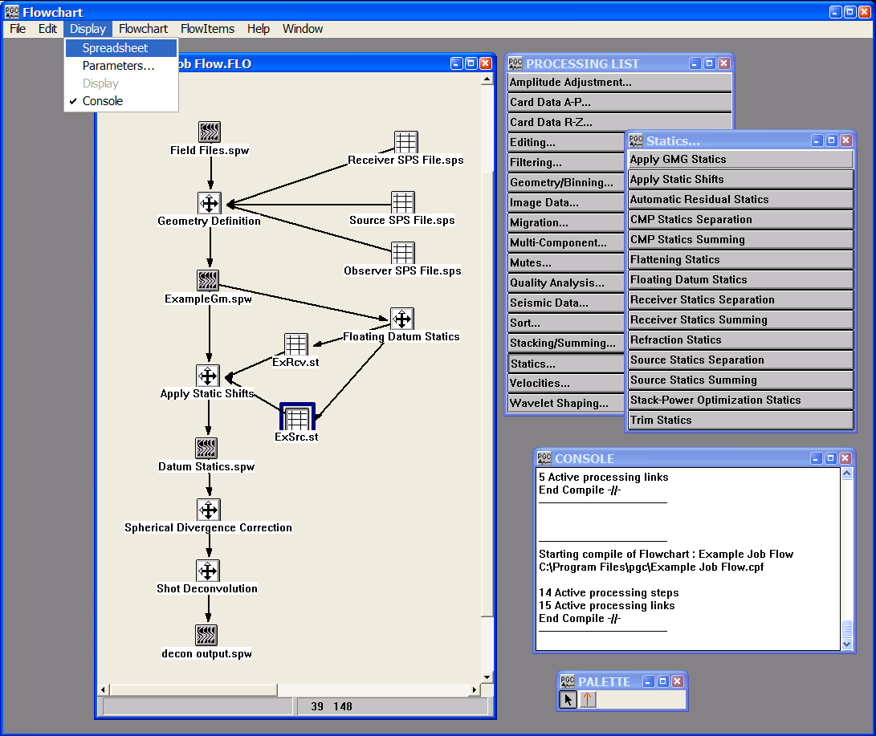
The Display Menu

The Flowchart Menu

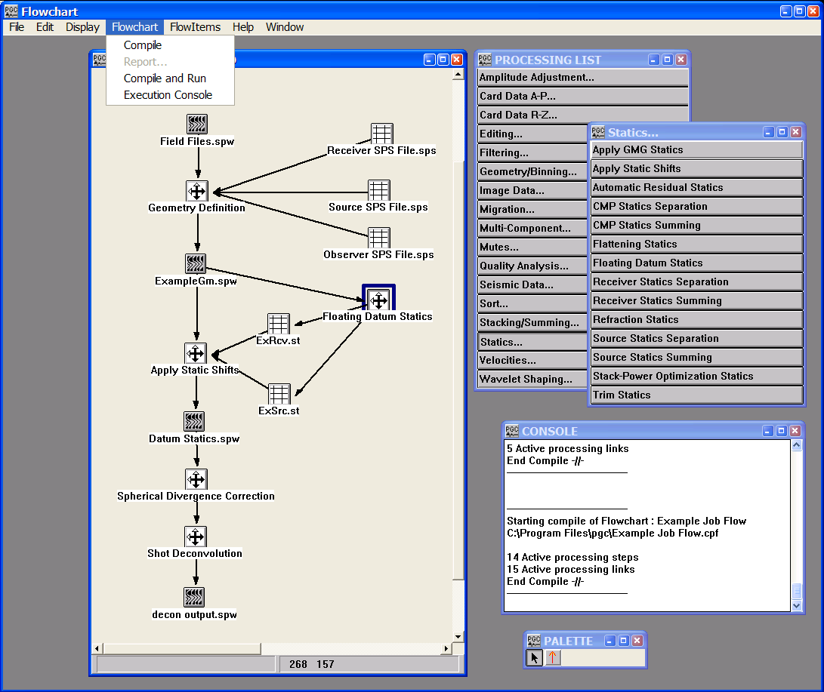
The Flowchart menu contains the Compile, Compile and Run, and the Execution Console commands.
The Flowchart Menu

The Compile command generates an output binary file containing the flow items and the flow links. This file is named the same as the flowchart document but with an extension of *.cpf. It is built in a directory specified in the Preferences dialog window that is accessed through the Edit menu. This file is read by the Executor application to run the processing flow.

The Compile and Run command provides a one click method of compiling a binary file and executing the flow. While running, the binary file is named the same as the flowchart document but with an extension of *.active. Upon completion of execution the extension of the binary file converts from *.active to *.done, and an additional *.console file is generated with the same name as the flowchart document. The *.console file contains run time statistic for the job and can be viewed with any text editor or through use of the Execution Console command (see below). The Compile and Run command is used to execute job flows one at a time. Batch processing is not possible with the Compile and Run command.

The Execution Console command launches a text window or windows that display the run time statistics contained in the most recently generated *.console (i.e. the run time statistics generated through use of the Compile and Run command) and *.cfp.con files (i.e. the run time statistics generated through use of the Executor).

The FlowItems Menu

None of the FlowItems commands are currently enabled. When they are implemented, you will be able to customize the Processing List sub-window and rearrange the processing steps into groups that suit your working environment.
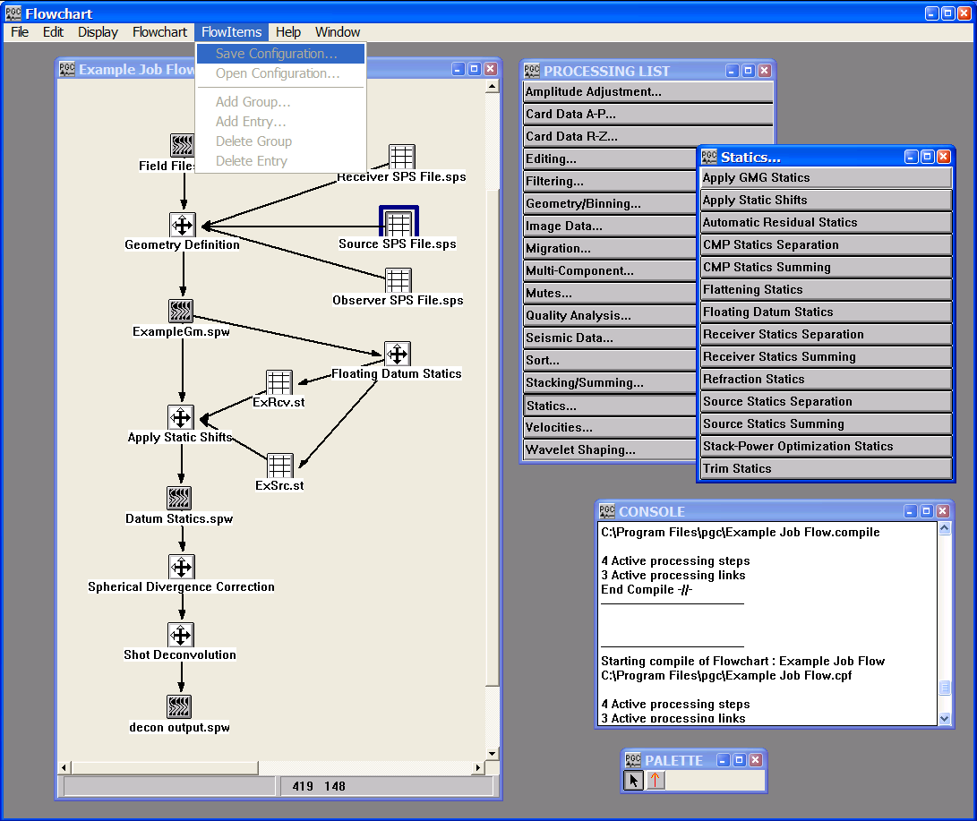

The FlowItems Menu

The Help Menu

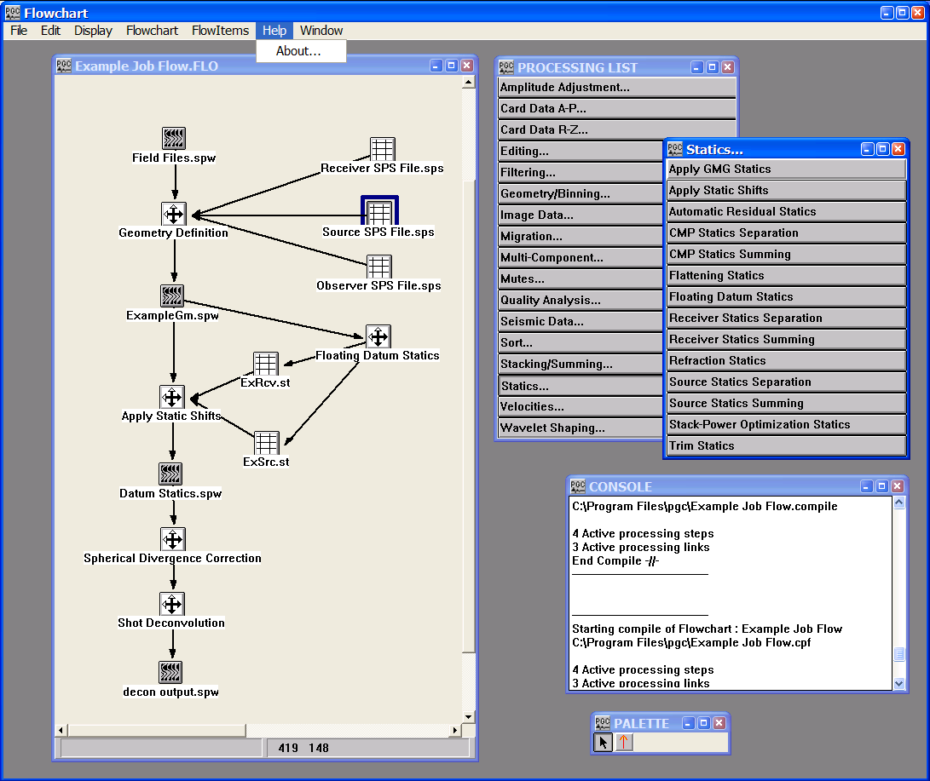
The Help menu contains the About… command, which displays version information for the application.

The Help Menu
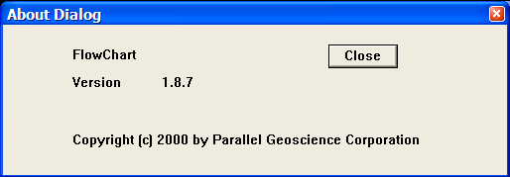

Results of selecting About… from the Help menu

The Window Menu

The Window menu allows you to toggle between sub-windows in the FlowChart application. Selecting an item activates the associated sub-window.
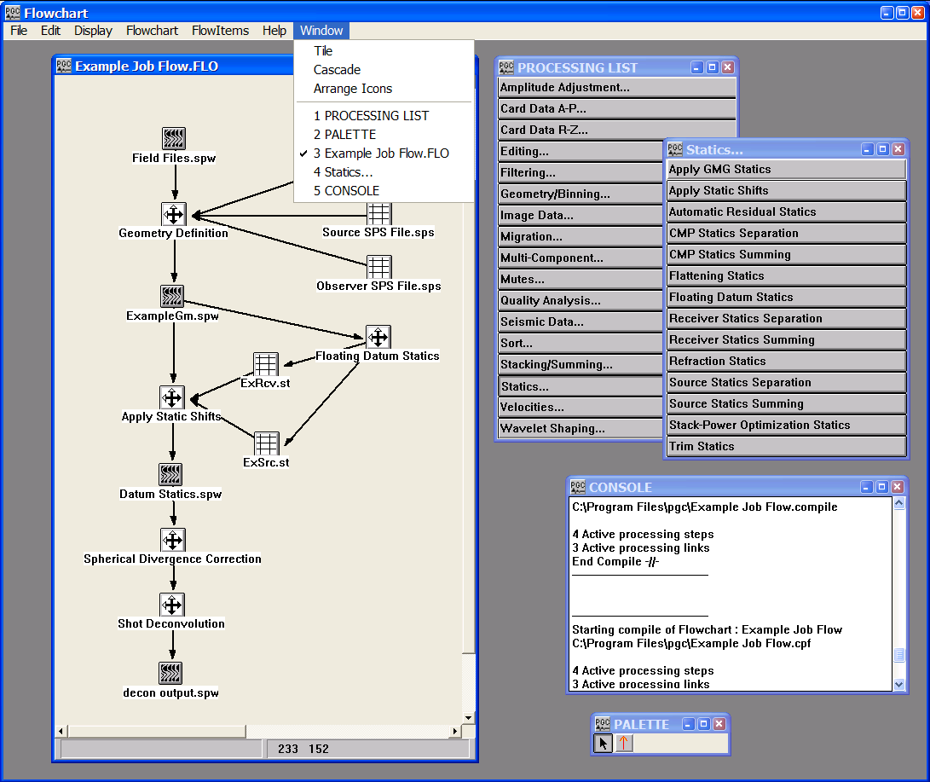
The Window Menu

Building a Flow

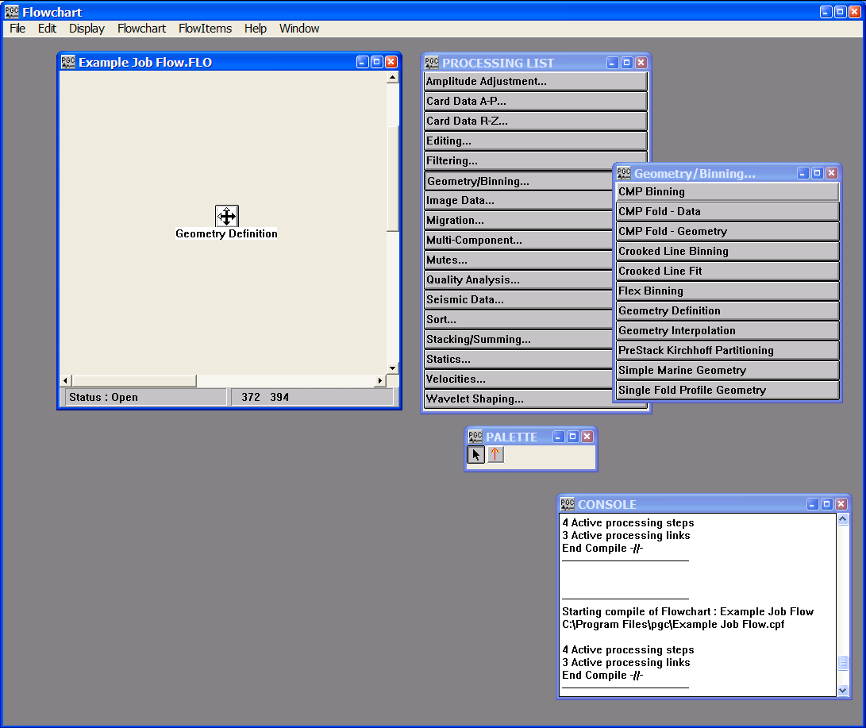
Building a processing flow is a simple matter of placing the desired processing steps onto a flowchart sub-window. Select the desired step by first choosing the category from the Processing List with a single click. A list of steps will appear.

Building a Flow

From this list, single-click again to select the particular processing step you wish to place in the flowchart. This activates the flow item and allows you to position it wherever you wish by clicking inside the flowchart sub-window. After you have placed it on the flowchart sub-window, you may click-and-drag the item anywhere you wish to reposition it. You can place as many copies of a step in a flow as you desire.
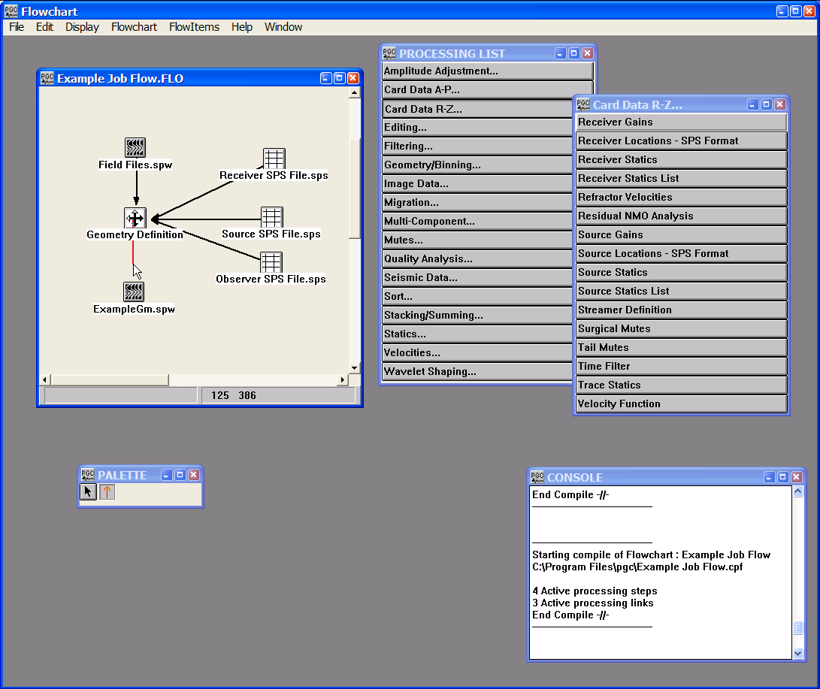
Once you have your processing steps in a flowchart document, you may then select the linking tool from the tool palette and connect the steps together. You draw straight lines from one step to the next and thereby create the data flow between the processes. Each data step item can output a maximum of six links.
Drawing Links

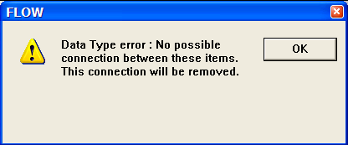
Each link is type-checked for validity at the time you draw the link. If an improper association is made, either directionally or sequentially, an error message will appear, and the link will not be completed. For example, if you attempt to make a link from the Geometry Definition step to an SPS survey file in the above example, the following error message will appear:

Setting Processing Step and Data Step Parameters

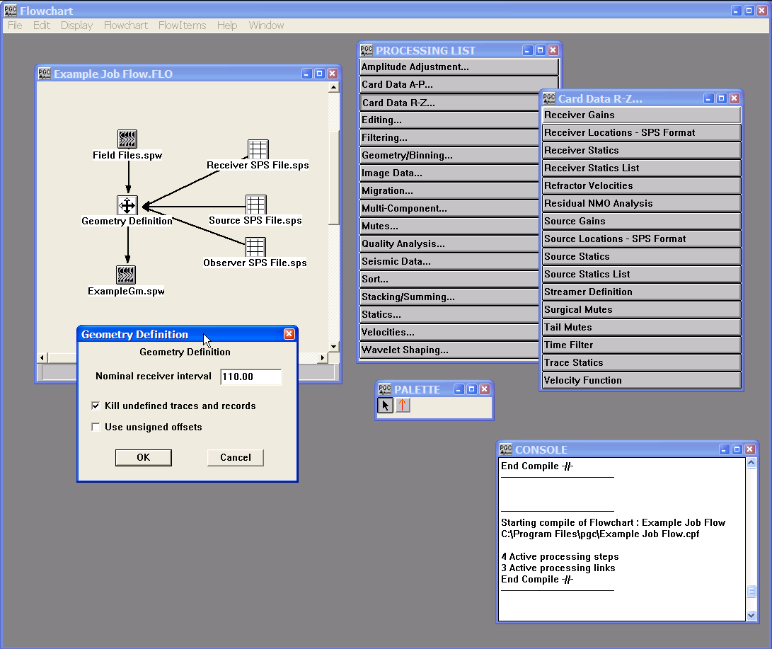
To set the parameters for a processing step, you double click with the left mouse button on the step. Alternatively, you may set the parameters by highlighting the processing step with a single click of the mouse button and then selecting Parameters… from the Display menu. This will display the dialog for setting the processing step parameters. Each dialog contains the parameters specific to that step. These parameters are set using numeric data entry fields, radio button controls, check boxes and drop down list boxes.

A Step Parameter Dialog

Displaying Data Spreadsheets and using the Spreadsheet Command

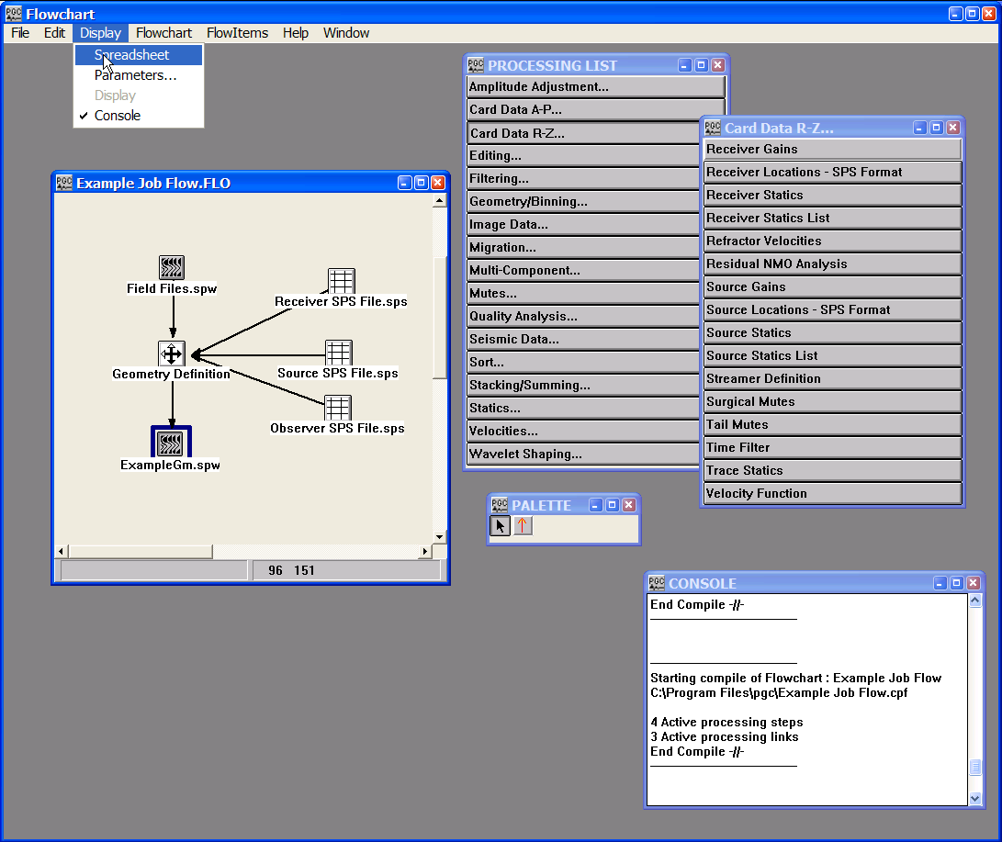
To display a spreadsheet of trace headers associated with a seismic data set or the numeric values associated with a card data file, first select a data icon in the flow chart.

Select a Data File for Spreadsheet Display

Next, issue the Spreadsheet command from the Display menu. To achieve the same results faster, double-click on the data item using the right mouse button.

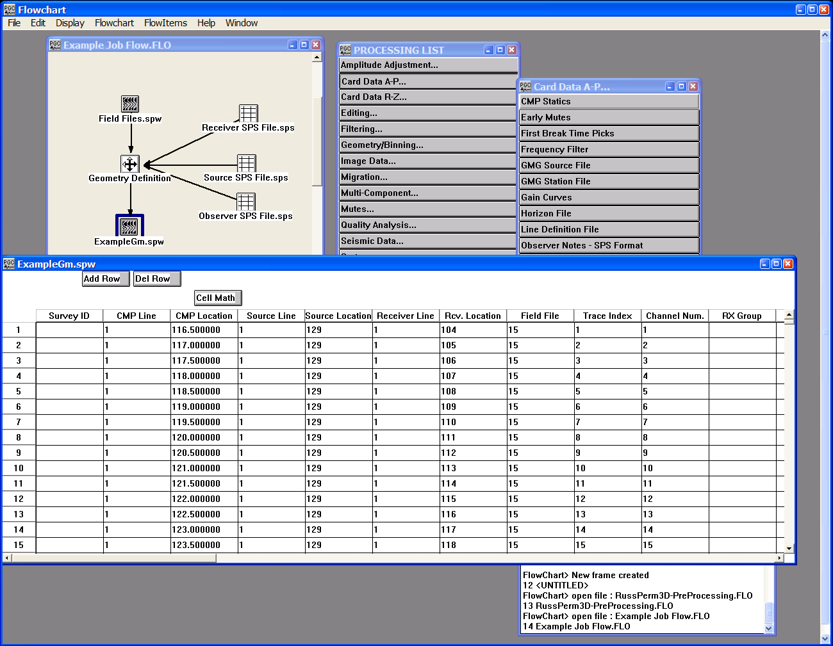
A Spreadsheet of Seismic Trace Headers

Spreadsheet Controls

<< — This button on the spreadsheet moves to the first sheet in a multiple sheet spreadsheet.

< — This button on the spreadsheet moves back (down) one sheet in a multiple sheet spreadsheet.

> — This button on the spreadsheet moves forward (up) one sheet in a multiple sheet spreadsheet.

>> — This button on the spreadsheet moves to the last sheet in a multiple sheet spreadsheet.
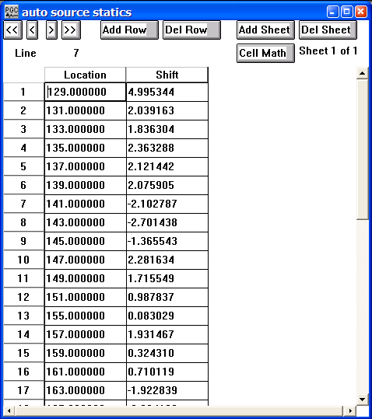

Spreadsheet Controls

Add Row — This button adds a row to the spreadsheet. To quickly add multiple rows to a spreadsheet, hold down the Ctrl button when clicking on the Add Row button and the following dialog window will appear:
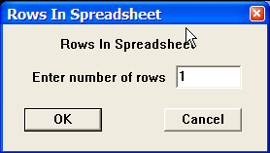

Simply enter the total number of rows you desire.

Del Row — This button deletes the currently selected rows from the spreadsheet. Rows are selected by clicking on the row number at the left of the display.

Add Sheet – This button adds a new sheet to a multi-sheet spreadsheet.

Del Sheet – This button deletes the current sheet from a multi-sheet spreadsheet.

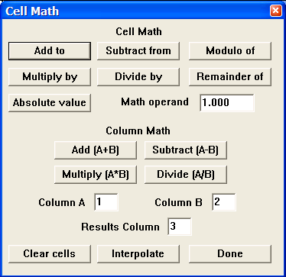
Cell Math – This command brings up the following dialog. The operations in the dialog are performed on the selected fields in the spreadsheet. You can select entire columns by clicking in the column name at the top of the spreadsheet.

Cell Math Dialog

Running the FlowChart

Once you are satisfied with the flow you have constructed, you must do three things to obtain results.

- Name and Save the Flow
- Compile the Flow
- Execute the Flow

Naming and Saving a Flow

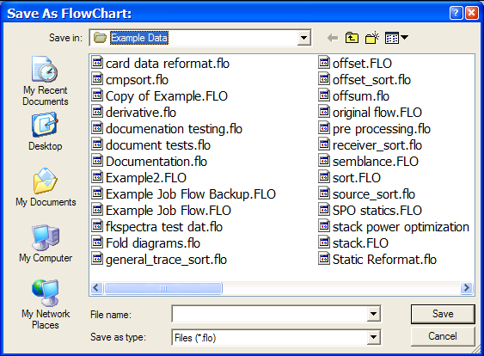
First, you must give the flow a name and save it. To name a flow document, use the Save… or the Save As… commands in the File menu. This allows you to browse for the directory location where you wish to save the flow and assign a meaningful name to the flow document.
Save As FlowChart dialog

If you try to compile a job that has not been named and saved, the Save as FlowChart dialog will automatically appear and you will be prompted to give the flow chart a name.
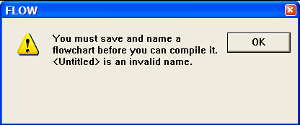
If you do not give the flow chart a name the following error message will appear:

Un-named Flow error

Compiling a Flow

Second, you must compile the flow. You may compile the entire flow chart by selecting no steps on the flow or you may compile only a portion of the flow by selecting a single step or a few steps on the flow chart. You compile the flow by simply selecting Compile from the FlowChart menu.
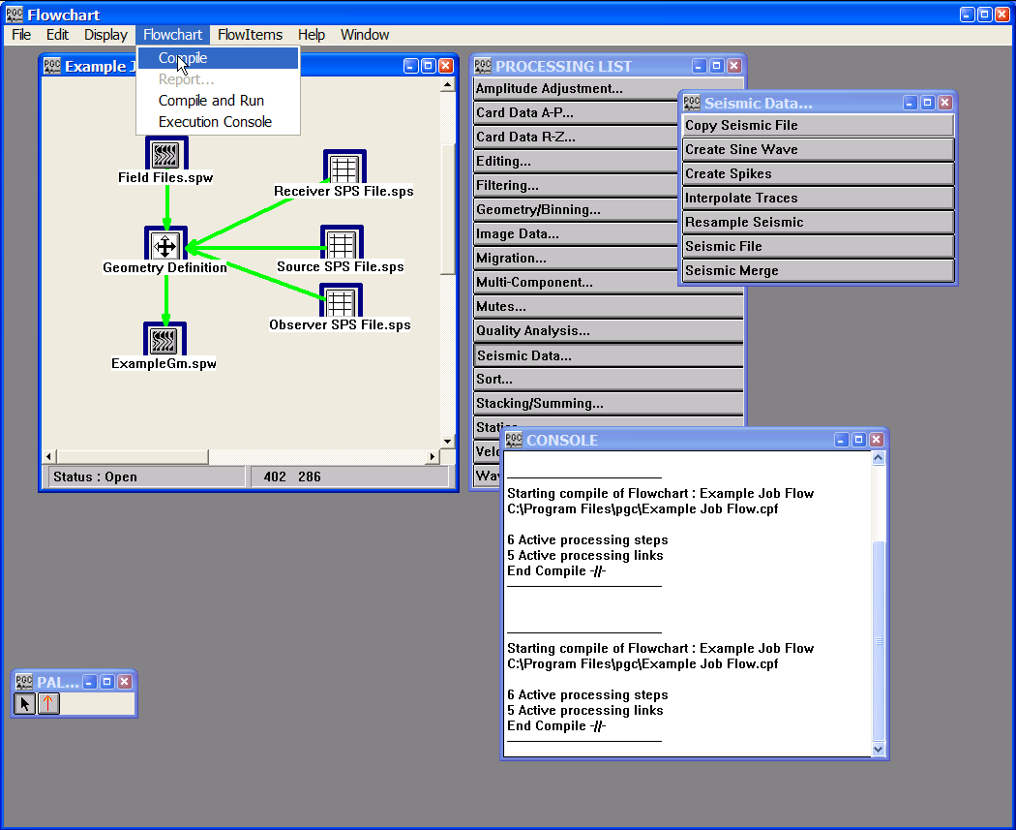

Compile a Flow

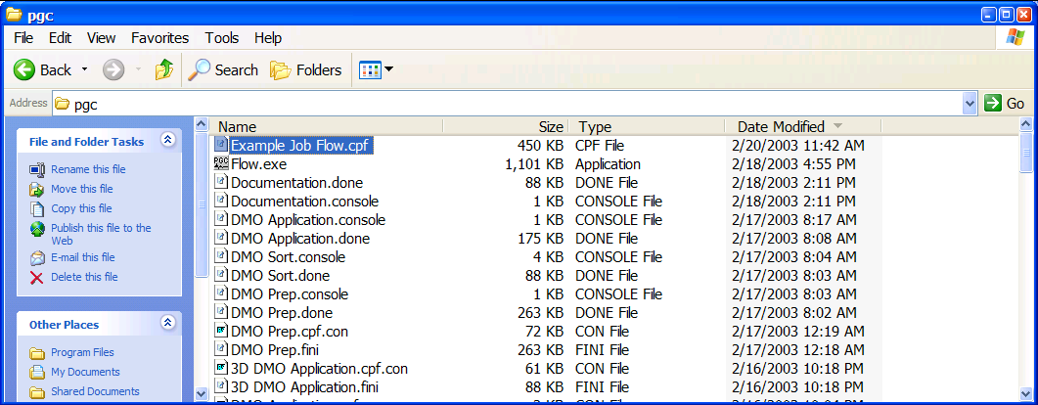
This will automatically compile the flow and generate a binary file (.cpf) that is ready to execute. The compiled (.cpf) file is written to the target directory specified in the Preferences dialog that is accessed under the Edit menu. By default, this is the directory containing the Flowchart executable file.

The compiled flow chart (.cpf) file

Executing a Flow

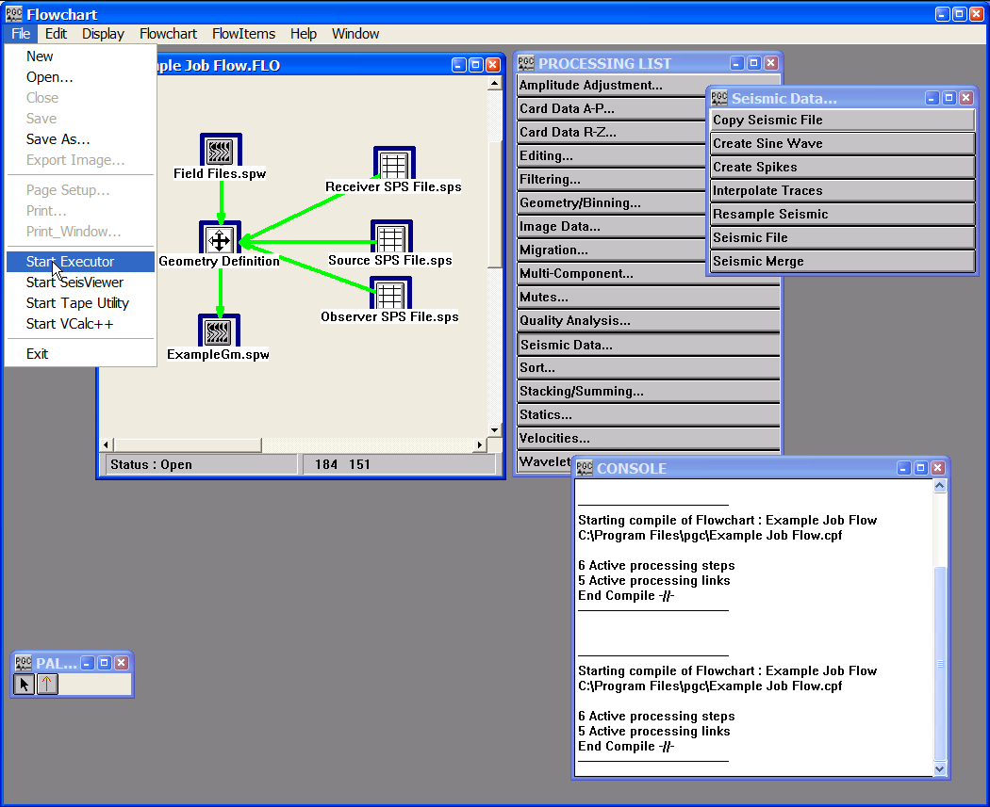
There are currently two ways to execute a newly compiled flow. The first is to launch the executor from the File menu by selecting Start Executor. The Executor will find the appropriate .cpf file in the target directory specified in the Preferences dialog (under the Edit menu). If the Executor is already open, it will automatically begin executing all compiled flows that are in the target directory. It will continue to execute flows as long as the application remains open, unless errors are encountered. The execution is sequential (i.e. only one flow will execute at a time) and operates in alphabetic order.

Accessing the Start Executor command
Selection of Start Executor from the File menu launches the Executor Dos window and automatically begins execution of the existing .cpf files
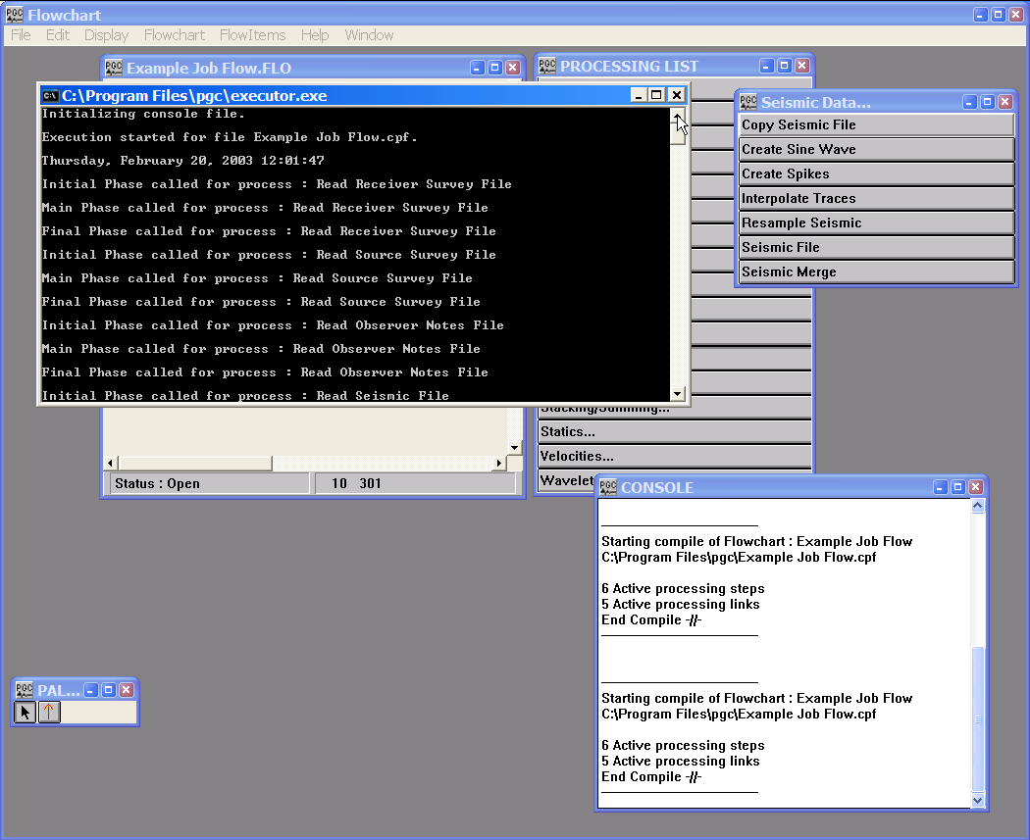

FlowChart Execution

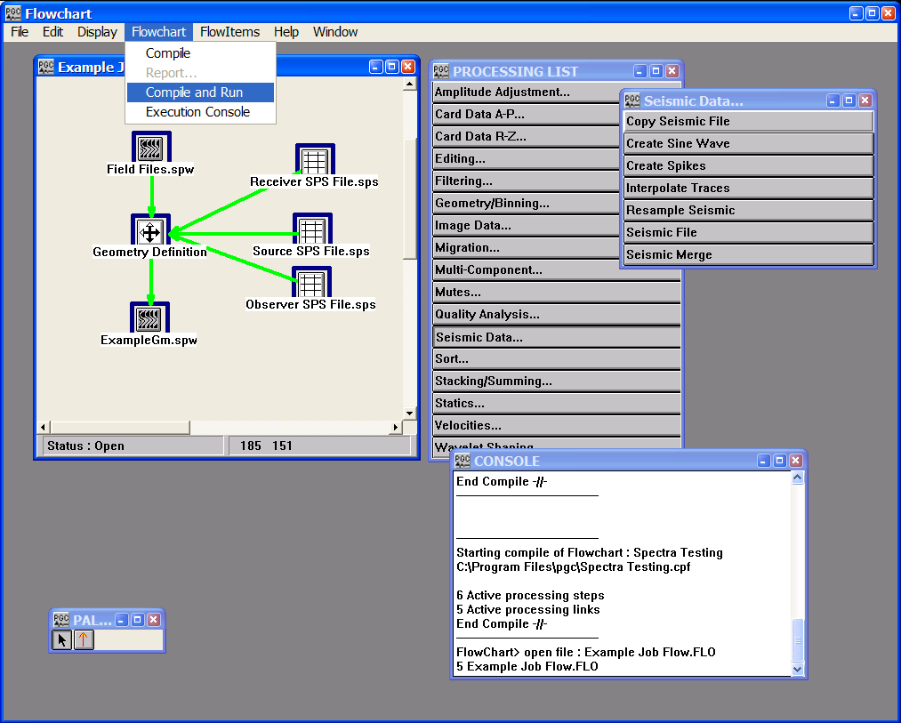
The second method of compiling and executing a flow is to select the Compile and Run command from the Flowchart menu. Selection of the Compile and Run command will launch the Executor Dos window and result in the compiled flow chart being directly executed without the intermediate step of launching the Executor from the file menu. The Compile and Run command allows execution of one flow per command. Job queuing is not an option with the Compile and Run command. The Executor Dos window automatically closes following completion job flow execution.

The Compile and Run command

Viewing the Statistics of an Executed Flow

Once the compiled flow chart has been successfully executed, a report of the execution is output as a file in the target directory. These files will have the name of the flow chart. If you chose to execute the job with the Compile and Run command found under the Flowchart menu, the report of the execution will be written to the target directory with a .console extension. If you compile the job and let the active Executor execute the job, the report of the execution will be written to the target directory with a .cpf.con extension. You may directly access either of these files by selecting Execution Console from the Flowchart menu.
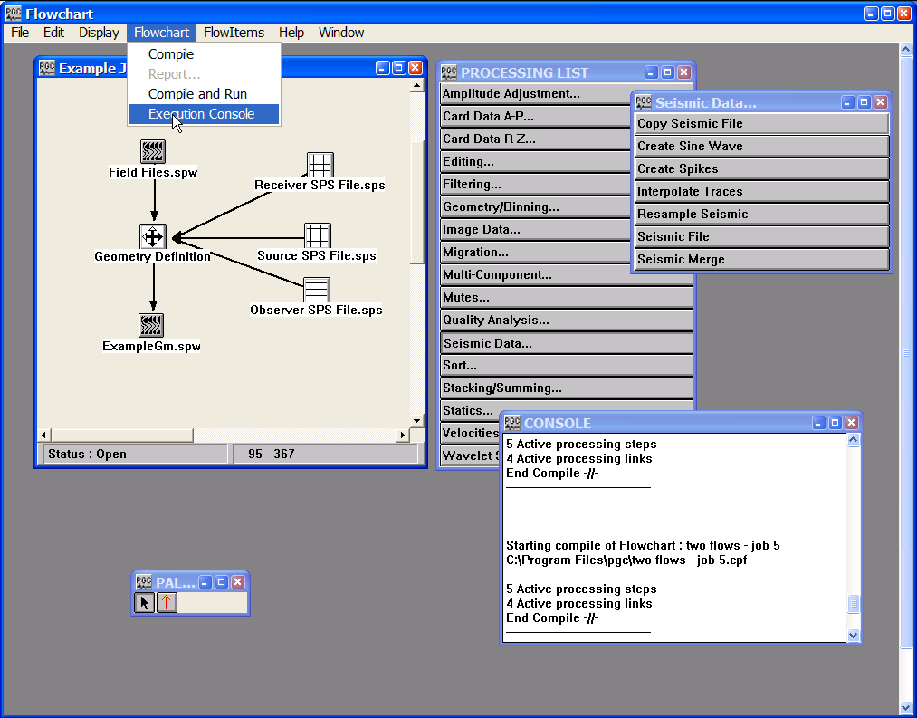
Accessing the Execution Console command

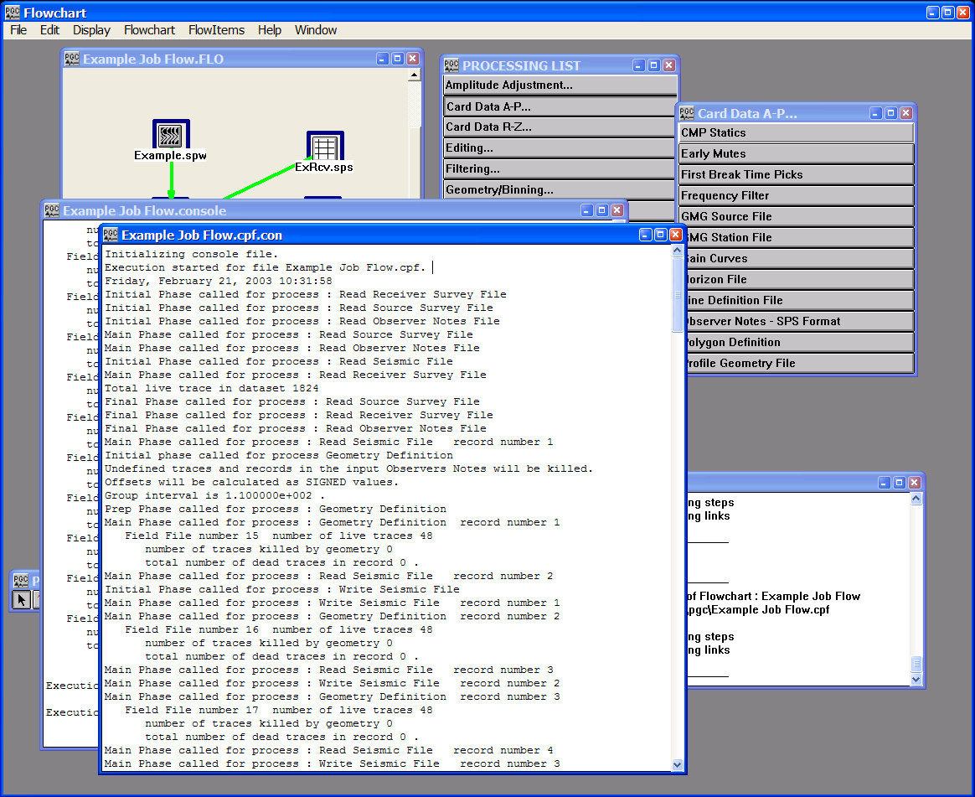
View of a report of an executed flow with the .cpf.con extension.

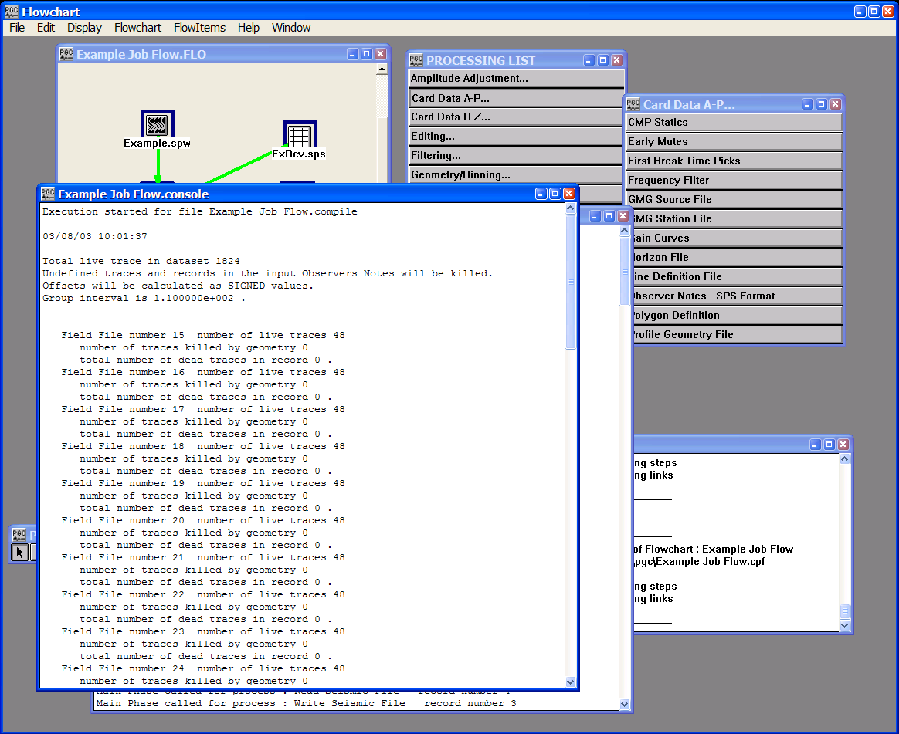
View of a report of an executed flow with the .console extension.

Encountering Errors in Execution

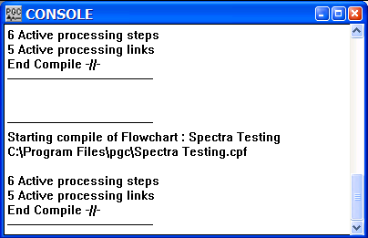
If there are errors in the way you constructed your flow chart, they may not appear until you execute the job. Your console may indicate that the compile ended without detecting any errors, such as the normal compile you see below.
FlowChart Console Contents

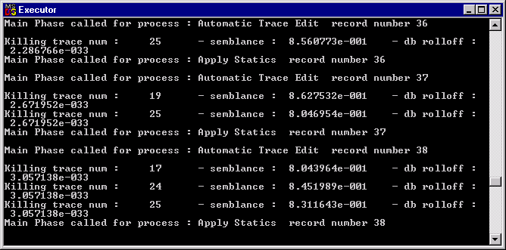
However, the Executor may pick up the job and fail to finish. If this happens, you may not receive an error message.
Executor Console Contents

Notice in the above Executor console, that the job has hung during the main phase. No errors are reported. The job activity has ceased. And there is no message indicating job completion.
At this point you must close the Executor. You may then compile and execute the job again, once you have found and corrected the error. If you have difficulty finding and correcting the error, Parallel Geoscience Corporation has technical support available to assist you (support@parallelgeo.com).

If the job executes successfully, you will observe the “Execution completed…” message at the bottom of the Executor window. To close the Executor window, you can press the Escape key, the window close (X) control in the upper right corner, or the Close command from the C:\ menu in the upper left corner.
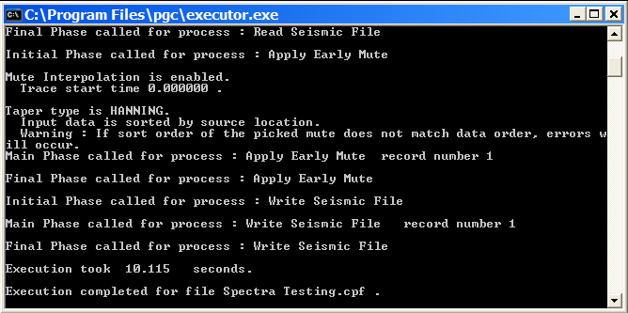
Execution Completed in Executor

File Database

The file database catalogues the basic information contained in each data file, such as the data file name, the project name, and the name of the processing flow that created the data file. Also registered in the database are the min-max range of trace header values in the data file, such as Field File number Shot Line number, Shot Location number, Receiver Line number, Receiver Location number, CMP Line number, and CMP Location number. Information regarding the name, number, and/or contents of physical tapes must be entered into this database by hand. Information regarding the contents of disk files created by SPW processing flows is automatically input to the database when a seismic file is created in a processing flow. The database is contained in a standard text file that may be accessed with any text editor or a spreadsheet application such as Excel.

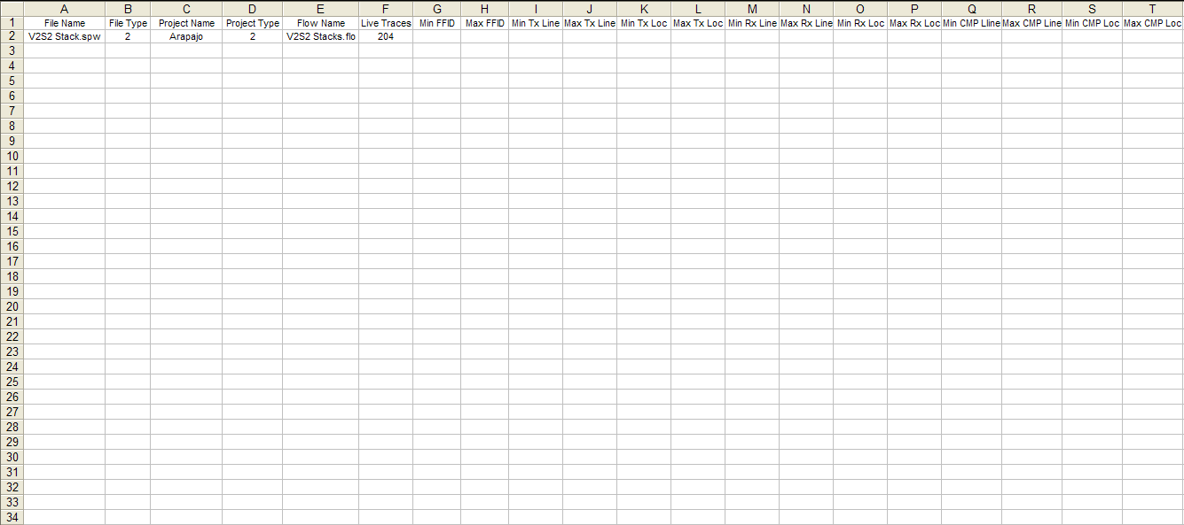

Example of the File Database spreadsheet.

Templates

Flowchart templates are read-only files that were designed to serve as examples of the most common processing flows. A text file accompanies each FlowChart processing template that explains the purpose of the flow, indicates how to use the flow, and describes the inputs and outputs required by the flow. Several templates have been created for each of the following processing categories:

- Input-output
- Geometry
- Filtering
- Velocities
- Statics
- Stacking
- Example Processing Flows

A zip file (Templates.zip) containing a complete range of FlowChart and SeisViewer templates is available as a free download from the Parallel Geoscience web site at:

ftp.parallelgeo.com/SPW_Products/Windows/Beta_Release/

The path name of each file in Templates.zip is specified relative to the pgc directory, which is C:\Program Files\pgc. Therefore, if you will want to extract the entire contents of the zip file to the C:\Program Files\pgc directory. The next few pages will explain how to access and implement the template for the application of 2D trace header geometry.

Example Template: 2D Geometry Application

To access the 2D Geometry Application template, select Open Templates from the File menu.
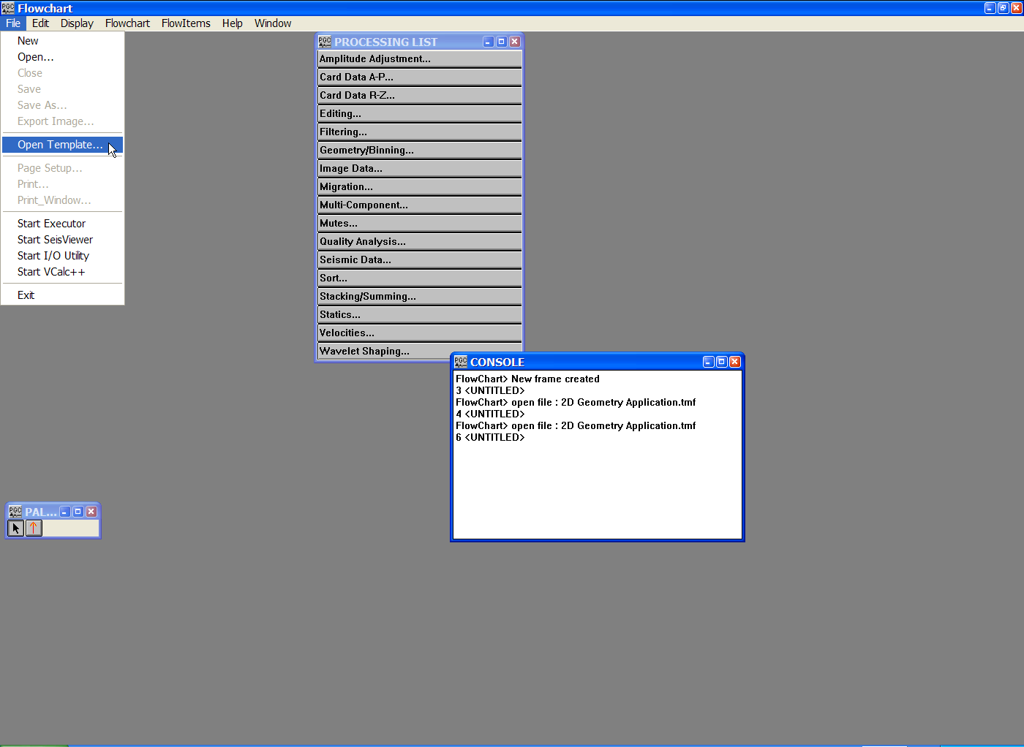
Step 1: select Open Template… from the File menu.

Selection of the Open Templates… will launch a dialog box that will prompt you to select a particular template.

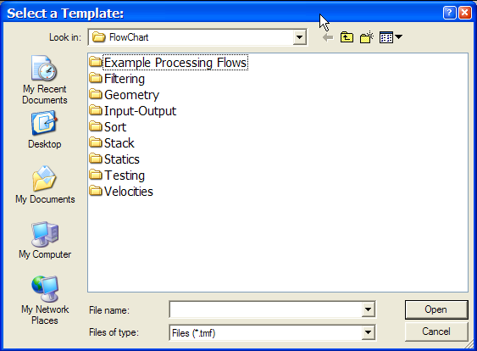
The FlowChart template directory.

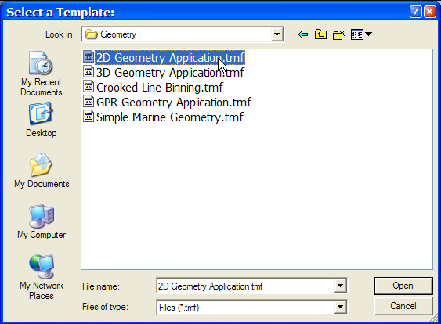
We are looking for the processing template that applies 2D-trace header geometry, so we will open the Geometry subfolder.

The Geometry templates.

Select the file 2D Geometry Application.tmf, which is the FlowChart template file (*.tmf) for the application of 2D Geometry. A processing flow and its accompanying text file will open on the screen.
The processing flow 2D Geometry Application.tmf and the accompanying text file.
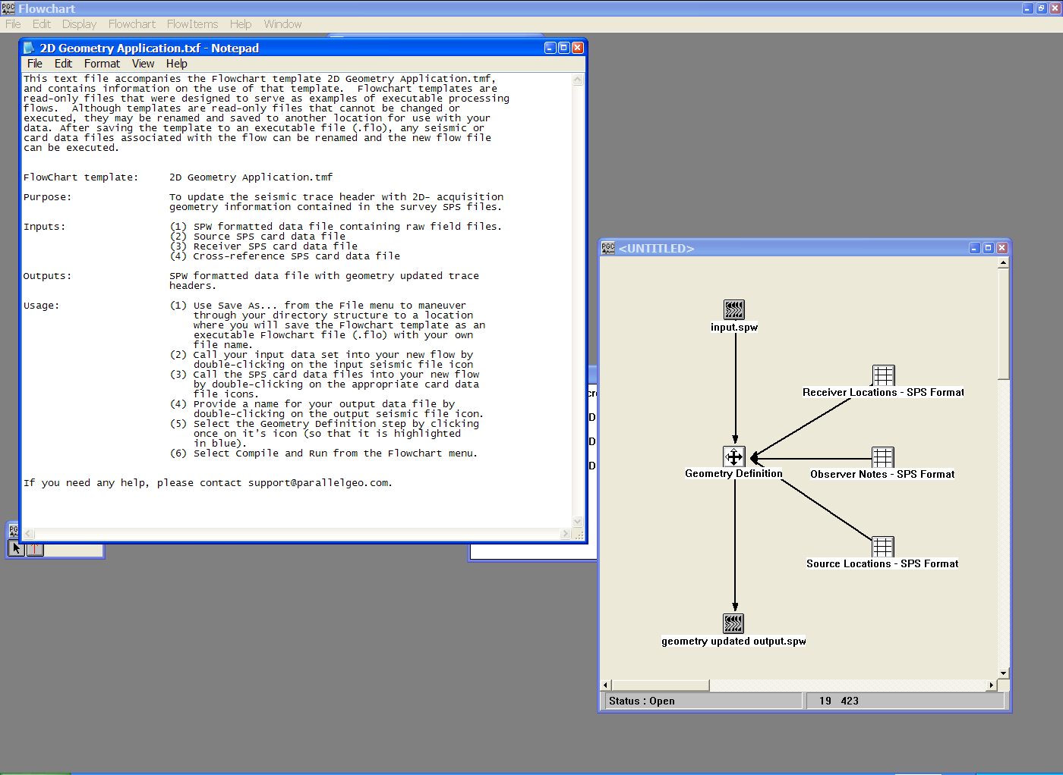

FlowChart templates, such as 2D Geometry Application.tmf are read-only files that can be neither altered nor executed. However, you may use the file by saving it as a new file and assigning the appropriate inputs and outputs. In the case of 2D Geometry Application.tmf, this would involve saving the file to a new directory (i.e. C:\My Project) and assigning the file a new name (i.e. 2D Geometry Application.flo). You would then associate a data file with the input by double-clicking on the input icon and using the Browse button to locate the input data set. File names are assigned to the output data file and the three SPS geometry files in a similar manner. Once the file has been renamed and each of the inputs and outputs have been assigned, the file is ready for execution.

The Processing Library:

Overview

The library of processing steps is separated into categories. The categories are as follows:

- Amplitude Adjustment
- Card Data A-P
- Card Data R-Z
- Editing
- Filtering
- Geometry/Binning
- Image Data
- Migration
- Multi-Component
- Mutes
- Quality Analysis
- Seismic Data
- Sort
- Stacking/Summing
- Statics
- Velocities
- Wavelet Shaping

The standard use of each processing step will be described in the pages that follow. If the step is enabled for only 2-D or only 3-D, it will be explicitly annotated as such; otherwise the process may be used with both 2-D and 3-D data. Each of the Processing Step descriptions lists the mandatory and optional input and output links required for execution, and contains an illustration of an example flow chart. References are given for some processing steps based upon specific published techniques or algorithms. An image of the processing step's parameter dialog is also displayed for your reference. Finally, you will find a description of each parameter for each processing step. At the end of each parameter description, the valid range for each parameter is shown in brackets {}.
Abbreviations for the parameters are as follows –
- - Greater than
<= - Less than or equal to
< - Less than
>= - Greater than or equal to
#,# - Range of values from first number to last number

Parameter range checking is enabled for some of the processing step parameters. Additional parameter range checking will be enabled in the future.

Note: For processing parameters with spatial units such as feet, meters, feet per second, meters per second, etc., SPW assumes that you are consistent in your use of spatial units for the entire data set. If your geometry information is in meters then you should consistently use metric units as your unit of measure for the SPW processing parameters applied to that data set. If your geometry information is in feet then you should consistently use English units as your unit of measure for the SPW processing parameters applied to that data set. Combining English and metric units of measure when processing in SPW will yield erroneous results.

Amplitude Adjustment Steps

This section documents the processing steps available for Amplitude Adjustment.

Processing steps currently available are:

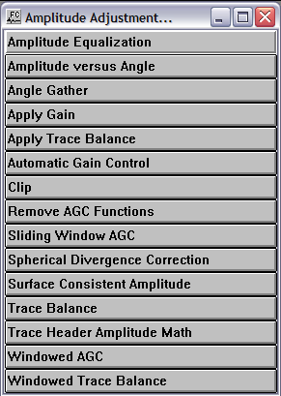

Amplitude Equalization
Usage:
The Amplitude Equalization step allows you to balance the RMS values of your data traces to a constant specified RMS level. You can also clip your data at a specified level. You can specify the data window to use in calculating the RMS amplitudes, the output RMS and clipping levels, and the method of amplitude equalization, which may be either trace constant or record constant.

Input Links:
- Seismic data in any sort order (mandatory).

Output Links:
1) Seismic data in same sort order as input (mandatory).

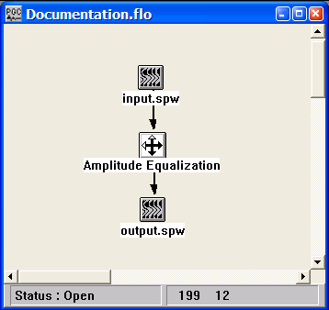
Example Flowchart:

Step Parameter Dialog:
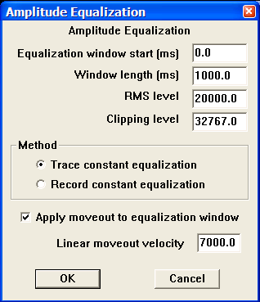

Parameter Description:
Equalization window start (ms) — Enter the start time in milliseconds of the window to be used in calculating the trace amplitude. {=>0}

Window length (ms) — Enter the length in milliseconds of the window to be used in calculating the trace amplitude. {>0.0}

RMS level — Enter the output RMS level of the data window specified. {>0.0}

Clipping level — Enter the clipping level of the trace data. {>0.0}

Method — Select whether to apply the equalization on a trace by trace basis or to maintain relative amplitudes and level the RMS value of the entire record.

Trace constant — If selected, your data will be equalized on a trace by trace basis.

Record constant — If selected, your data will be equalized on a record by record basis, which will depend on the sort order of the input data.

Apply moveout window — If checked, the equalization will be performed after linear moveout at the specified velocity. The window start time will shift by: delta time = offset/velocity.

Moveout velocity — Enter the constant moveout velocity. {>0.0}

Amplitude versus Angle
Usage:
The Amplitude versus Angle step inverts the amplitudes contained in pre-stack NMO corrected CMP gathers to obtain attributes that may be used to characterize earth materials in terms of P-wave reflectivity, S-wave reflectivity, Density, and Poisson’s ratio. The inversion may be based on either the Shuey or the Aki and Richards approximation of the Zoeppritz equations.

Input Links:
- Seismic data file containing NMO corrected CMP gathers (mandatory).

Output Links:
- None, the chosen AVA attribute is output directly to a disk file, which is mandatory.

References:
Shuey, R. T., 1985, A simplification of the Zoeppritz equations, Geophysics, 50, 609-614.
Aki, K. and Richards, P. G., 1979, Quantitative Seismology, W. H. Freeman and Co.

Example Flowchart:

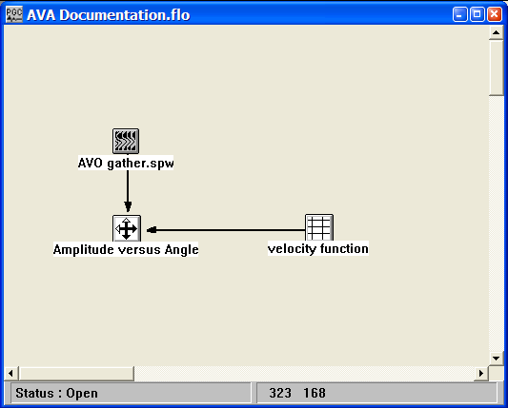

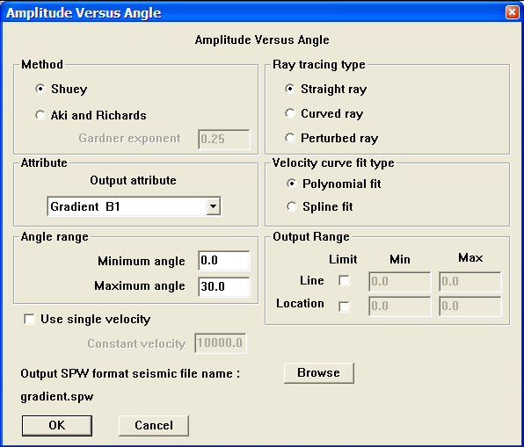
Step Parameter Dialog:

Parameter Description:
Method – Select an approximation to the Zoeppritz equations that will be used to interpret the amplitude values. The Shuey method is accurate out to approximately 30 degrees, whereas the Aki and Richards method can be considered accurate out to 40 degrees.

Shuey – If selected, the Shuey approximation will be used.

Aki and Richards – If selected, the Aki and Richards approximation will be used.

Attribute – Select the attribute that will be calculated and output as a seismic data file.

Intercept B0 – If selected, the intercept will be calculated.

Gradient B1 – If selected, the gradient will be calculated.

B1*SignOf(B0) – If selected, the product of the gradient and the absolute value of the intercept will be calculated.

B1/B0 – If selected, the quotient of the gradient and the intercept will be calculated.

(B0-B1)/2 – If selected, shear wave reflectivity will be calculated.

(B0+B1)/2 – If selected, Poisson reflectivity will be calculated.

Maximum angle – Enter the maximum angle.

Angle range – Define the minimum and maximum angles used in the calculation of AVA attributes.

Minimum angle – Enter the minimum angle.

Maximum angle – Enter the maximum angle.

Ray tracing type – Define the ray tracing method used in the estimation of propagation angles.

Straight – If selected, rays will be traced using a straight ray algorithm.

Curved – If selected, rays will be traced using a curved ray algorithm.

Perturbed – If selected, rays will be traced using a perturbed ray algorithm.

Velocity curve fit type – Define the procedure to interpolate velocities between time-velocity pairs specified in the linked velocity file.

Polynomial fit – If selected, velocities will be interpolated with a polynomial interpolator.

Spline fit – If selected, velocities will be interpolated with a spline interpolator.

Output range — Define the spatial range of the output data volume

Line – If checked, the output volume will be limited by CMP line number.

Min – Enter the minimum CMP line number to output.

Max – Enter the maximum CMP line number to output.

Location – If checked, the output volume will be limited by CMP location number.

Min – Enter the minimum CMP location number to output.

Max – Enter the maximum CMP location number to output.

Use single velocity – If checked, a single velocity will be used to determine angles of wavefield propagation. In the case of a single velocity specification, all ray tracing procedures are equivalent.

Constant velocity – Enter the constant velocity for ray tracing.

Output SPW format seismic file name – Use the Browse button to assign an output file name to the chosen AVA attribute.

Angle Gather
Usage:
The Angle Gather step is designed to mute pre-stack gathers as a function of the angle of incidence. Alternatively, the data may be muted as a function of the angle of emergence.

Input Links:
- Seismic data in any sort order (mandatory).

Output Links:
1) Seismic data in same sort order as input (mandatory).

Example Flowchart:
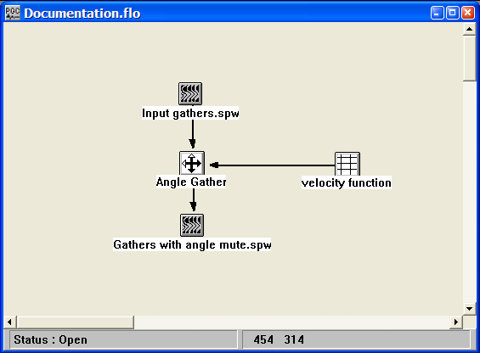

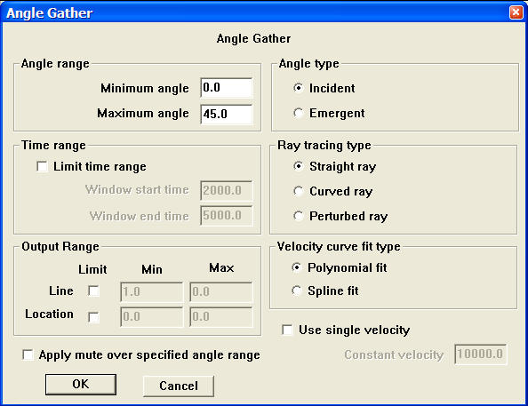
Step Parameter Dialog:

Parameter Description:
Angle range – Define the minimum and maximum angles retained in the output data.

Minimum angle – Enter the minimum angle.

Maximum angle – Enter the maximum angle.

Time range – Define the time range of the output data volume.

Limit time range – If checked, the output will be time limited.

Window start time – Enter the start time of the output data.

Window end time – Enter the end time of the output data.

Output range — Define the spatial range of the output data volume

Line – If checked, the output volume will be limited by CMP line number.

Min – Enter the minimum CMP line number to output.

Max – Enter the maximum CMP line number to output.

Location – If checked, the output volume will be limited by CMP location number.

Min – Enter the minimum CMP location number to output.

Max – Enter the maximum CMP location number to output.

Angle type – Define the angle type for angle muting.

Incident – If selected, angle muting will be based on incident angles.

Emergent – If selected, angle muting will be based on emergent angles.

Ray tracing type – Define the ray tracing method used in the estimation of propagation angles.

Straight – If selected, rays will be traced using a straight ray algorithm.

Curved – If selected, rays will be traced using a curved ray algorithm.

Perturbed – If selected, rays will be traced using a perturbed ray algorithm.

Velocity curve fit type – Define the procedure to interpolate velocities between time-velocity pairs specified in the linked velocity file.

Polynomial fit – If selected, velocities will be interpolated with a polynomial interpolator.

Spline fit – If selected, velocities will be interpolated with a spline interpolator.

Use single velocity – If checked, a single velocity will be used to determine angles of wavefield propagation. In the case of a single velocity specification, all ray tracing procedures are equivalent.

Constant velocity – Enter the constant velocity for ray tracing.

Apply mute over specified angle range – If checked, the angle range specified under “Angle Range” will be muted rather than preserved.

Apply Gain
Usage:
The Apply Gain step allows you to apply gain function curves to your seismic data. The gain curves are specified as time – dB pairs and are linearly interpolated to each location along the line. A constant gain multiplier may also be applied to the data.

Input Links:
1) Seismic data in any sort order (mandatory).
2) Gain Curves cards (mandatory).

Output Links:
1) Seismic data in same sort order as input (mandatory).

Example Flow chart:

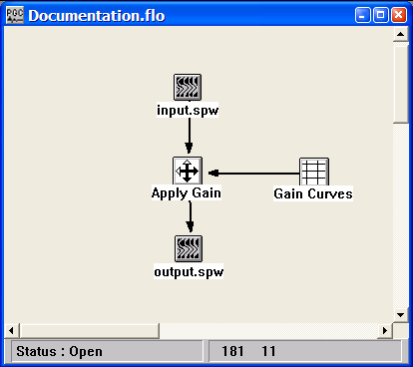

Step Parameter Dialog:
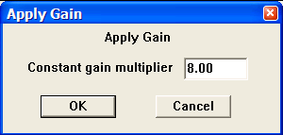

Parameter Description:
Constant gain multiplier — Each trace data sample is multiplied by this constant value.

Apply Trace Balance
Usage:
The Apply Trace Balance step applies the surface consistent source and receiver gains calculated by the Trace Balance process.

Input Links:
1) Seismic data in any sort order (mandatory).
2) Receiver Gains card data (mandatory).
3) Source Gains card data (mandatory).

Output Links:
1) Seismic data in same sort order as input (mandatory).

Example Flow chart:
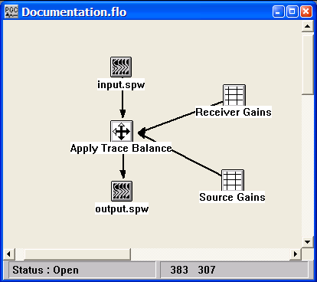
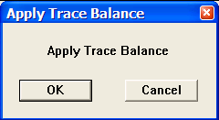
Step Parameter Dialog:

Parameter Description:
There are no parameters for this step.

Automatic Gain Control
Usage:
The Automatic Gain Control step allows you to apply up to five sliding window gain functions to each data trace. You specify the number (<=5) of gated windows, the overlap between the gated windows, and the start time and length of each gate. The calculated gain functions may be output to an optional seismic file, which allows you the option to remove the AGC functions prior to subsequent processing steps.

Input Links:
1) Seismic data in any sort order (mandatory).

Output Links:
1) Seismic data in same sort order as input (mandatory).
2) Seismic data file containing AGC functions (optional).

Example Flowcharts:
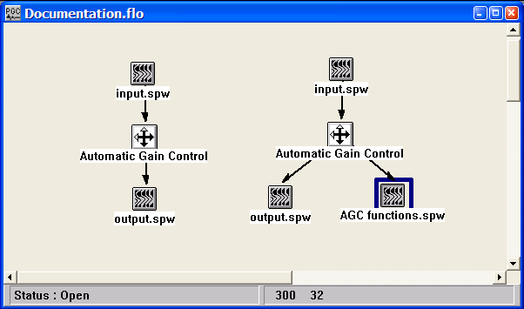

Step Parameter Dialog:
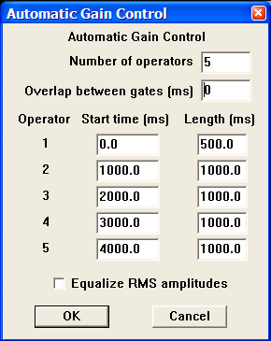
Parameter Description:
Number of operators — Enter the number of operators to design and apply on each trace. Each trace will be divided into this number of time gates (windows). {1,5}

Overlap between gates (ms) — Enter the overlap between gates in milliseconds. Longer overlap between gates results in a smoother transition between the gated windows. {=>0}

Start Time (ms) — Enter the start time in milliseconds for each gate. {=>0.0}

Length (ms) — Enter the operator length in milliseconds for each gate. {=>0.0}

Equalize RMS amplitudes — If checked, the trace RMS amplitude prior to AGC and after AGC will be the same.

Clip
Usage:
The Clip step is used to remove high-amplitude sample values from the input data and replace them with a user supplied threshold sample value. The largest positive and largest negative acceptable sample amplitudes are provided by the user. Values outside of this range are replaced by the threshold value.

Input Links:
1) Seismic data in any sort order (mandatory).

Output Links:
1) Seismic data in same sort order as input (mandatory).

Example Flowchart:

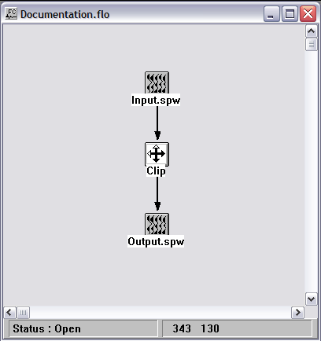

Step Parameter Dialog:

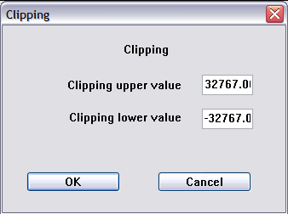
Parameter Description:

Clipping upper value — Specify the largest acceptable positive value. Positive values larger than the clipping upper limit are replaced with the clipping upper limit.

Clipping lower value — Specify the largest acceptable negative value. Negative values greater than the clipping lower limit are replaced with the clipping lower limit.

Remove AGC
Usage:
The Remove AGC step removes a previously applied AGC function.

Input Links:
1) Seismic data in any sort order (mandatory).
2) Seismic data file containing AGC functions computed by the Automatic Gain Control Step (mandatory).

Output Links:
1) Seismic data in same sort order as input (mandatory).

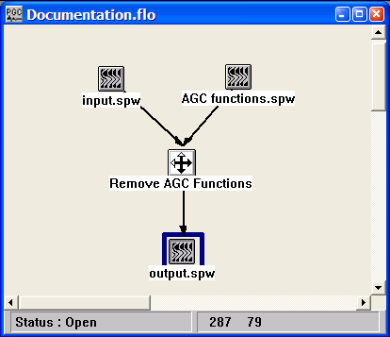
Example Flowchart:

Step Parameter Dialog:
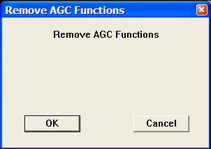

Parameter Description:
There are no parameters for this step.

Sliding Window AGC
Usage:
The Sliding Window AGC step allows you to apply AGC with a different operator length at the top and bottom of the seismic trace. The length is continuously changed from top to bottom.

Input Links:
1) Seismic data in any sort order (mandatory).

Output Links:
1) Seismic data in same sort order as input (mandatory).

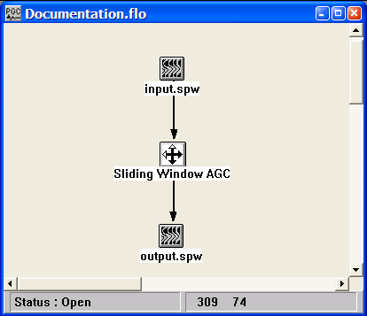
Example Flowchart:

Step Parameter Dialog:
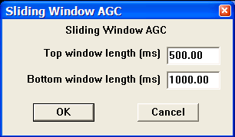
Parameter Description:
Top window length (ms) — Enter the operator length in milliseconds at the top of the trace. {>=0.0}

Bottom window length (ms) — Enter the operator length in milliseconds at the bottom of the trace. {>=0.0}

Spherical Divergence Correction
Usage:
The spherical divergence correction is designed to compensate for the decrease in seismic amplitude as a wavefront propagates away from the source location. The Spherical Divergence Correction step allows you to apply a gain to the data traces based on the equation:

Gain = T_Multiplier * (Time ** T_Exponent) * V_Multiplier * (Velocity(Time) ** V_Exponent).

The T_Multiplier and the V_Multiplier are constant gain factors and the T_Exponent and the V_Exponent vary the gain with time. Multipliers of one (1) and an exponents of two (2) are commonly used for the spherical divergence correction since energy from a point source dissipates in proportion to the square of distance traveled. To apply the spherical divergence correction as a function of both time and velocity, you must supply the optional velocity function. Otherwise, the velocity terms in the above equation will be ignored and the spherical divergence correction will only be applied as a function of time. You also have the option to apply the inverse spherical divergence correction function to your data.

Input Links:
1) Seismic data in any sort order (mandatory).
2) Velocity Function cards (optional).

Output Links:
1) Seismic data in same sort order as input (mandatory).

Reference:
Claerbout, Jon F., 1985, Fundamentals of Geophysical Data Processing: Blackwell Scientific Publications.

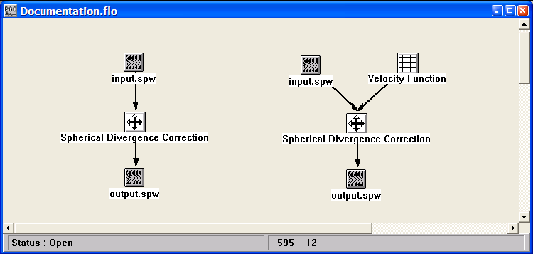
Example Flowcharts:
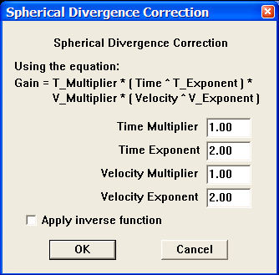
Step Parameter Dialog:

Parameter Description:
The Gain equation for the following definitions is:

Gain = T_Multiplier * (Time ** T_Exponent) * V_Multiplier * (Velocity(Time) ** V_Exponent).

Time Multiplier — Enter the time multiplier in the gain equation.

Time Exponent — Enter the time exponent in the gain equation.

Velocity Multiplier — Enter the velocity multiplier in the gain equation.

Velocity Exponent — Enter the velocity exponent in the gain equation.

Apply inverse function — If checked, an inverse spherical divergence correction will be applied to your data.

Surface Consistent Amplitude Corrections
Usage:
The Surface Consistent Amplitude Correction step applies source and receiver amplitude corrections generated by the Surface Consistent Deconvolution step, which decomposes of the amplitude spectra of the input seismic data into source, receiver, offset, and CMP components. The shot and receiver amplitudes decomposed during the generation of the surface-consistent deconvolution operators are then used for surface-consistent amplitude scaling.

Input Links:
- Seismic data in any sort order (mandatory).
- Auxiliary data file containing the deconvolution operators output by the Surface Consistent Deconvolution step. The last sample of each operator contains the surface consistent scalar (mandatory).

Output Links:
- Seismic data in any sort order (mandatory).

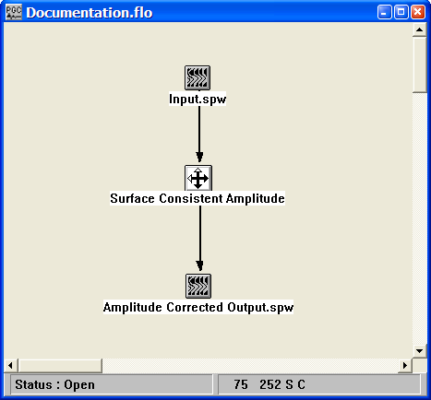
Example Flowchart:

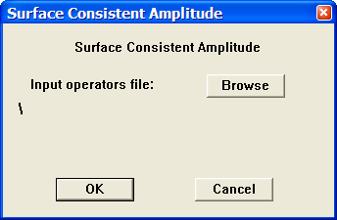
Step Parameter Dialog:

Parameter Description:
Input operators file — Use the Browse button to locate the SPW formatted file of surface-consistent deconvolution operators output by the Surface Consistent Deconvolution step. The last sample of each operator contains the surface consistent scalar.

Trace Balance

2-D only
Usage:
The Trace Balance step allows you to calculate surface consistent source and receiver gain corrections by a least squares analysis of trace amplitudes. You may designate the length of the analysis window for calculating the trace amplitudes if you do not want to use the entire trace for calculation of the trace amplitudes. You may also apply a moveout velocity to that window. Using a moveout window allows you to design the trace balancing around a constant event even for non-NMO corrected data.

Input Links:
1) Seismic data in CMP sort order (mandatory).

Output Links:
1) Receiver Gains card data (mandatory).
1) Source Gains card data (mandatory).

Reference:
Taner, M.T., and Koelher, F., 1981, Surface consistent corrections, Geophysics, v. 46, no. 1, p. 17-22.

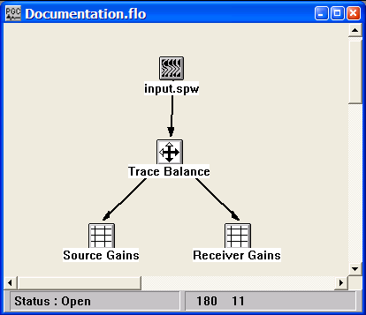
Example Flowchart:

Step Parameter Dialog:
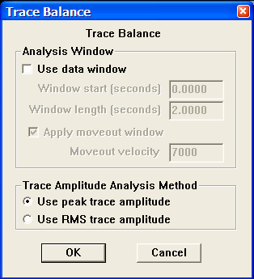

Parameter Description:
Use data window — If checked, an analysis window of the data will be used to calculate the trace amplitude for use in the matrix inversion solution.

Window start (sec) — Enter the starting time of the window.

Window length (sec) — Enter the length in seconds of the analysis window.

Apply moveout window — If checked, the analysis window for calculating the trace amplitudes will be applied after linear moveout at the specified velocity. The analysis window start time will shift by: delta time = offset / velocity.

Moveout velocity — Enter the constant moveout velocity of the analysis window. {>0.0}

Trace Amplitude Analysis Method —

Use peak trace amplitude — The peak amplitude of each trace will be used in the analysis process.

Use RMS trace amplitude — The RMS trace amplitude of each trace will be used in the analysis process.

Trace Header Amplitude Math
Usage:
The Trace Header Amplitude Math step use used to modify sample values using mathematical operations on trace header fields. Any of the trace header fields can be used.

Input Links:
1) Seismic data in any sort order (mandatory).

Output Links:
1) Seismic data in same sort order as input (mandatory).

Example Flowchart:

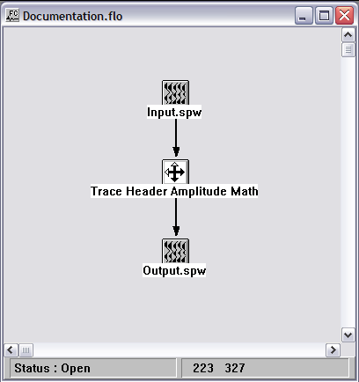

Step Parameter Dialog:

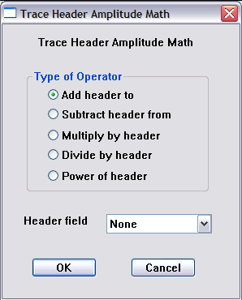

Parameter Description:
Type of operator — Select the mathematical operation that will modify the seismic amplitude values.

Header Field — Select the trace header field that will modify the seismic amplitude values.

Example: If the Multiply by header operator is selected and the Header field is set to offset, then the sample values in each input trace will be multiplied by the value of offset in the corresponding trace header.

Windowed AGC
Usage:
The Windowed AGC step allows you to apply an AGC function using up to ten different windows of the trace.

Input Links:
1) Seismic data in any sort order (mandatory).

Output Links:
1) Seismic data in same sort order as input (mandatory).

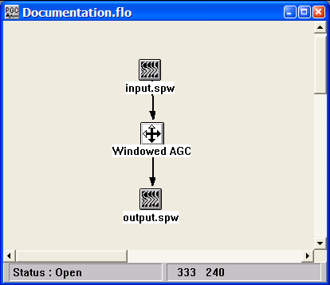
Example Flowchart:

Step Parameter Dialog:
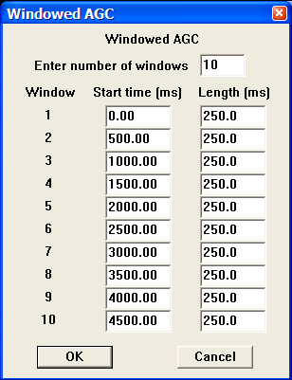

Parameter Description:
Enter number of windows — Enter the number of windows to use. {1,10}

Start (ms) — Enter the start time in milliseconds for each window.

Length (ms) — Enter the operator lengths in milliseconds for each window. {>0.0}

Windowed Trace Balancing
Usage:

Input Links:
1) Seismic data in any sort order (mandatory).

Output Links:
1) Seismic data in same sort order as input (mandatory).

Example Flowchart:

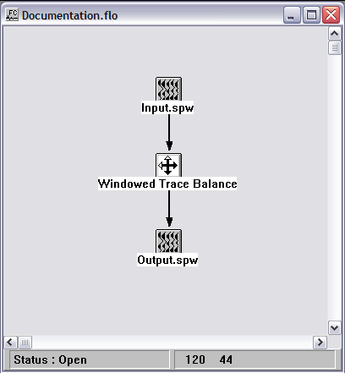

Step Parameter Dialog:

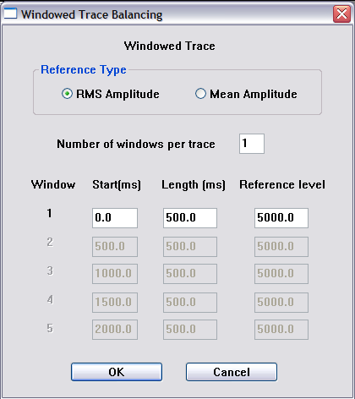

Parameter Description:
Reference type – Select whether the traces will be leveled according to RMS or mean amplitude.

Number of windows per trace — Enter the number of balancing windows per data trace.

Start (ms) — Enter the start time in milliseconds for the balancing window.

Length (ms) — Enter the length in milliseconds for the balancing window. The window will extend from the start time to start time + length.

Reference level — Enter the reference level for the balancing window. On output, the RMS or mean amplitude of the data trace will be equal to the specified value.

Card Data Steps

This section documents the support information available as Card Data. Card data may be imported from foreign data formats or output as foreign data formats. Both processes are performed through the use of a card data customization dialog available with each of the card data types listed below.

Card Data items currently available are:

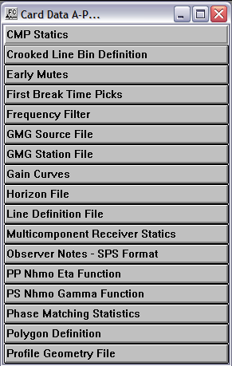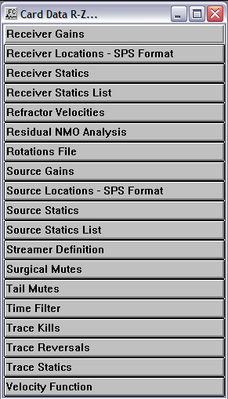

Creating and Editing Card Data Files

Each of the card data types can be created and edited manually within FlowChart. To create a card data file, select the appropriate icon from the card data list and place that icon on the FlowChart canvas. To add information to the card data file, you must first assign it a name. To assign a name to the card data file double-right click on the icon and use the Browse button. Once the card data file has a name, you may double-left click on the icon to open the spreadsheet and insert card data values. In the following example, we will create and edit a source SPS file.
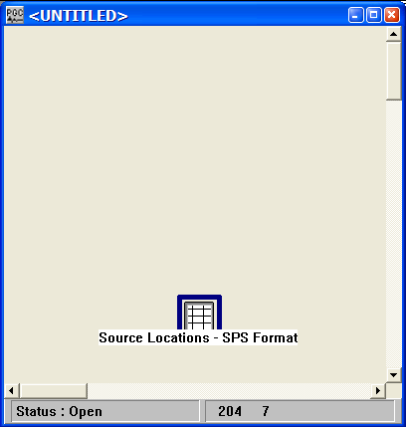
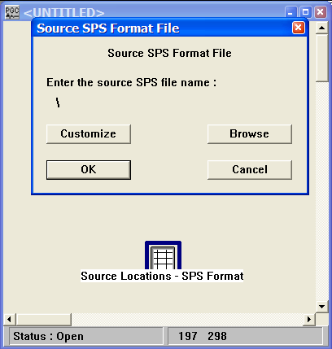
Step 1. Place the Source Locations – SPS Format card data file on the FlowChart canvas.

Step 2. Double-right click on the icon and use the Browse button to assign a name to the file.
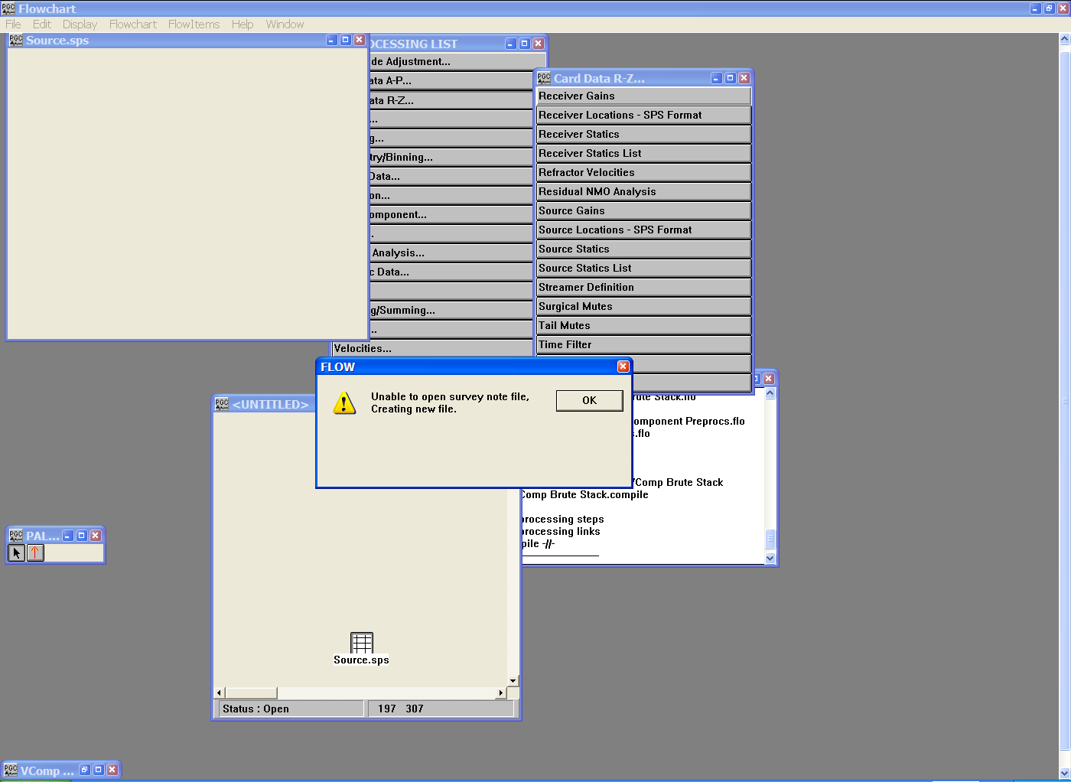
Step 3. Double-left click on the icon to access the spreadsheet of data values. Since the data file is currently empty, FlowChart will issue a warning message stating that it is unable to open the specified file, and that a new file will be created. Click OK.
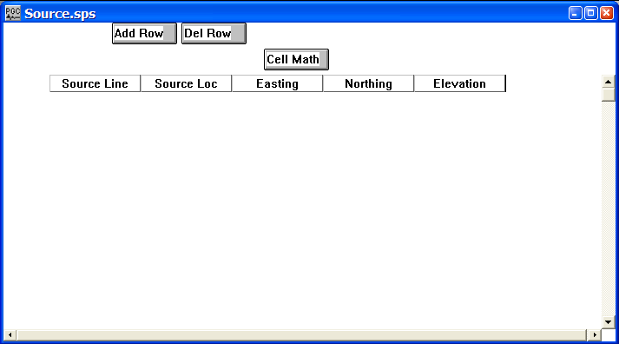

Step 3 (cont.). An example of an empty Source Locations – SPS Format file.

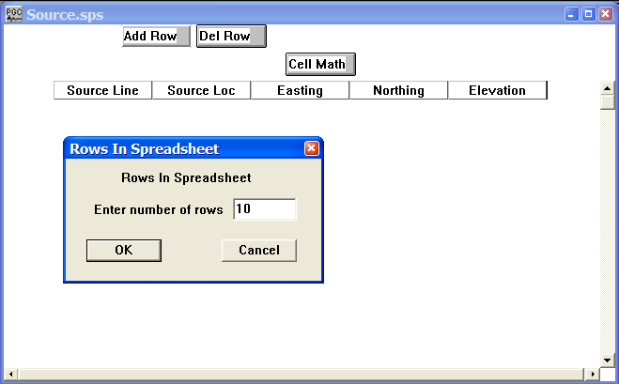
Step 4. You can add a row at a time to the empty data file by using the Add Row button, or add multiple rows by clicking on the Add Row button while simultaneously pressing the Ctrl key on your keyboard. If you decide to add multiple rows, a dialog will appear o the screen requesting the number of rows you would like to add.

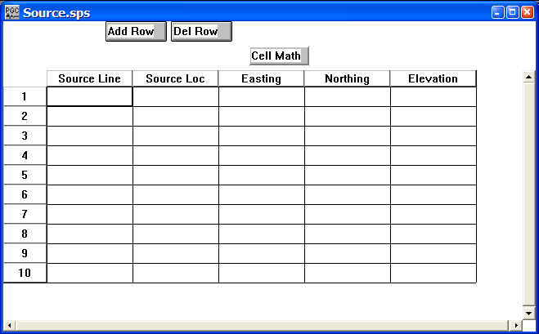
Step 4 (cont.). Now we have a spreadsheet full of empty cells and can begin to enter values. Most of the data values can be entered by using the Cell Math function.

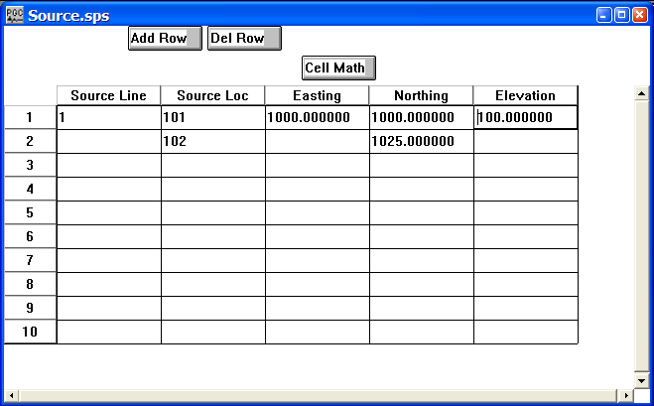
Step 5. Fill out the values in the first row as well as those in the second row that are need to determine the series of subsequent values. In the case of the source location, the two values 101 and 102 are sufficient to determine that the source position advances by 1. In the case of the source northing, the two values 1000 and 1025 are sufficient to determine that the source northing advances by 25.

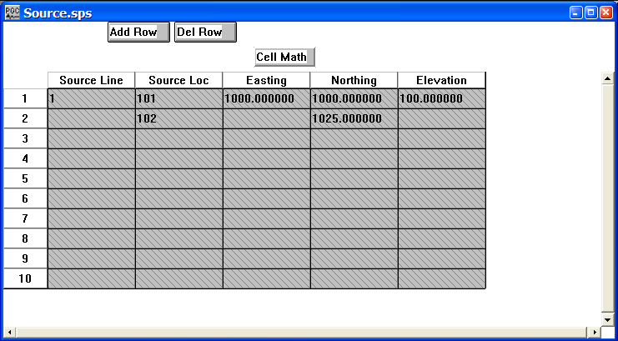
Step 6. Highlight the columns to which you will apply the Cell Math function. In this case we select the entire spreadsheet by clicking on the Source Line tab, holding down the mouse button, and scrolling over to the Elevation tab.
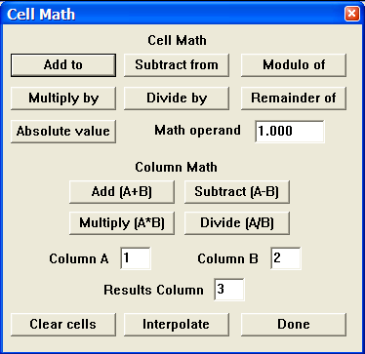
Step 7. Click on the Cell Math button to view the functions available with the Cell Math tool. The Cell Math tool consists of intuitive functions that can be used to alter the values in card data spreadsheets or trace header spreadsheets. All we will do in this example is use the Interpolate function to fill out the remainder of the Source Locations – SPS Format file. Click on Interpolate.

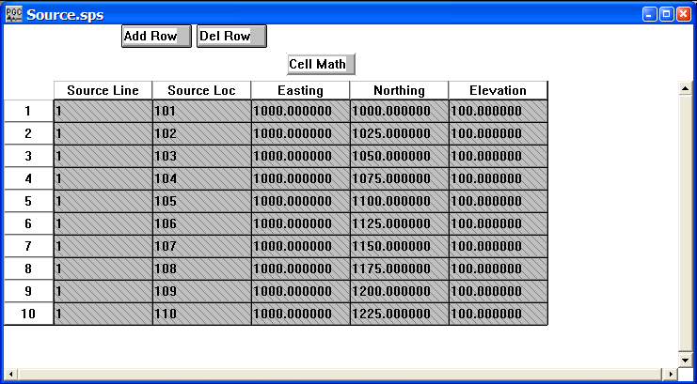
Step 7 (cont.). The complete source SPS spreadsheet. Click on the red X in the upper right corner to close the spreadsheet. Be sure to save your changes.

Card Data Customization Dialog

The utility of the card data customization feature is best understood through an example. Consider the following job flow designed to compute automatic source and receiver residual statics.

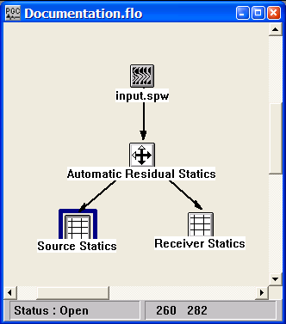

Double clicking on the Source Statics icon brings up the following dialog, which allows you to set the file name of the output statics file with the Browse button, and to customize the format of the output statics file with the Customize button:
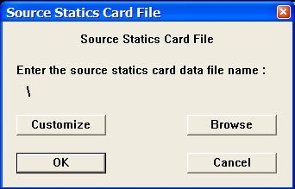

Select the Customize button and the following dialog appears:

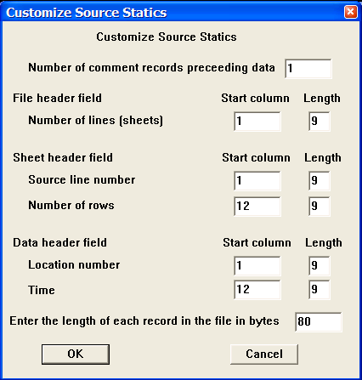

Parameter descriptions:
Number of comment records preceding data – Indicates the number of lines in the output file reserved for writing comment cards. These are the first lines in the file. A minimum of one line is required.

File header field – Indicates the number of sheets contained in the card data file. In the case of the source statics file above, there would be one sheet per source line.

Number of lines – Allows you to describe the formatting of the value indicating the number of source lines in the output source statics file.

Start column – Enter the column number to start writing the number of source lines in the output source statics file.

Length – Enter the number of columns reserved for writing the number of source lines in the output source statics file.

Sheet header field – Indicates the sheet number and the number of entries per sheet. In the case of the source statics file above, the sheet header line contains the source line number and the number of source locations on the line.

Source line number – Allows you to describe the formatting of the value indicating the source line number in the output source statics file.

Start column – Enter the column number to start writing the source line number in the output source statics file.

Length – Enter the number of columns reserved for writing the source line number in the output source statics file.

Number of rows – Allows you to describe the formatting of the value indicating the number of source locations in the output source statics file.

Start column – Enter the column number to start writing the number of source locations in the output source statics file.

Length – Enter the number of columns reserved for writing the number of source locations in the output source statics file.

Data header field – In the case of source statics, these header fields represents the source location number and the corresponding source static.

Location number – Allows you to describe the formatting of the value corresponding to the source location number in the output source statics file.

Start column – Enter the column number to start writing the source location number in the output data file.

Length – Enter the number of columns reserved for writing the source location number in the output source statics file.

Time – Allows you to describe the formatting of the value corresponding to the source location static in the output source statics file.

Start column – Enter the column number to start writing the source location static in the output source static file.

Length – Enter the number of columns reserved for writing the source location static in the output source static file.
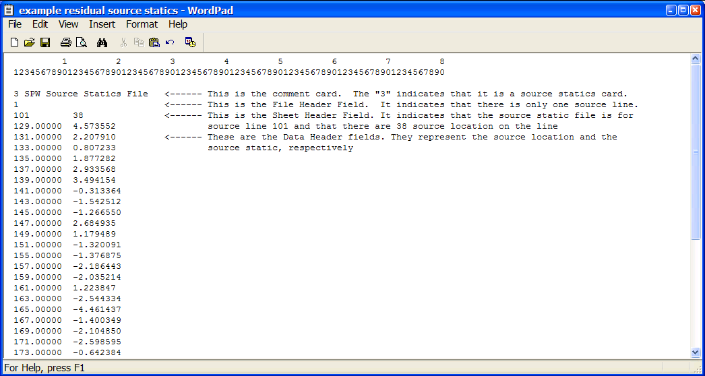
The source statics card data file output with the above parameterization will have the following form (the comments with arrows have been added for explanation):

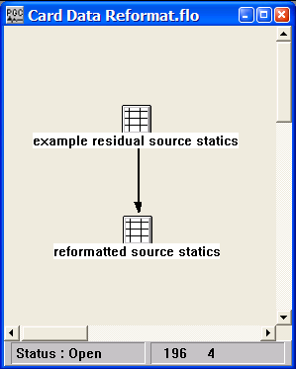
To output this file to in a known foreign format, create a simple job that inputs the SPW static file and outputs the reformatted, foreign format file:

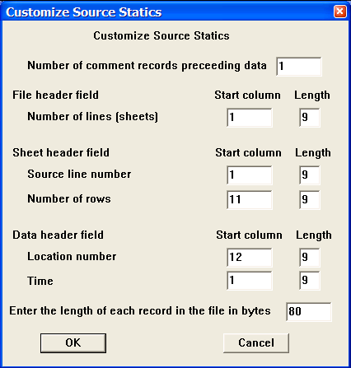
In this case, the card data customization dialog for the reformatted source statics file appears as follows, where the static value precedes the location number in the data field:

The resulting source statics card data file with this parameterization will have the source static value in the first column followed by location number in the second column:

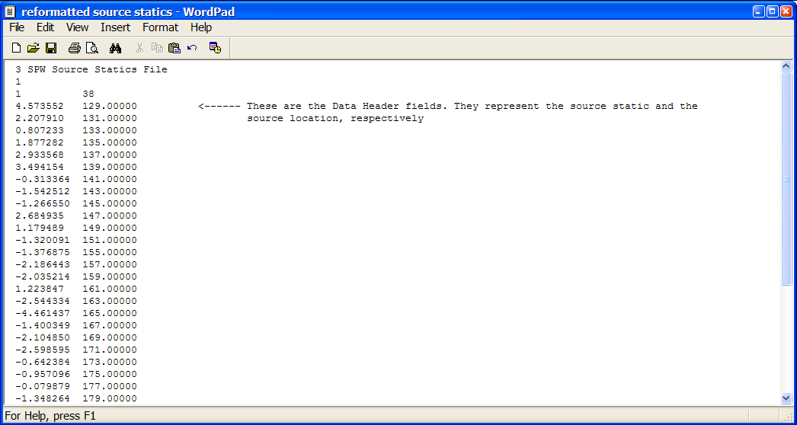

Creating Card Data in Excel

All of the card data types may be created in Microsoft Excel and transferred to SPW. To transfer a few data values, simply copy and paste from the Excel spreadsheet to the Card data spreadsheet. To transfer an entire file, you will need to reformat the Excel file as an SPW card data file. As an example we will create a receiver SPS file in Excel and reformat the file in Flowchart.

Step 1: Open the Excel application.

Step 2: Determine or set the width of the required amount of columns. Column width is set under the Format menu by selecting Column and then selecting width. The default width of an Excel spreadsheet column is 8.43, which means you will get 8 spaces when you save the file as a space delimited text file.

Step 3: Left justify each of the columns that will contain numeric values.

Step 4: Enter data values. In the case of a receiver SPS file there are five columns, which from column 1 to column 5 are labeled as Receiver Line, Receiver Location, Receiver Easting, Receiver Northing, and Receiver Elevation.

Step 5: Save the file as a space delimited text file. To save a space delimited text file go to the File menu and select Save As. Open the Save as type drop down menu in the Save As dialog and select Formatted Text (Space delimited). The default extension for Formatted Text files is *.prn.

Step 6: In FlowChart, select the appropriate Card Data item (in this case Receiver Locations – SPS Format) from the Processing List and place the item on the flow chart.

Step 7: Locate the Formatted Text file created in Excel. To locate the file, double click on the card data icon in FlowChart and a Format File dialog will appear. Click on the Browse button and a Select File dialog will appear that allows you to maneuver through your directory structure and locate the file.

Step 8: Customize the file format so that SPW can properly read your text file. To customize the file, click on the Customize button in the Format File dialog, and a Customize Format dialog will appear. In the case of the receiver SPS file created in Excel, we will load five columns (Line, Location, Easting, Northing, and Elevation), each of which is 8 characters wide. The starting column for Line number is 1 and the length of the Line field is 8. The starting column for the Location number is 9 and the length of the Location field is 8….. The starting column for the Elevation field is 33 and the length of the Elevation field is 8. When the appropriate parameters have been entered, select OK.

Step 9: View the card data spreadsheet to verify the data values.

Crooked Line Bin Definition
Usage:
The Crooked Line Bin Definition card file is used to (1) store the best fit line to the scatter of CMP resulting from a crooked line seismic survey, and (2) to specify, and ultimately extract a random 2-D line from a 3-D data volume

Step Parameter Dialog:
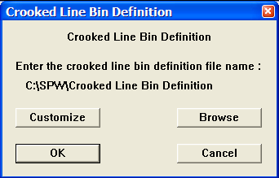

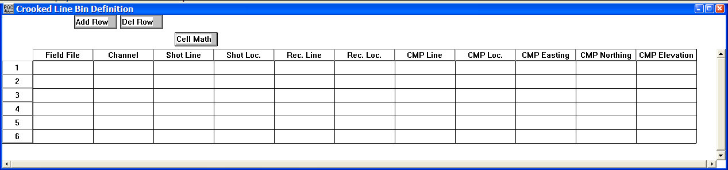
Example Card Data:
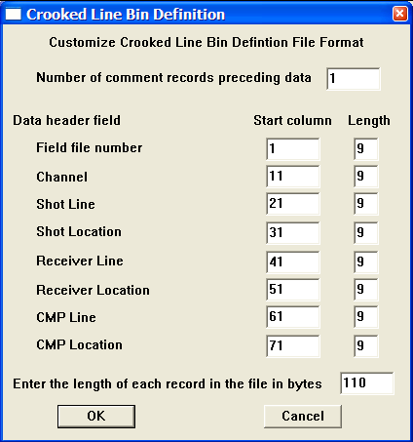
Card Data Customization Parameter Dialog:

Parameter descriptions:
Number of comment records preceding data: – Indicates the number of lines in the output file reserved for writing comment cards. These are the first lines in the file. A minimum of one line is required.

Data header field:
Field file number — Enter the start column and the number of columns allocated to write the Field File number associated with a given coordinate pair in the crooked line bin definition file.

Channel — Enter the start column and the number of columns allocated to write the channel number associated with a given coordinate pair in the crooked line bin definition file.

Shot Line — Enter the start column and the number of columns allocated to write the shot line associated with a given coordinate pair in the crooked line bin definition file.

Shot Location — Enter the start column and the number of columns allocated to write the shot location associated with a given coordinate pair in the crooked line bin definition file.

Receiver Line — Enter the start column and the number of columns allocated to write the receiver line associated with a given coordinate pair in the crooked line bin definition file.

Receiver Location — Enter the start column and the number of columns allocated to write the receiver location associated with a given coordinate pair in the crooked line bin definition file.

CMP Line — Enter the start column and the number of columns allocated to write the cmp line associated with a given coordinate pair in the crooked line bin definition file.

CMP Location — Enter the start column and the number of columns allocated to write the cmp location associated with a given coordinate pair in the crooked line bin definition file.

CMP Easting — Enter the start column and the number of columns allocated to write the cmp easting associated with a given coordinate pair in the crooked line bin definition file.

CMP Northing — Enter the start column and the number of columns allocated to write the cmp northing associated with a given coordinate pair in the crooked line bin definition file.

CMP Elevation — Enter the start column and the number of columns allocated to write the cmp elevation associated with a given coordinate pair in the crooked line bin definition file.

Enter the length of each record in the file in bytes – Enter the length in bytes of one line of the crooked line bin definition file.

CMP Statics
Usage:
The CMP Statics card data item is used to store CMP based static shift values in milliseconds.

Step Parameter Dialog:
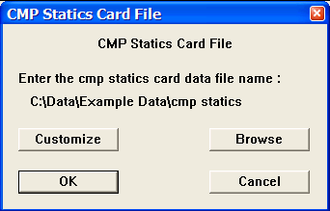

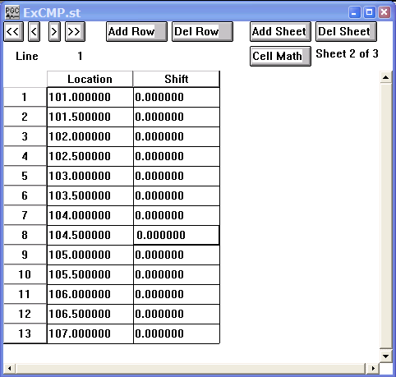
Example Card Data:
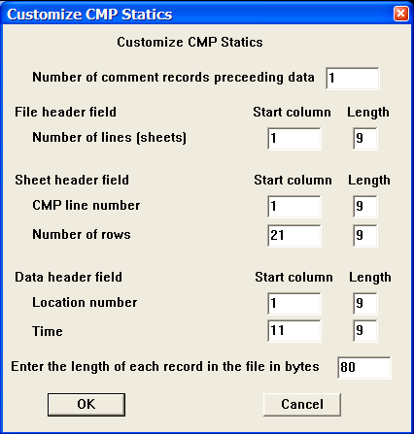
Card Data Customization Parameter Dialog:

Parameter descriptions:
Number of comment records preceding data: – Indicates the number of lines in the output file reserved for writing comment cards. These are the first lines in the file. A minimum of one line is required.

File Header field:
Number of lines — Enter the start column and the number of columns allocated to write the number of CMP lines in the output CMP static file.

Sheet Header field:
CMP line number — Enter the start column and the number of columns allocated to write CMP line number in the output CMP static file.

Number of rows — Enter the start column and the number of columns allocated to write the number of CMP positions in the CMP line in the output CMP static file.

Data header field:
Location number — Enter the start column and the number of columns allocated to write the CMP location number in the output CMP static file.

Time — Enter the start column and the number of columns allocated to write the CMP static value (in milliseconds) in the output CMP static file.

Early Mutes
Usage:
The Early Mutes card data item is used to store the mute definition for early (top) mutes. Mute times are in units of seconds. Early mutes may be interactively defined in SeisViewer using the Pick Traces tool located in the Picking menu.

Step Parameter Dialog:
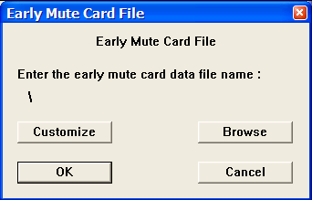

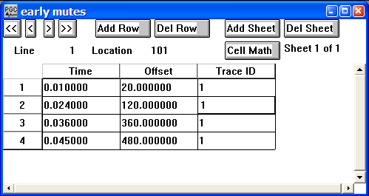
Example Card Data:
Card Data Customization Parameter Dialog:
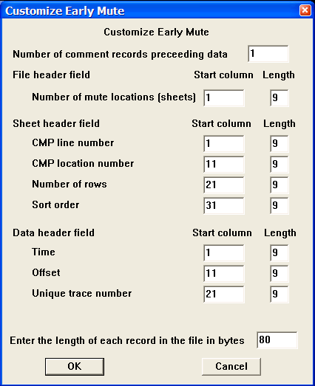

Parameter descriptions:
Number of comment records preceding data: – Indicates the number of lines in the output file reserved for writing comment cards. These are the first lines in the file. A minimum of one line is required.

File Header field:
Number of mute locations — Enter the start column and the number of columns allocated to write the number of mute locations in the output mute file.

Sheet Header field:
CMP line number — Enter the start column and the number of columns allocated to write the CMP line number in the output mute file.

CMP location number — Enter the start column and the number of columns allocated to write the CMP location number in the output mute file.

Number of rows — Enter the start column and the number of columns allocated to write the number of CMP positions in the CMP line in the output mute file.

Sort order — Enter the start column and the number of columns allocated to write the sort order (e.g. common source, CMP, etc…) of the data file on which the early mute was picked.

Data header field:
Time — Enter the start column and the number of columns allocated to write the mute time (in milliseconds) at a specified offset and trace number in the output mute file.

Offset — Enter the start column and the number of columns allocated to write the source receiver offset corresponding to a specified mute time and trace number in the output mute file.

Unique trace number — Enter the start column and the number of columns allocated to write the unique trace number corresponding to a specified mute time and source-receiver offset in the output mute file.

First Break Time Picks
Usage:
The First Break Time Picks card data item is used to store the first break time picks (in milliseconds). First break may be picked interactively in SeisViewer using the Pick Traces tool located in the Picking menu.

Step Parameter Dialog:
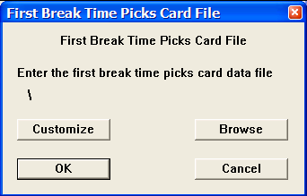

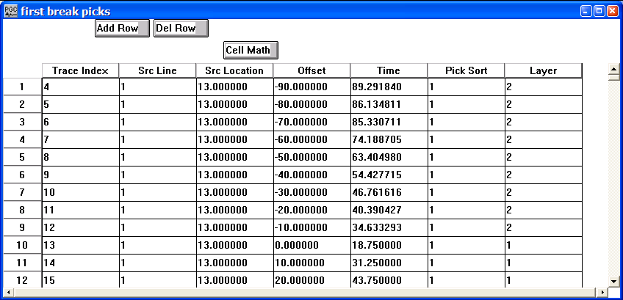
Example Card Data:

Card Data Customization Parameter Dialog:
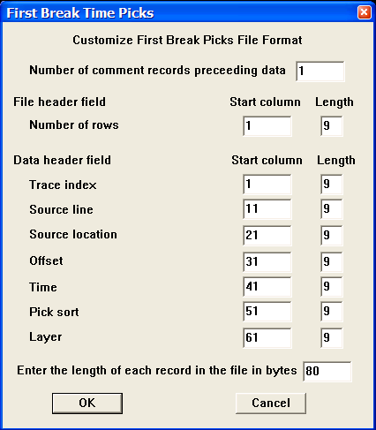

Parameter descriptions:
Number of comment records preceding data: – Indicates the number of lines in the output file reserved for writing comment cards. These are the first lines in the file. A minimum of one line is required.

File Header field:
Number of rows — Enter the start column and the number of columns allocated to write the first break time picks in the output first break pick file.

Data header field:
Trace index — Enter the start column and the number of columns allocated to write the trace index value associated with the pick time in the first break pick file.

Source line — Enter the start column and the number of columns allocated to write the source line number associated with a specific pick time in the first break pick file.

Source location — Enter the start column and the number of columns allocated to write the source location number associated with a specific pick time in the first break pick file.

Offset — Enter the start column and the number of columns allocated to write the source receiver offset associated with a specific pick time in the first break pick file.

Time — Enter the start column and the number of columns allocated to write the pick time (in milliseconds) in the first break pick file.

Pick Sort — Enter the start column and the number of columns allocated to write the sort order (e.g. common source, CMP, etc…) of the data file on which the first break times were picked.

Time — Enter the start column and the number of columns allocated to write the layer number associated with a specific pick time in the first break pick file.

Enter the length of each record in the file in bytes – Enter the length in bytes of one line of the output file.

Frequency Filter
Usage:
The Frequency Filter card data item is used to store the frequency-domain (transfer function) representation of a filter.

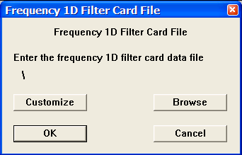
Step Parameter Dialog:

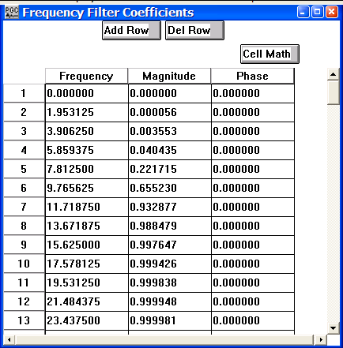
Example Card Data:

Card Data Customization Parameter Dialog:
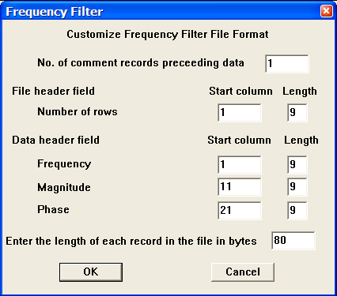

Parameter descriptions:
Number of comment records preceding data: – Indicates the number of lines in the output file reserved for writing comment cards. These are the first lines in the file. A minimum of one line is required.

File Header field:
Number of rows — Enter the start column and the number of columns allocated to write the frequency domain filter coefficients in the frequency filter file.

Data header field:
Frequency — Enter the start column and the number of columns allocated to write the frequency value in Hertz associated with a given magnitude and phase in the output frequency filter file.

Magnitude — Enter the start column and the number of columns allocated to write the magnitude value associated with a given frequency and phase in the output frequency filter file.

Phase — Enter the start column and the number of columns allocated to write the phase value associated with a given frequency and magnitude in the output frequency filter file.

Enter the length of each record in the file in bytes – Enter the length in bytes of one line of the output frequency filter file.

GMG Source Card File
Usage:
The GMG Source Card File is used to store source statics information previously computed with Green Mountain Geophysics refraction statics software. These files cannot be created manually in SPW.

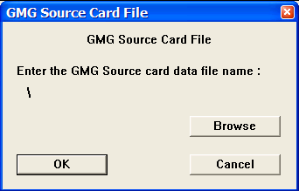
Step Parameter Dialog:

Example Card Data:

GMG Station Card File
Usage:
The GMG Station Card File is used to store receiver station statics information previously computed with Green Mountain Geophysics refraction statics software. These files cannot be created manually in SPW.

Step Parameter Dialog:
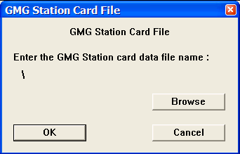

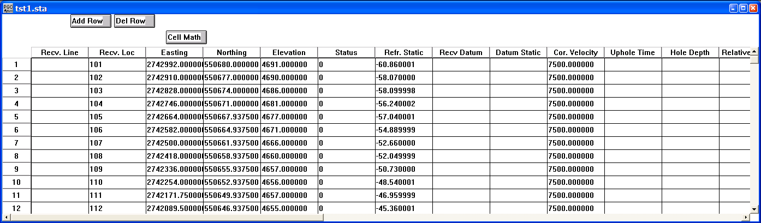
Example Card Data:

GMG Station Card File
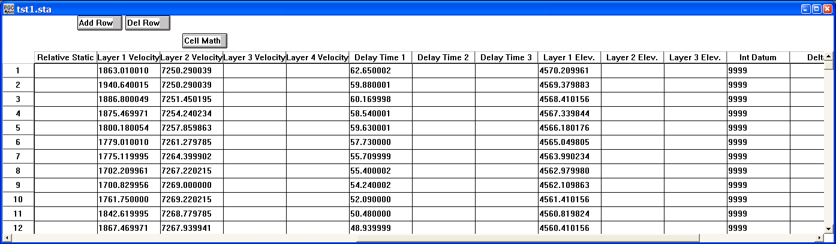

GMG Station Card File cont.

Gain Curves
Usage:
The Gain Curves card data item is used to store time-decibel gain pairs. A gain of 0 dB is equivalent to scalar multiplication by a factor of 1, a gain of 6 dB by a factor of 2, a gain of 12 dB by a factor of 4, a gain of 18 dB by a factor of 8, and so on. Time is in milliseconds.

Step Parameter Dialog:
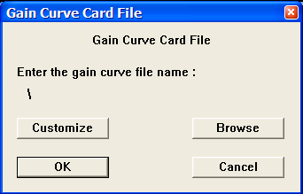

Example Card Data:
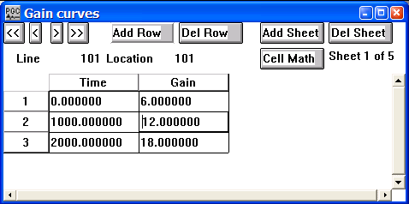

Card Data Customization Parameter Dialog:
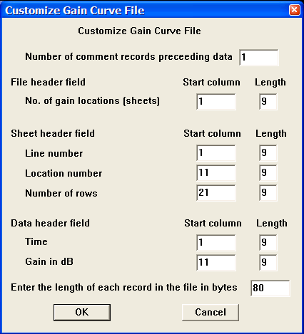

Parameter descriptions:
Number of comment records preceding data: – Indicates the number of lines in the output file reserved for writing comment cards. These are the first lines in the file. A minimum of one line is required.

File Header field:
No. of gain locations — Enter the start column and the number of columns allocated to write the number of gain locations in the output gain file.

Sheet Header field:
Line number — Enter the start column and the number of columns allocated to write the line number associated with a gain location in the output gain file.

Location number — Enter the start column and the number of columns allocated to write the location number associated with a gain location in the output gain file.

Number of rows — Enter the start column and the number of columns allocated to write the number of gain locations per line in the output gain file.

Data header field:
Time — Enter the start column and the number of columns allocated to write the two-way time (in milliseconds) associated with a given gain value in the output gain file.

Gain in dB — Enter the start column and the number of columns allocated to write the gain in dB associated with a given two-way travel time in the output gain file.

Enter the length of each record in the file in bytes – Enter the length in bytes of one line of the output frequency filter file.

Horizon File
Usage:
The Horizon File card data item is used to store horizon time picks. Horizon event picking may be performed interactively in SeisViewer using the Pick Traces tool located in the Picking menu.

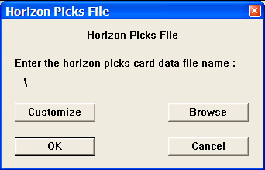
Step Parameter Dialog:

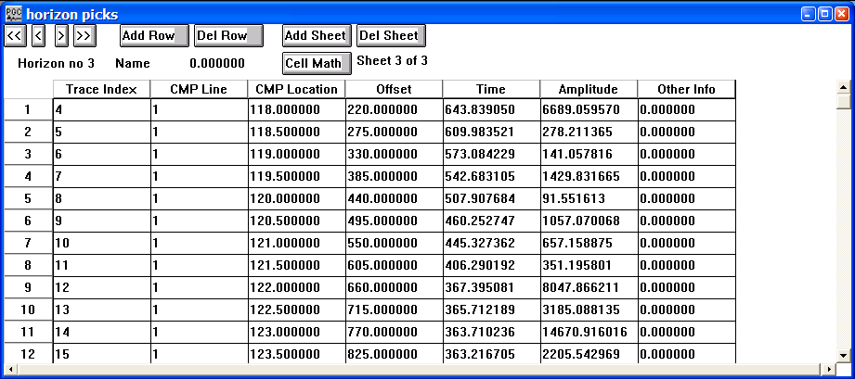
Example Card Data:

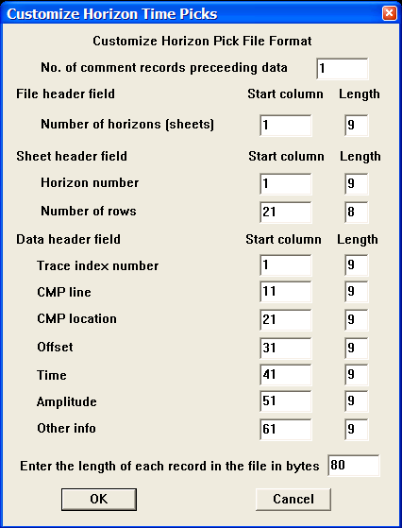
Card Data Customization Parameter Dialog:

Parameter descriptions:
Number of comment records preceding data: – Indicates the number of lines in the output file reserved for writing comment cards. These are the first lines in the file. A minimum of one line is required.

File Header field:
Number of horizons — Enter the start column and the number of columns allocated to write the number of horizons in the output horizon file.

Sheet Header field:
Horizon number — Enter the start column and the number of columns allocated to write the horizon number associated with a given horizon in the output horizon file.

Number of rows — Enter the start column and the number of columns allocated to write the number of time picks per horizon in the output horizon file.
Data header field:
Trace index number — Enter the start column and the number of columns allocated to write the trace index number associated with a given horizon time pick in the output horizon file.

CMP Line — Enter the start column and the number of columns allocated to write the CMP line number associated with a given horizon time pick in the output horizon file.

CMP Location — Enter the start column and the number of columns allocated to write the CMP location number associated with a given horizon time pick in the output horizon file.

Offset — Enter the start column and the number of columns allocated to write the offset in meters (from the first CMP on the line for a stacked section) associated with a given horizon time pick in the output horizon file.

Time — Enter the start column and the number of columns allocated to write the two-way time (in milliseconds) associated with a given horizon pick in the output horizon file.

Amplitude — Enter the start column and the number of columns allocated to write the amplitude of the event associated with a given horizon pick in the output horizon file.

Other info — Enter the start column and the number of columns allocated to write the additional information in the output horizon file.

Enter the length of each record in the file in bytes – Enter the length in bytes of one line of the output frequency filter file.

Line Definition File
Usage:
The Line Definition File card data is used to (1) store the best fit line to the scatter of CMP resulting from a crooked line seismic survey, and (2) to specify, and ultimately extract a random 2-D line from a 3-D data volume

Step Parameter Dialog:

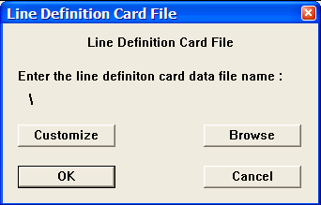

Example Card Data:
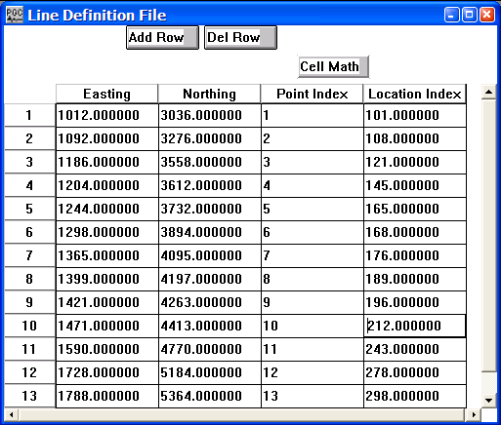
Card Data Customization Parameter Dialog:
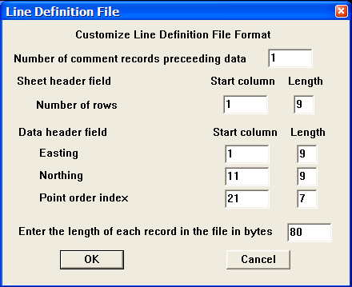

Parameter descriptions:
Number of comment records preceding data: – Indicates the number of lines in the output file reserved for writing comment cards. These are the first lines in the file. A minimum of one line is required.

Sheet Header field:
Number of rows — Enter the start column and the number of columns allocated to write the number of coordinate pairs used to define the line in the output line definition file.

Data header field:
Easting — Enter the start column and the number of columns allocated to write the easting associated with a given coordinate pair in the output line definition file.

Northing — Enter the start column and the number of columns allocated to write the northing associated with a given coordinate pair in the output line definition file.

Point order index — Enter the start column and the number of columns allocated to write the point index associated with a given coordinate pair in the output line definition file.

Enter the length of each record in the file in bytes – Enter the length in bytes of one line of the output line definition file.

Multicomponent Receiver Statics File
Usage:
The Multicomponent Receiver Statics card data is used to store unique receiver statics for multicomponent data volumes containing P-wave arrivals, S-wave arrivals, and/or PS-wave converted arrivals. Static values are stored in units of milliseconds.

Step Parameter Dialog:
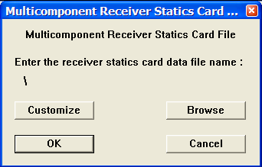

Example Card Data:
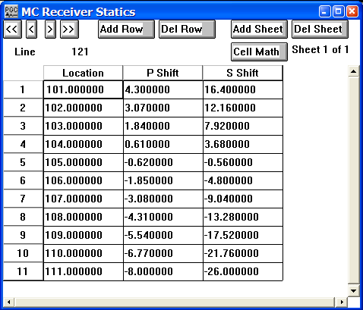
Card Data Customization Parameter Dialog:
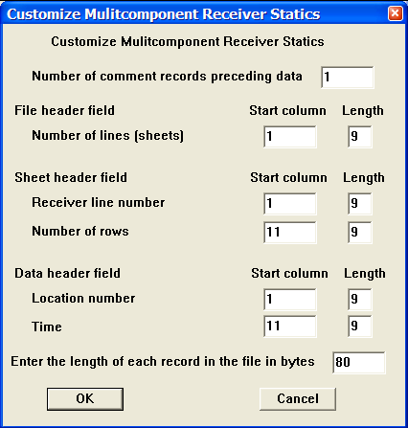

Parameter descriptions:
Number of comment records preceding data: – Indicates the number of lines in the output file reserved for writing comment cards. These are the first lines in the file. A minimum of one line is required.

File Header field:
Number of rows — Enter the start column and the number of columns allocated to write the number of receiver lines in the output multicomponent receiver statics file.

Sheet Header field:
Receiver line number — Enter the start column and the number of columns allocated to write the receiver line number in the output multicomponent receiver statics file.

Number of rows — Enter the start column and the number of columns allocated to write the number of receiver stations in the output multicomponent receiver statics file.

Data header field:
Location number — Enter the start column and the number of columns allocated to write the receiver location number in the multicomponent receiver statics file.

Time — Enter the start column and the number of columns allocated to write the receiver static (in milliseconds) in the receiver static file.

Enter the length of each record in the file in bytes – Enter the length in bytes of one line of the output multi-component receiver statics file.

Observers Notes – SPS Format
Usage:
The Observer Notes card data item is used to store the relational acquisition geometry information for sources and receivers. In the SPS lingo this is referred to as the Cross Reference file. An example seismic survey with the corresponding source, receiver, and observer SPS files is illustrated in the Geometry Definition step (p. 243).

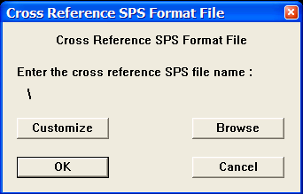
Step Parameter Dialog:

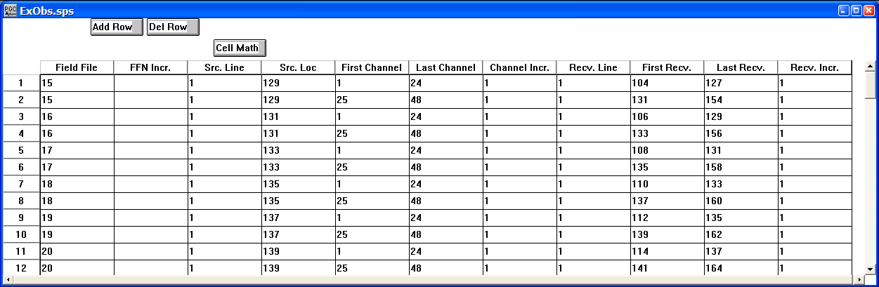

Example Card Data:

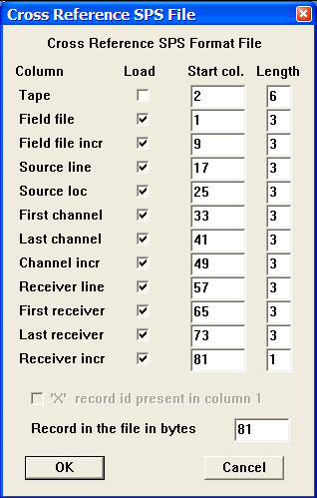
Card Data Customization Parameter Dialog:

Parameter descriptions:
Load – If checked, indicates the existence of the entity in the file.

Tape — Enter the start column and the number of columns allocated to write the tape number (disk or physical) associated with a given record in the Cross Reference SPS file.

Field file — Enter the start column and the number of columns allocated to write the field file number associated with a given record in the Cross Reference SPS file.

Field file incr. — Enter the start column and the number of columns allocated to write the increment between field files in the Cross Reference SPS file.

Source line — Enter the start column and the number of columns allocated to write the source line number associated with a given record in the Cross Reference SPS file.

Source location — Enter the start column and the number of columns allocated to write the source location number associated with a given record in the Cross Reference SPS file.

First channel — Enter the start column and the number of columns allocated to write the first channel associated with a given record in the Cross Reference SPS file.

Last channel — Enter the start column and the number of columns allocated to write the last channel associated with a given record in the Cross Reference SPS file.

Channel incr — Enter the start column and the number of columns allocated to write the increment between channels associated with a given record in the Cross Reference SPS file.

Receiver line — Enter the start column and the number of columns allocated to write the receiver line number associated with a given record in the Cross Reference SPS file.

First receiver — Enter the start column and the number of columns allocated to write the first receiver associated with a given record in the Cross Reference SPS file.

Last receiver — Enter the start column and the number of columns allocated to write the last receiver associated with a given record in the Cross Reference SPS file.

Receiver incr — Enter the start column and the number of columns allocated to write the increment between receivers associated with a given record in the Cross Reference SPS file.

Enter the length of each record in the file in bytes – Enter the length in bytes of one line of the SPS Observer Notes file.

Phase Matching Statistics File
Usage:
The Phase Matching Statistics card data item is stores the statistical output of the Phase Matching processing step. In addition to the phase rotation and the static shift required to match one data set to another, the Phase Matching Statistics card stores the CMP Line number, CMP Location number, CMP Easting, and CMP Northing for each pair of traces for which a phase matching analysis was performed. The phase rotation is stored in User Def 1, and the static shift is stored in User Def 2. The Phase Matching step contains an option to output the correlation coefficient between the two data sets after the auxiliary data has been rotated and shifted. The correlation coefficient is stored in User Def 3.

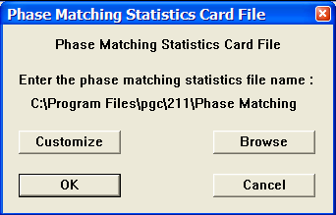
Step Parameter Dialog:

Example Card Data:

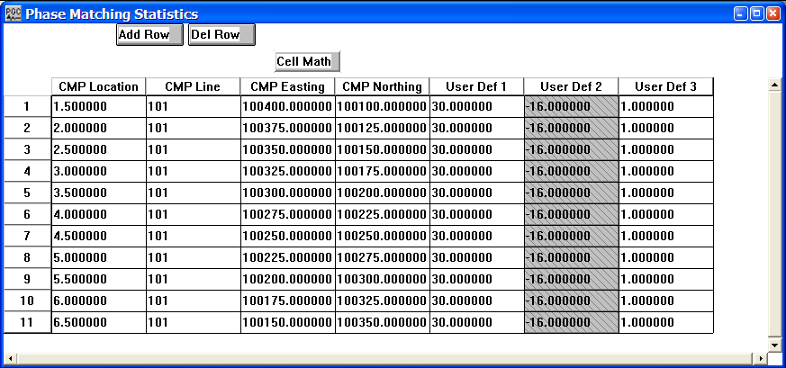

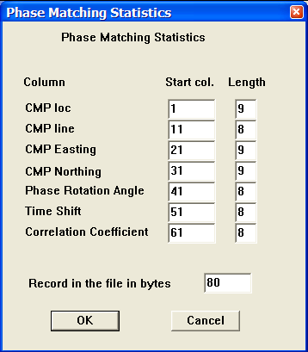
Card Data Customization Parameter Dialog:

Parameter descriptions:
CMP loc — Enter the start column and the number of columns allocated to write the CMP Location number.

CMP line — Enter the start column and the number of columns allocated to write the CMP Line number.

CMP Easting — Enter the start column and the number of columns allocated to write the CMP Easting.

CMP Northing — Enter the start column and the number of columns allocated to write the CMP Northing.

Phase Rotation Angle — Enter the start column and the number of columns allocated to write the Phase Rotation Angle.

Time Shift — Enter the start column and the number of columns allocated to write the Time Shift.

Correlation Coefficient — Enter the start column and the number of columns allocated to write the Correlation Coefficient.

Record in the file in bytes – Enter the length in bytes of one line of the Phase Matching Statistics file.

Polygon Definition File
Usage:
The Polygon Definition File card data item is used to specify the coordinates of a polygon that will be used to select data from a seismic volume. The Polygon Definition File may be used to selectively input data in conjunction with the SPW Tape Utility or may be linked to the Select Traces processing step for the same purpose.

Step Parameter Dialog:
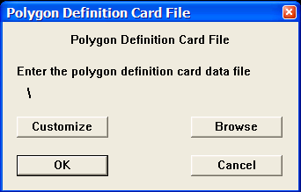

Example Card Data:
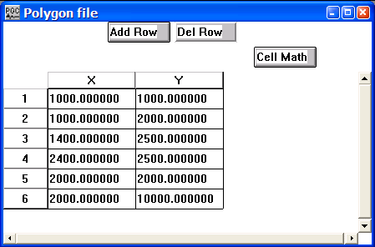

Card Data Customization Parameter Dialog:
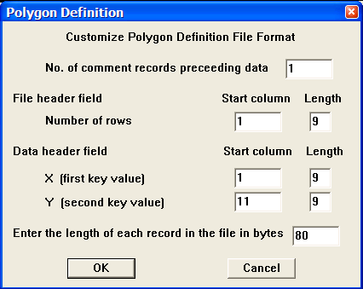

Parameter descriptions:
Number of comment records preceding data: – Indicates the number of lines in the output file reserved for writing comment cards. These are the first lines in the file. A minimum of one line is required.

File Header field:
Number of rows — Enter the start column and the number of columns allocated to write the number of coordinate pairs used to define the polygon in the output polygon definition file.

Data header field:
X (first key value) — Enter the start column and the number of columns allocated to write the X coordinate associated with a given coordinate pair in the output polygon definition file.

Y (second key value) — Enter the start column and the number of columns allocated to write the Y coordinate associated with a given coordinate pair in the output polygon definition file.

Enter the length of each record in the file in bytes – Enter the length in bytes of one line of the polygon definition file.

PP Nhmo Eta Function
Usage:
The PP Nhmo Eta Function card data item is used to store time-eta pairs for the case of P-wave non-hyperbolic moveout, where Eta is a parameter that characterizes the anisotropy in transversely isotropic media. Once the short-spread P-wave stacking velocity function has been picked, corresponding Eta functions may be picked interactively in SeisViewer on Eta Semblance gathers. The PP Nhmo Eta Function card has the same structure as a Velocity Function card.

Step Parameter Dialog:
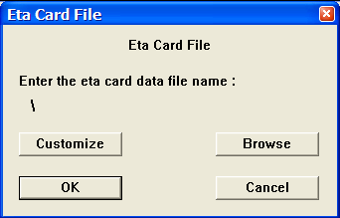

Example Card Data:

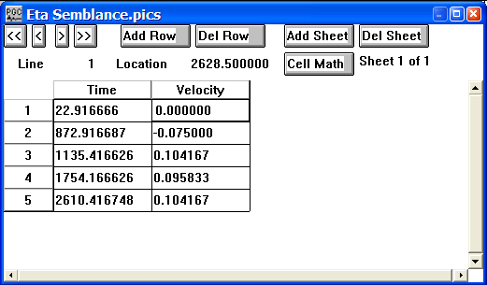

Card Data Customization Parameter Dialog:
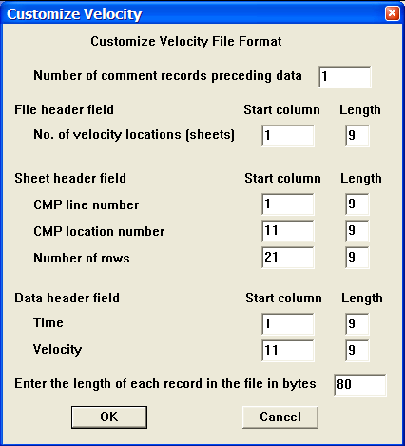

Parameter descriptions:
Number of comment records preceding data: – Indicates the number of lines in the output file reserved for writing comment cards. These are the first lines in the file. A minimum of one line is required.

File Header field:
Number of velocity locations — Enter the start column and the number of columns allocated to write the number of velocity locations in the velocity file.

Sheet header field:
CMP line number — Enter the start column and the number of columns allocated to write the CMP line number associated with a velocity function in the velocity file.

CMP location number — Enter the start column and the number of columns allocated to write the CMP location number associated with a velocity function in the velocity file.

Number of rows — Enter the start column and the number of columns allocated to write the CMP locations per CMP line in the velocity file.

Data header field:
Time — Enter the start column and the number of columns allocated to write the two-way travel time (in milliseconds) associated with a given velocity pick in the velocity file.

Velocity — Enter the start column and the number of columns allocated to write the RMS or interval velocity value associated with a given velocity pick in the velocity file.

Enter the length of each record in the file in bytes – Enter the length in bytes of one line of the PP NMO eta function file.

PP Nhmo Gamma Function
Usage:
The PP Nhmo Gamma Function card data item is used to store time-gamma pairs for the case of PS-wave (i.e. converted wave) non-hyperbolic moveout, where Gamma is the effective V_{p}/V_{s} ratio down to the event being analyzed. Once the short-spread P-wave stacking velocity function has been picked, corresponding Gamma functions may be picked interactively in SeisViewer on Gamma Semblance gathers. The PP Nhmo Gamma Function card has the same structure as a Velocity Function card.

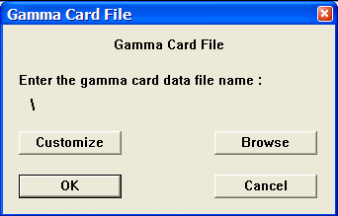
Step Parameter Dialog:

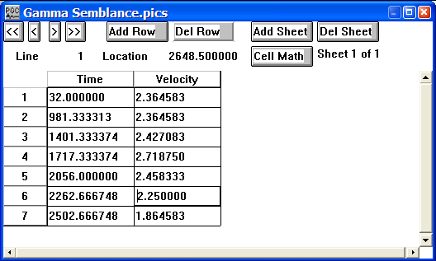
Example Card Data:

Card Data Customization Parameter Dialog:

Parameter descriptions:
Number of comment records preceding data: – Indicates the number of lines in the output file reserved for writing comment cards. These are the first lines in the file. A minimum of one line is required.

File Header field:
Number of velocity locations — Enter the start column and the number of columns allocated to write the number of velocity locations in the velocity file.

Sheet header field:
CMP line number — Enter the start column and the number of columns allocated to write the CMP line number associated with a velocity function in the velocity file.

CMP location number — Enter the start column and the number of columns allocated to write the CMP location number associated with a velocity function in the velocity file.

Number of rows — Enter the start column and the number of columns allocated to write the CMP locations per CMP line in the velocity file.

Data header field:
Time — Enter the start column and the number of columns allocated to write the two-way travel time (in milliseconds) associated with a given velocity pick in the velocity file.

Velocity — Enter the start column and the number of columns allocated to write the RMS or interval velocity value associated with a given velocity pick in the velocity file.

Enter the length of each record in the file in bytes – Enter the length in bytes of one line of the PP NHMO gamma function file.

Profile Geometry File
Usage:
The Profile Geometry File card data item is used to store the profile (single fold or radar data) information used in conjunction with the Single Fold Profile Geometry step to update trace headers with survey geometry information.

Step Parameter Dialog:
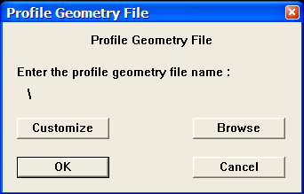

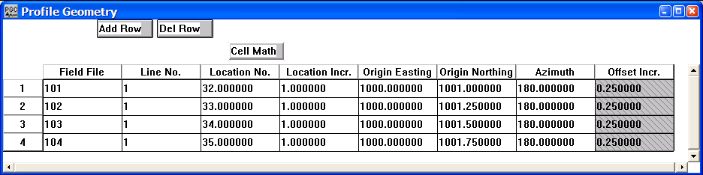
Example Card Data:

Card Data Customization Parameter Dialog:

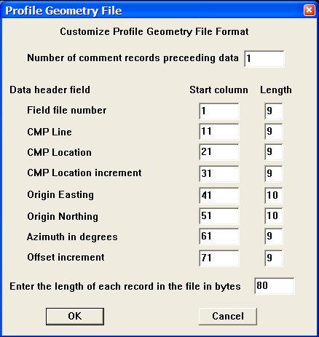
Parameter descriptions:
Number of comment records preceding data: – Indicates the number of lines in the output file reserved for writing comment cards. These are the first lines in the file. A minimum of one line is required.

Data header field:
Field file number — Enter the start column and the number of columns allocated to write the field file number associated with a given record in the profile geometry file.

CMP Line — Enter the start column and the number of columns allocated to write the CMP line number associated with a given record in the profile geometry file.

CMP Location — Enter the start column and the number of columns allocated to write the CMP location number associated with a given record in the profile geometry file.

CMP Location increment — Enter the start column and the number of columns allocated to write the increment between CMP location numbers associated with a given record in the profile geometry file.

Origin Easting — Enter the start column and the number of columns allocated to write the easting of the coordinate pair associated with the survey origin for the given record in the profile geometry file.

Origin Northing — Enter the start column and the number of columns allocated to write the northing of the coordinate pair associated with the survey origin for the given record in the profile geometry file.

Azimuth in degrees — Enter the start column and the number of columns allocated to write the source-origin azimuth associated with a given record in the profile geometry file.

Offset increment — Enter the start column and the number of columns allocated to write the source-receiver offset increment associated with a given record in the profile geometry file.

Enter the length of each record in the file in bytes – Enter the length in bytes of one line of the profile geometry file.

Receiver Gains
Usage:
The Receiver Gains card data item is used to store surface consistent gains associated with receiver locations.

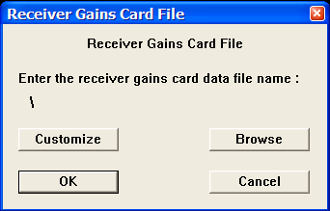
Step Parameter Dialog:

Example Card Data:
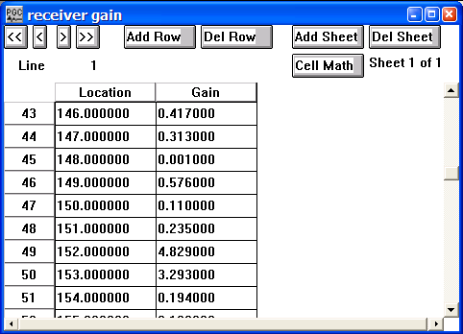

Card Data Customization Parameter Dialog:

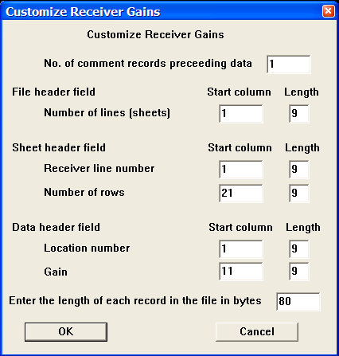

Parameter descriptions:
Number of comment records preceding data: – Indicates the number of lines in the output file reserved for writing comment cards. These are the first lines in the file. A minimum of one line is required.

File Header field:
Number of lines — Enter the start column and the number of columns allocated to write the number of receiver lines in the receiver gain file.

Sheet Header field:
Receiver line number — Enter the start column and the number of columns allocated to write the receiver line number in the output receiver gain file.

Number of rows — Enter the start column and the number of columns allocated to write the number of receiver positions per receiver line in the output receiver gain file.

Data header field:
Location number — Enter the start column and the number of columns allocated to write the receiver location number in the receiver gain file.

Gain — Enter the start column and the number of columns allocated to write the receiver gain in the receiver gain file.

Enter the length of each record in the file in bytes – Enter the length in bytes of one line of the receiver gains file.

Receiver Locations – SPS Format
Usage:
The Receiver Locations – SPS Format card data item is used to store positional receiver location information. An example seismic survey with the corresponding source, receiver, and observer SPS files is illustrated in the Geometry Definition step (p. 243).

Step Parameter Dialog:
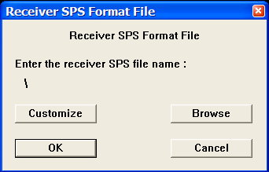

Example Card Data:
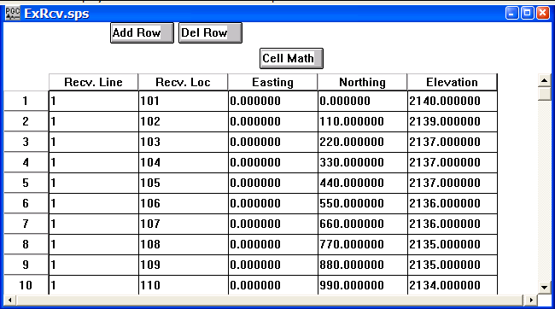
Card Data Customization Parameter Dialog:
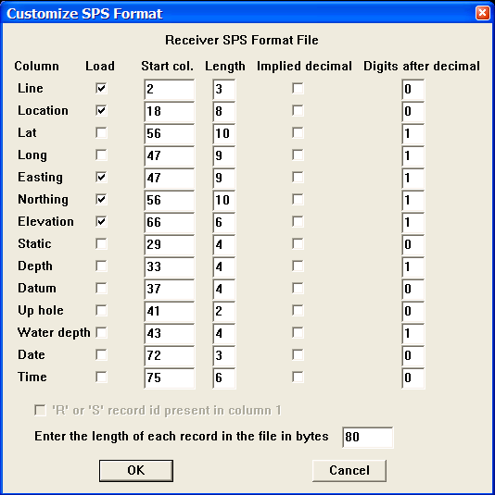

Parameter descriptions:
Load – If checked, indicates the existence of the entity in the file.

Line — Enter the start column and the number of columns allocated to write the receiver line associated with a given record in the Receiver SPS file.

Location — Enter the start column and the number of columns allocated to write the receiver location associated with a given record in the Receiver SPS file.

Latitude — Enter the start column and the number of columns allocated to write the receiver latitude associated with a given record in the Receiver SPS file.

Longitude — Enter the start column and the number of columns allocated to write the receiver longitude associated with a given record in the Receiver SPS file.

Easting — Enter the start column and the number of columns allocated to write the receiver easting associated with a given record in the Receiver SPS file.

Northing — Enter the start column and the number of columns allocated to write the receiver northing associated with a given record in the Receiver SPS file.

Elevation — Enter the start column and the number of columns allocated to write the receiver elevation associated with a given record in the Receiver SPS file.

Static — Enter the start column and the number of columns allocated to write the receiver static associated with a given record in the Receiver SPS file.

Depth — Enter the start column and the number of columns allocated to write the receiver depth associated with a given record in the Receiver SPS file.

Datum — Enter the start column and the number of columns allocated to write the elevation of the datum at a receiver station associated with a given record in the Receiver SPS file.

Uphole — Enter the start column and the number of columns allocated to write the interpolated uphole time (ms) at a receiver station associated with a given record in the Receiver SPS file.

Water depth — Enter the start column and the number of columns allocated to write the water depth at a receiver station associated with a given record in the Receiver SPS file.

Date — Enter the start column and the number of columns allocated to write the Julian day on which the receiver station was initially deployed in the Receiver SPS file.

Time — Enter the start column and the number of columns allocated to write the time of day on which the receiver station was initially deployed in the Receiver SPS file.

Enter the length of each record in the file in bytes – Enter the length in bytes of one line of the SPS receiver file.

Receiver Statics
Usage:
The Receiver Statics card data item is used to store receiver static information in units of milliseconds.

Step Parameter Dialog:
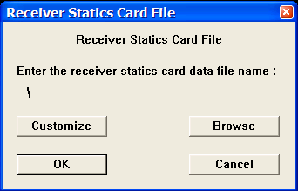

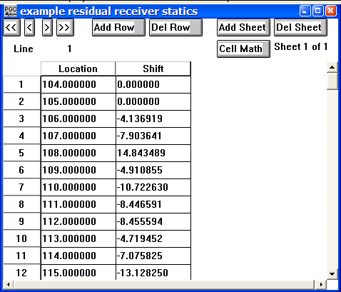
Example Card Data:

Card Data Customization Parameter Dialog:
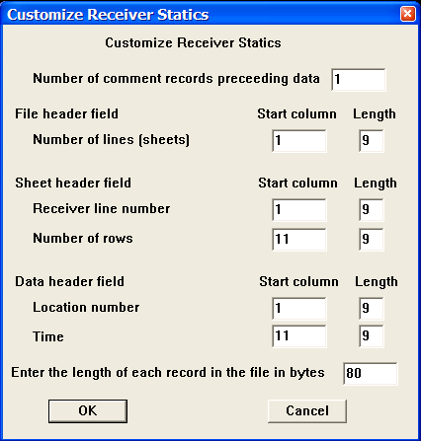

Parameter descriptions:
Number of comment records preceding data: – Indicates the number of lines in the output file reserved for writing comment cards. These are the first lines in the file. A minimum of one line is required.

File Header field:
Number of lines — Enter the start column and the number of columns allocated to write the number of receiver lines in the receiver statics file.

Sheet Header field:
Receiver line number — Enter the start column and the number of columns allocated to write the receiver line number in the output receiver statics file.

Number of rows — Enter the start column and the number of columns allocated to write the number of receiver positions per receiver line in the output receiver statics file.

Data header field:
Location number — Enter the start column and the number of columns allocated to write the receiver location number in the receiver statics file.

Time — Enter the start column and the number of columns allocated to write the receiver static (in milliseconds) in the receiver static file.

Enter the length of each record in the file in bytes – Enter the length in bytes of one line of the receiver statics file.

Receiver Statics List
Usage:
The Receiver Statics List card data item is used to store receiver static information received in a foreign text format.

Step Parameter Dialog:

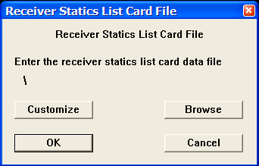
Card Data Customization Parameter Dialog:
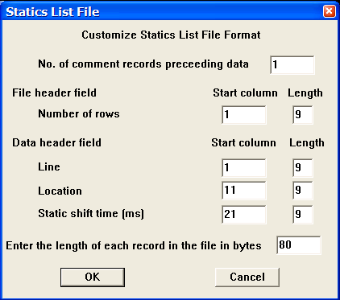

Parameter descriptions:
Number of comment records preceding data – Indicates the number of lines in the output file reserved for writing comment cards. These are the first lines in the file. A minimum of one line is required.

File Header field:
Number of rows — Enter the start column and the number of columns allocated to write the number of receiver stations in the receiver statics list file.

Data Header field:
Line — Enter the start column and the number of columns allocated to write the receiver line number in the output receiver statics list file.

Location — Enter the start column and the number of columns allocated to write the receiver location number in the output receiver statics list file.

Static shift time (ms) — Enter the start column and the number of columns allocated to write the receiver static shift in the output receiver statics list file.

Enter the length of each record in the file in bytes – Enter the length in bytes of one line of the receiver statics list file.

Refractor Velocities

Usage:
The Refractor Velocity card data item is used to store laterally varying refractor velocities. These velocities may be picked interactively in SeisViewer using the Pick Traces tool located in the Picking menu.

Step Parameter Dialog:
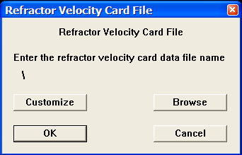

Example Card Data:
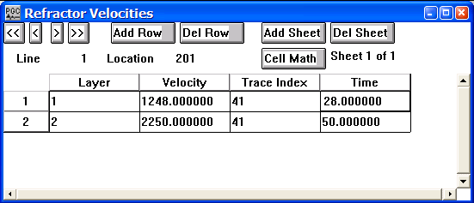

Card Data Customization Parameter Dialog:
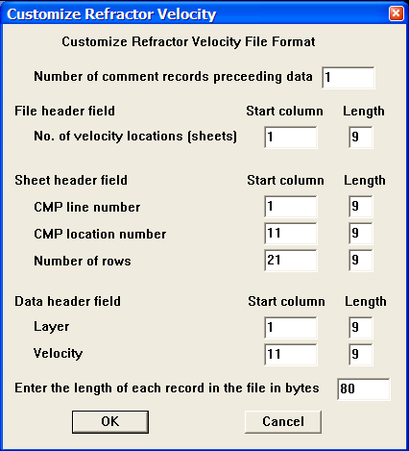

Parameter descriptions:
Number of comment records preceding data – Indicates the number of lines in the output file reserved for writing comment cards. These are the first lines in the file. A minimum of one line is required.

File Header field:
Number of velocity locations — Enter the start column and the number of columns allocated to write the number of refractor velocity locations in the refractor velocity file.

Sheet Header field:
CMP line number— Enter the start column and the number of columns allocated to write the CMP line number associated with a specified refractor velocity in the output refractor velocity file.

CMP location number — Enter the start column and the number of columns allocated to write the CMP location number associated with a specified refractor velocity in the output refractor velocity file.

Number of rows — Enter the start column and the number of columns allocated to write the number of CMP location per CMP line in the output refractor velocity file.

Data Header field:
Layer — Enter the start column and the number of columns allocated to write the layer associated with a specified refractor velocity value in the output refractor velocity file.

Velocity — Enter the start column and the number of columns allocated to write the velocity associated with a specified layer and location in the output refractor velocity file.

Enter the length of each record in the file in bytes – Enter the length in bytes of one line of the refractor velocities file.

Residual NMO Analysis

Usage:
The Residual NMO card data item is used to store residual NMO velocity information. These velocities may be picked interactively in SeisViewer using the Pick Traces tool located in the Picking menu.

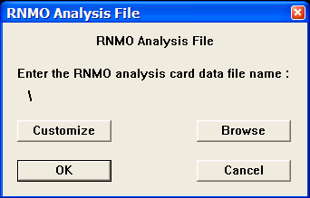
Step Parameter Dialog:

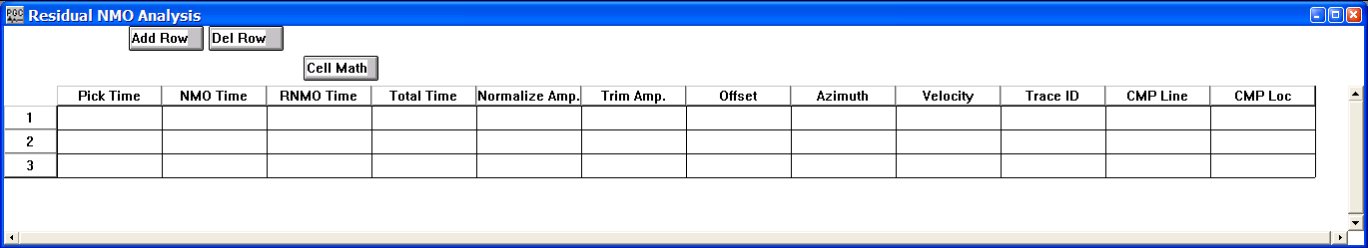
Example Card Data:

Card Data Customization Parameter Dialog:
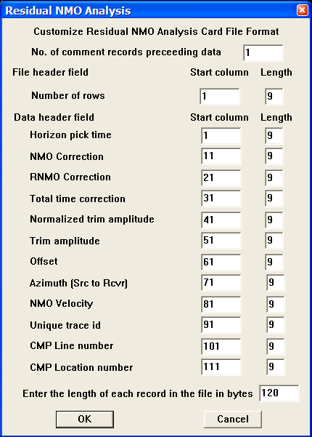

Parameter descriptions:
Number of comment records preceding data – Indicates the number of lines in the output file reserved for writing comment cards. These are the first lines in the file. A minimum of one line is required.

File Header field:
Number of rows — Enter the start column and the number of columns allocated to write the number of refractor velocity locations in the refractor velocity file.

Sheet Header field:
CMP line number— Enter the start column and the number of columns allocated to write the CMP line number associated with a specified refractor velocity in the output refractor velocity file.

CMP location number — Enter the start column and the number of columns allocated to write the CMP location number associated with a specified refractor velocity in the output refractor velocity file.

Number of rows — Enter the start column and the number of columns allocated to write the number of CMP location per CMP line in the output refractor velocity file.

Data Header field:
Layer — Enter the start column and the number of columns allocated to write the layer associated with a specified refractor velocity value in the output refractor velocity file.

Velocity — Enter the start column and the number of columns allocated to write the velocity associated with a specified layer and location in the output refractor velocity file.

Enter the length of each record in the file in bytes – Enter the length in bytes of one line of the residual NMO analysis file.

Rotation Card File
Usage:
The Rotation Card File is used to store horizontal rotations output from the Two-Component Horizontal Rotation step in units of degrees.

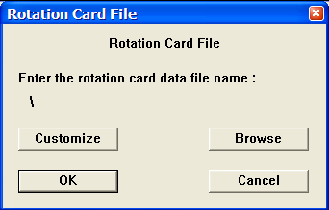
Step Parameter Dialog:

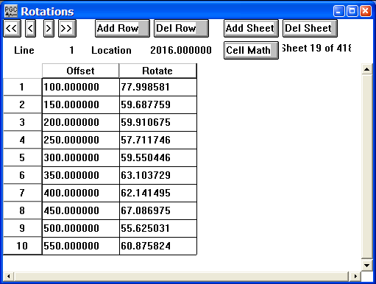
Example Card Data:

Card Data Customization Parameter Dialog:
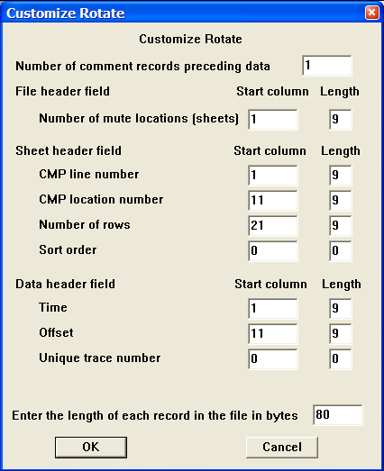

Parameter descriptions:
Number of comment records preceding data: – Indicates the number of lines in the output file reserved for writing comment cards. These are the first lines in the file. A minimum of one line is required.

File Header field:
Number of lines — Enter the start column and the number of columns allocated to write the number of receiver locations in the Rotation Card file.

Sheet Header field:
CMP line number — Enter the start column and the number of columns allocated to write the receiver line number in the output Rotation Card file.

CMP location number — Enter the start column and the number of columns allocated to write the receiver location number in the output Rotation Card file.

Number of rows — Enter the start column and the number of columns allocated to write the number of rotation estimates – one per source-receiver offset - in the output Rotation Card file.

Sort Order — Enter the start column and the number of columns allocated to write the sort order of the data.

Data header field:
Offset — Enter the start column and the number of columns allocated to write the source-receiver offset associated with the rotation estimate in the Rotation Card file.

Rotate — Enter the start column and the number of columns allocated to write the rotation estimate in the Rotation Card file.

Unique Trace Number — Enter the start column and the number of columns allocated to write the unique trace number associated with the estimated rotation in the Rotation Card file.

Enter the length of each record in the file in bytes – Enter the length in bytes of one line of the rotation card file.

Source Gains
Usage:
The Source Gains card data item is used to store gains associated with source locations.

Step Parameter Dialog:
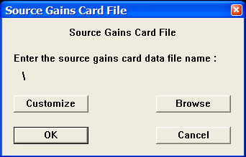

Example Card Data:
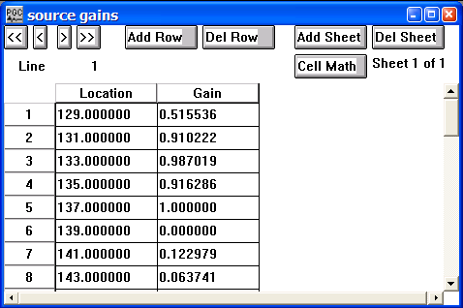
Card Data Customization Parameter Dialog:
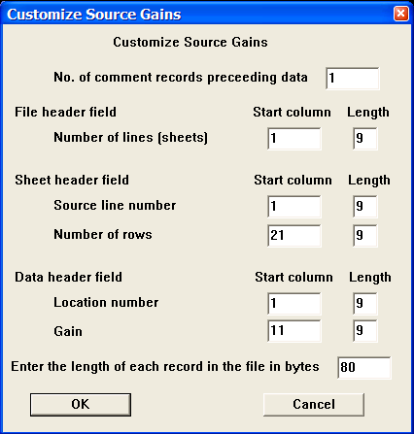

Parameter descriptions:
Number of comment records preceding data: – Indicates the number of lines in the output file reserved for writing comment cards. These are the first lines in the file. A minimum of one line is required.

File Header field:
Number of lines — Enter the start column and the number of columns allocated to write the number of source gain pairs in the source gain file.

Sheet Header field:
Source line number — Enter the start column and the number of columns allocated to write source line number in the output source gain file.

Number of rows — Enter the start column and the number of columns allocated to write the number of source positions per source line in the output source gain file.

Data header field:
Location number — Enter the start column and the number of columns allocated to write the source location number in the source gain file.

Gain — Enter the start column and the number of columns allocated to write the source gain in the source gain file.
Enter the length of each record in the file in bytes – Enter the length in bytes of one line of the source gains file.

Source Locations – SPS Format
Usage:
The Source Locations – SPW Format card data item is used to source location geometry information. An example seismic survey with the corresponding source, receiver, and observer SPS files is illustrated in the Geometry Definition step (p. 243).

Step Parameter Dialog:
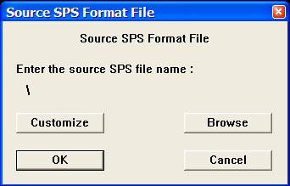

Example Card Data:

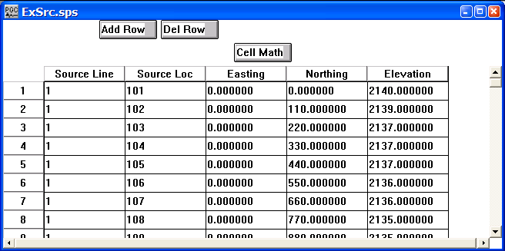
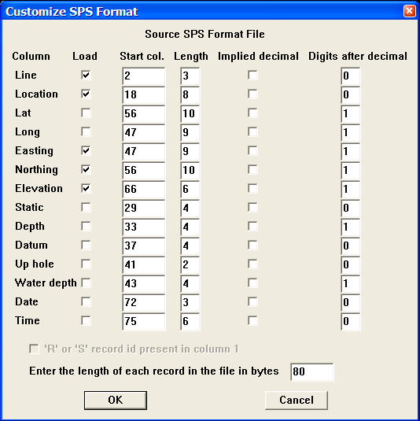
Card Data Customization Parameter Dialog:

Parameter descriptions:
Load – If checked, indicates the existence of the entity in the file.

Line — Enter the start column and the number of columns allocated to write the source line associated with a given record in the Source SPS file.

Location — Enter the start column and the number of columns allocated to write the source location associated with a given record in the Source SPS file.

Latitude — Enter the start column and the number of columns allocated to write the source latitude associated with a given record in the Source SPS file.

Longitude — Enter the start column and the number of columns allocated to write the source longitude associated with a given record in the Source SPS file.

Easting — Enter the start column and the number of columns allocated to write the source easting associated with a given record in the Source SPS file.

Northing — Enter the start column and the number of columns allocated to write the source northing associated with a given record in the Source SPS file.

Elevation — Enter the start column and the number of columns allocated to write the source elevation associated with a given record in the Source SPS file.

Static — Enter the start column and the number of columns allocated to write the source static associated with a given record in the Source SPS file.

Depth — Enter the start column and the number of columns allocated to write the source depth associated with a given record in the Source SPS file.

Datum — Enter the start column and the number of columns allocated to write the elevation of the datum at the source station associated with a given record in the Source SPS file.

Uphole — Enter the start column and the number of columns allocated to write the uphole time (ms) at a source station associated with a given record in the Source SPS file.

Water depth — Enter the start column and the number of columns allocated to write the water depth at a source station associated with a given record in the Source SPS file.

Date — Enter the start column and the number of columns allocated to write the Julian day on which the source station was occupied in the Source SPS file.

Enter the length of each record in the file in bytes – Enter the length in bytes of one line of the SPS source file.

Source Statics
Usage:
The Source Statics card data item is used to store source statics information in units of milliseconds.

Step Parameter Dialog:
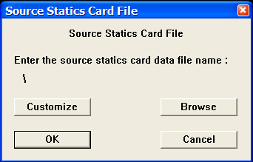

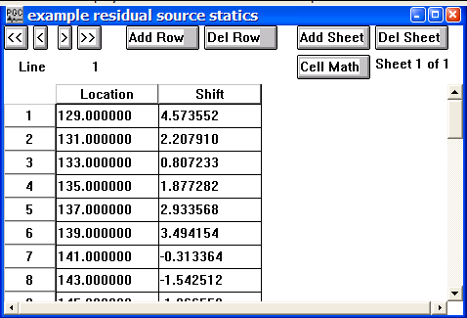
Example Card Data:

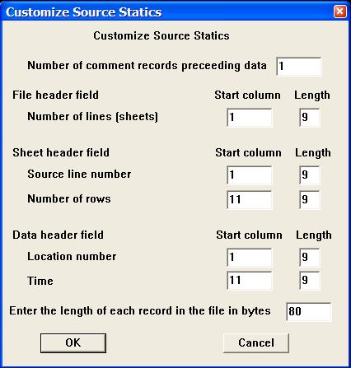
Card Data Customization Parameter Dialog:

Parameter descriptions:
Number of comment records preceding data: – Indicates the number of lines in the output file reserved for writing comment cards. These are the first lines in the file. A minimum of one line is required.

File Header field:
Number of lines — Enter the start column and the number of columns allocated to write the number of source lines in the source statics file.

Sheet Header field:
Receiver line number — Enter the start column and the number of columns allocated to write source line number in the output source statics file.

Number of rows — Enter the start column and the number of columns allocated to write the number of source positions per source line in the output source statics file.

Data header field:
Location number — Enter the start column and the number of columns allocated to write the source location number in the source statics file.

Time — Enter the start column and the number of columns allocated to write the source static (in milliseconds) in the source static file.

Enter the length of each record in the file in bytes – Enter the length in bytes of one line of the source statics file.

Source Statics List
Usage:
The Source Statics card data item is used to store source static information received in a foreign format.

Step Parameter Dialog:

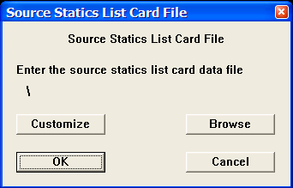
Card Data Customization Parameter Dialog:
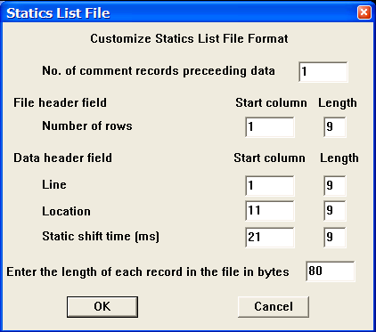

Parameter descriptions:
Number of comment records preceding data – Indicates the number of lines in the output file reserved for writing comment cards. These are the first lines in the file. A minimum of one line is required.

File Header field:
Number of rows — Enter the start column and the number of columns allocated to write the number of source stations in the source statics list file.

Data Header field:
Line — Enter the start column and the number of columns allocated to write source line number in the output source statics list file.

Location — Enter the start column and the number of columns allocated to write the source location number in the output source statics list file.

Static shift time (ms) — Enter the start column and the number of columns allocated to write the source static shift in the output source statics list file.

Enter the length of each record in the file in bytes – Enter the length in bytes of one line of the source statics list file.

Streamer Definition
Usage:
The Streamer Definition card data item is used to define the coordinate positions of receivers in a streamer. The receivers may be hydrophones, as is the case in marine acquisition, or geophones attached to a land streamer for land acquisition. The Streamer Definition card data is linked to the Simple Marine Geometry step to update trace headers with the relevant geometry information.

Step Parameter Dialog:
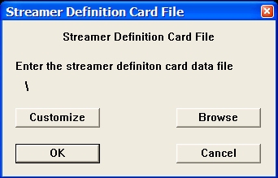

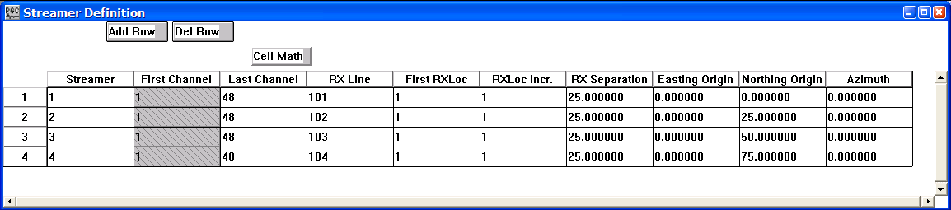
Example Card Data:

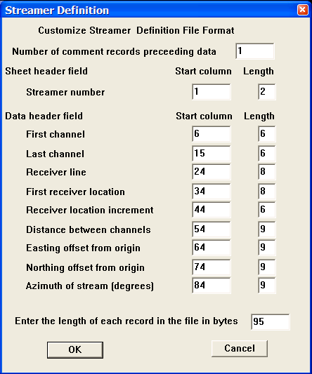
Card Data Customization Parameter Dialog:

Parameter descriptions:
Number of comment records preceding data – Indicates the number of lines in the output file reserved for writing comment cards. These are the first lines in the file. A minimum of one line is required.

Sheet Header field:
Streamer number — Enter the start column and the number of columns allocated to write the number of streamers in the streamer definition file.

Data Header field:
First channel — Enter the start column and the number of columns allocated to write the number of the first channel on the streamer in the streamer definition file.

Last channel — Enter the start column and the number of columns allocated to write the number of the last channel on the streamer in the streamer definition file.

Receiver line — Enter the start column and the number of columns allocated to write the number of the receiver line associated with a particular streamer number in the streamer definition file.

First receiver location — Enter the start column and the number of columns allocated to write the number of the first receiver location on the streamer in the streamer definition file.

Receiver location increment — Enter the start column and the number of columns allocated to write the increment between receiver numbers associated with each channel on the streamer in the streamer definition file.

Distance between channels — Enter the start column and the number of columns allocated to write the group interval associated with a group of channels on the streamer in the streamer definition file.

Easting offset from origin — Enter the start column and the number of columns allocated to write the easting offset distance from the survey origin for the first channel on the streamer in the streamer definition file.

Northing offset from origin — Enter the start column and the number of columns allocated to write the northing offset distance from the survey origin for the first channel on the streamer in the streamer definition file.

Azimuth of stream — Enter the start column and the number of columns allocated to write the streamer azimuth in the streamer definition file.

Enter the length of each record in the file in bytes – Enter the length in bytes of one line of the streamer definition file.

Surgical Mutes
Usage:
The Surgical Mutes card data item is used to store surgical mute data. Mute times are in units of seconds. Surgical mutes may be defined interactively in SeisViewer using the Pick Traces tool located in the Picking menu.

Step Parameter Dialog:
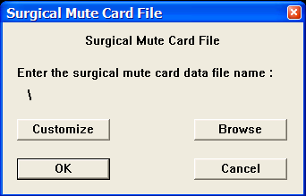

Example Card Data:
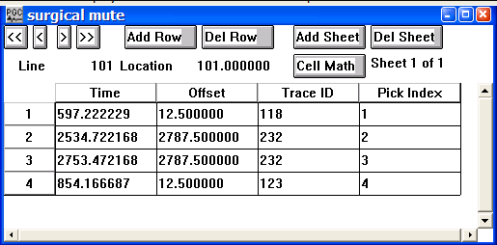

Card Data Customization Parameter Dialog:
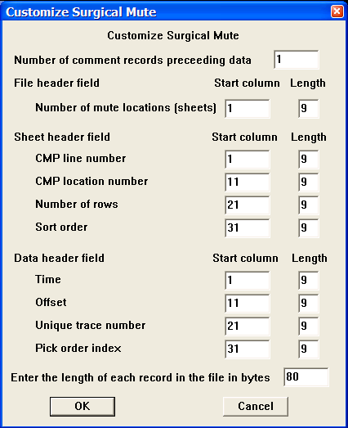

Parameter descriptions:
Number of comment records preceding data: – Indicates the number of lines in the output file reserved for writing comment cards. These are the first lines in the file. A minimum of one line is required.

File Header field:
Number of mute locations — Enter the start column and the number of columns allocated to write the number of mute locations in the output mute file.

Sheet Header field:
CMP line number — Enter the start column and the number of columns allocated to write CMP line number in the output mute file.

CMP location number — Enter the start column and the number of columns allocated to write CMP location number in the output mute file.

Number of rows — Enter the start column and the number of columns allocated to write the number of CMP positions in the CMP line in the output mute file.

Sort — Enter the start column and the number of columns allocated to write the sort order (e.g. common source, CMP, etc…) of the data file on which the early mute was picked.

Data header field:
Time — Enter the start column and the number of columns allocated to write the mute time (in seconds) at a specified offset and trace number in the output mute file.

Offset — Enter the start column and the number of columns allocated to write the source receiver offset corresponding to a specified mute time and trace number in the output mute file.

Unique trace number — Enter the start column and the number of columns allocated to write the unique trace number corresponding to a specified mute time and source-receiver offset in the output mute file.

Pick order index — Enter the start column and the number of columns allocated to write the pick index corresponding to a specified mute time, source-receiver offset, and unique trace number in the output mute file.

Enter the length of each record in the file in bytes – Enter the length in bytes of one line of the surgical mute file.

Tail Mutes
Usage:
The Tail Mutes card data item is used to store tail or end mute data. Mute times are in units of seconds. Tail mutes may be interactively defined in SeisViewer using the Pick Traces tool located in the Picking menu.

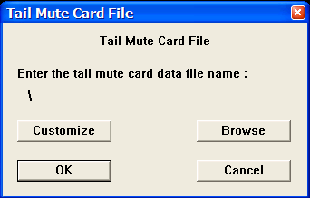
Step Parameter Dialog:

Example Card Data:
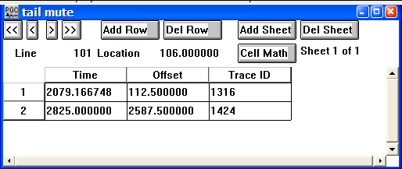
Card Data Customization Parameter Dialog:
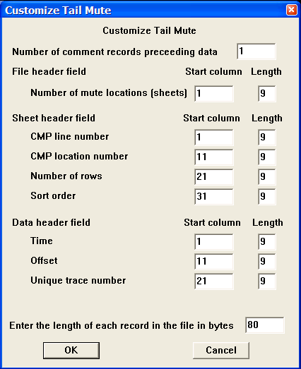

Parameter descriptions:
Number of comment records preceding data: – Indicates the number of lines in the output file reserved for writing comment cards. These are the first lines in the file. A minimum of one line is required.

File Header field:
Number of mute locations — Enter the start column and the number of columns allocated to write the number of mute locations in the output mute file.

Sheet Header field:
CMP line number — Enter the start column and the number of columns allocated to write CMP line number in the output mute file.

CMP location number — Enter the start column and the number of columns allocated to write CMP location number in the output mute file.

Number of rows — Enter the start column and the number of columns allocated to write the number of CMP positions in the CMP line in the output mute file.

Sort — Enter the start column and the number of columns allocated to write the sort order (e.g. common source, CMP, etc…) of the data file on which the early mute was picked.

Data header field:
Time — Enter the start column and the number of columns allocated to write the mute time (in seconds) at a specified offset and trace number in the output mute file.

Offset — Enter the start column and the number of columns allocated to write the source receiver offset corresponding to a specified mute time and trace number in the output mute file.

Unique trace number — Enter the start column and the number of columns allocated to write the unique trace number corresponding to a specified mute time and source-receiver offset in the output mute file.

Enter the length of each record in the file in bytes – Enter the length in bytes of one line of the tail mute file.

Time Filter
Usage:
The Time Filter card data item is used to store the time-domain (impulse response) representation of a filter in units of milliseconds.

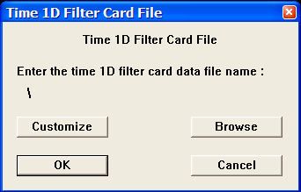
Step Parameter Dialog:

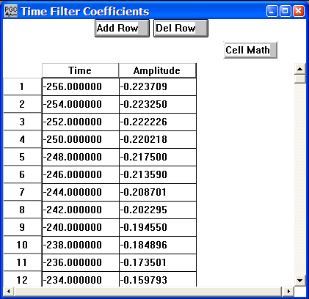
Example Card Data:

Card Data Customization Parameter Dialog:

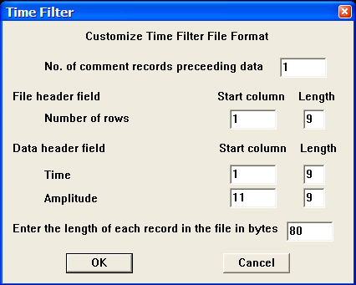
Parameter descriptions:
Number of comment records preceding data: – Indicates the number of lines in the output file reserved for writing comment cards. These are the first lines in the file. A minimum of one line is required.

File Header field:
Number of rows — Enter the start column and the number of columns allocated to write the time domain filter coefficients in the time filter file.

Data header field:
Time — Enter the start column and the number of columns allocated to write the time series values (in milliseconds) associated with a given filter coefficient in the output time filter file.

Amplitude — Enter the start column and the number of columns allocated to write the amplitude value associated with a given time series coefficient in the output time filter file.

Enter the length of each record in the file in bytes – Enter the length in bytes of one line of the time filter file.

Trace Kills

Usage:
The Trace Kills card data item is used to store the trace header values of traces that have been killed by the Automatic Trace Edits step or that will be killed with the Kill Traces step. In the case of traces that were killed by the Automatic Trace Edits step, the Trace Kills card file will contain the calculated value of trace semblance in the User Defined 1 field and the calculated value of the power ratio decay in the User Defined 2 field.

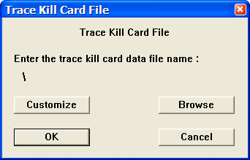
Step Parameter Dialog:

Example Card Data:

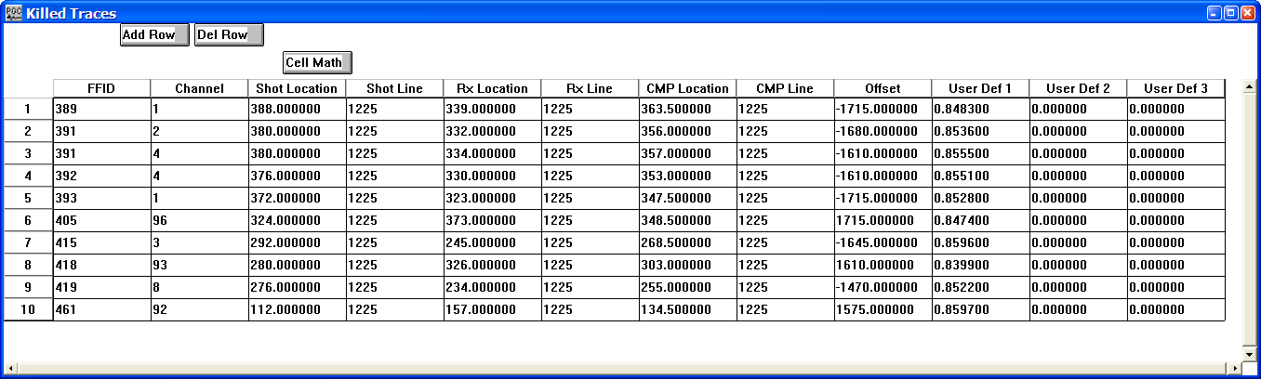

Card Data Customization Parameter Dialog:

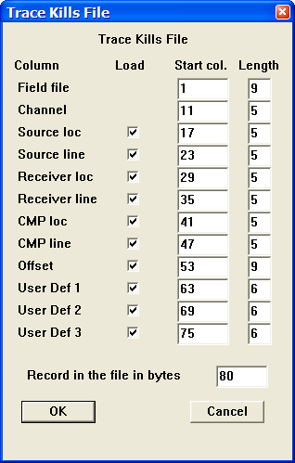

Parameter descriptions:
Load – If checked, indicates the existence of the entity in the file.

Field File — Enter the start column and the number of columns allocated to write the field file number associated with the trace kill.

Channel — Enter the start column and the number of columns allocated to write the channel number associated with the trace kill.

Source loc — Enter the start column and the number of columns allocated to write the source location associated with the trace kill.

Source line — Enter the start column and the number of columns allocated to write the source line associated with the trace kill.

Receiver loc — Enter the start column and the number of columns allocated to write the receiver location associated with the trace kill.

Receiver line — Enter the start column and the number of columns allocated to write the receiver line associated with the trace kill.

CMP loc — Enter the start column and the number of columns allocated to write the CMP location associated with the trace kill.

CMP line — Enter the start column and the number of columns allocated to write the CMP line associated with the trace kill.

Offset — Enter the start column and the number of columns allocated to write the source-receiver offset associated with the trace kill.

User Def 1 — Enter the start column and the number of columns allocated to write the value stored in the User Def 1 trace header field of the trace kill. In the case of a trace kill output by the Automatic Trace Edits step, this value will correspond to the calculated trace semblance.

User Def 2 — Enter the start column and the number of columns allocated to write the value stored in the User Def 2 trace header field of the trace kill. In the case of a trace kill output by the Automatic Trace Edits step, this value will correspond to the calculated power ratio decay.

User Def 3 — Enter the start column and the number of columns allocated to write the value stored in the User Def 3 trace header field of the trace kill. This value is currently undefined, and may contain optional information defined by the user.

Record in the file in bytes – Enter the length in bytes of one line of the trace kills file.

Trace Reversals

Usage:
The Trace Reversals card data item is used to store the trace header values of traces whose polarity will be reversed with the Reverse Traces step..

Step Parameter Dialog:
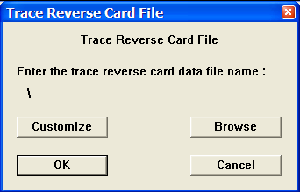

Example Card Data:
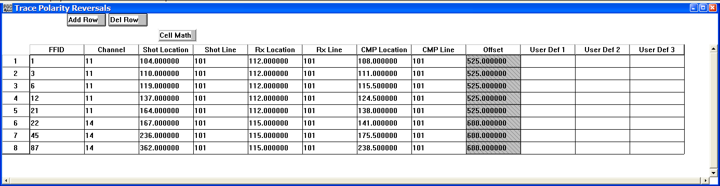

Card Data Customization Parameter Dialog:
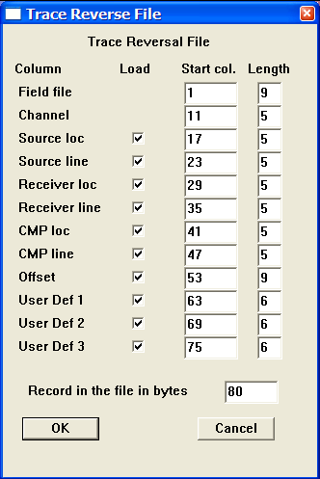

Parameter descriptions:
Load – If checked, indicates the existence of the entity in the file.

Field File — Enter the start column and the number of columns allocated to write the field file number associated with the trace kill.

Channel — Enter the start column and the number of columns allocated to write the channel number associated with the trace kill.

Source loc — Enter the start column and the number of columns allocated to write the source location associated with the trace kill.

Source line — Enter the start column and the number of columns allocated to write the source line associated with the trace kill.

Receiver loc — Enter the start column and the number of columns allocated to write the receiver location associated with the trace kill.

Receiver line — Enter the start column and the number of columns allocated to write the receiver line associated with the trace kill.

CMP loc — Enter the start column and the number of columns allocated to write the CMP location associated with the trace kill.

CMP line — Enter the start column and the number of columns allocated to write the CMP line associated with the trace kill.

Offset — Enter the start column and the number of columns allocated to write the source-receiver offset associated with the trace kill.

User Def 1 — Enter the start column and the number of columns allocated to write the value stored in the User Def 1 trace header field of the trace kill. In the case of a trace kill output by the Automatic Trace Edits step, this value will correspond to the calculated trace semblance.

User Def 2 — Enter the start column and the number of columns allocated to write the value stored in the User Def 2 trace header field of the trace kill. In the case of a trace kill output by the Automatic Trace Edits step, this value will correspond to the calculated power ratio decay.

User Def 3 — Enter the start column and the number of columns allocated to write the value stored in the User Def 3 trace header field of the trace kill. This value is currently undefined, and may contain optional information defined by the user.

Record in the file in bytes – Enter the length in bytes of one line of the trace kills file

Trace Statics
Usage:
The Trace Statics card data item is used to store trace static values in units of milliseconds as a function of trace ID.

Step Parameter Dialog:
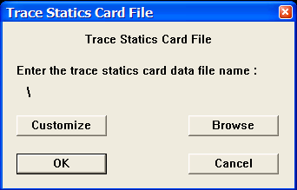

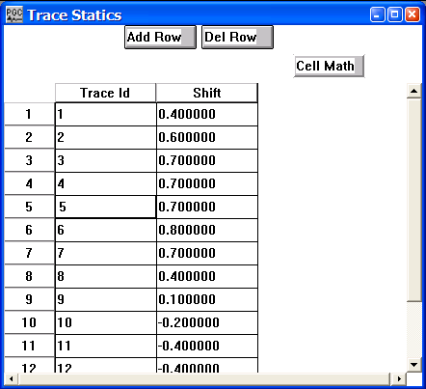
Example Card Data:

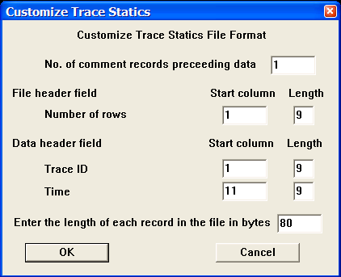
Card Data Customization Parameter Dialog:

Parameter descriptions:
Number of comment records preceding data: – Indicates the number of lines in the output file reserved for writing comment cards. These are the first lines in the file. A minimum of one line is required.

File Header field:
Number of rows — Enter the start column and the number of columns allocated to write the number of static values in the trace statics file.

Data header field:
Trace ID — Enter the start column and the number of columns allocated to write the trace ID number in the trace statics file.

Time — Enter the start column and the number of columns allocated to write the trace static (in milliseconds) in the trace static file.

Enter the length of each record in the file in bytes – Enter the length in bytes of one line of the trace statics file.

Velocity Function
Usage:
The Velocity Function card data item is used to store time-velocity pairs. Stacking velocities may be picked interactively in SeisViewer using the Pick Traces tool located in the Picking menu..

Step Parameter Dialog:
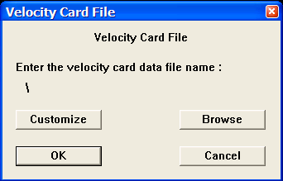

Example Card Data:
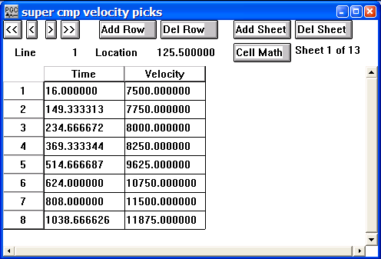

Card Data Customization Parameter Dialog:
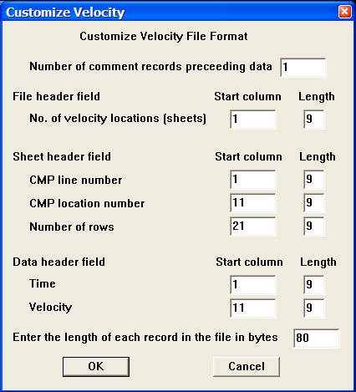

Parameter descriptions:
Number of comment records preceding data: – Indicates the number of lines in the output file reserved for writing comment cards. These are the first lines in the file. A minimum of one line is required.

File Header field:
Number of velocity locations — Enter the start column and the number of columns allocated to write the number of velocity locations in the velocity file.

Sheet header field:
CMP line number — Enter the start column and the number of columns allocated to write the CMP line number associated with a velocity function in the velocity file.

CMP location number — Enter the start column and the number of columns allocated to write the CMP location number associated with a velocity function in the velocity file.

Number of rows — Enter the start column and the number of columns allocated to write the CMP locations per CMP line in the velocity file.

Data header field:
Time — Enter the start column and the number of columns allocated to write the two-way travel time (in milliseconds) associated with a given velocity pick in the velocity file.

Velocity — Enter the start column and the number of columns allocated to write the RMS or interval velocity value associated with a given velocity pick in the velocity file.

Enter the length of each record in the file in bytes – Enter the length in bytes of one line of the velocity function file.

Editing Steps

This section documents the processing steps available in the Editing Steps category.

Processing steps currently available are:

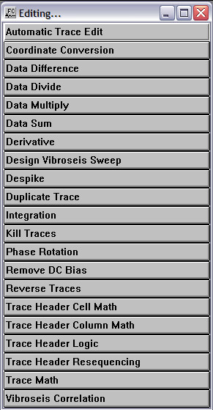

Automatic Trace Edit
Usage:
The Automatic Trace Edit step allows you to automatically remove invalid or noisy traces from your data set based on user defined criteria. An option exists to output both the trace header values corresponding to the edited traces to a Trace Kills card data file.

Input Links:
1) Seismic data in any sort order (mandatory).

Output Links:
- Seismic data in any sort order (mandatory).
- Trace Kill Card file containing information on the killed traces (optional).

Example Flowchart:

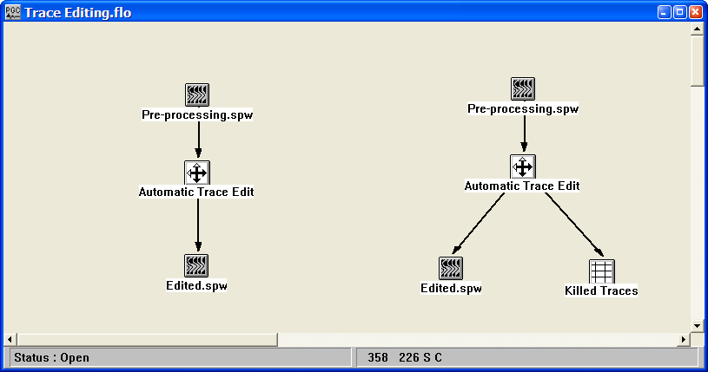
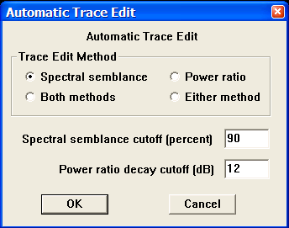
Step Parameter Dialog:

Parameter Description:
Trace Edit Method: — Select the analysis method(s) to be used to determine if a trace will be killed.

Spectral semblance — The spectral semblance method uses the semblance between a single traces power spectrum and the average power spectrum of the gather as the basis for killing a trace.

Power ratio — The power ratio method uses the ratio of trace energy in the upper part of a trace to that in the lower part of a trace as the basis for killing a trace. This is often an effective means of editing traces that are contaminated with 60 Hz powerline noise, which does not decay as a function of record time.

Both methods — Traces will be killed only if they fail BOTH the power ratio test AND the spectral semblance test.

Either method — Traces will be killed if they fail EITHER the power ratio test OR the spectral semblance test.

Spectral semblance cutoff percent — If you choose the spectral semblance method, enter the minimum semblance value you expect for each trace’s power spectrum relative to the power spectrum for the gather.

Power ratio decay cutoff in dB — If you choose the power ratio method, enter the minimum decay of trace energy in dB that you expect between the first and second half of the trace.

Coordinate Conversion
Usage:
The Coordinate conversion step is used to convert source, receiver, and midpoint locations from latitude and longitude values to rectangular coordinate values.

Input Links:
1) Seismic data in any sort order (mandatory).

Output Links:
- Seismic data in any sort order (mandatory).

Example Flowchart:

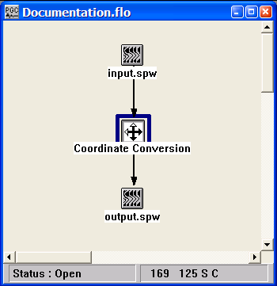
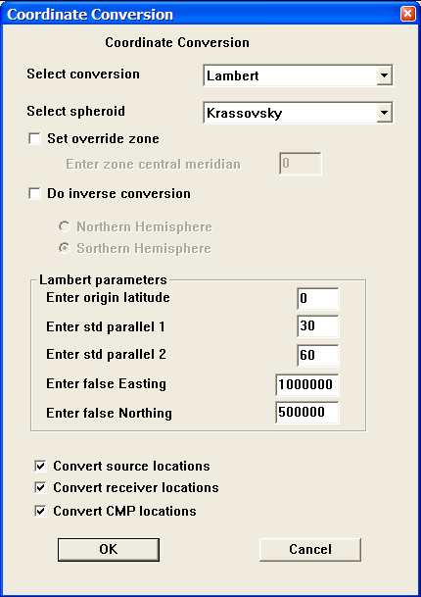
Step Parameter Dialog:

Parameter Description:
Select conversion — Select which projection the latitude and longitude values will be converted from. At present, the Lambert, the Universal Polar Stereographic, and the Universal Transverse Mercator projections are available.

Select spheriod — Select the appropriate spheriod definition.

Select override zone — If checked

Do inverse conversion — If checked, the conversion will be from rectangular coordinates to latitude and longitude pairs.

Northern Hemisphere – Converts the rectangular coordinates to latitude and longitude pairs in the Northern Hemisphere.

Southern Hemisphere – Converts the rectangular coordinates to latitude and longitude pairs in the Southern Hemisphere.

Lambert parameters - Enter parameters that control the Lambert projection.

Enter origin latitude – Latitudinal origin of the Lambert projection.

Enter std parallel 1 – Angle (in degrees) from the origin to the first parallel.

Enter std parallel 2 – Angle (in degrees) from the origin to the second parallel.

Enter false Easting – False origin of the X-axis on the central meridian of the Lambert projection.

Enter false Northing – False origin of the Y-axis on the central meridian of the Lambert projection.

Convert source locations — If checked, the coordinates of the source locations will be converted.

Convert receiver locations — If checked, the coordinates of the receiver locations will be converted.

Convert CMP locations — If checked, the coordinates of the CMP locations will be converted.

Data Difference
Usage:
The Data Difference step will subtract the samples of one data file from the corresponding samples of a second data file and output the difference to a seismic file.

Input Links:
1) Seismic data in any sort order (mandatory).
2) Seismic data in any sort order (mandatory).

Output Links:
1) Seismic data in same sort order as the input (mandatory).

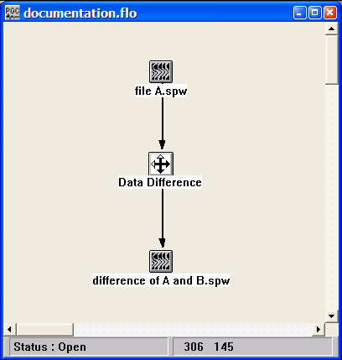
Example Flowchart:

Step Parameter Dialog:
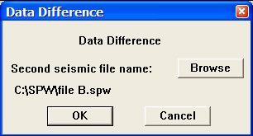

Parameter Description:
Second seismic file name – Use the Browse button to select the second seismic file, which will be subtracted from file A.

Data Divide
Usage:
The Data Divide step will divide the samples of one data file by the corresponding samples of an auxiliary data file and output the result to a seismic file.

Input Links:
- Seismic data in any sort order (mandatory).
- Auxiliary data file selected with the Browse…button in the Data Divide dialog.

Output Links:
1) Seismic data in same sort order as the input (mandatory).

Example Flowchart:
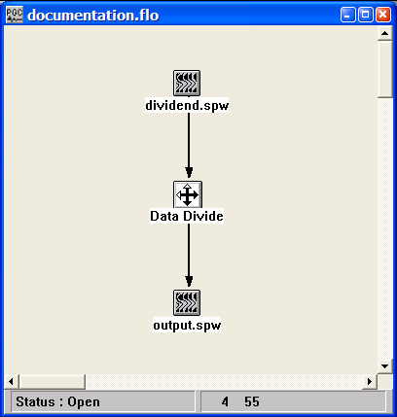

Step Parameter Dialog:
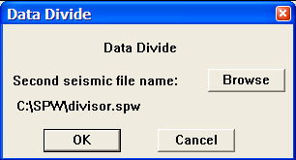

Parameter Description:
Second seismic file name – Use the Browse button to select the second seismic file, which will serve as the divisor.

Data Multiply
Usage:
The Data Multiply step will multiply the samples of one data file by the corresponding samples of an auxiliary data file and output the result to a seismic file.

Input Links:
1) Seismic data in any sort order (mandatory).
2) Auxiliary data file selected with the Browse…button in the Data Multiply dialog.

Output Links:
1) Seismic data in same sort order as the input (mandatory).

Example Flowchart:

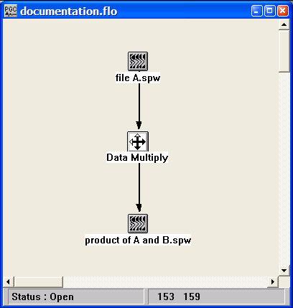
Step Parameter Dialog:
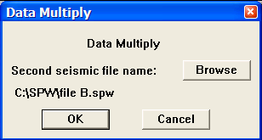

Parameter Description:
Second seismic file name – Use the Browse button to select the seismic file that will be multiplied with the input seismic file.

Data Sum
Usage:
The Data Sum step will add the samples of one data file to the corresponding samples of a second data file and output the result to a seismic file.

Input Links:
- Seismic data in any sort order (mandatory).
- Auxiliary data file selected with the Browse…button in the Data Sum dialog.

Output Links:
1) Seismic data in same sort order as the input (mandatory).

Example Flowchart:

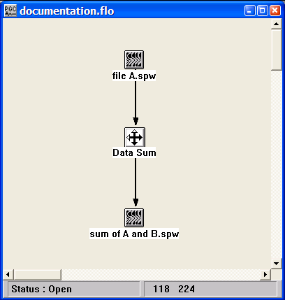
Step Parameter Dialog:
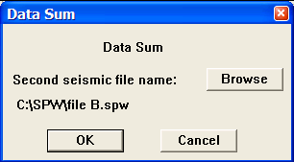

Parameter Description:
Second seismic file name – Use the Browse button to select the seismic file that will be summed with the input seismic file.

Derivative
Usage:
The Derivative step computes the derivative of the data samples in each input seismic trace.

Input Links:
1) Seismic data in any sort order (mandatory).

Output Links:
1) Seismic data in any sort order (mandatory).

Example Flowchart:
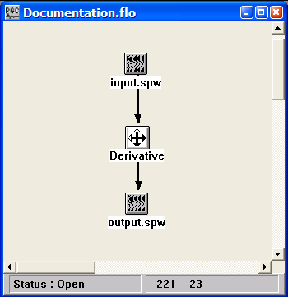

Step Parameter Dialog:
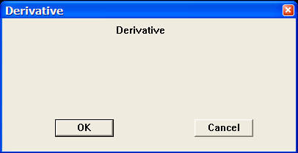

Parameter Description:
There are no parameters for this step.

Design Vibroseis Sweep
Usage:
The Design Vibroseis Sweep step is a utility for building vibroseis sweeps.

Input Links:
None

Output Links:
1) Vibroseis sweep as a seismic data file (mandatory).

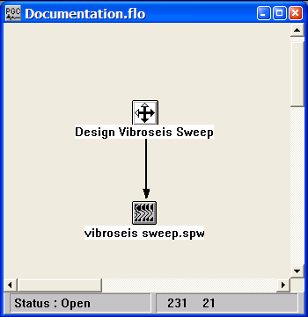
Example Flowchart:

Step Parameter Dialog:

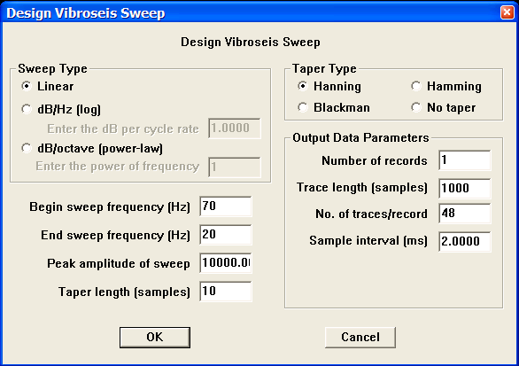

Parameter Description:
Sweep Type — Select the type of sweep to generate.

Linear — Sweep power will be constant from the beginning sweep frequency to the end sweep frequency.

dB/Hz (log) — Sweep power will increase or decrease as dB/Hz from the beginning sweep frequency to the end sweep frequency.

dB/octave (power-law) — Sweep power will increase as dB/octave from the beginning sweep frequency to the end sweep frequency.

Begin sweep frequency (Hz) — Enter the frequency of the start of the sweep in Hertz.

End sweep frequency (Hz) — Enter the frequency of the end of the sweep in Hertz.

Peak amplitude of sweep — Enter the peak amplitude of the sweep.

Taper length (ms) — Enter the taper length in milliseconds. Longer taper lengths result in a smoother transition from the mute zone to the data zone.

Taper Type — Select the type of taper to use between the mute zone and the data zone.

Hanning — A Hanning taper is specified by the equation : x(n) = 0.5 - 0.5 * cos (2*pi*n/N).

Hamming — A Hamming taper is specified by the equation : x(n) = 0.54 - 0.46 * cos (2*pi*n/N).

Blackman — A Blackman taper is specified by the equation : x(n) = 0.42 - 0.5 * cos (2*pi*n/N)+ 0.08 * cos (4*pi*n/N)

No taper — No taper will be applied from the mute zone to the data zone. The resulting step function may result in problems in later processing steps due to Gibbs effect.

Output parameters — Select parameters for outputting the sweep as a seismic file.

Number of records – Choose the number of records to output.

Trace length – Choose the trace length in samples.

No. of traces/record – Choose the number of output traces per record.

Sample interval – Choose the sample interval of the output traces.

Despike
Usage:
The Despike step is used to remove single-sample high-amplitude spikes from a data trace. The editing is based on a Gaussian statistical description of the trace sample values, and assumes that the removal of a single-sample spike is results in a decrease in variance of those trace sample values.

Input Links:
1) Seismic data in any sort order (mandatory).

Output Links:
1) Seismic data file containing the duplicated trace (mandatory).

Example Flowchart:

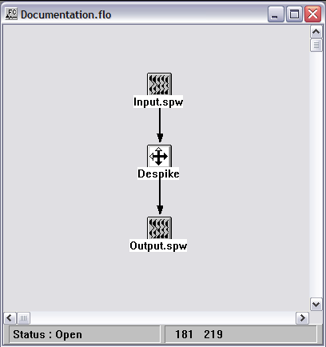

Step Parameter Dialog:

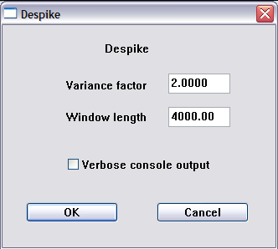

Parameter Description:
Variance factor — Specify the decrease in variance that must result from the removal of a sample value for that sample value to be considered a spike. Values smaller than the default of 2 will potentially result in the removal of more spikes.

Window length (ms) — Enter the window length over which to perform variance calculations. If the whole trace is not analyzed, the windows will overlap by 50%.

Duplicate Trace
Usage:
The Duplicate Trace step duplicates a specified trace in the input seismic data file.

Input Links:
1) Seismic data in any sort order (mandatory).

Output Links:
1) Seismic data file containing the duplicated trace (mandatory).

Example Flowchart:
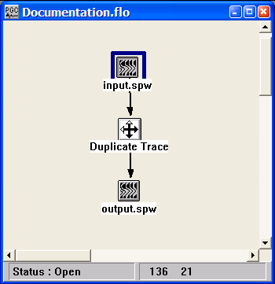

Step Parameter Dialog:
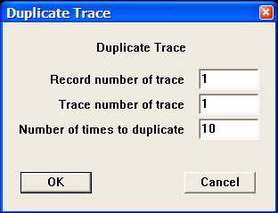

Parameter Description:
Record number of trace — Enter the record number that contains the trace to be duplicated.

Trace number of trace — Enter the trace number to be duplicated in the chosen record.

Number of times to duplicate — Enter the number of times to duplicate the trace.

Integration
Usage:
The Integration step will integrate the data samples in each input seismic data trace.

Input Links:
1) Seismic data in any sort order (mandatory).

Output Links:
1) Seismic data in same sort order as the input (mandatory).

Example Flowchart:
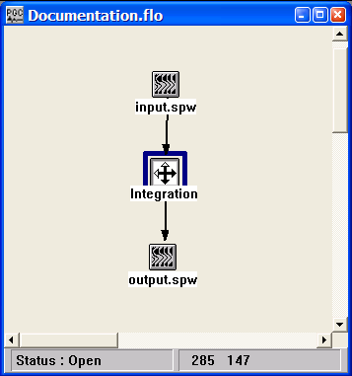

Step Parameter Dialog:
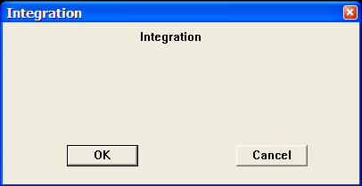

Parameter Description:
There are no parameters for this step.

Kill Traces
Usage:
The Kill Traces step kills traces according to specified trace header values and ranges. Alternatively, the trace kills may be specified in a Trace Kills card data file that is linked to the Kill Traces step. Note: You may also kill and unkill traces interactively in SeisViewer using the Kill Traces tool located under the Picking menu.

Input Links:
- Seismic data in any sort order (mandatory).
- Trace kill card file (optional).

Output Links:
1) Seismic data in same sort order as the input (mandatory).

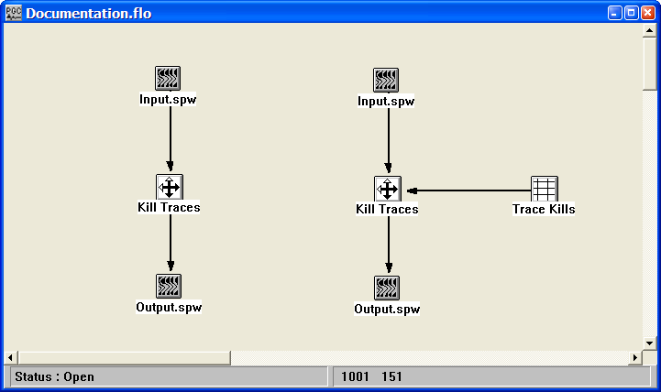
Example Flowchart:

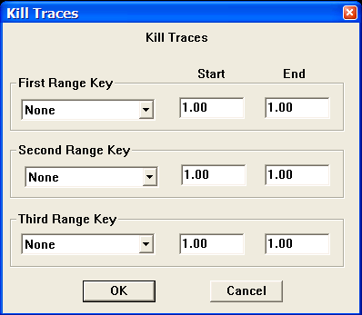
Step Parameter Dialog:

Parameter Description:
First Range Key — Select the first trace header field to use for killing traces. This is combined with the other selected header key values to determine the set of traces to kill.

Start — Enter the start value for the first selected header field.

End — Enter the end value for the first selected header field.

Second Range Key — Select the second trace header field to use for killing traces. This is combined with the other selected header key values to determine the set of traces to kill.

Start — Enter the start value for the second selected header field.

End — Enter the end value for the second selected header field.

Third Range Key — Select the third trace header field to use for killing traces. This is combined with the other selected header key values to determine the set of traces to kill.

Start — Enter the start value for the third selected header field.

End — Enter the end value for the third selected header field.

Phase Rotation
Usage:
The Phase Rotation step allows you to rotate your seismic traces by a constant phase angle from –180 to +180 degrees. Values outside this range will be wrapped back into this range (i.e. 240 degrees is equivalent to –60 degrees).

Input Links:
1) Seismic data in any sort order (mandatory).

Output Links:
1) Seismic data in same sort order as the input (mandatory).

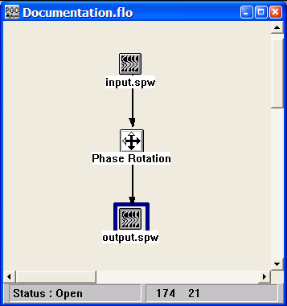
Example Flowchart:

Step Parameter Dialog:
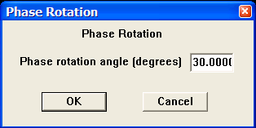

Parameter Description:
Enter the rotation angle in degrees — Enter the constant phase rotation angle to apply to all the seismic data traces.

Remove DC Bias
Usage:
The Remove DC Bias step removes the average or median DC bias on a trace by trace basis.

Input Links:
1) Seismic data in any sort order (mandatory).

Output Links:
1) Seismic data in same sort order as the input (mandatory).

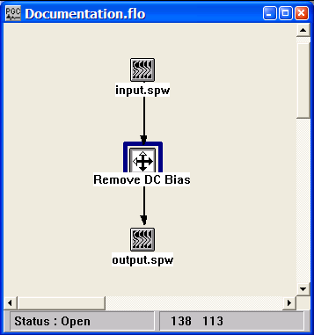
Example Flowchart:

Step Parameter Dialog:
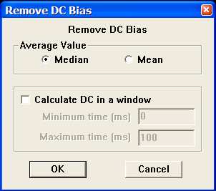

Parameter Description:
Average Value — Select the method for calculating the DC bias to be removed. You may use either a median or a mean.

Calculate DC in a window — If checked, only the entered window of each trace will be used to calculate the DC.

Minimum time (ms) — Enter the start time of the window to be used for calculating the DC value.

Maximum time (ms) — Enter the ending time of the window to be used for calculating the DC value.

Reverse Traces
Usage:
The Reverse Traces step allows you to invert the polarity of traces according specified trace header values and ranges. Alternatively, the trace polarity reversals may be specified in a Trace Kills card data file that is linked to the Kill Traces step. Note: You may also reverse traces interactively in SeisViewer using the Invert Trace tool located under the Picking menu.

Input Links:
- Seismic data in any sort order (mandatory).
- Trace Reversal card file (optional).

Output Links:
1) Seismic data in same sort order as the input (mandatory).

Example Flowchart:
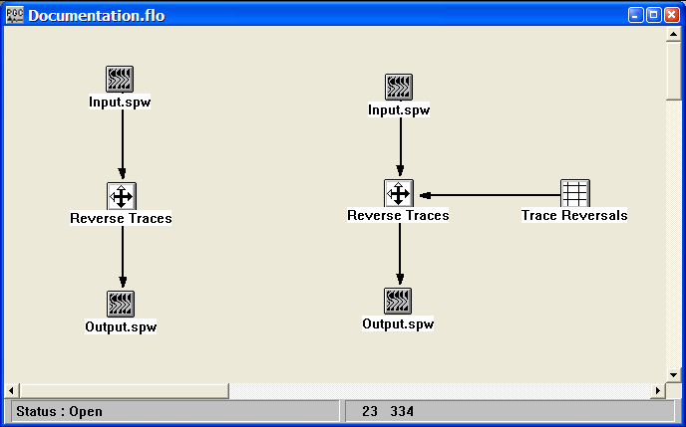

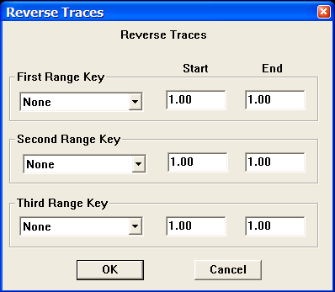
Step Parameter Dialog:

Parameter Description:
First Range Key — Select the first trace header field to use for reversing traces. This is combined with the other selected header key values to determine the set of traces to reverse.

Start — Enter the start value for the first selected header field.

End — Enter the end value for the first selected header field.

Second Range Key — Select the second trace header field to use for reversing traces. This is combined with the other selected header key values to determine the set of traces to reverse.

Start — Enter the start value for the second selected header field.

End — Enter the end value for the second selected header field.

Third Range Key — Select the third trace header field to use for reversing traces. This is combined with the other selected header key values to determine the set of traces to reverse.

Start — Enter the start value for the third selected header field.

End — Enter the end value for the third selected header field.

Trace Header Cell Math
Usage:
The Trace Header Cell Math step allows you modify the trace header values of a seismic trace using standard mathematical operations.

Input Links:
1) Seismic data in any sort order (mandatory).

Output Links:
1) Seismic data in same sort order as the input (mandatory).

Example Flowchart:
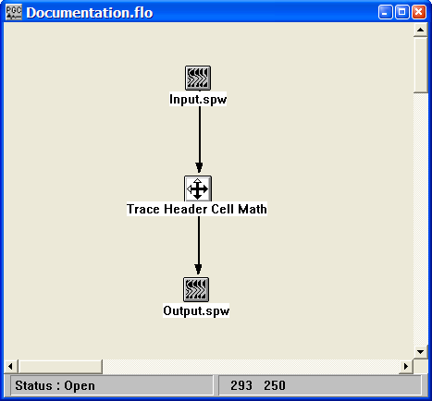

Step Parameter Dialog:
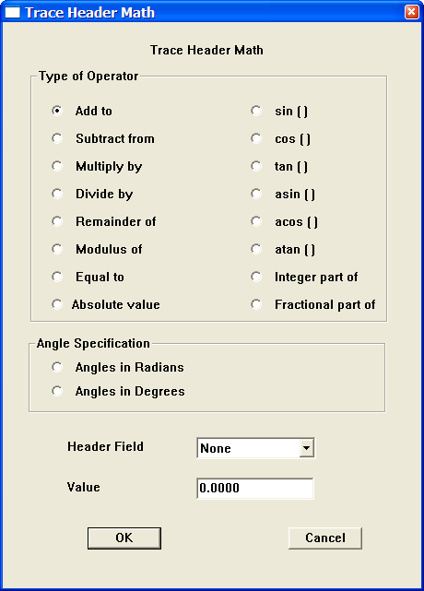

Parameter Description:
Type of operator — Select the mathematical operation that will be applied to the seismic trace header.

Angle Specification — If a trigonometric operation is to be performed, indicate whether the angles involved are measured in units of degrees or radians.

Header Field — Select the trace header field to be modified.

Value — Enter the value that will be used to modify the selected trace header field.

Example: Add 40 to the existing value of the Uphole time.

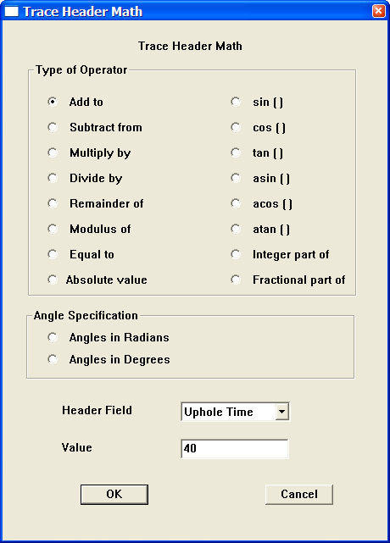

Trace Header Column Math
Usage:
The Trace Header Column Math step allows you modify the trace header values of a seismic trace using standard mathematical operations on combinations of trace header values.

Input Links:
1) Seismic data in any sort order (mandatory).

Output Links:
1) Seismic data in same sort order as the input (mandatory).

Example Flowchart:
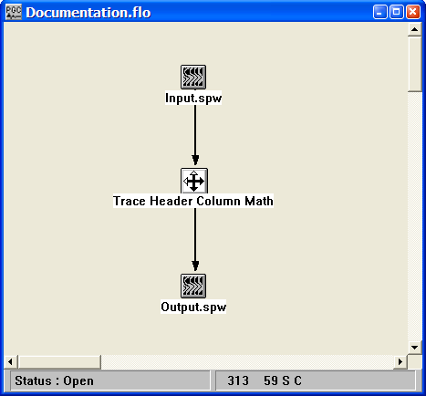

Step Parameter Dialog:
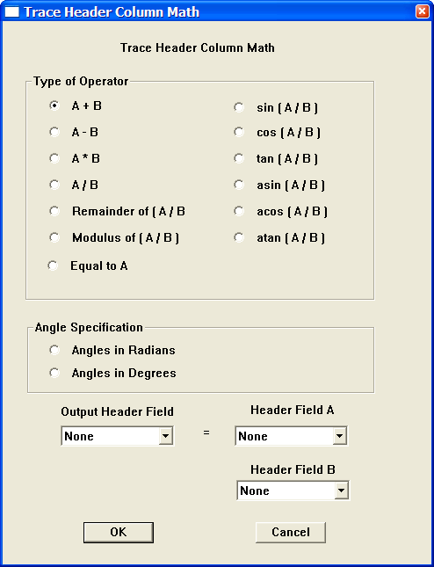

Parameter Description:
Type of operator — Select the mathematical operation that will be applied to the seismic trace header.

Angle Specification — If a trigonometric operation is to be performed, indicate whether the angles involved are measured in units of degrees or radians.

Output Header Field — Select the trace header field where the result of the operation will be output.

Header Field A — Select the first trace header field used in the operation
Header Field B — Select the second trace header field used in the operation

Example: Set the CMP Location equal to the sum of the Source Location and the Receiver Location.
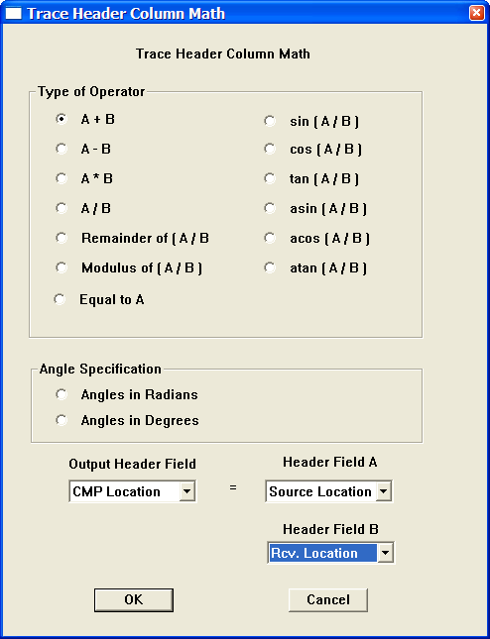

Trace Header Logic
Usage:
The Trace Header Logic step allows you modify the trace header values of a seismic trace using the relational operators and logic conditions characteristic of an If - Then – Else statement.

Input Links:
1) Seismic data in any sort order (mandatory).

Output Links:
1) Seismic data in same sort order as the input (mandatory).

Example Flowchart:
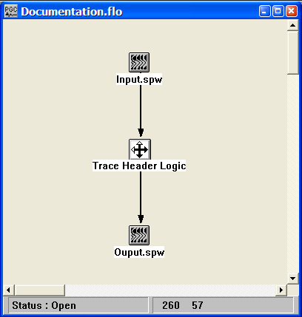

Step Parameter Dialog:
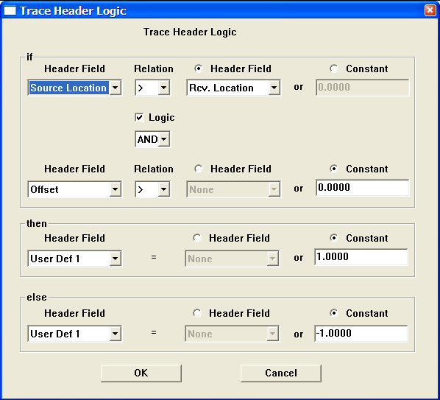

Parameter Description:
if — Select the relational and logic conditions for which the then statement will be executed.

Header Field – Select the primary trace header field to be tested.

Relation – Select the primary relational operator

Header Field – If selected, the primary trace header field will be evaluated against the chosen header field using the primary relational operator.

Constant – If selected, the primary trace header field will be evaluated against the user-supplied constant using the primary relational operator.

Logic – If checked, the Logic option allows selection of a secondary header field using and|or logic.

Header Field – Select the secondary trace header field to be tested.

Relation – Select the secondary relational operator

Header Field – If selected, the primary trace header field will be evaluated against the chosen header field using the secondary relational operator.

Constant – If selected, the primary trace header field will be evaluated against the-user supplied constant using the secondary relational operator.

then — Define the trace header operation to be performed in the case that the if conditions are satisfied.

Header Field – Select the trace header field to be modified in the case that the if conditions are satisfied.

Header Field – If selected, the header field selected above will be set equal to the chosen header field.

Constant – If selected, the header field selected above will be set equal to the user-supplied constant.

else — Define the trace header operation to be performed in the case that the if conditions are not satisfied.

Header Field – Select the trace header field to be modified in the case that the if conditions are not satisfied.

Header Field – If selected, the header field selected above will be set equal to the chosen header field.

Constant – If selected, the header field selected above will be set equal to the user-supplied constant.

Example: If the source-receiver azimuth is greater than or equal to zero, set the User Def 1 field equal to +1. Otherwise, set the User Def 1 field equal to -1.
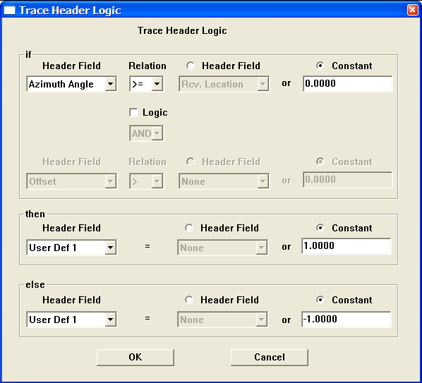

Trace Header Resequencing
Usage:
The Trace Header Resequencing step is used to modify trace header values based on changes in other trace header values.

Input Links:
1) Seismic data in any sort order (mandatory).

Output Links:
1) Seismic data file containing the duplicated trace (mandatory).

Example Flowchart:

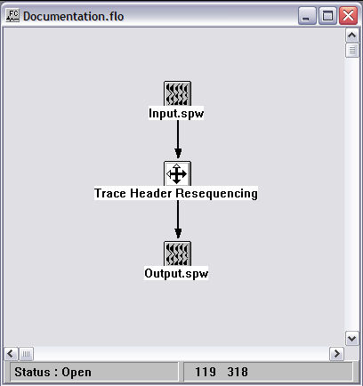
Step Parameter Dialog:

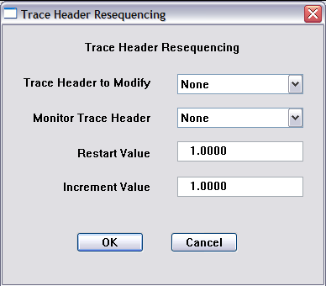

Parameter Description:
Trace Header to Modify – Select the trace header field that will be modified.

Monitor Trace Header – Select the monitor trace header field. A change in value of the Monitor Trace Header will result in a change in value of the Trace Header to Modify based on the following two values:

Restart value — This value will be placed in the Trace Header to Modify whenever there is a change in the Monitor Trace Header.

Increment value — This value will be added to the Restart value for each trace header in which the Trace Header to Modify does not change.

Trace Math
Usage:
The Trace Math step allows you to apply various math operators the trace data amplitude values.

Input Links:
1) Seismic data in any sort order (mandatory).

Output Links:
1) Seismic data in same sort order as the input (mandatory).

Example Flowchart:
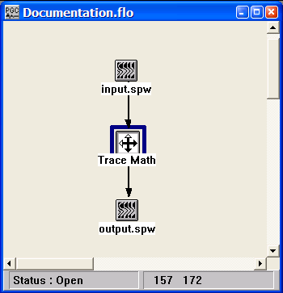

Step Parameter Dialog:
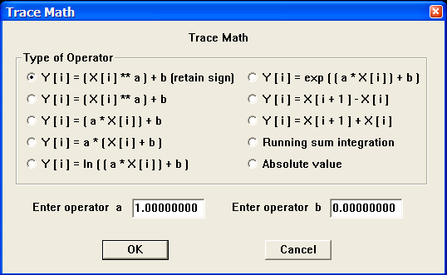

Parameter Description:
Type of operator — Select the equation to that will be applied to the seismic data trace amplitude values.

Enter operator a — Enter the value for the parameter a in the equations.

Enter operator b — Enter the value for the parameter b in the equations.

Vibroseis Correlation
Usage:
The Vibroseis Correlation step cross correlates uncorrelated seismic data acquired with the Vibroseis™ method with the corresponding vibroseis sweep. The correlated output data should be considered zero phase.

Input Links:
- Seismic data in any sort order (mandatory).
2) Seismic data — Vibroseis™ pilot sweeps (optional).

Output Links:
1) Seismic data in same sort order as the input (mandatory).

Example Flowchart:

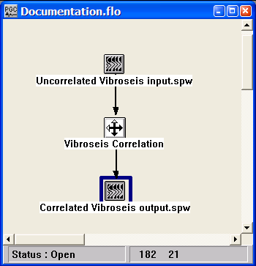

Step Parameter Dialog:
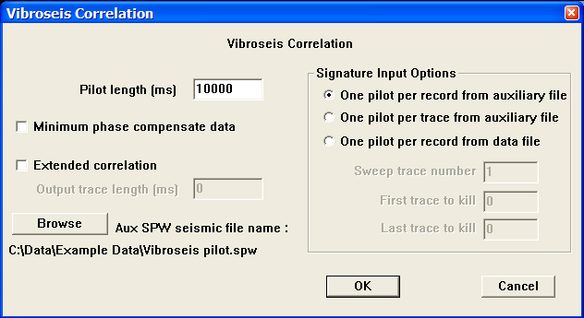

Parameter Description:
Pilot length (ms) — Enter the length of the pilot sweep in milliseconds.

Minimum phase compensate data —If checked, a minimum phase compensation filter will be calculated and applied so that the correlated data will be minimum phase on output.

Extended Correlation — If checked, an extended correlation will be done using the entered trace output length.

Output trace length (ms) — Enter the output length of the result of the cross correlation.

Signature Input Options — Select the method of accessing the Vibroseis pilot sweep.

Auxiliary SPW seismic file – Select the seismic file that contains the Vibroseis pilot.

One pilot per record from an auxiliary file — This option inputs one pilot trace in sequential order from an auxiliary file and crosscorrelates that pilot signature with the respective sequential record. Therefore, number of pilot traces should equal the number of input records.

One pilot per trace from an auxiliary file — This option inputs one pilot trace in sequential order from an auxiliary file and crosscorrelates that pilot signature with the respective sequential trace. Therefore, number of pilot traces should equal the number of input traces.

One pilot per record in the data file — This option uses one trace from the each of the uncorrelated input records as the pilot trace for that record.

Sweep trace number — Enter the trace number to use as the pilot sweep.

First trace to kill — If you demultiplexed the data set with the auxiliary traces to recover the pilot sweep, you may wish to kill the these auxiliary traces so that the do not appear on output. Enter the first trace number to kill.

Last trace to kill — If you demultiplexed the data set with the auxiliary traces to recover the pilot sweep, you may wish to kill the these auxiliary traces traces so that the do not appear on output. Enter the last trace number to kill.

Browse — Select this button to set the input auxiliary file containing the pilot traces.

Filtering Steps

This section documents the processing steps available in the Filtering Steps category.

Processing steps currently available are:

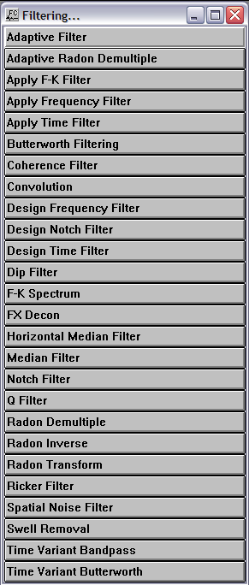

Adaptive Filter
Usage:
The Adaptive Filter step is currently under development.

Input Links:
1) Seismic data in any sort order (mandatory).

Output Links:
1) Seismic data in same sort order as the input (mandatory).

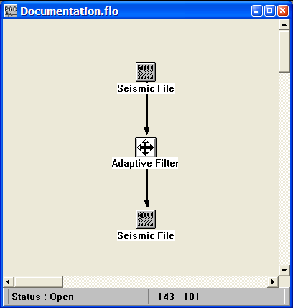
Example Flowchart:

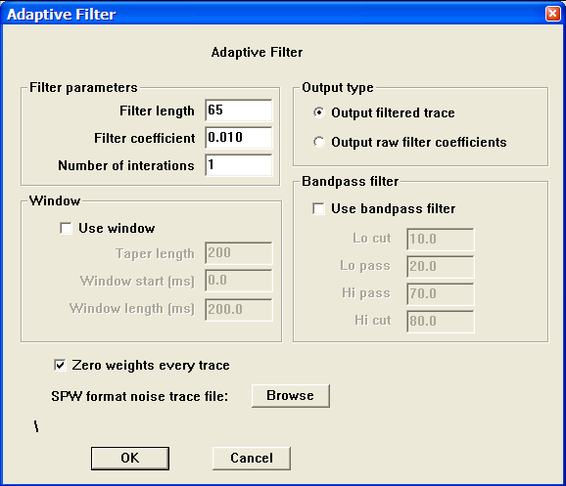
Step Parameter Dialog:

Parameter Description:
Filter parameters -

Filter length —.

Filter coefficient —

Number of iterations —

Window — If the Use window box is checked, the following window parameters will be applied.

Taper length —.

Window start (ms) —

Window length (ms) —

Output type -

Output filtered traces—.

Output raw filter coefficients —

Bandpass filter -

Lo cut —.

Lo pass —

High pass —

High cut —

Adaptive Radon Demultiple
Usage:
The Adaptive Radon Demultiple step performs parabolic radon demultiple through a modeling of primaries, multiples, and noise in the parabolic radon domain followed by subtraction of multiples and noise in the time domain. You specify the transform type, the range of ray parameters in the output transform, a percentage of multiples plus noise to subtract, and the spatial and temporal taper lengths used to generate the transform.

Input Links:
1) Seismic data in any sort order (mandatory).

Output Links:
1) Seismic data in any sort order (mandatory).

Reference:
Hampson, D., 1991, Inverse velocity stacking for multiple elimination, Journal of the Canadian Society of Exploration Geophysics, 22, p. 44-55.

Example Flowchart:

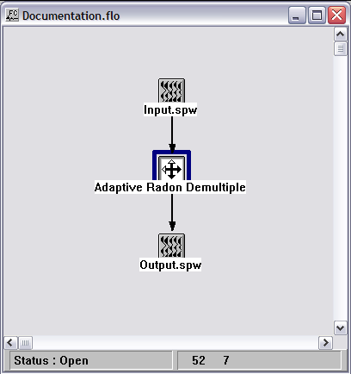
Step Parameter Dialog:
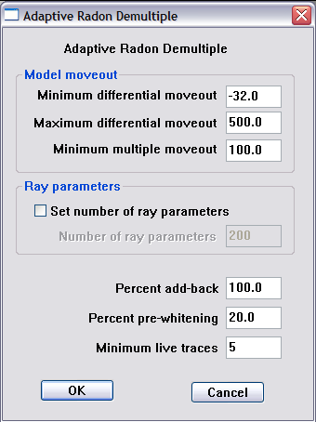

Parameter Description:
Model moveout — Set the range of parabolas that will generate the primary and multiple models.

Minimum differential moveout – Set the minimum differential moveout, expressed in milliseconds on the far-offset trace. The primary model is generated with parabolas from the <minimum differential moveout> to the <minimum multiple moveout>.

Maximum differential moveout – Set the maximum differential moveout, expressed in milliseconds on the far-offset trace. The multiple model is generated with parabolas from the <minimum multiple moveout> to the <maximum differential moveout>.

Minimum multiple moveout – Set the minimum multiple moveout, expressed in milliseconds on the far-offset trace. The multiple model is generated with parabolas from the <minimum multiple moveout> to the <maximum differential moveout>.

Set number of ray parameters — If checked, the number of ray parameters is determined manually. By default, the number of ray parameters is determined internally.

Number of ray parameters – set the number of ray parameter.

Percent add-back – Enter the percentage of the multiple + noise model to be subtracted from the input gather.

Percent pre-whitening – Enter the amount of pre-whitening used to stabilize the least-squares inversion in the presence of noise.

Minimum live traces – Enter the minimum number of live traces that must be present in a gather in order to transform that gather.
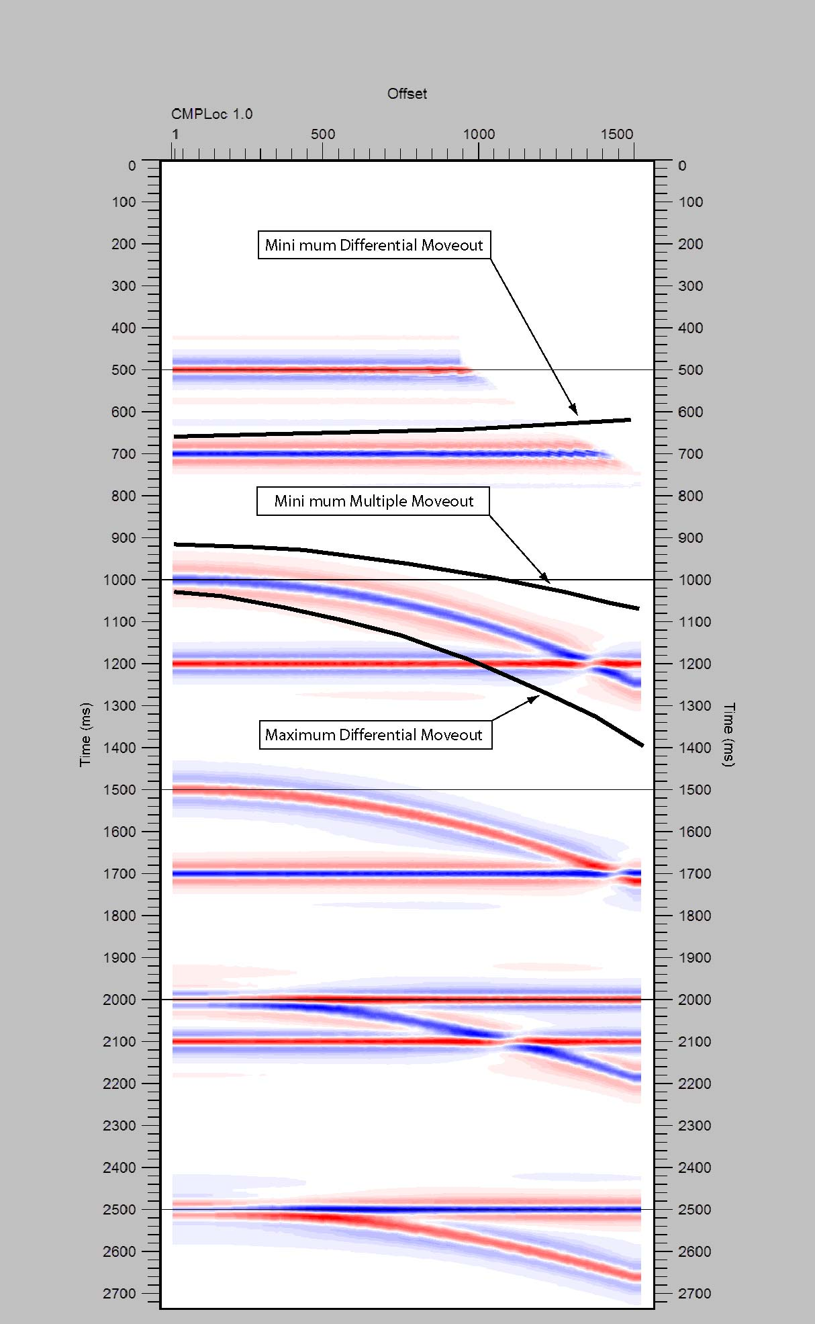

Apply F-K Filter
Usage:
The Apply F-K Filter step transforms T-X domain data to the F-K domain, applies a specified F-K reject filter, and returns the data to the T-X domain. F-K Filters are picked interactively as Surgical Mutes in SeisViewer using the Pick Traces tool located in the Picking menu.

Input Links:
1) Seismic data in any sort order (mandatory).
2) Surgical Mutes cards (mandatory).

Output Links:
1) Seismic data in same sort order as the input (mandatory).

Example Flowchart:
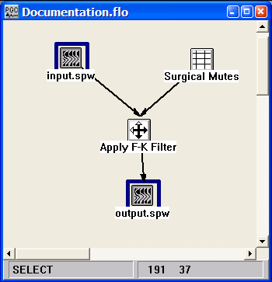
Step Parameter Dialog:
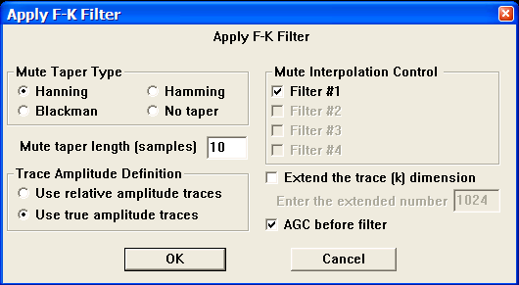

Parameter Description:
Mute Taper Type — Select the type of taper to use when applying the F-K mute function.

Hanning — A Hanning taper is specified by the equation : x(n) = 0.5 - 0.5 * cos (2*pi*n/N).

Hamming — A Hamming taper is specified by the equation : x(n) = 0.54 - 0.46 * cos (2*pi*n/N).

Blackman — A Blackman taper is specified by the equation : x(n) = 0.42 - 0.5 * cos (2*pi*n/N)+ 0.08 * cos (4*pi*n/N)

No taper — No taper will be applied to the mute. This may result in problems in later processing steps due to Gibbs effect.

Mute taper length — Enter the mute taper length in samples. Longer taper lengths result in a smoother transition from the mute zone to the data zone.

Trace Amplitude Definition — Select the trace amplitude type to use, True or Relative.

Use relative amplitude traces — Selects the use of relative amplitude scaled traces in the analysis. Relative amplitude traces are scaled independently of one another.

Use true amplitude traces — Selects the use of true amplitude scaled traces in the analysis. True amplitude traces are scaled by one common factor per record.

Mute Interpolation Control — Set the interpolation mode for each of the F-K mutes. Note: Turning off the interpolation will filter only the records associated with the picked F-K mutes. Only one filter is currently available in the current release of SPW.

Filter # 1 — If checked, the first filter will be interpolated between picked control points.

Filter # 2 — If checked, the first filter will be interpolated between picked control points.

Filter # 3 — If checked, the first filter will be interpolated between picked control points.

Filter # 4 — If checked, the first filter will be interpolated between picked control points.

Extend the trace (k) dimension — If checked, the trace dimension may be extended (padded) to help reduce Fourier wrap around effects.

Enter the extended number — Enter the number of traces to extend (pad) in the trace direction for the 2-D FFT.

AGC before filter — If checked, an AGC is applied to each trace before filtering. The AGC gain function is removed after filtering.

Apply F-K Velocity Filter
Usage:
The Apply F-K Velocity Filter step transforms T-X domain data to the F-K domain, applies an F-K pass or reject filter, and returns the data to the T-X domain. A user-specified minimum and maximum velocity defines the pass or reject zone. Note: the step is currently under construction.

Input Links:
1) Seismic data in any sort order (mandatory).

Output Links:
1) Seismic data in any sort order (mandatory).

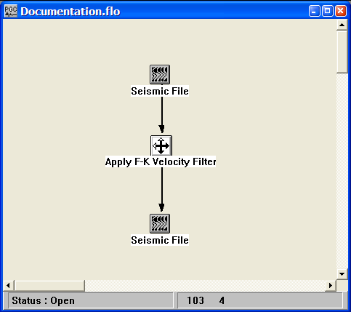
Example Flowchart:

Step Parameter Dialog:

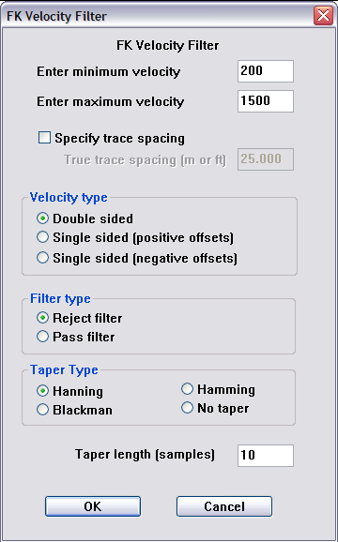

Parameter Description:
Enter minimum velocity – Specify the minimum velocity of the pass or reject zone.

Enter maximum velocity – Specify the maximum velocity of the pass or reject zone.

Specify trace spacing – Check this box to manual set the trace-to-trace spacing in the gather to be filtered. By default, the group interval is read from the seismic data and the trace-to-trace spacing is calculated from the group interval. If the Geometry Definition step has not been applied to the data, the seismic data will not contain information regarding the group interval and this option should be used.

Velocity type – Specify whether the applied F-K filter will be symmetrical or asymmetrical.

Double sided — The specified minimum and maximum velocities will be used to create a double-sided, or symmetrical F-K filter.

Single sided (positive offsets) — The specified minimum and maximum velocities will be used to pass or reject energy propagating in the direction of increasingly positive source-to-receiver offset.

Single sided (negative offsets) — The specified minimum and maximum velocities will be used to pass or reject energy propagating in the direction of increasingly negative source-to-receiver offset.

Filter type – Specify whether the minimum and maximum velocity values specify a pass or a reject zone.

Reject filter — The portion of F-K space defined by the minimum and maximum velocities will be rejected.

Pass filter — The portion of F-K space defined by the minimum and maximum velocities will be passed.

Taper Type — Select the type of taper to use when applying the F-K mute function.

Hanning — A Hanning taper is specified by the equation : x(n) = 0.5 - 0.5 * cos (2*pi*n/N).

Hamming — A Hamming taper is specified by the equation : x(n) = 0.54 - 0.46 * cos (2*pi*n/N).

Blackman — A Blackman taper is specified by the equation : x(n) = 0.42 - 0.5 * cos (2*pi*n/N)+ 0.08 * cos (4*pi*n/N)

No taper — No taper will be applied to the mute. This may result in problems in later processing steps due to Gibbs effect.

Taper length (ms)— Enter the mute taper length in samples. Longer taper lengths result in a smoother transition from the mute zone to the data zone.

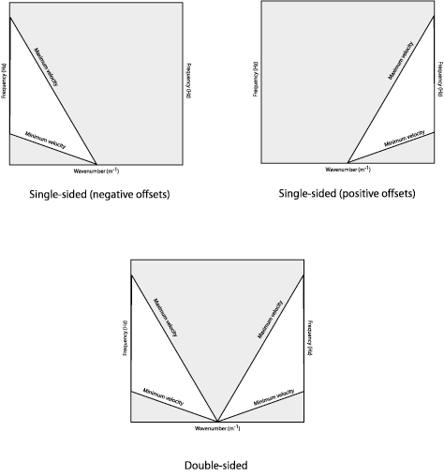

Types of FK Velocity filters.

Apply Frequency Filter
Usage:
Apply the input frequency filter card to the seismic data.

Input Links:
1) Seismic data in any sort order (mandatory).
2) Frequency Filter cards (mandatory).

Output Links:
1) Seismic data in any sort order (mandatory).

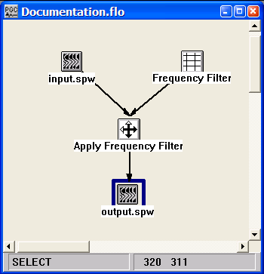
Example Flowchart:

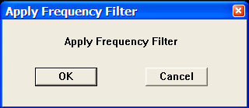
Step Parameter Dialog:

Parameter Description:
There are no parameters for this process.

Apply Time Filter
Usage:
Apply the input time filter card to the seismic data.

Input Links:
1) Seismic data in any sort order (mandatory).
2) Time Filter cards (mandatory).

Output Links:
1) Seismic data in any sort order (mandatory).

Example Flowchart:

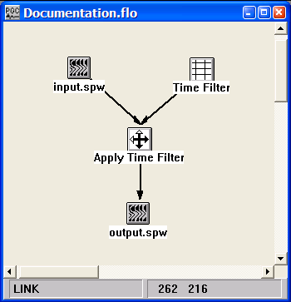
Step Parameter Dialog:
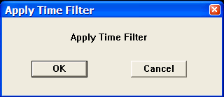

Parameter Description:
There are no parameters for this process.

Butterworth Filtering
Usage:
The Butterworth Filtering step allows you to apply recursively a Butterworth filter to your trace data in the time domain. You specify the low pass, high pass and high and low rolloff rates in decibels (dB) for the filter. You may choose to apply the filter as either a zero phase or minimum phase filter.

Input Links:
1) Seismic data in any sort order (mandatory).

Output Links:
1) Seismic data in any sort order (mandatory).

Example Flowchart:
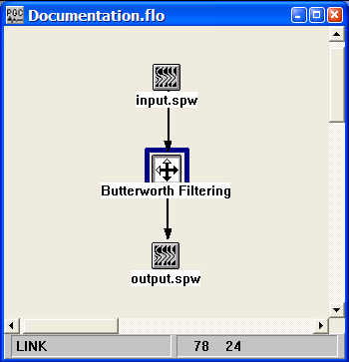

Step Parameter Dialog:
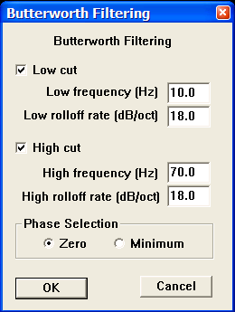

Parameter Description:
Low cut — Check this box to attenuate low frequencies. If unchecked, a low cut filter will not be applied to your data.

Low frequency — Enter the low half-power frequency in Hertz to be applied to your data. The amplitude of this frequency will be reduced by a factor of two relative to the input.

Low rolloff rate — Enter the low rolloff filter slope in decibels per octave (dB/Octave) to be applied to your data. Higher numbers give steeper rolloff.

High cut — Check this box to attenuate high frequencies. If unchecked, a high cut filter will not be applied to your data.

High frequency — Enter the high half-power frequency in Hertz to be applied to your data. The amplitude of this frequency will be reduced by a factor of two relative to the input.

High rolloff rate — Enter the high rolloff filter slope in decibels per octave (dB/Octave) to be applied to your data. Higher numbers give steeper rolloff.

Phase selection — Select the phase type of the filter.

Zero — Zero phase filter selected.

Minimum — Minimum phase filter selected.

Coherence Filter
Usage:
The Coherence filter is used to accentuate the visual coherence of seismic events.

Input Links:
1) Seismic data in any sort order (mandatory).

Output Links:
1) Seismic data in any sort order (mandatory).

Example Flowchart:

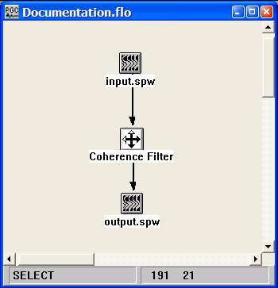
Step Parameter Dialog:
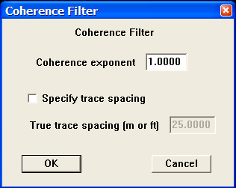

Parameter Description:
Coherence Exponent — Enter the coherency filter exponent. Values of 1 to 1.5 are usually used. A value of 1 does nothing. A value of 1.5 significantly increases coherency.

Specify trace spacing – If checked, allows manual entry of the trace-to-trace spacing.

True trace spacing – Entry the trace-to-trace spacing of the input record.

Convolution
Usage:
The Convolution step is used to convolve traces in an seismic data file with a filter function specified in an auxiliary data set.

Input Links:
1) Seismic data in any sort order (mandatory).
2) Auxiliary file in any sort order (mandatory).

Output Links:
- Seismic data in any sort order (mandatory).

Example Flowchart:

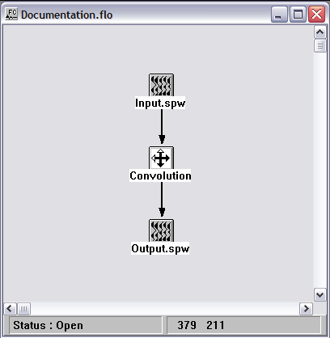

Step Parameter Dialog:

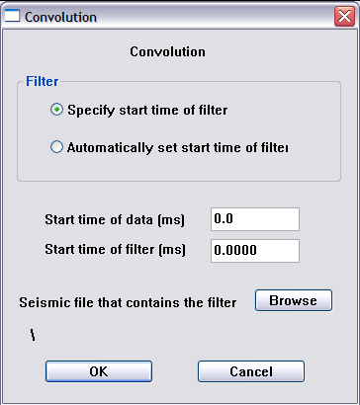

Parameter Description:
Filter

Specify start time of filter -.

Automatically set start time of filter -.

Start time of data – Specify the time at which to start convolving the input data with the filter.

Start time of filter – Specify the time-zero of the filter if the “Specify start time of filter” option is being used.

Seismic file that contains filter – Use the Browse button to locate the seismic file that contains the filter.

Design Frequency Filter
Usage:
The Design Frequency Filter step generates the frequency domain coefficients (i.e. the transfer function) of a digital filter.

Input Links:
None.

Output Links:
1) Frequency Filter cards (mandatory).

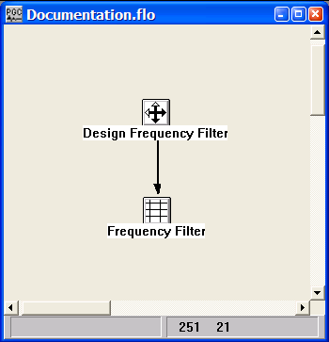
Example Flowchart:

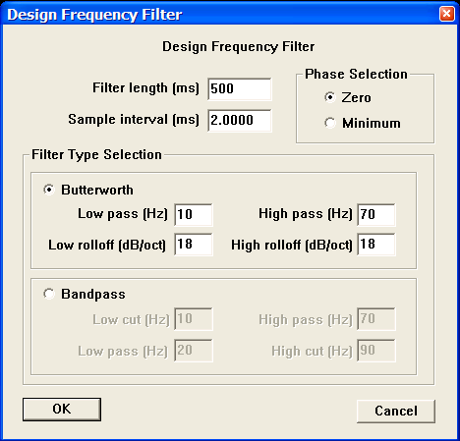
Step Parameter Dialog:

Parameter Description:
Filter length (ms) — Enter the length of the filter in milliseconds.

Sample interval (ms) — Enter the sample interval of the filter in milliseconds.

Phase Selection — Select either a zero phase filter or a minimum phase filter.

Filter Type Selection — Select either a Butterworth filter or a Bandpass filter.

Butterworth Filter —
Low pass— Enter the low half-power frequency in Hertz to be applied to your data. The amplitude of this frequency will be reduced by a factor of two relative to the input.

Low rolloff rate — Enter the low pass rolloff filter slope in decibels per octave (dB/Octave) to be applied to your data. Higher numbers give steeper rolloff.

High frequency — Enter the high half-power frequency in Hertz to be applied to your data. The amplitude of this frequency will be reduced by a factor of two relative to the input.

High rolloff rate — Enter the high pass rolloff filter slope in decibels per octave (dB/Octave) to be applied to your data. Higher numbers give steeper rolloff.

Bandpass Filter —
Low cut — Enter the low cut frequency of the bandpass filter in Hertz.

Low pass — Enter the low pass frequency of the bandpass filter in Hertz.

High pass — Enter the high pass frequency of the bandpass filter in Hertz.

High cut — Enter the high cut frequency of the bandpass filter in Hertz.

Design Notch Filter
Usage:
The Design Notch Filter step generates the frequency domain coefficients (i.e. the transfer function) of a digital notch filter. The notch filter will remove the specified notch and the associated harmonics (i.e. 60 Hz, 120 Hz, 180 Hz, etc…).

Input Links:
None

Output Links:
1) Frequency Filter cards (mandatory).

Example Flowchart:
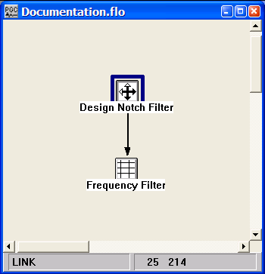

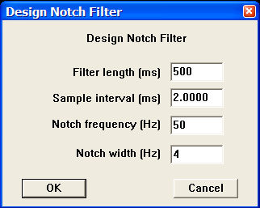
Step Parameter Dialog:

Parameter Description:
Filter length (ms) — Enter the length of the filter in milliseconds.

Sample interval (ms) — Enter the sample interval of the filter in milliseconds.

Phase Selection — Select either a zero phase filter or a minimum phase filter.

Notch frequency — Notch frequency in Hertz.

Notch width — Enter the notch width in Hertz. Wider notches result in less ringy filters.

Design Time Filter
Usage:
The Design Time Filter step generates the time domain coefficients (i.e. the impulse response) of a digital filter.

Input Links:
1) Seismic data in any sort order (mandatory).

Output Links:
1) Seismic data in any sort order (mandatory).

Example Flowchart:

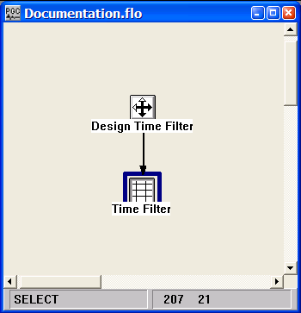
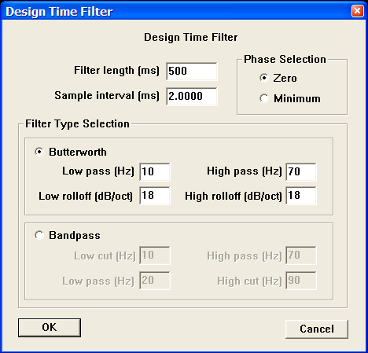
Step Parameter Dialog:

Parameter Description:
Filter length (ms) — Enter the length of the filter in milliseconds.

Sample interval (ms) — Enter the sample interval of the filter in milliseconds.

Phase Selection — Select either a zero phase filter or a minimum phase filter.

Filter Type Selection — Select either a Butterworth filter or a Bandpass filter.

Butterworth Filter —
Low pass— Enter the low half-power frequency in Hertz to be applied to your data. The amplitude of this frequency will be reduced by a factor of two relative to the input.

Low rolloff rate — Enter the low pass rolloff filter slope in decibels per octave (dB/Octave) to be applied to your data. Higher numbers give steeper rolloff.

High frequency — Enter the high half-power frequency in Hertz to be applied to your data. The amplitude of this frequency will be reduced by a factor of two relative to the input.

High rolloff rate — Enter the high pass rolloff filter slope in decibels per octave (dB/Octave) to be applied to your data. Higher numbers give steeper rolloff.

Bandpass Filter —
Low cut — Enter the low cut frequency of the bandpass filter in Hertz.

Low pass — Enter the low pass frequency of the bandpass filter in Hertz.

High pass — Enter the high pass frequency of the bandpass filter in Hertz.

High cut — Enter the high cut frequency of the bandpass filter in Hertz.

Diffusion Filter
Usage:
The Diffusion filter is a noise reduction filter based on the diffusion equation. An option exists to calculate a continuity factor that inhibits diffusion across edges.

Input Links:
1) Seismic data in any sort order (mandatory).

Output Links:
1) Seismic data in any sort order (mandatory).

Reference:
Fehmers, G.C, and Hocker, C.F.W., 2003, Fast structural interpretation with structure-oreiented filters, Geophysics, vol. 68, no. 4, p. 1286-1293.

Example Flowchart:

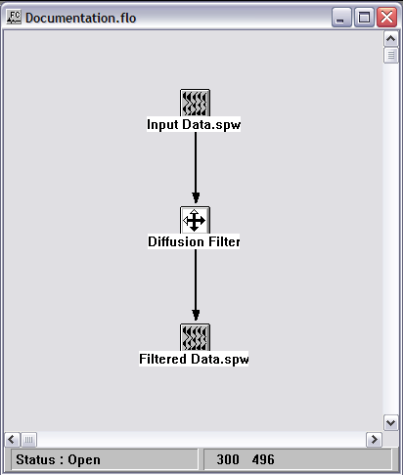
Step Parameter Dialog:

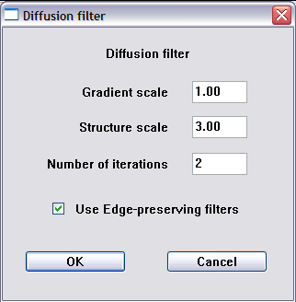

Parameter Description:
Gradient scale — Standard deviation of 2D Gaussian filter used for smoothing the input data prior to gradient calculation.

Structure scale — Standard deviation of 2D Gaussian filter used for smoothing the gradient tensors prior to eigendecomposition.

Number of iterations — Number of filter iteration to apply to the input data.

Use Edge-preserving filters — If check, a continuity (coherence) factor is calculated that inhibits diffusion across edges.

Dip Filter
Usage:
The Dip Filter step allows you to apply a double-sided, or symmetric dip filter to your data. You designate whether you want to pass or reject in the filter zone. The pass or reject zone can be specified as milliseconds per trace or in velocity. The number of poles controls the steepness of your filter. The higher the number of poles, the steeper the slopes on your filter. You may also enter a maximum frequency to pass or reject. To specify your filter in terms of velocity, trace headers with valid offsets and a valid group interval are required.

Input Links:
1) Seismic data in any sort order (mandatory).

Output Links:
1) Seismic data in any sort order (mandatory).

Reference:
Hale, D., and Claerbout, J., 1983, Butterworth dip filters, Geophysics, vol. 48, no. 8, p. 1033-1038.

Example Flowchart:

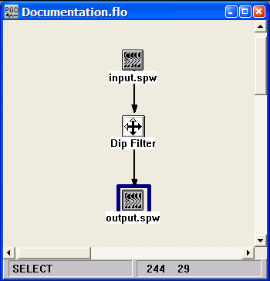
Step Parameter Dialog:
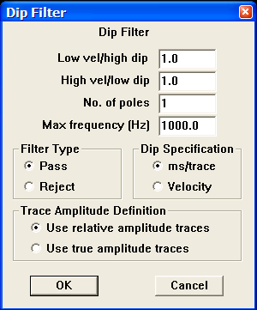

Parameter Description:
Low vel/hi dip — Enter the steeper dip (ms/trace) or the lower apparent velocity (distance units/sec). The filter is identical for negative dips. Be sure to select the appropriate dip specification button below.

Hi vel/low dip — Enter the shallower dip (ms/trace) or the higher apparent velocity (distance units/sec). The filter is identical for negative dips. Be sure to select the appropriate dip specification button below.

No. of poles — Enter the number of poles to define the filter slope. The larger the number of poles the steeper the filter rolloff slope.

Max frequency — You can specify a maximum frequency to pass or reject. Set this to a very large number to extend the filter to Nyquist frequency.

Filter Type — Select whether to pass or reject the specified range of dips.

Pass — Pass the range of dips.

Reject — Reject the range of dips.

Dip Specification — Select whether the dips are specified in ms/trace or distance units/sec. If distance units/sec is selected, the group interval is used as the trace spacing. Thus, valid trace headers must exist for the data.

Ms/trace — Interpret the dips specified above as units of ms/trace.

Velocity — Interpret the dips specified above as distance units/sec.

Trace Amplitude Definition — Select the trace amplitude type to use.

Use relative amplitude traces — Selects the use of relative amplitude scaled traces in the analysis. Relative amplitude traces are scaled independently of one another.

Use true amplitude traces — Selects the use of true amplitude scaled traces in the analysis. True amplitude traces are scaled by one common factor per record.

F-K Spectrum
Usage:
The F-K Spectrum step allows you to create F-K spectrum image plots of your seismic data for designing F-K filters. Alternatively, the F-K spectrum can be directly created in SeisViewer from a selected seismic file.

Input Links:
1) Seismic data in any sort order (mandatory).

Output Links:
1) Seismic data containing F-K spectrum (mandatory).

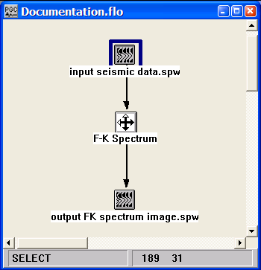
Example Flowchart:

Step Parameter Dialog:
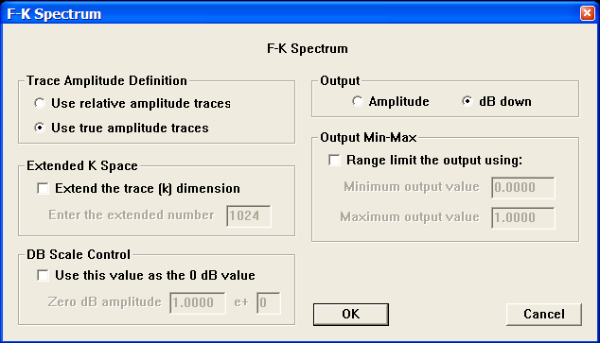

Parameter Description:
Trace Amplitude Definition — Select the amplitude to use as input to the F-K transform, either relative or true amplitude.

Use relative amplitude traces — Selects the use of relative amplitude scaled traces in the analysis. Relative amplitude traces are scaled independently of one another.

Use true amplitude traces — Selects the use of true amplitude scaled traces in the analysis. True amplitude traces are scaled by one common factor per record.

Extend the trace (k) dimension — If checked, the trace dimension may be extended (padded) to help reduce Fourier wrap around effects.

Enter the extended number — Enter the number of traces to extend (pad) in the trace direction for the 2-D FFT.

dB scale control — If checked, the zero dB amplitude value may be entered. Using this option allows you to compare two dB scale images.

Output — Select the output amplitude scale, either absolute amplitude or dB down from the maximum.

Output min - max — If this option is on, the output amplitude values may be range limited by the input values. Again this is useful for comparisons.

F-X Deconvolution
Usage:
The FX Deconvolution step is a 2D multi-channel noise filter designed to attenuate random noise. This time-variant, adaptive filter removes the non-predictable part of the data using the assumption that the signal portion of the data is predictable and the noise portion of the data is inherently random, and therefore non-predictable. You specify the length of the filter window, in samples, the width of the filter window, in traces, and the filter adaptation percent.

Input Links:
1) Seismic data in any sort order (mandatory).

Output Links:
1) Seismic data in any sort order (mandatory).

Reference:
Hornbostel, S., 1991, Spatial prediction filtering in the t-x and f-x domain, Geophysics, v. 56, no 12, p. 2019-2026.

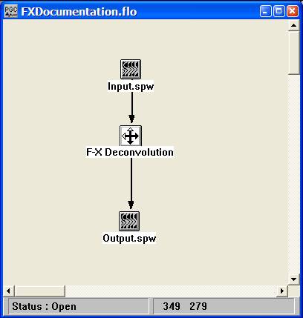
Example Flowchart:

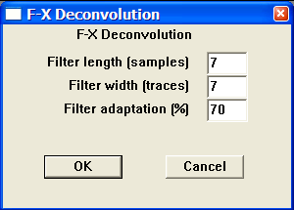
Step Parameter Dialog:

Parameter Description:
Filter length in samples — Enter the length of the filter in number of time samples

Filter width in traces — Enter the width of the filter in number of traces.

Filter adaptation percent — Enter the percent adaptation of the filter. Use a smaller percent if filter destroys signal.

F-XY Deconvolution
Usage:
The FXY Deconvolution step is a 3D multi-channel noise filter designed to attenuate random noise. This time-variant, adaptive filter removes the non-predictable part of the data using the assumption that the signal portion of the data is predictable and the noise portion of the data is inherently random, and therefore non-predictable. You specify the length of the filter window, in samples, the inline dimension of the filter window, in traces, the crossline dimension of the filter window, in traces, and the filter adaptation percent. Note: the step is currently under construction.

Input Links:
1) Seismic data in any sort order (mandatory).

Output Links:
1) Seismic data in any sort order (mandatory).

Reference:
Hornbostel, S., 1991, Spatial prediction filtering in the t-x and f-x domain, Geophysics, v. 56, no 12, p. 2019-2026.

Example Flowchart:
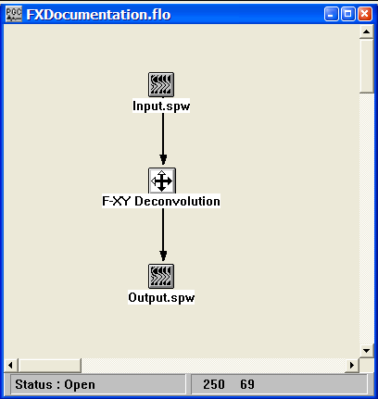

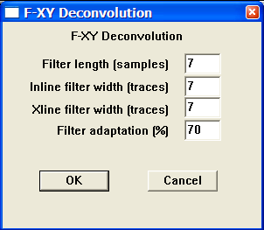
Step Parameter Dialog:

Parameter Description:

Filter length in samples — Enter the length of the filter in number of time samples

Inline filter width in traces — Enter the width of the filter in along the inline direction.

Xline filter width in traces — Enter the width of the filter in along the crossline direction.

Filter adaptation percent — Enter the percent adaptation of the filter. Use a smaller percent if filter destroys signal.

Horizontal Median Filter
Usage:
The Horizontal Median step allows you to apply a horizontal median filter across the data traces of a gather or stack. This process is very useful in processing VSP data for separation of up-going and down-going events.

Input Links:
1) Seismic data in any sort order (mandatory).

Output Links:
- Seismic data in any sort order (mandatory).

References:
Hardage, B. A., 1983, Vertical Seismic Profiling, Geophysical Press.

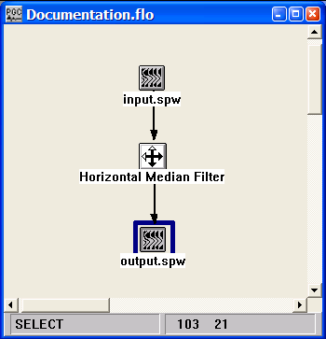
Example Flowchart:

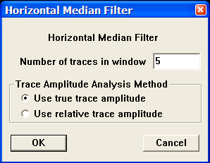
Step Parameter Dialog:

Parameter Description:
Number of traces in window — Enter the number of traces in the spatial window.

Trace Amplitude Analysis Method — Amplitude summing selection.

Use true amplitude traces — True amplitude traces will be used in the median process. True amplitude traces are scaled by one common factor per record.

Use relative amplitude traces — Relative amplitude traces will be used in the median process. Relative amplitude traces are scaled independently of one another.

Median Filter
Usage:
The Median Filter step is a single channel filter that may be used to remove spikes from your data or any other features such as the wow in radar, which may be filtered by a median operator. You enter the size of the window for calculating the median value.

Input Links:
1) Seismic data in any sort order (mandatory).

Output Links:
1) Seismic data in any sort order (mandatory).

Example Flowchart:
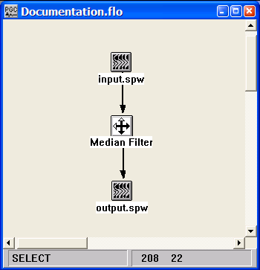

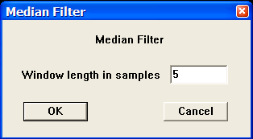
Step Parameter Dialog:

Parameter Description:
Window length in samples — Enter the number of samples in the window over which the median will be calculated. The sample at the windows center will be replaced by the calculated median value.

Notch Filter
Usage:
The Notch Filter step applies a frequency domain notch filter to the input data. The filter is specified by describing the frequency notch and the width of the notch. Options exist to (1) apply the filter as a function of header word flags, (2) parameterize the notch as a function of header word flags.

Input Links:
1) Seismic data in any sort order (mandatory).

Output Links:
1) Seismic data in any sort order (mandatory).

Example Flowchart:

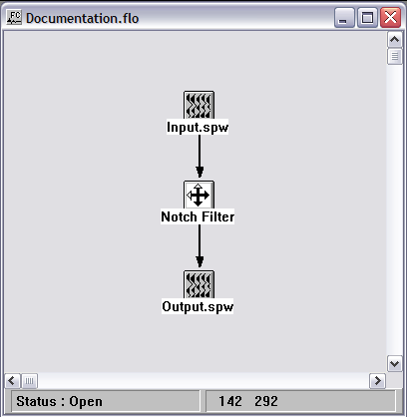

Step Parameter Dialog:

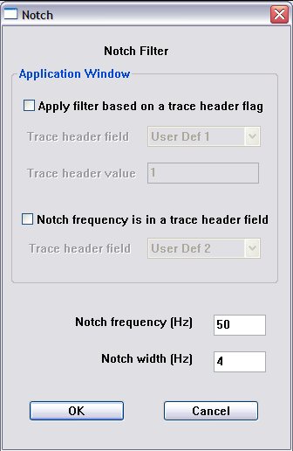

Parameter Description:
Application window
Apply filter based on a trace header flag – check this option if the application of the filter is to be controlled by the value of a trace header flag.

Trace header field – If the filter is to be controlled by the value of a trace header flag, select the trace header from the drop down menu.

Trace header value – If the filter is to be controlled by the value of a trace header flag, set the value of the trace header. When the value of the trace header equals the specified value, the filter will be applied. Otherwise, the filter will not be applied.

Notch frequency is in a trace header field – check this option if the value of the notch frequency is to be controlled by the value of a trace header field.

Trace header field – If the notch of the filter is to be controlled by the value of a trace header field, select the trace header from the drop down menu.

Notch frequency (Hz) — Specify the value of the notch frequency in Hertz.

Notch width (Hz) — Specify the width of the notch frequency in Hertz.

Q Filter
Usage:
The Q Filter step applies an attenuation (i.e. “Q”) compensation filter or an attenuation modeling filter to the input file. For both attenuation and modeling options, additional options exist to apply phase only or phase and amplitude filters.

Input Links:
1) Seismic data in any sort order (mandatory).

Output Links:
1) Seismic data in any sort order (mandatory).

Reference:
Hargreaves, N. D., Calvert A. J., 1991, Inverse Q filtering by Fourier Transform, Geophysics, 56, p. 519.
Hargreaves, N., 1992, Similarity and the inverse Q filter: Some simple algorithms for inverse Q filtering, Geophysics, 57, p. 994.
Wang, Y., 2002, A stable and efficient approach of inverse Q filtering, Geophysics, 67, p. 657.

Example Flowchart:

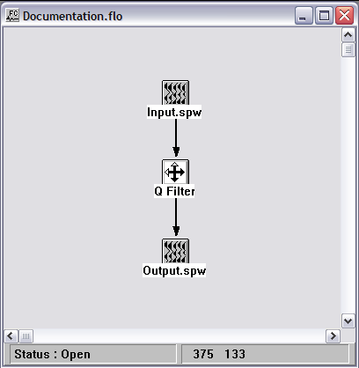

Step Parameter Dialog:

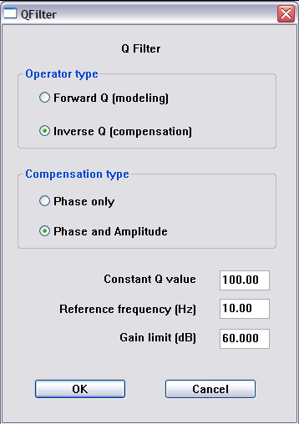

Parameter Description:
Operator type

Forward Q (modeling) – Check this option if attenuation is to be introduced to the input seismic traces.

Inverse Q (modeling) – Check this option if attenuation is to be removed from the input seismic traces.

Compensation type

Phase only – Check this option if an allpass, phase-only filter is to be applied for forward or inverse Q filtering. This is the computationally efficient option.

Phase and Amplitude – Check this option if a phase and amplitude type filter is to be applied for forward or inverse Q filtering. This is the computer intensive option.

Constant Q value— Specify the value of Q for forward or inverse Q filtering.

Reference frequency (Hz) — Specify the reference frequency for forward or inverse Q filtering. There will be slight frequency dependent phase shifts with respect to this frequency.

Gain limit (dB) — Specify the maximum gain limit per frequency in the case of inverse Q filtering.

Radon Demultiple
Usage:
The Radon Demultiple step performs parabolic radon demultiple through a modeling of multiples in the parabolic radon domain followed by subtraction of those multiples in the time domain. You specify the transform type, the range of ray parameters in the output transform, and the spatial and temporal taper lengths used to generate the transform.

Input Links:
1) Seismic data in any sort order (mandatory).

Output Links:
1) Seismic data in any sort order (mandatory).

Reference:
Hampson, D., 1991, Inverse velocity stacking for multiple elimination, Journal of the Canadian Society of Exploration Geophysics, 22, p. 44-55.

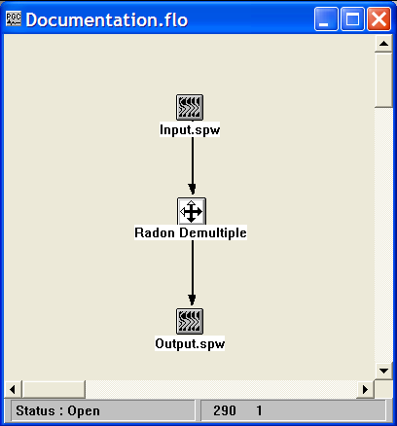
Example Flowchart:
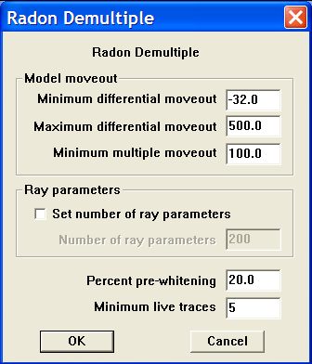
Step Parameter Dialog:

Parameter Description:
Model moveout — Set the range of parabolas that will generate the primary and multiple models.

Minimum differential moveout – Set the minimum differential moveout, expressed in milliseconds on the far-offset trace. The primary model is generated with parabolas from the <minimum differential moveout> to the <minimum multiple moveout>.

Maximum differential moveout – Set the maximum differential moveout, expressed in milliseconds on the far-offset trace. The multiple model is generated with parabolas from the <minimum multiple moveout> to the <maximum differential moveout>.

Minimum multiple moveout – Set the minimum multiple moveout, expressed in milliseconds on the far-offset trace. The multiple model is generated with parabolas from the <minimum multiple moveout> to the <maximum differential moveout>.

Set number of ray parameters — If checked, the number of ray parameters is determined manually. By default, the number of ray parameters is determined internally.

Number of ray parameters – set the number of ray parameter.

Percent pre-whitening – Enter the amount of pre-whitening used to stabilize the least-squares inversion in the presence of noise.

Minimum live traces – Enter the minimum number of live traces that must be present in a gather in order to transform that gather.

Radon Transform
Usage:
The classical Radon transform consists of a straight-line summation over a range of ray parameters at each intercept value. The generalized Radon transform allows for summation along curved surfaces, which for geophysical applications may also be parabolic and hyperbolic functions of offset. The Radon Transform step can be used to compute the linear, parabolic, or hyperbolic Radon transform from the space-time domain to the domain of linear, parabolic, or hyperbolic ray parameter and intercept. You specify the transform type, the range of ray parameters in the output transform, and the spatial and temporal taper lengths used to generate the transform.

Input Links:
1) Seismic data in any sort order (mandatory).

Output Links:
1) Seismic data in any sort order (mandatory).

Reference:
Thorston, J. R. and Claerbout, J. F., 1985, Velocity-stack and slant-stack stochastic inversion, Geophysics, 50, p. 2727-2741.
Hampson, D., 1991, Inverse velocity stacking for multiple elimination, Journal of the Canadian Society of Exploration Geophysics, 22, p. 44-55.

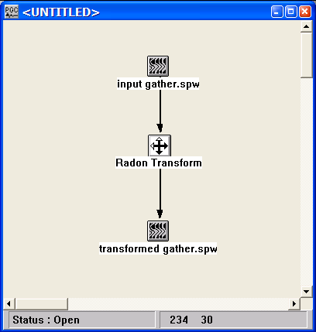
Example Flowchart:
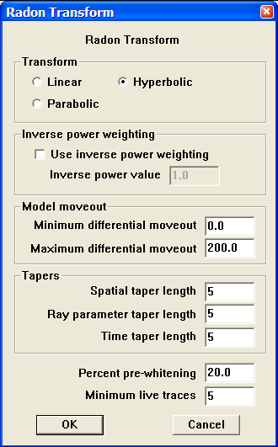
Step Parameter Dialog:

Parameter Description:
Transform — Select the type of Radon transform to perform.

Linear – If selected, a transform will be performed from the domain of space and time to the domain of ray parameter and intercept.

Parabolic – If selected, a transform will be performed from the domain of space and time to the domain of parabolic ray parameter and intercept.

Hyperbolic – If selected, a transform will be performed from the domain of space and time to the domain of hyperbolic ray parameter and intercept.

Inverse power weighting — If checked, a weighting scheme is applied to the input data prior to computing the transform. Not Recommended.

Model moveout — Set the range of ray parameters for the transformed output.

Minimum differential moveout – minimum far-offset moveout value present in the transformed data.

Maximum differential moveout – maximum far-offset moveout value present in the transformed data.

Tapers — Set the spatial and temporal taper lengths used in constructing the transform.

Spatial taper length – Number of traces to taper at the near and far offsets of the X-T gather prior to computing the transform.

Ray parameter taper length – Ray taper.

Time taper length – Length of taper to apply at the start and end of the X-T gather prior to computing the transform.

Percent pre-whitening – Enter the amount of pre-whitening used to stabilize the least-squares inversion in the presence of noise.
.

Minimum live traces – Enter the minimum number of live traces that must be present in a gather in order to transform that gather.

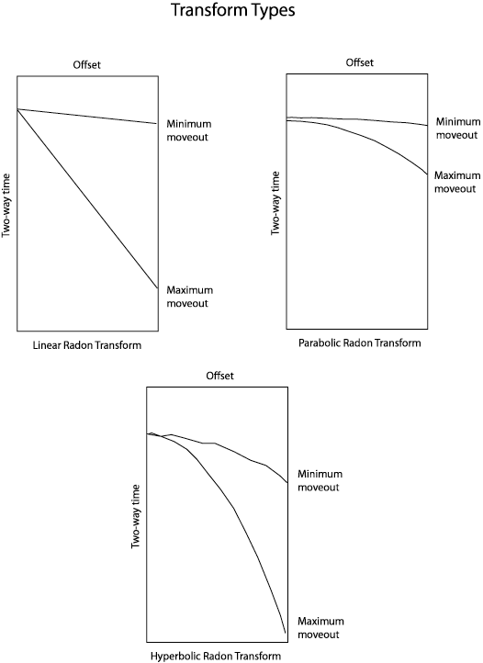

Radon Inverse
Usage:
The Radon Inverse step transforms data from the linear, parabolic, or hyperbolic Radon transform domain to the space-time domain. You specify the transform type and the range and number of transformed output traces.

Input Links:
1) Seismic data in any sort order (mandatory).

Output Links:
1) Seismic data in any sort order (mandatory).

Reference:
Thorston, J. R. and Claerbout, J. F., 1985, Velocity-stack and slant-stack stochastic inversion, Geophysics, 50, p. 2727-2741.
Hampson, D., 1991, Inverse velocity stacking for multiple elimination, Journal of the Canadian Society of Exploration Geophysics, 22, p. 44-55.

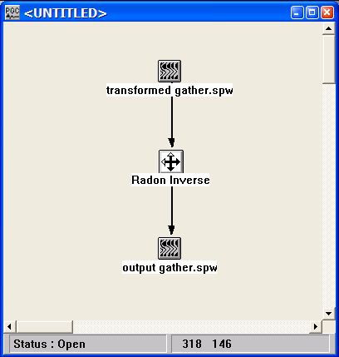
Example Flowchart

Step Parameter Dialog:
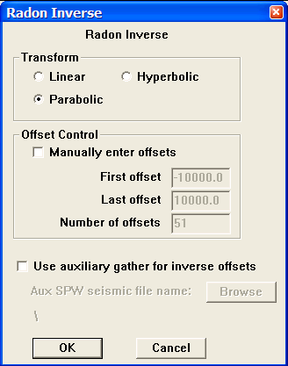

Parameter Description:
Transform — Select the type of Radon transform to perform.

Linear – If selected, a transform will be performed from the domain of space and time to the domain of ray parameter and intercept.

Parabolic – If selected, a transform will be performed from the domain of space and time to the domain of parabolic ray parameter and intercept.

Hyperbolic – If selected, a transform will be performed from the domain of space and time to the domain of hyperbolic ray parameter and intercept.

Offset control — Allows manual control of the output offsets.

Manually enter offsets — If checked, indicates that the offsets in the output gathers will be entered manually

First offset – enter the smallest offset to be present in the output gather.

Last offset – enter the largest offset to be present in the output gather.

Number of offsets – enter the number of offsets to be present in the output gather.

User auxiliary gather for inverse offsets — If checked, the offsets in the output gathers will be taken from those of an auxiliary data file (e.g. the input to the forward transform).

Browse – select the data file that will provide the offset header information.

Ricker Filter
Usage:
The Ricker Filter step applies a ricker filter to the input seismic file. The Ricker filter is completely determined by the center frequency of the Ricker wavelet.

Input Links:
1) Seismic data in any sort order (mandatory).

Output Links:
1) Seismic data in any sort order (mandatory).

Example Flowchart:

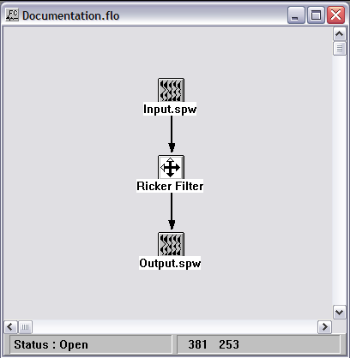

Step Parameter Dialog:

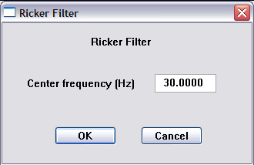

Parameter Description:
Center frequency (Hz) — Specify the center frequency of the Ricker wavelet.

Spatial Noise Filter
Usage:
The spatial noise filter step is a random noise reduction technique for removing or suppressing random noise in your data. This time-variant, adaptive filter removes the non-predictable part of the data using the assumption that the signal portion of the data is predictable and the noise portion of the data is inherently random, and therefore non-predictable. You specify the length of the filter window, in samples, the width of the filter window, in traces, and the filter adaptation percent. You may choose to apply the filter a bottom up (i.e. bottom to top) direction or a top down (i.e. top to bottom) direction.

Input Links:
1) Seismic data in any sort order (mandatory).

Output Links:
1) Seismic data in any sort order (mandatory).

Reference:
Hornbostel, S., 1991, Spatial prediction filtering in the t-x and f-x domain, Geophysics, v. 56, no 12, p. 2019-2026.

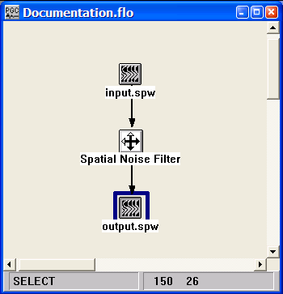
Example Flowchart:

Step Parameter Dialog:
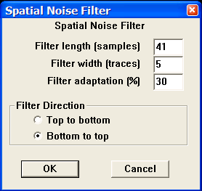

Parameter Description:
Filter length in samples — Enter the length of the filter in number of time samples

Filter width in traces — Enter the width of the filter in number of traces.

Filter adaptation percent — Enter the percent adaptation of the filter. Use a smaller percent if filter blows up data.

Filter Direction — Select the direction to apply the filter. Since this is an adaptive filter, bottom to top filters often give better results.

Top to bottom — This selection applies the filter from the top of the trace to the bottom. If selected, the filter will be applied starting from the top left corner of your data and continuing downward. When the end of this column of your data is reached, the filter shifts to the right by the specified number of traces (i.e. filter width) and starts down the next column of your data from the top.

Bottom to top — This selection applies the filter from the bottom of the trace to the top. If selected, the filter will be applied starting from the bottom left corner of your data and continue upward. When the end of this column of your data is reached, the filter shifts to the right by the specified number of traces (i.e. filter width) and starts up the next column of your data from the bottom.

Swell Removal
Usage:
The Swell Removal step allows you to remove short period static shifts caused by the ocean swell. The statics are picked using correlation over the trace and then smoothed using a multi-trace smoother.

Input Links:
1) Seismic data in any sort order (mandatory).

Output Links:
1) Seismic data in any sort order (mandatory).

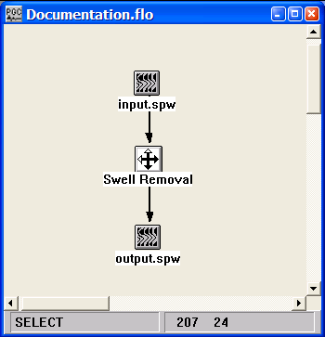
Example Flowchart:

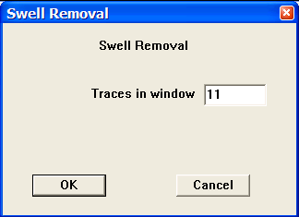
Step Parameter Dialog:

Parameter Description:
Traces in window — Enter the number of traces in each analysis window.

Time Variant Bandpass
Usage:
The Time Variant Bandpass step allows you to apply up to five (5) different time-variant bandpass filters to your trace data. You specify the low cut, low pass, high pass and high cut, filter points for each filter and the starting time for application of the filter. You also specify the filter taper length, which allows you to control the smoothness of the transition between adjacent filters.

Input Links:
1) Seismic data in any sort order (mandatory).

Output Links:
1) Seismic data in any sort order (mandatory).

Example Flowchart:
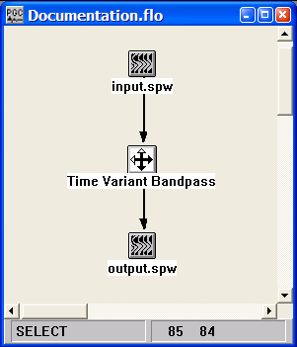

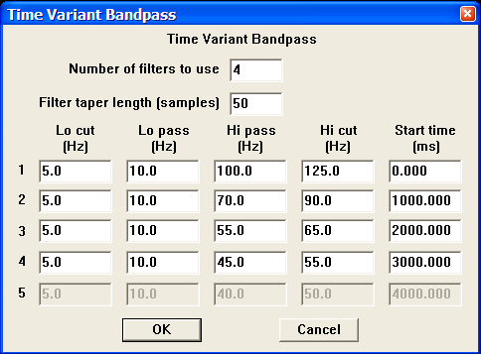
Step Parameter Dialog:

Parameter Description:
Number of filters to use — Enter the number of filters to apply.

Filter taper length — Enter the length of the filter taper in samples. The longer the filters taper length, the smoother the transition between adjacent filters.

Low cut — Enter the low cut frequency of the bandpass filter in Hertz.

Low pass — Enter the low pass frequency of the bandpass filter in Hertz.

High pass — Enter the high pass frequency of the bandpass filter in Hertz.

High cut — Enter the high cut frequency of the bandpass filter in Hertz.

Start time (ms) —Enter the start time in milliseconds to start the application of each filter.

Time Variant Butterworth
Usage:
The Time Variant Butterworth step allows you to apply up to five (5) different time-variant Butterworth filters to your trace data. You specify the low pass, high pass and low and high rolloff rates in decibels (dB) for each filter, as well as the starting time for application of the filter. You also specify the filter taper length, which controls the smoothness of the transition between adjacent filters.

Input Links:
1) Seismic data in any sort order (mandatory).

Output Links:
1) Seismic data in any sort order (mandatory).

Example Flowchart:
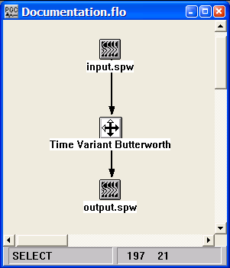

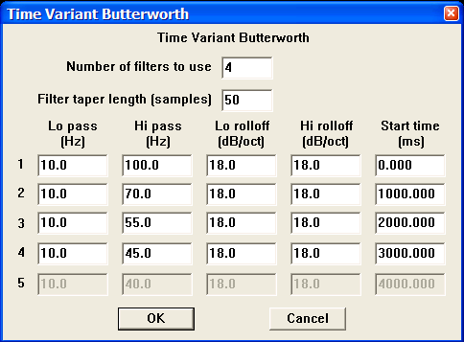
Step Parameter Dialog:

Parameter Description:
Number of filters to use — Enter the number of filters to apply.

Filter taper length— Enter the length of the filter taper in samples. The longer the filters taper length, the smoother the transition between adjacent filters.

Low frequency — Enter the low pass frequency of the Butterworth filter in Hertz.

Low rolloff rate — Enter the low pass rolloff rate in dB/Octave. Higher numbers give a steeper filter rolloff.

High frequency — Enter the high pass frequency of the Butterworth filter in Hertz.

High rolloff rate — Enter the high pass rolloff rate in dB/Octave. Higher numbers give a steeper filter rolloff.

Time (ms) — (Start) — Enter the start time in milliseconds to the start application of each filter.

Wave Equation Multiple Attenuation
Usage:
The Wave Equation Multiple Attenuation step predicts water-bottom and peg-leg multiples by extrapolating the observed seismic data through one round trip of the water column. The predicted multiples are then subtracted from the observed data to achieve multiple suppression. Note: the step is currently under construction.

Input Links:
- Seismic data in any sort order (mandatory).
- Horizon pick card containing water bottom pick times (mandatory).

Output Links:
- Seismic data in any sort order (mandatory).

Reference:
Berryhill, J. R, and Kim, Y. C., 1986, Deep-water peg legs and multiples: Emulation and suppression, Geophysics, v. 51, no 12, p. 2177-2184.

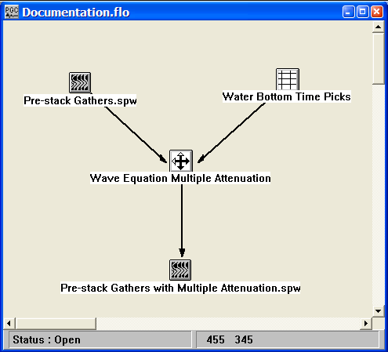
Example Flowchart:

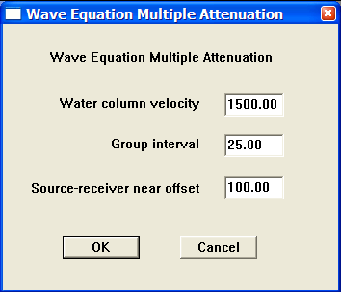
Step Parameter Dialog:

Parameter Description:
Water column velocity — Enter the velocity of propagation in the water column.

Group interval — Enter the acquisition group interval.

Source-receiver near offset — Enter the offset from the source to the nearest receiver in the spread.

Geometry/Binning Steps

This section documents the processing steps available in the Geometry/Binning category.

Processing steps currently available are:

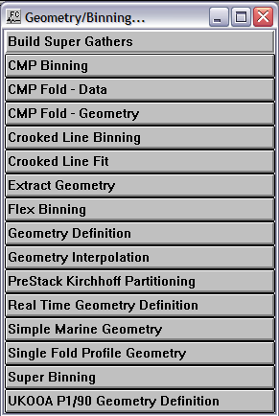

Note Trace Header Geometry Application

The first step in the majority of processing sequences is to update the seismic field headers with the acquisition geometry information. This information is required to perform basic data analysis and to execute almost all multi-channel processing steps.

There are three basic structures for the processing flow that is used to update the seismic trace header with the acquisition geometry information. The structure you use will depend on the nature of the seismic survey. The three seismic surveys and their associated processing flows can be classified as follows;

- 2D seismic. In SPW, 2D seismic surveys are those in which the sources and receivers are laid out on the same 2D line and the CMP number can be computed as CMP = (Source Location + Receiver Location) / 2. This implies that source location 101 and receiver location 101 are co-located (i.e. have the same X,Y coordinates).

- Crooked line 2D seismic. In SPW, Crooked line 2D seismic surveys are those that will be processed as a single CMP line, though the sources and receivers are not necessarily laid out along the same line. This implies that source location 101 and receiver location 101 need not be co-located (i.e. are not required to have the same X,Y coordinates).

- 3D seismic. In SPW, 3D seismic surveys are those in which the sources and receivers are laid out areally and the data will be organized in terms of inlines and crosslines.

An example of each of these three types of processing flows can be found in the Templates library under the Geometry category.

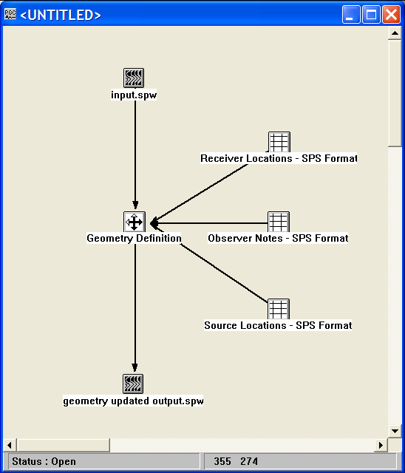
Example flowchart for a 2D seismic survey:
Example flowchart for a crooked line 2D seismic survey:
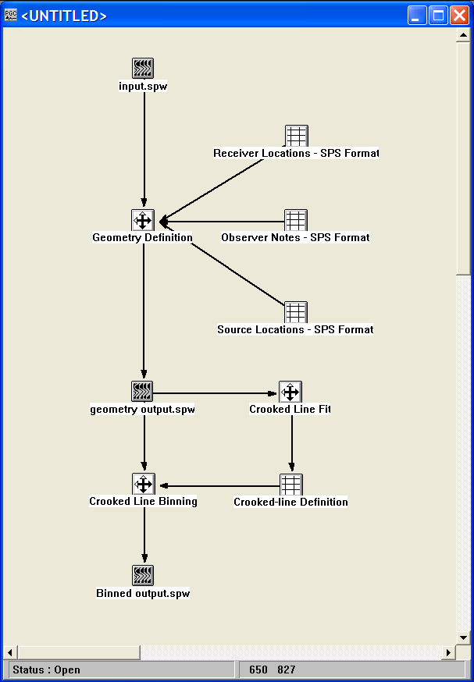
Example flowchart for a 3D seismic survey:
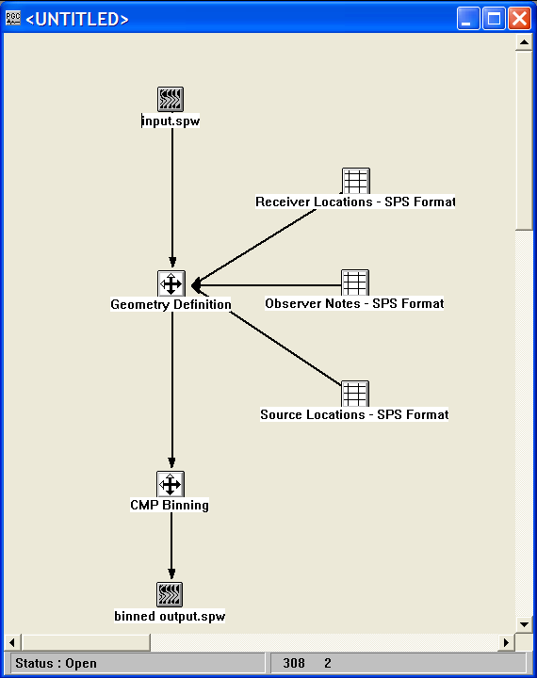

Build Supergathers

Usage:
The Build Supergathers step outputs patches of pre-stack CMP data defined on an inline and crossline grid. The output of the Build Supergathers step is designed to be input to the Super Gather Velocity Analysis step located in the Velocities category. Together, the two steps allow for improved velocity analysis by increasing the fold of coverage at the velocity analysis location. The user defines the patch size and the patch interval in units of inlines and crosslines.

Input Links:
1) Seismic data in any sort order (mandatory).

Output Links:
1) Seismic data in any sort order (mandatory).

Example Flowchart:

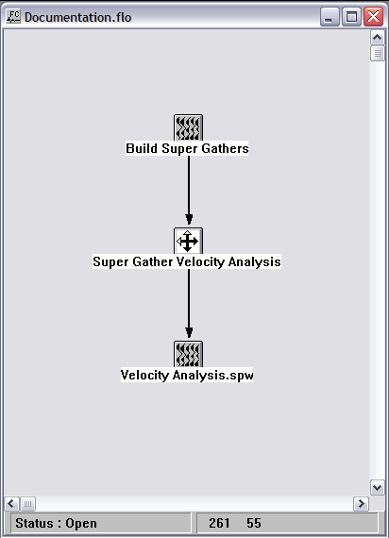
Step Parameter Dialog:

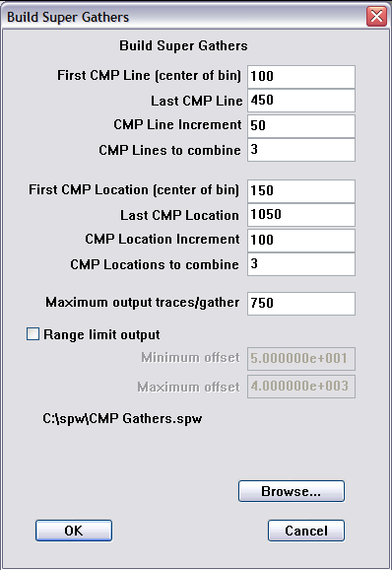

Parameter Description:
First CMP Line (center of bin) — First line to output binned gathers.

Last CMP Line — Last line to output binned gathers.

CMP Line Increment — Line increment for outputting binned gathers.

CMP Lines to combine — Number of lines to combine in a bin.

First CMP Location (center of bin) — First location to output binned gathers.

Last CMP Location — Last location to output binned gathers.

CMP Location Increment — Location increment for outputting binned gathers.

CMP Location to combine — Number of locatios to combine in a bin.

Maximum output traces per gather — Maximum fold of the binned gathers.

Range limit output — Check this box if you wish to limit the offset range of the output binned gathers.

Minimum offset – enter minimum offset of the range-limited supergathers.

Maximum offset – enter maximum offset of the range-limited supergathers.

Browse – Use the browse button to select the input file.

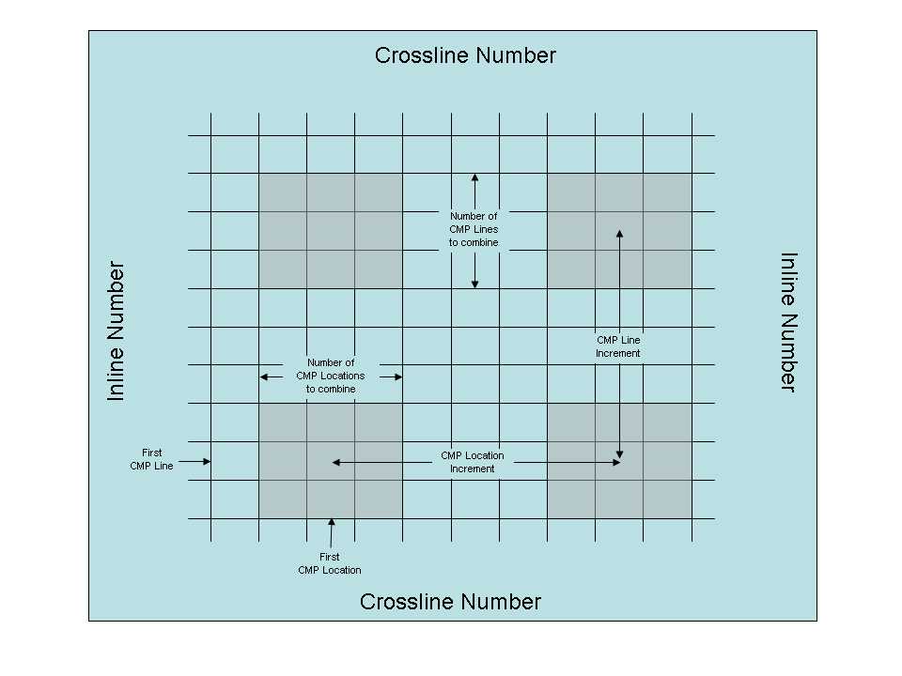
Illustration of parameters in the Build Supergathers step.

CMP Binning

Usage:
The CMP Binning process assigns CMP line and location numbers according to user specified coordinate parameters.

Input Links:
1) Seismic data in any sort order (mandatory).

Output Links:
1) Seismic data in any sort order (mandatory).

Example Flowchart:

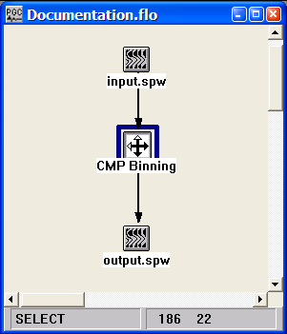
Step Parameter Dialog:
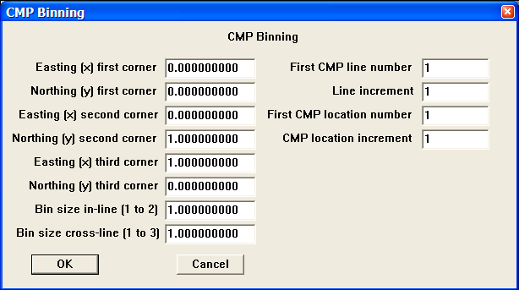
Parameter Description:
Easting (x) first corner — Enter the easting coordinate of the first corner of your survey.

Northing (y) first corner — Enter the northing coordinate of the first corner of your survey.

Easting (x) second corner — Enter the easting coordinate of the second corner of your survey.

Northing (y) second corner — Enter the northing coordinate of the second corner of your survey.

Easting (x) third corner — Enter the easting coordinate of the third corner of your survey.

Northing (y) third corner — Enter the northing coordinate of the third corner of your survey.

Bin size in-line (1 to 2) — Enter the size in distance units of the in-line side of each bin.

Bin size cross-line (1 to 3) — Enter the size in distance units of the cross-line side of each bin.

First CMP line number — Enter the first CMP line number. This line number is assigned to all the bins along the side of the survey from corner 1 to corner 2.

Line increment — Enter the increment in line numbers between adjacent CMP lines.

First CMP location number — Enter the first CMP location number. This location number is assigned to all the bins along the side of the survey from corner 1 to corner 3.

CMP location increment — Enter the increment in locations between adjacent CMP locations.

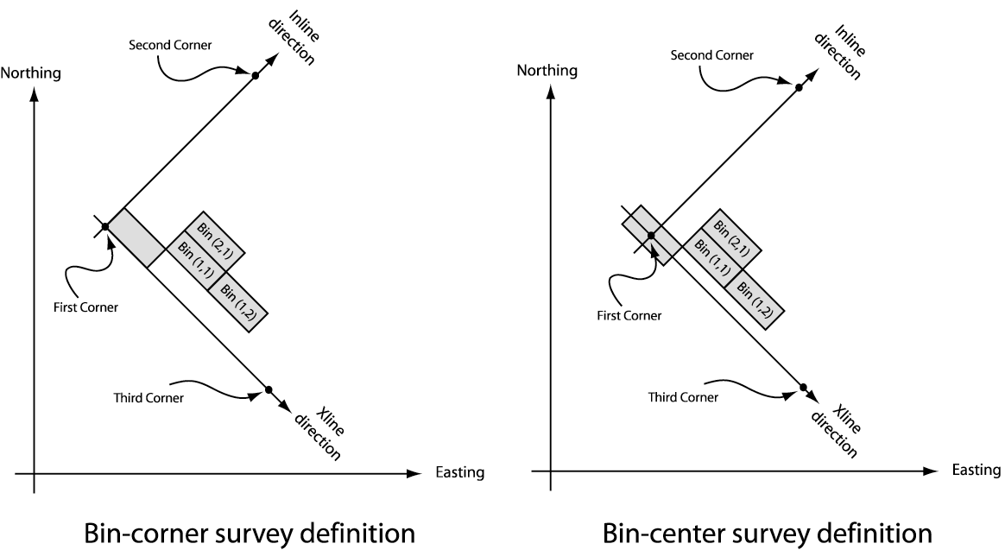

CMP Fold - Data
Usage:
The CMP Fold – Data step extracts CMP fold from the seismic data trace headers.

Input Links:
1) Seismic data in any sort order (mandatory).

Output Links:
None

Example Flowchart:

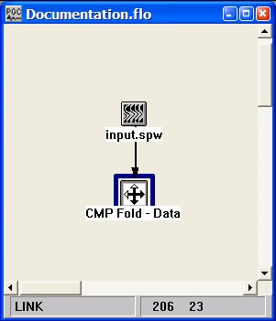
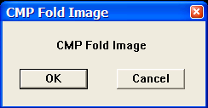
Step Parameter Dialog:

Parameter Description:
There are no parameters for this step.

CMP Fold - Geometry
Usage:
The CMP Fold – Geometry step extracts CMP fold from the source, receiver, and cross-reference SPS card data files.

Input Links:
- Observers Notes – SPS Format cards (mandatory).
- Receiver Locations – SPS Format cards (mandatory).
- Source Locations – SPS Format cards (mandatory).

Output Links:
1) CMP Fold Image file (mandatory).

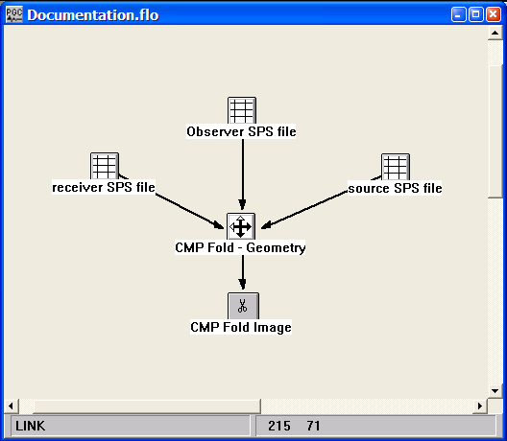
Example Flowchart:

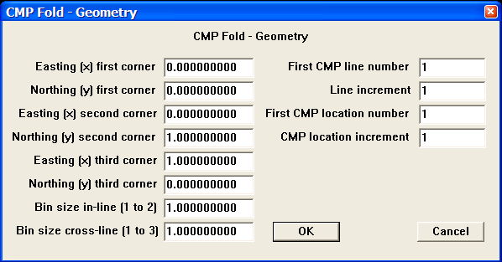
Step Parameter Dialog:

Parameter Description:
Easting (x) first corner — Enter the easting coordinate of the first corner of your survey.

Northing (y) first corner — Enter the northing coordinate of the first corner of your survey.

Easting (x) second corner — Enter the easting coordinate of the second corner of your survey.

Northing (y) second corner — Enter the northing coordinate of the second corner of your survey.

Easting (x) third corner — Enter the easting coordinate of the third corner of your survey.

Northing (y) third corner — Enter the northing coordinate of the third corner of your survey.

Bin size in-line (1 to 2) — Enter the size in distance units of the in-line side of each bin.

Bin size cross-line (1 to 3) — Enter the size in distance units of the cross-line side of each bin.

First CMP line number — Enter the first CMP line number. This line number is assigned to all the bins along the side of the survey from corner 1 to corner 2.

Line increment — Enter the increment in line numbers between adjacent CMP lines.

First CMP location number — Enter the first CMP location number. This location number is assigned to all the bins along the side of the survey from corner 1 to corner 3.

CMP location increment — Enter the increment in locations between adjacent CMP locations.

Crooked Line Binning
Usage:
The Crooked Line Binning step assigns CMP line and location numbers to crooked line seismic data based on CMP easting and northing values. The CMP easting and northing values, along with easting and northing values for the sources and receivers, will have been placed in the trace headers though the use of SPS files with the Geometry Definition step. The CMP bins follow a best-fit line through the scatter of CMP positions. The best-fit line is determined by the Crooked Line Fit processing step and stored in a Line Definition card data file.

Input Links:
- Seismic data in any sort order (mandatory).
- Line Definition card data file (mandatory).

Output Links:
1) Seismic data in any sort order (mandatory).

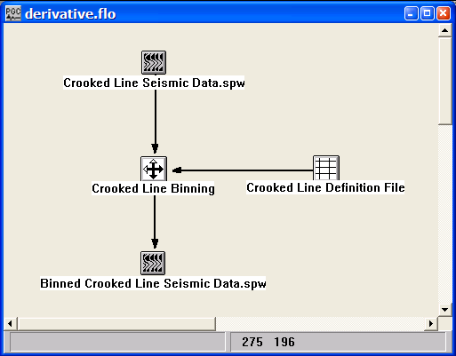Example Flowchart:

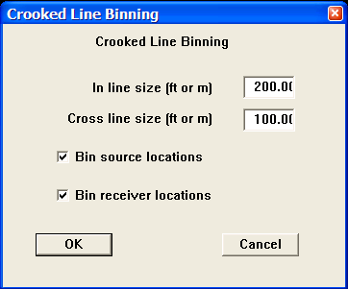
Step Parameter Dialog:

Parameter Description:
In line size (ft or m) — Enter the dimensions of the in-line bin dimension.

Cross line size (ft or m) — Enter the dimensions of the cross-line bin dimension.

Bin source locations — Select this option to bin source locations. With crooked line seismic data this is required for the calculation of surface consistent gains and residual statics.

Bin receiver locations — Select this option to bin receiver locations. With crooked line seismic data this is required for the calculation of surface consistent gains and residual statics.

Crooked Line Fit
Usage:
The Crooked Line Fit process determines a best-fit line through a scatter of CMP positions in a crooked line survey.

Input Links:
1) Seismic data in any sort order (mandatory).

Output Links:
1) Line Definition File card data (mandatory).

Example Flowchart:
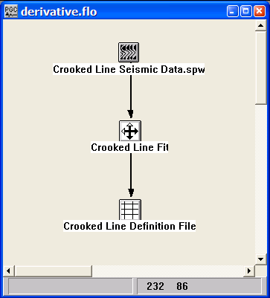
Step Parameter Dialog:
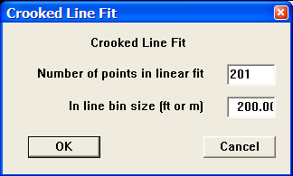
Parameter Description:
Number of points in linear fit — Enter the number of CMP coordinate pairs used in determining the best fit line through the sources and receivers.

In-line bin size (ft or m) – Enter the dimensions of the in-line bin dimension along the direction of the best-fit line.

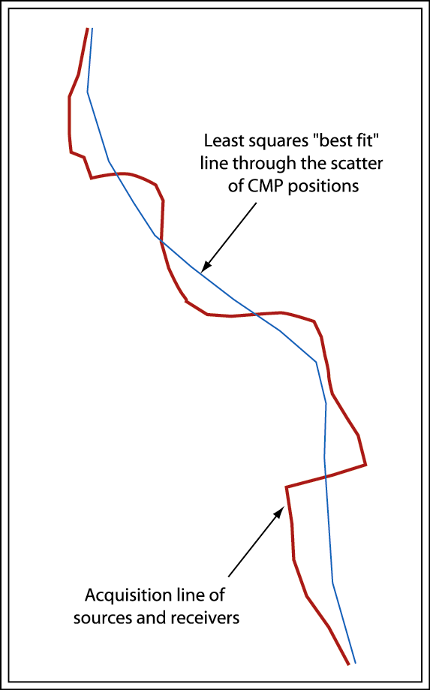

Best fit line through a scatter of source-receiver midpoints.

Extract Geometry
Usage:
The Extract Geometry step will extract geometry information from the seismic trace header and create source, receiver, and observer (i.e. cross reference) SPS card data files.

Input Links:
1) Seismic data in any sort order (mandatory).

Output Links:
- Source SPS card data file (mandatory).
- Receiver SPS card data file (mandatory).
- Observer SPS card data file (mandatory).

Example Flowchart:
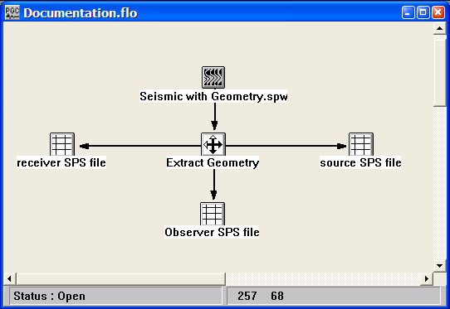

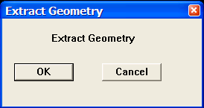
Step Parameter Dialog:

Parameter Description:
There are no parameters for this step.

Flex Binning
Usage:
The Flex Binning step is used to regularize fold in a 3D survey by borrowing traces from neighboring bins.

Input Links:
None – This process requires an input seismic disk file (mandatory).

Output Links:
1) Seismic data in any sort order (mandatory).

Example Flowchart:

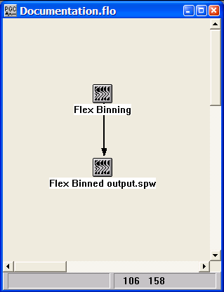
Step Parameter Dialog:
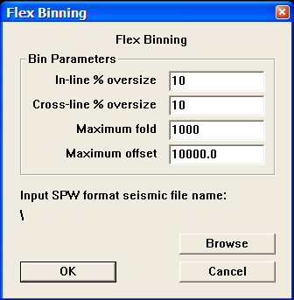

Parameter Description:
In-line % oversize — Enter the percent of the in-line bin dimension used to extend the bin in the in-line direction for the purpose of trace borrowing.

Cross-line % oversize — Enter the percent of the cross-line bin dimension used to extend the bin in the cross-line direction for the purpose of trace borrowing.

Maximum fold — Enter the maximum allowable fold attainable through flex binning.

Maximum offset — Enter the maximum allowable source-receiver offset among traces in neighboring bins used to increase fold.

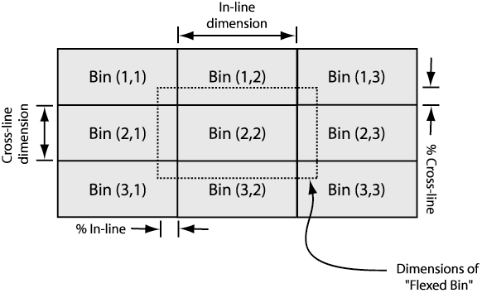

Geometry Definition
Usage:
The Geometry Definition step assigns survey information to the trace headers based on the source, receiver, and observer notes SPS files. The Geometry Definition step assigns CMP number based on the source and receiver numbers using the following formula: CMP Location = (Source Location + Receiver Location) / 2. Therefore, for 2D lines it is imperative that source and receiver locations as defined in the SPS files share the same coordinate system. This implies that Source location 1 has the same X,Y position as Receiver location 1, and that Source location 2 has the same X,Y position as Receiver location 2, etc… In the case of 3D data, this is not an issue, as CMP Line and Location will be labeled by the CMP Binning step.

Input Links:
1) Seismic data in any sort order (mandatory).
2) Observers Notes – SPS Format cards (mandatory).
3) Receiver Locations – SPS Format cards (mandatory).
4) Source Locations – SPS Format cards (mandatory).

Output Links:
1) Seismic data in any sort order (mandatory).

References:
See Technical Note TN-Geom.doc

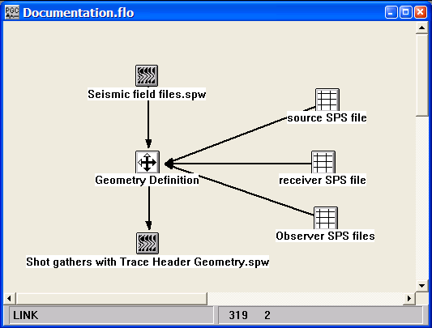
Example Flowchart:

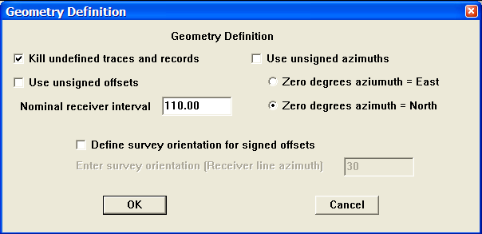
Step Parameter Dialog:

Parameter Description:
Kill undefined traces and records — If checked, any traces or records that are not represented in the SPS files will be marked as dead.

Use unsigned offsets — If checked, the offset values written to the seismic header will be unsigned.

Nominal receiver interval — Enter the nominal interval between receiver stations in distance units.

Use unsigned azimuths — If checked, the azimuth values written to the seismic header will range from 0 to 360 degrees, with zero degrees of azimuth equal to the user-specified direction. By default, azimuth values are signed and range from 0 to +/-180 degrees, with zero degrees of azimuth equal to the user-specified direction.

Zero degrees azimuth = East – If selected, then zero degrees of source-receiver azimuth will be set equal to due East.

Zero degrees azimuth = North – If selected, then zero degrees of source-receiver azimuth will be set equal to due North.

Define survey orientation for signed offsets – If checked, the sign on offset values will be adjusted for the orientation of the dominant receiver line azimuth, such that offset up-the-spread will be positive, and offsets down-the-spread will be negative.

Enter survey orientation (Receiver line azimuth) – Enter the value of the receiver line azimuth with respect to West that will be used to assign signs to source-receiver offsets.

Geometry Definition Example:

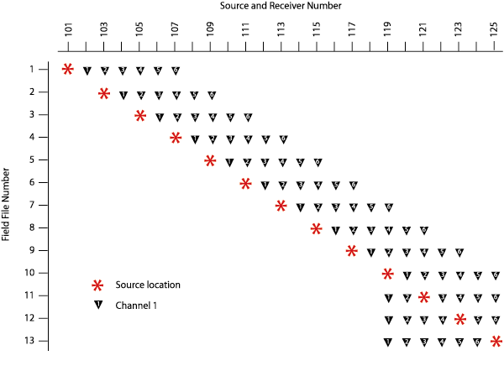

Figure 1. 2D seismic survey consisting of a 6-channel spread and a 25-m station interval. The spread “rolls-off” at the end of the line.

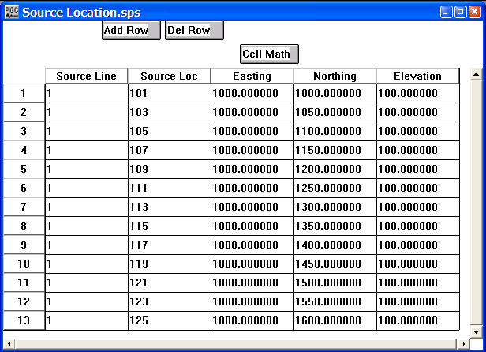
Figure 2. Source SPS file corresponding to the survey illustrated in figure 1.

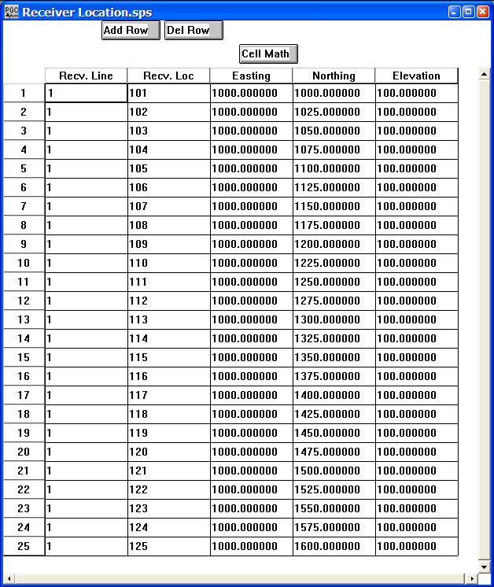
Figure 3. Receiver SPS file corresponding to the survey illustrated in figure 1.

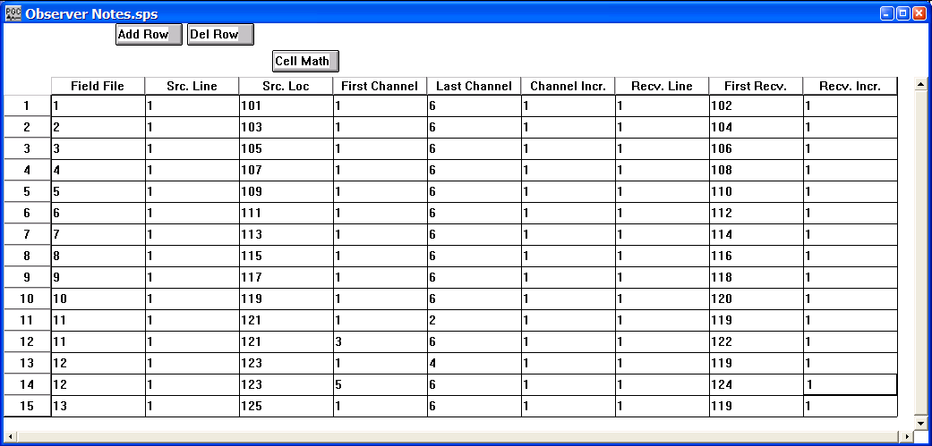
Figure 4. Observer SPS file corresponding to the survey illustrated in figure 1.

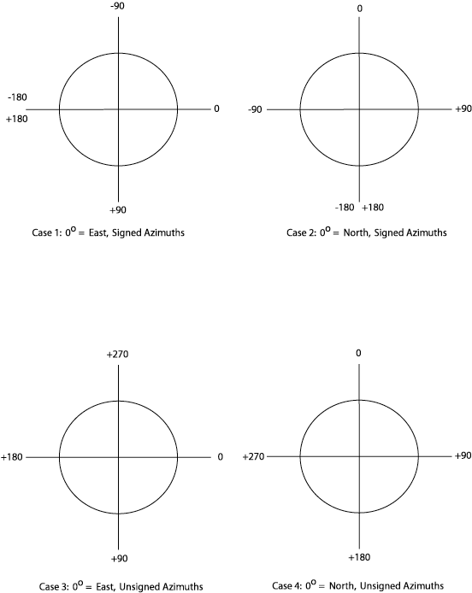

Figure 5. Definition of azimuths using the Geometry Definition parameters.

Geometry Interpolation
Usage:
The Geometry Interpolation step.

Input Links:
None – This process requires an input seismic disk file (mandatory).

Output Links:
1) Receiver SPS file (mandatory).

Example Flowchart:
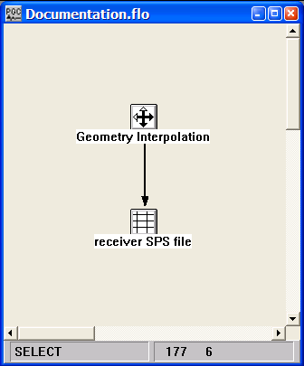

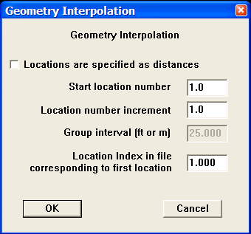
Step Parameter Dialog:

Parameter Description:
Locations are specified as distances — If checked, the group interval is manually defined.

Start location number — Enter the number of the first receiver location

Location number increment — Enter the receiver increment

Group interval — Distance between receiver groups in feet or meters.

Location index in file corresponding to first location —

PreStack Kirchhoff Partitioning
Usage:
Pre-Stack Time Migration (PTM) is a very compute intensive process, and large migration apertures can result in the traces of a single CMP gather being migrated to a large number of output migration bins. As a result, in addition to the disk space required to hold the input data set, the migration also requires a working data store. Proper sizing of the working data set size can greatly improve the processing speed of the migration. The Pre-Stack Kirchhoff Partitioning step identifies the input traces that will contribute to a specified output set of migration bins and creates an input data volume from the candidate CMP gathers. By partitioning the output data volume to fit within system memory limits, the migration run time can be optimized. The resultant migrations are conveniently merged with the Tape Utility.

Input Links:
None - This process requires an input seismic disk file (mandatory).

Output Links:
1) Seismic data partitioned for Pre-Stack Kirchhoff Time Migration (mandatory).

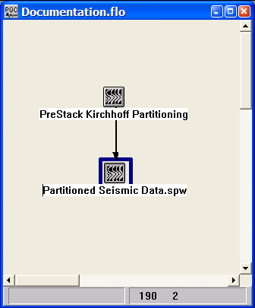
Example Flowchart:

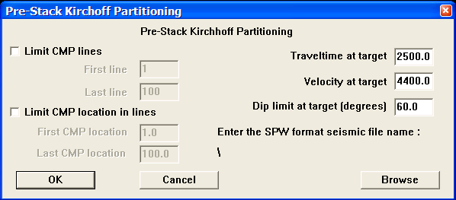
Step Parameter Dialog:

Parameter Description:
Limit CMP lines — If checked, allows selection of input traces that will contribute to the selected CMP lines during migration.

First line – Enter the first output line for PSTM partitioning.

Last line – Enter the last output line for PSTM partitioning.

Limit CMP location in lines — If checked, allows selection of input traces that will contribute to the selected CMP locations in the previously selected CMP lines during migration.

First CMP location – Enter the first output location for PSTM partitioning.

Last CMP location – Enter the last output location for PSTM partitioning.

Traveltime at target — Estimated travel time of target event. This time is used to estimate candidate CMP bins for Pre-Stack Kirchhoff partitioning.

Velocity at target — Velocity of target event. This value is used to estimate the aperture of the migration operator, and therefore the candidate CMP bins for Pre-Stack Kirchhoff partitioning.

Dip limit at target – Estimated dip limit of target event. This value is used to estimate the aperture of the migration operator, and therefore the candidate CMP bins for Pre-Stack Kirchhoff partitioning.

Enter the SPW format seismic file name – Using the Browse button, select the input file to be partitioned for Pre-Stack Kirchhoff Time Migration.

Simple Marine Geometry
Usage:
The Simple Marine Geometry step assigns geometry information to the seismic trace headers based on a survey information contained in the Streamer Definition card data.

Input Links:
- Seismic data in any sort order (mandatory).
- Streamer Definition card data (mandatory).

Output Links:
1) Seismic data in any sort order (mandatory).

Example Flowchart:
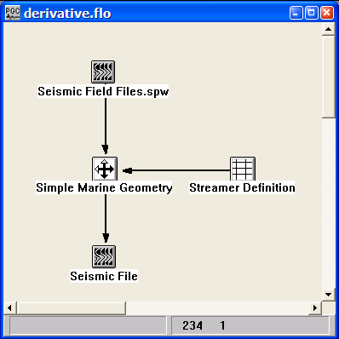

Step Parameter Dialog:
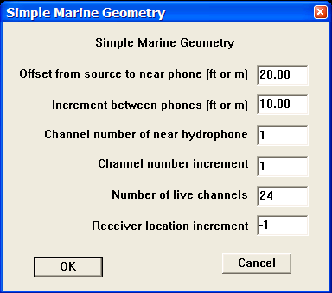
Parameter Description:
Offset from source to near phone (ft or m) — Enter the nominal interval between source and the first receiver in distance units.

Increment between phones (ft or m) — Enter the nominal interval between phones in distance units.

Channel number of near hydrophone — Enter the channel number assigned in the trace headers to the closest hydrophone on the cable.

Channel number increment — Enter the increment between channels.

Number of live channels — Enter the number of live channels recorded per shot point.

Receiver location increment — Enter the increment between receiver locations.

Single Fold Profile Geometry
Usage:
The Single Fold Profile Geometry step allows you to assign geometry for single fold lines and GPR data lines.

Input Links:
1) Seismic data in any sort order (mandatory).
2) Profile Geometry File cards (optional).

Output Links:
1) Seismic data in any sort order (mandatory).

Example Flowchart:
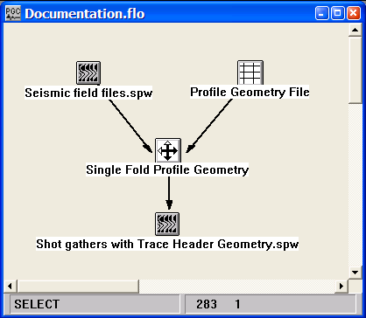
Or
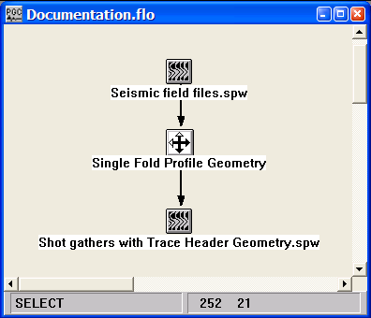
Step Parameter Dialog:
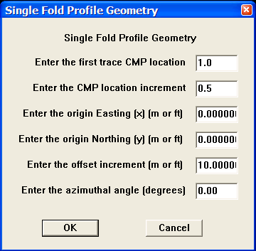

Parameter Description:
Enter the first trace CMP location — Enter the CMP location of the first trace.

Enter the CMP location increment — Enter the CMP location increment between traces.

Enter the origin Easting (x) (m or ft) — Enter the Easting of the first trace in this line.

Enter the origin Northing (y) (m or ft) — Enter the Northing of the first trace in this line.

Enter the offset increment (m or ft) — Enter the nominal interval between traces in distance units.

Enter the azimuthal angle — Enter the angle from north for this line.

UKOOA P1/90 Geometry
Usage:
The UKOOA P1/90 Geometry step.

Input Links:
1) Seismic data in any sort order (mandateory).
2) SPS Observer notes (mandatory). For the UKOOA P1/90 Geometry step, on the field file, source line, and source location fields are required in the Observer notes.

Output Links:
1) Seismic data in any sort order (mandatory).

Example Flowchart:

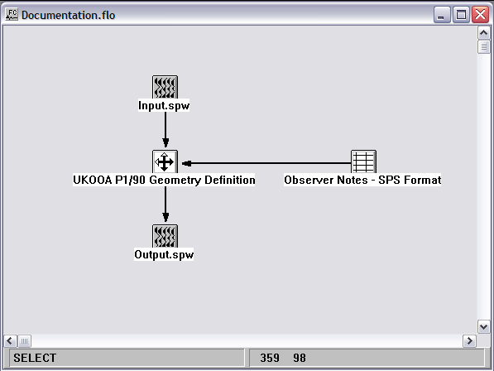
Step Parameter Dialog:

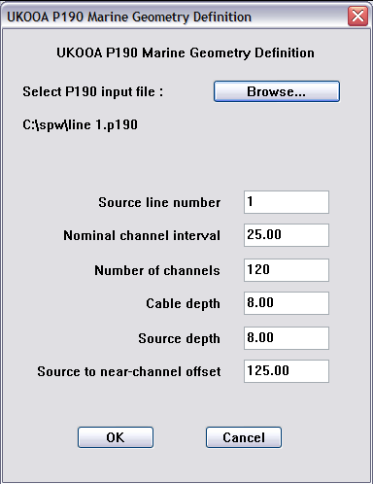

Parameter Description:
Select P190 input file – Use the Browse… button to select the P1/90 text file that contains the source, and potentially the receiver, coordinate information.

Source line number — Enter the source/sail line number corresponding to the selected P1/90 coordinate file.

Nominal channel interval — Enter the spacing between channels on the cable.

Number of channels – Enter the number of channels in the cable.

Cable depth – Enter the depth of the cable below sea level.

Source depth – Enter the depth of the source below sea level.

Source to near-channel offset – Enter the distance between the source and the nearest channel in the cable.

Image data

This section documents the processing steps available for the creation of Image Data.

The types of Image Data currently available are:
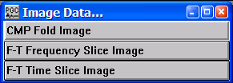
CMP Fold Image
Usage:
The CMP Fold Image step allows you to select or name an image file on disk. It is the output SPW image format file for the fold diagram.

Input Links:
- This process requires input from the CMP Fold – Geometry or the CMP Fold – Data steps.

Output Links:
None - This process requires a SPW image format disk file.

Example Flowcharts:

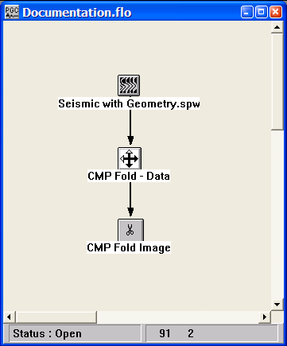
Or,

Step Parameter Dialog:

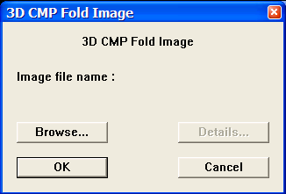

Parameter Description:
Enter the name of the Image format disk file that will contain the CMP Fold image.

F-T Frequency Slice Image
Usage:
The F-T Frequency Slice Image step allows you to select or name an image file on disk. It is the output SPW image format file for the F-T Frequency slice data.

Input Links:
1) The F-T Frequency Slice Image receives the output from the F-T Frequency Slice step.

Output Links:
None – This process requires a SPW image format disk file.

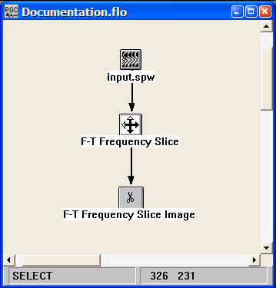
Example Flowchart:

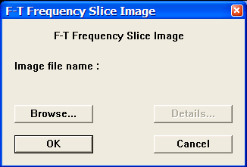
Step Parameter Dialog:

Parameter Description:
Enter the name of the Image format disk file that will contain the F-T Frequency Slice Image.

F-T Time Slice Image
Usage:
The F-T Time Slice Image step allows you to select or name an image file on disk. It is the output SPW image format file for the F-T Time slice data.

Input Links:
1) The F-T Time Slice Image receives the output from the F-T Time Slice step.

Output Links:
None – This process requires a SPW image format disk file.

Example Flowchart:

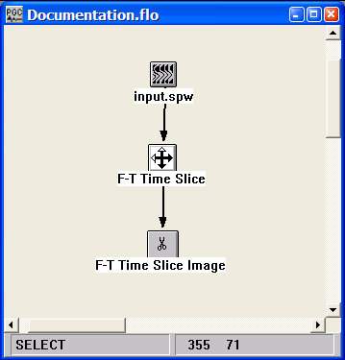
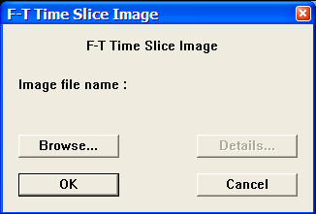
Step Parameter Dialog:

Parameter Description:
Enter the name of the Image format disk file that will contain the F-T Time Slice Image.

Migration

This section documents the processing steps available in the Migration category.

The types of migration currently available are:

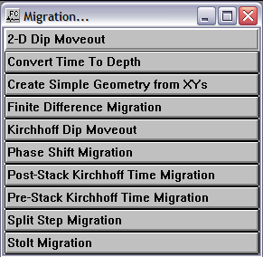

2-D Dip Moveout

Usage:
Normal moveout corrections assume a layered earth. In areas of significant structure, the NMO corrections can have large residual NMO contributions. To correct for dipping structures an elliptical dip moveout summation operator can be applied to NMO corrected CMP gathers. Following the DMO correction, the CMP gathers are more properly common reflection point (CRP) gathers.

We apply an integral DMO correction as described by Yilmaz (see Yilmaz, 2001, ‘Seismic Data Analysis’, p.655-835). This is a summation operator applied to each source-receiver pair. There are no assumptions about regular geometry and the correction can be applied to irregularly spaced CMP gathers. This step operates on common offset gathers for calculating dip-related NMO corrections. You must enter the first time (in milliseconds) of interest for dip moveout correction. The algorithm pads the data volume on the order of four times the trace length and width for stability of the algorithm. In that regard, the later the first time of interest that you enter, the less memory needed for computations, and the faster the algorithm will complete.

Input Links:
1) Seismic data in offset order (mandatory).

Output Links:
1) Seismic data in offset order (mandatory).

References:
Hale, D., 1984, Dip-moveout by Fourier transform, Geophysics, v. 49, no. 6, p. 741-757.
See Technical Note TN-DMO.doc

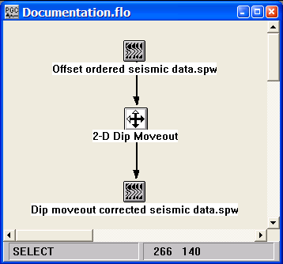
Example Flowchart:

Step Parameter Dialog:
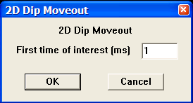

Parameter Description:
First time of interest (ms) — Enter the first time of interest in milliseconds. The later this time, the faster the step will run and the less memory it will use.

Create Simple Geometry from XY’s

Usage:
The Create Simple Geometry from XY’s step is a utility that was designed for use with the Parallel Migrations application. The step updates the trace headers of the input file with inline and crossline information based on easting and northing trace header values.

Input Links:
1) Seismic data in offset order (mandatory).

Output Links:
1) Seismic data in offset order (mandatory).

Example Flowchart:

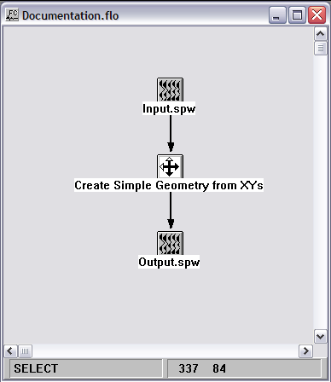

Step Parameter Dialog:

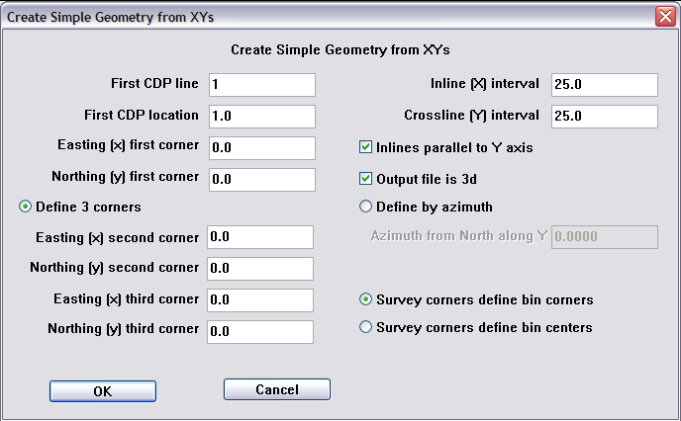

Parameter Description:
First CDP line —

First CDP location —

Easting (x) first corner —

Northing (y) first corner —

Easting (x) second corner —

Northing (y) second corner —

Easting (x) third corner —

Northing (y) third corner —

Inline (X) interval —

Crossline (Y) interval —

Define 3 corners –

Inlines parallel to Y axis –

Output file is 3D –

Define by azimuth –

Azimuth from north along Y-

Survey corners define bin corners –

Survey corners define bin centers –

Convert Time to Depth
Usage:
The Convert Time to Depth step does a vertical time to depth conversion of a seismic file using an input set of interval velocities. The input velocities are assumed to be in units of feet or meters per second. If the input file to be depth converted is a GPR image, and the input velocity file is in units of feet or meters per nanosecond, you must first multiply the velocity values by 1x10⁻⁹.

Input Links:
1) Seismic data in any sort order (mandatory).
2) Velocity Function cards (optional).

Output Links:
1) Seismic data in any sort order (mandatory).

References:
See Technical Note TN-DpthConv.doc

Example Flowchart:

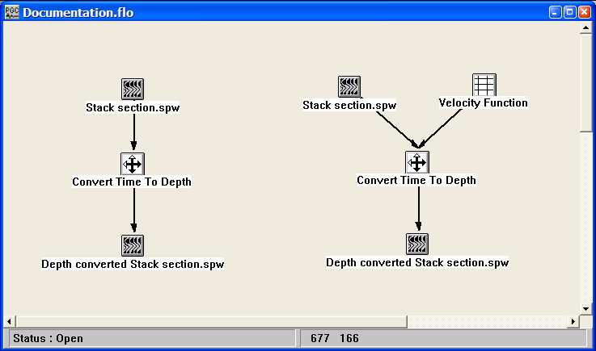

Step Parameter Dialog:
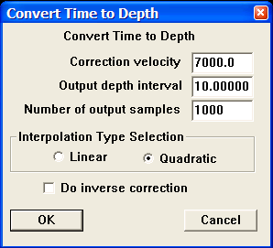
Parameter Description:

Correction velocity — Enter the correction velocity (ft/sec or m/sec) to be used in the conversion. This constant velocity will be used unless a velocity function is connected to the step. In the case of GPR data, convert this value to the appropriate units.

Output depth interval — Enter the depth interval in your spatial units. To obtain an estimate of the output depth interval, first employ the formula X = VT, where X = estimated depth of section, V = average velocity of section, and T = one-way time of the section (i.e. record length divided by two). Second, employ the formula output depth interval = ΔX = X/(number of samples – 1).

Number of output samples — Enter the number of samples to output.

Interpolation Type Selection — Select the type of interpolator to use. This interpolator is used to resample the data to the specified depth interval.

Do inverse correction — If checked, a depth to time conversion will be performed.

Finite Difference Migration

2-D only
Usage:
The Finite Difference Migration step implements a variable velocity post-stack depth migration based on a finite-difference approximation of the scalar wave equation. The finite difference migration scheme accommodates a vertically and laterally varying velocity field that is supplied with an SPW velocity function card. You specify the depth sampling interval, the total number of depth samples to output, and the migration aperture in degrees of dip from 45 – 90 degrees. The computation time of the algorithm increases as a function of increased aperture. The velocity field may be adjusted by a scalar value to compensate for the fact that the supplied interval velocities may have been derived using Dix's equation, and are not true interval velocities. Finally, you can override the SPW calculated trace spacing and specify the true trace spacing of your data in your spatial units of choice. SPW calculates the trace spacing for the stack as the group interval, as you defined it in the geometry definition, divided by two (2).

Input Links:
1) Seismic data in stacked order (mandatory).
2) Velocity Function cards (mandatory).

Output Links:
1) Seismic data in stacked order (mandatory) and sampled in depth.

Reference:
Claerbout, J.F, 1985, Imaging the earth’s interior, Blackwell Scientific Publications.

Example Flowchart:
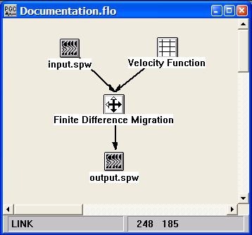
Step Parameter Dialog:
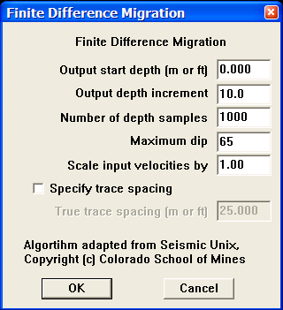

Parameter Description:
Output start depth (m or ft) — Enter the starting depth for migration.

Output depth increment (tau) — Depth sampling interval.

Number of depth samples — Total number of output depth samples.

Maximum dip — Maximum dip of migration operator in degrees

Scale input velocities by — Input velocities will be multiplied by this number. This scalar is used for adjusting the input velocities in the case that they were derived using Dix's equation, and are not true interval velocities.

Specify trace spacing — If checked, allows for manual specification of the trace spacing. By default, SPW calculates the trace spacing for the stack as the group interval, as you defined it in the geometry definition, divided by two (2).

Kirchhoff Dip Moveout

Usage:
Normal moveout corrections assume a horizontally layered earth. In areas of significant structure, the NMO corrections can have large residual NMO contributions. To correct for dipping structures an elliptical dip moveout summation operator can be applied to NMO corrected CMP gathers. Following the DMO correction, the CMP gathers are more properly common reflection point (CRP) gathers.

We apply an integral DMO correction as described by Yilmaz (see Yilmaz, 2001, ‘Seismic Data Analysis’, p.655-835). This is a summation operator applied to each source-receiver pair. There are no assumptions about regular geometry and the correction can be applied to irregularly spaced CMP gathers. The summation operator is applied at a user-specified number of evenly spaced offsets located along an axis connecting the source and receiver. These DMO corrected traces are then summed at each bin location.
For 3D datasets, the summation at each bin can cause the resulting gathers to be spatially aliased. To avoid aliasing, a 2D sinc interpolator with an apodizing Hanning filter is applied to spatially smooth the DMO corrected traces.

Input Links:
1) Seismic data in any sort order (mandatory).

Output Links:
1) None. The DMO corrected data are output to an auxiliary disc file.

Reference:
See Technical Note TN-DMO.doc

Example Flowchart:
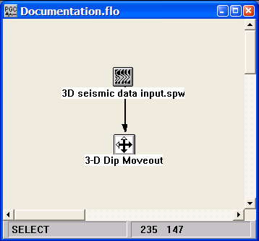
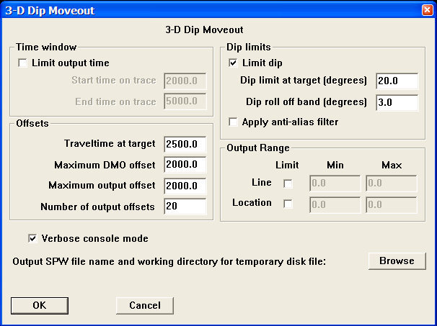
Step Parameter Dialog:

Parameter Description:

Time window — The output time may be limited to decrease the run time and the amount of memory required for execution.

Start time on trace – Enter the start time for DMO correction in msecs.

End time on trace – Enter the end time for DMO correction in msecs.

Offsets — Determine the range of offsets output by the 3D DMO algorithm.

Traveltime at target – Estimated travel time of target event. This time is used to estimate candidate CMP bins for the DMO correction.

Maximum DMO offset – The maximum offset from the source-receiver mid-point to apply the DMO correction. Typically, this number should be no larger than 10 times the CMP bin spacing.

Maximum output offset – The maximum source-receiver offset for the output DMO corrected gathers.

Number of output offset – Enter the number of output offsets (Maximum output offset/Number of output offsets) is the output DMO offset spacing.

Dip Limits — The maximum allowable DMO operator dip in degrees. Limiting the aperture of the DMO operator will decrease the run time and the amount of memory required for execution.

Dip limit at target – Enter the number of degrees of aperture in the DMO impulse response at the target time.

Dip rolloff band – Taper length in degrees of aperture over which the DMO impulse response is tapered to zero.

Apply anti-alias filter – If checked, applies a 2D sinc interpolator with an apodizing Hanning filter to reduce spatial aliasing of high frequency components of the DMO operator.

Output range – Allows control of the spatial range of DMO corrected output data.

Line – If checked, allows you to limit the range of CMP lines output by the algorithm.

Min – Minimum CMP line number to output.

Max – Maximum CMP line number to output.

Location – If checked, allows you to limit the range of CMP locations output by the algorithm.

Min – Minimum CMP location number to output.

Max – Maximum CMP location number to output.

Output SPW file name and working directory for temporary disk file – The Browse button allows selection of the DMO corrected output data volume.

Phase Shift Migration

2-D only
Usage:
The Phase Shift Migration step implements a constant velocity or a depth-variable velocity post stack phase shift time migration in the frequency domain. The input velocity field is assumed to be the stacking velocity field derived from velocity analysis of the pre-stack data.

Input Links:
1) Seismic data in stacked order (mandatory).
2) Velocity Function cards (optional).

Output Links:
1) Seismic data in stacked order (mandatory) and sampled in time.

Reference:
Gazdag, J, 1978, Wave-equation migration by phase shift, Geophysics, v. 43, p. 1342-1351.

Example Flowchart:
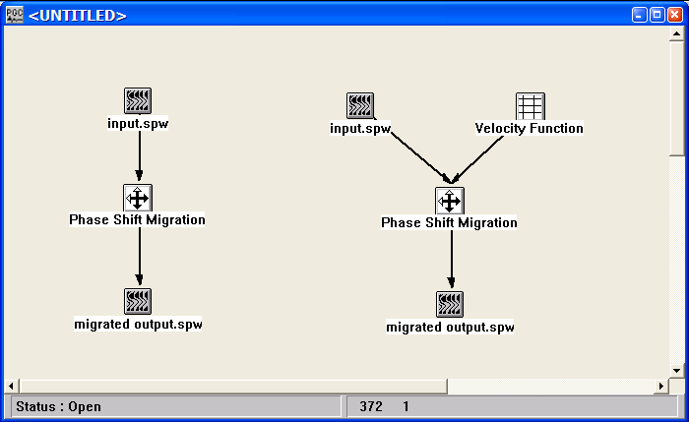

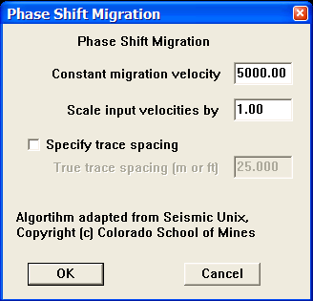
Step Parameter Dialog:

Parameter Description:
Constant migration velocity — This constant velocity value will be used as the migration velocity if no velocity cards are linked.

Scale input velocities by — The input velocities are multiplied by this number. This scalar is used for adjusting the input velocities if they are interval velocities derived using Dix's equation rather than true interval velocities.

Specify trace spacing — If checked, allows for manual specification of the trace spacing. By default, SPW calculates the trace spacing for the stack as the group interval, as you defined it in the geometry definition, divided by two (2).

Post-Stack Kirchhoff Time Migration

Usage:
The Post-Stack Kirchhoff Time Migration implements a diffraction summation migration of the Kirchhoff type that is capable of handing vertically and laterally varying velocity fields. The input velocity field is assumed to be the stacking velocity field derived from velocity analysis of the pre-stack data.

Input Links:
1) Seismic data in stacked order (mandatory).
2) Velocity Function cards (mandatory).

Output Links:
1) None. The migrated section is output to an auxiliary disc file.

Reference:
Schneider, W. A., 1976, Integral formulation for migration in two and three dimensions, Geophysics, 43, p. 49-76.

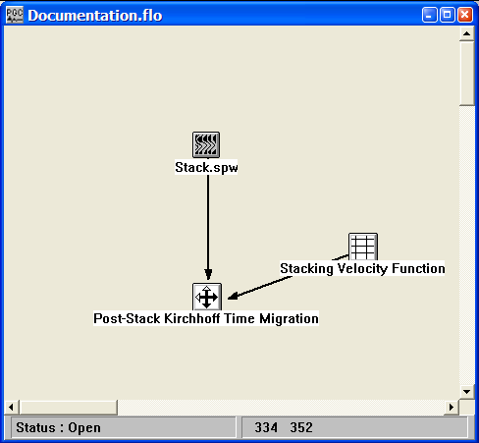
Example Flowchart:

Step Parameter Dialog:

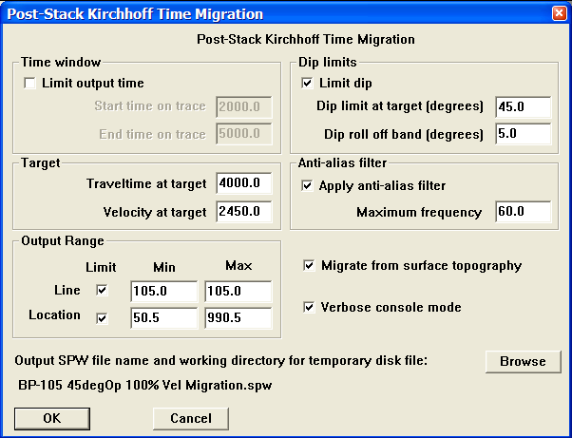

Parameter Description:
Time window — The output time may be limited to decrease the run time and the amount of memory required for execution.

Limit output time – If checked, the output time of the migration will be limited

Start time on trace – Enter the start time for migration in milliseconds.

End time on trace – Enter the end time for migration in milliseconds.

Target

Traveltime at target – Estimated travel time of target event. This time is used to set the migration aperture.

Velocity at target – Estimated velocity of target event. This velocity is used to set the migration aperture.

Output range – Allows control of the spatial range of migrated output data.

Line – If checked, allows you to limit the range of CMP lines output by the algorithm.

Min – Minimum CMP line number to output.

Max – Maximum CMP line number to output.

Location – If checked, allows you to limit the range of CMP locations output by the algorithm.

Min – Minimum CMP location number to output.

Max – Maximum CMP location number to output.

Dip Limits — The maximum allowable migration aperture in degrees of dip. Limiting the aperture of the migration operator will decrease the run time and the amount of memory required for execution.

Dip limit at target – Enter the number of degrees of aperture in the migration impulse response at the target time.

Dip rolloff band – Taper length in degrees of aperture over which the migration impulse response is tapered to zero.

Apply anti-alias filter – If checked, applies a filter to reduce spatial aliasing of high frequency components of the migration operator.

Migrate from surface topography – If checked, the migration will be performed from the surface elevations stored in the trace header. If not check, the migration step will assume that the stack has been previously static corrected to a flat reference datum.

Output SPW file name and working directory for temporary disk file – The Browse button allows selection of the migrated output data volume.

Pre-Stack Kirchhoff Time Migration

Usage:
The Pre-Stack Kirchhoff Time Migration implements a diffraction summation migration of the Kirchhoff type on a pre-stack data volume that is capable of handing vertically and laterally varying velocity fields.

Introduction
Pre-stack Time Migration is a compute intensive process. The length of the processing run is proportional to the migration aperture size and the size of the input seismic volume. By partitioning the output data volume to fit within system memory limits, the migration run time can be optimized.

The Kirchhoff Pre-stack Time Migration follows the traditional SPW processing flow and migrates a single CMP gather at a time. Large migration apertures can result in a single CMP gather trace being migrated to a large number of output migration bins. As a result, in addition to the disk space required to hold the input dataset, the migration also requires a working data store. Proper sizing of the working dataset size can greatly improve the processing speed of the migration.

The migration requires a working data store size that is approximately equivalent to the size of the output data volume. This size is equal to the number of output bins times the number of output offsets times the number of output samples times 4 in bytes. The ‘Minimum virtual memory size’ printed during the initial phase of the migration is the amount of memory required for the data store. If the amount of real or virtual memory available is not greater than this value, the migration creates a disk file to use for the data store. Disk input/output is substantially slower than memory input/output. As such, the best performance occurs when the data store can reside in memory.

For modest 3d data volume sizes, the working file can be large. In the event that the working file size is greater than available memory, best performance is obtained by partitioning the output data volume and merging the resultant migrations once they have completed. Tape Utility provides a convenient option for the merging process.

The partitioning process identifies all the input traces that are candidates for contributing to a given set of migration bins and creates an input data volume from the candidate CMP gathers. For large apertures, these data volumes can overlap.

Partitioning
- Identify available real or virtual memory.

For Windows see Help: Managing Computer Memory: Virtual Memory or Pagefile

For Linux see ManPages: Swapfile

- Divide available memory in bytes by the number of output samples * the number
of output offsets * 4. This is the number of output bins that can fit into memory.

- Determine the number of complete inlines that can fit within this number of bins.

- Allow a little margin.

- The partition size is the subset number of inlines by the number of cross lines.

- Use the PreStack Kirchhoff Data Input processing flow to generate input volumes
for the partitioned data set.

- Migrate each partition separately.

- Use Tape Utility SPW File Merge to collate the output volume from each of the
partitions.

Monitoring
Migration times can be lengthy depending on the migration aperture and the input seismic volume size. The migration process generates quality control (QC) files for evaluation during the migration.

QC files are generated at a user specified line interval. The output QC CMP gathers correspond to the gathers for a partial migration of the last completed inline of input CMP records. The line number is printed to the console screen for reference. Since the full migration is not complete until all records within the migration aperture have been migrated, the purpose of the QC file is to monitor the migration for amplitude spikes, dead traces and overall data character. The QC file can be found in the spwQC subdirectory located in the same directory as the input data volume.

A checkpoint file is saved to disk at the same time the QC file is created. Checkpoints occur at the same interval specified for the QC files. In the event that a migration needs to be restarted, check the console file for the input record number that corresponds with the last saved checkpoint file. In the Flowchart processing flow for Kirchhoff Pre-Stack Time Migration, check the restart box and specify the starting record number. Compile the processing flow and restart the migration.
Directory setup
Refer to the SPW INSTALL notes for a description of the initial directory configuration. Distributed processing requires master and slave executables to reside in the SPWHOME and the SLAVEHOME directories respectively. The input dataset can reside anywhere on the master platform.

The user is responsible for creating a QC directory and a checkpoint directory. The QC directory should reside in the same directory as the input seismic volume and it should be named spwQC. If the directory does not exist, the user will receive a message during the migration start up and the migration will stop.

The checkpoint directory is not required but highly recommended. This directory needs to reside in the same directory as the migration slave executable execslv and should be named spwdata. There should be enough disk space to hold a checkpoint file that is the number of bins times the number of offsets times the number of output time samples times 4 in bytes.

Input Links:
1) Seismic data in bin sorted order (mandatory).
2) Velocity Function cards (mandatory).

Output Links:
1) None. The migrated data is output to an auxiliary disc file.

Reference:

Example Flowchart:

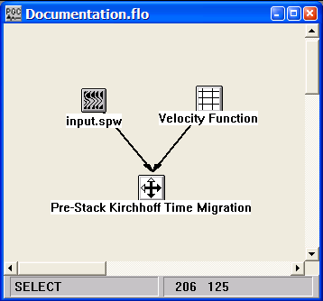
Step Parameter Dialog:
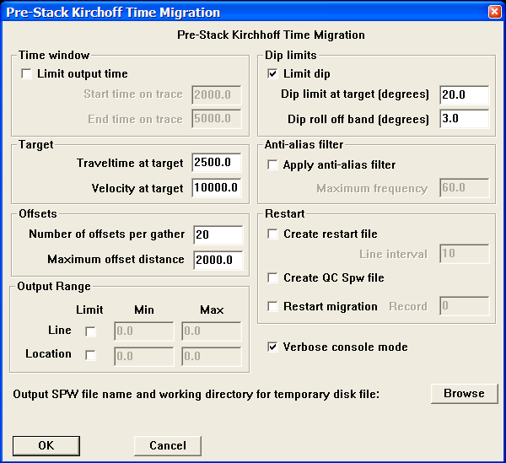

Parameter Description:
Time window — The output time may be limited to decrease the run time and the amount of memory required for execution.

Limit output time – If checked, the output time of the migration will be limited by the following parameters:

Start time on trace – Enter the start time for migration in milliseconds.

End time on trace – Enter the end time for migration in milliseconds.

Target – Allows the migration operator to be customized to the target time and velocity.

Traveltime at target – Two-way traveltime in milliseconds to the target event. This time is used to determine candidate bins in the migration aperture.

Velocity at target – Estimated velocity at the target event.

Offsets – The offset menu controls the range and number of the pre-stack migrated traces per bin according to the following parameters:

Number of offsets per gather – Enter the number of output pre-stack migrated offsets per bin.

Maximum offset distance – Enter the maximum offset distance to migrate. The offset interval of output traces in each bin will be (max. offset distance / # of offsets).

Output range – The Output range menu controls of the spatial range of pre-stack migrated data. The partitioning process identifies all the input traces that are candidates for contributing to the specified range of migration bins and creates an input data volume from the candidate CMP gathers.

Line – If checked, allows you to limit the range of CMP lines output by the algorithm.

Min – Minimum CMP line number to output.

Max – Maximum CMP line number to output.

Location – If checked, allows you to limit the range of CMP locations output by the algorithm.

Min – Minimum CMP location number to output.

Max – Maximum CMP location number to output.

Dip Limits — The Dip Limits menu controls the maximum dip of the migration operator in degrees. Limiting the aperture of the migration operator will decrease the run time and the amount of memory required for execution.

Limit dips – If checked, the maximum dip of the migration operator is limited by the following parameters:

Dip limit at target – Enter the number of degrees of aperture in the Migration impulse response at the target time.

Dip rolloff band – Taper length in degrees of aperture over which the Migration impulse response is tapered to zero.

Anti-alias filter – The summation of high temporal frequencies at each bin in 3D and at each CMP in irregularly sampled 2D data are prone to spatial aliasing. To avoid aliasing, a 2D sinc interpolator with an apodizing Hanning filter is applied to spatially smooth the migrated traces.

Apply anti-alias filter – If checked, applies a filter to reduce spatial aliasing of high frequency components of the migration operator.

Maximum frequency – Enter the maximum frequency of the migration operator.

Restart – In the case of system failure during migration, the following parameters allow the migration to be restarted from a point closely preceding the failure.

Create restart file – If checked, checkpoint files will be created during the migration to minimize data loss in the event of a system failure.

Line interval – Line interval to write restart and QC files. The writing of restart and QC files can be time consuming. Therefore, this option should only be used for prolonged migration runs (>3days).

Create QC SPW file – If checked, QC files will be generated at the user specified line intervals. The output QC CMP gathers correspond to the gathers for a partial migration of the last completed inline of input CMP records, and can be used to monitor the quality of the migration. It is recommended to create QC files during initial testing.

Restart migration – If checked, the migration is of a restart file and is restarted from the last checkpoint.

Record – Checks the console file for the input record number that corresponds with the last saved checkpoint file. The migration can be restarted from this point.

Verbose console mode – If checked, allows for the user to view a running summary of migrated traces and aperture bins.

Output SPW file name and working directory for temporary disk file – The Browse button allows selection of the migrated output data volume file name.

Split-Step Migration

2-D only
Usage:
The Split-Step Migration step implements a split-step frequency domain depth migration of post-stack data. The input velocity field is assumed to be an interval velocity field that was derived from the stacking velocity field via Dix Equation.

Input Links:
1) Seismic data in stacked order (mandatory).
2) Velocity Function cards (mandatory).

Output Links:
1) Seismic data in stacked order (mandatory) and sampled in depth.

Reference:
Stoffa, P. L., Fokkema, J. T., Freire, R. M. and Kessinger, W. P., 1990, Split-step Fourier migration, Geophysics, 55, 410-421.

Example Flowchart:
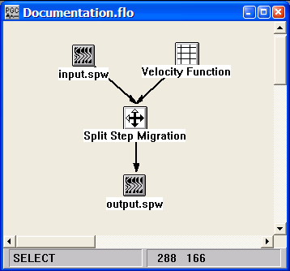

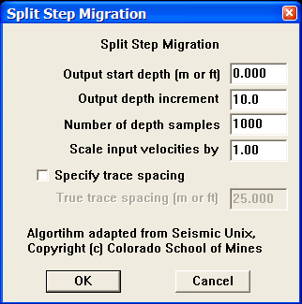
Step Parameter Dialog:

Parameter Description:
Output start depth (m or ft) — Enter the starting depth for migration.

Output depth increment (tau) — Depth sampling interval.

Number of depth samples — Total number of output depth samples.

Scale input velocities by — Input velocities will be multiplied by this number. This scalar is used for adjusting the input velocities in the case that they were derived using Dix's equation, and are not true interval velocities.

Specify trace spacing — If checked, allows for manual specification of the trace spacing. By default, SPW calculates the trace spacing for the stack as the group interval, as you defined it in the geometry definition, divided by two (2).

Stolt Migration

2-D only
Usage:
The Stolt Migration step implements a constant velocity or depth variable Stolt migration algorithm for post-stack time migration. This migration scheme can accommodate a vertically varying velocity field in the form of one SPW velocity function card. This velocity field is assumed to be the stacking velocity field derived from velocity analysis of the pre-stack data. The user designates a Stolt stretch factor, a maximum frequency to migrate, and temporal and spatial tapers. An option allows the input velocity function to be scaled. Finally, you can override the SPW calculated trace spacing and specify the true trace spacing of your data in your spatial units of choice. By default, SPW calculates the trace spacing for the stack as the group interval, as you defined it in the geometry definition, divided by two (2).

Input Links:
1) Seismic data in stacked order (mandatory).
2) Velocity Function cards (optional).

Output Links:
1) Seismic data in stacked order (mandatory) and sampled in time.

Reference:
Stolt, R.H, 1978, Migration by Fourier transform, Geophysics, v. 43, no 1., p. 23-48.

Example Flowchart:

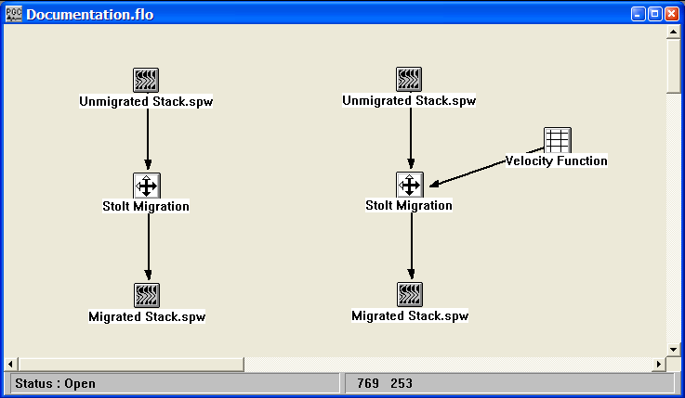
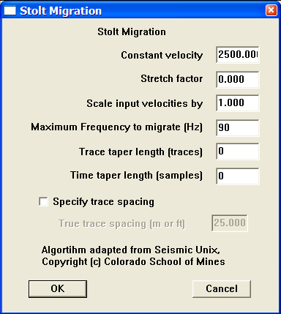
Step Parameter Dialog:

Parameter Description:
Constant velocity — Enter an "average" velocity for the entire stack. This velocity will be used as the constant migration velocity if no velocity cards are linked.

Stretch factor — In the case of a time-variable velocity field, the Stolt stretch factor is designed to stretch the time axis so that the data appear to have propagated through a constant-velocity earth. Values of 0.5 to 1 are typical.

Scale input velocities by — The input velocities are multiplied by this number. This scalar may be used for adjusting the input velocities if they are interval velocities derived using Dix's equation rather than true interval velocities.

Maximum frequency to migrate — Enter the maximum frequency component in the data to be migrated.

Trace taper length (traces)— Number of traces to over which to taper traces at the start and end of the line prior to migration.

Time taper length (samples) — Number of samples to over which to taper at the start and end of each trace prior to migration.

Specify trace spacing — If checked, allows for manual specification of the trace spacing. By default, SPW calculates the trace spacing for the stack as the group interval, as you defined it in the geometry definition, divided by two (2).

Multi-Component

This section documents the processing steps available in the Multi-
Component category.

The multi-component processing steps currently available are:

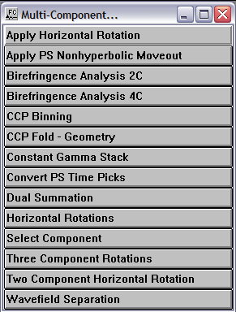
Note on Multi-component trace header values

Receiver Type | Receiver component trace-header value
Hydrophone or pressure sensor | 11
Vertical-component receiver | 12
Crossline-component receiver | 13
Inline component receiver | 14
Rotated vertical-component receiver | 15
Rotated transverse-component receiver | 16
Rotated radial-component receiver | 17
Summed vertical component receiver | 28
Receiver types and Receiver component trace header values

Source Type | Source component trace-header value
Vertical-component source | 22
Crossline-component source | 23
Inline component source | 24
Rotated vertical-component source | 25
Rotated transverse-component source | 26
Rotated radial-component source | 27
Source types and Source component trace header values

Apply Horizontal Rotation

Usage:
The Apply Horizontal Rotation step rotates the horizontal components of a multi-component data volume through rotation angles determined by the Two Component Horizontal Rotation step. The rotation angles are read from a Rotation Card file. In the case of 2D data acquisition with field oriented 3C receivers, an option exists to limit the rotation angle to a user-specified range.

Input Links:
- Seismic data in common receiver order (mandatory). The trace header must be updated with source-receiver azimuth and source- and receiver-component types. The common-receiver gathers should be sorted by (1) receiver number; (2) source-receiver offset; (3) receiver component.
- Rotation Card file containing the estimated rotation angles (optional).

Output Links:
- Seismic data in common receiver order (mandatory).

Example Flowchart:
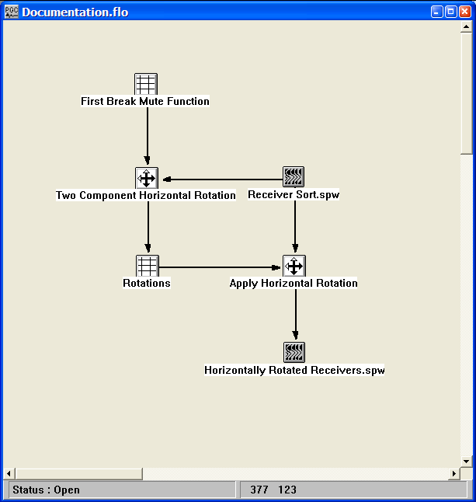

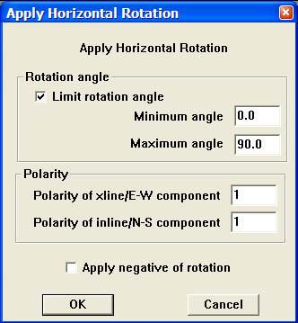
Step Parameter Dialog:

Parameter Description:

Rotation angle
Limit rotation angle - If checked, the rotation angle used to rotate the horizontal components will be limited by the user-specified minimum and maximum angles.

Minimum angle – The minimum allowable rotation angle.

Maximum angle – The maximum allowable rotation angle.

Polarity
Polarity of xline/E-W component – Defines polarity of crossline component. Valid values are +/- 1.

Polarity of inline/N-S component – Defines polarity of inline component. Valid values are +/- 1.

Apply PS Non-hyperbolic Moveout

Usage:
Converted wave travel-times are not a hyperbolic function of offset. The total moveout of a converted wave reflection can be described accurately with the double square root (DSR) equation. This equation gives the complete travel time correction as a function of offset, bounce point and gamma, where gamma is defined as the ratio of compressional-wave to shear-wave velocity. The Apply PS Non-hyperbolic Moveout step uses the combination of P-wave stacking velocities and Gamma functions to correct for non-hyperbolic moveout.

Input Links:
- Seismic data in any sort order (mandatory).
- PS Nhmo Gamma Function card data file containing gamma pics (mandatory).
- Velocity Function card data file containing P-wave velocity pics (optional).

Output Links:
1) Seismic data in any sort order (mandatory).

Reference:
Yilmaz, 2001, ‘Seismic Data Analysis’, 2nd Ed. p.1946-1959.

Example Flowchart:

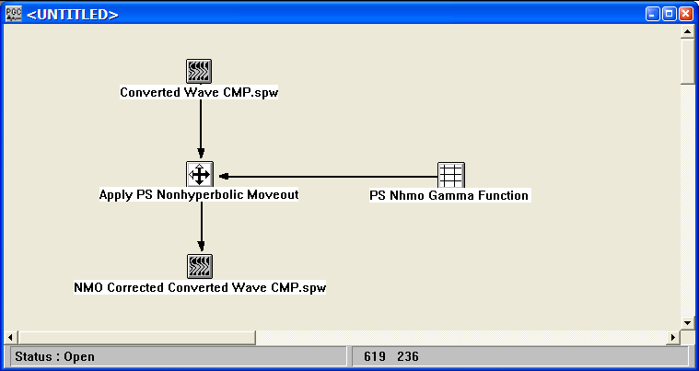
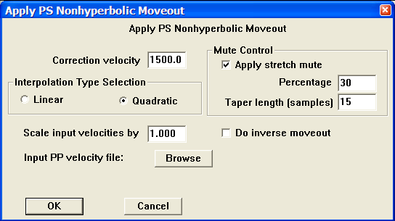
Step Parameter Dialog:

Parameter Description:
Correction velocity — Enter the P-wave NMO velocity. This constant velocity will be used if a P-wave stacking velocity function is NOT selected using the Browse button.

Interpolation Type Selection — Select the interpolation type (linear or quadratic). The moveout function causes trace data samples to be moved in time to new locations. Since these new time locations of the data sample values are not usually exactly at the sample interval of the data, the data is interpolated to be evenly sampled at the correct sample interval.

Linear — Linear interpolation uses the equation of a line (y = mx + b) to interpolate data values between or beyond existing data.

Quadratic — Quadratic interpolation uses the equation of a quadratic (y = ax^2 + bx + c) to interpolate data values between or beyond existing data.

Mute Control — Set the parameters for the stretch mute definition.

Apply stretch mute — If checked, a stretch mute will be applied to the NHMO corrected data. Stretch muting removes the stretching of the data due to the NMO correction.

Percentage — Enter the percent stretch mute. The smaller the percent the more severe the mute function.

Taper length — Enter the mute tape length in samples. Longer taper lengths result in a smoother transition from the mute zone to the data zone.

Scale input velocities by – Enter the amount by which the input velocities are scaled up or down. A value of 1.0 does not alter the velocity field.

Browse – Select the velocity card containing P-wave stacking velocities previously obtained through analysis of vertical component data.

Do inverse NMO application — If checked, the inverse NMO correction will be applied, instead of the usual forward NMO.

Birefringence Analysis - 2C

Usage:
The splitting of shear waves into fast and slow components is called Birefringence. Analysis of the split shear waves allow the data recorded in the acquisition, or inline-crossline coordinate system to be rotated into the frame of reference of the principal axes of the azimuthally anisotropic medium. The rotated data correspond to the radial and transverse components of motion. The 2C Birefringence analysis rotates the receiver components through 180 degrees and a time shift of up to +/- 50% of the analysis window to maximize the radial component energy of an inline source or the transverse component energy of a crossline source. The analysis also provides an estimate of the azimuth of anisotropy.

Input Links:
1) Seismic data in common-receiver order (mandatory). The trace header must be updated with source-receiver azimuth and source- and receiver-component types. The common-receiver gathers should be sorted by (1) receiver number; (2) source-receiver offset; (3) receiver component.

Output Links:
1) Seismic data rotated into principal axis of the azimuthally anisotropic medium in common receiver order with strike angle of the principal axis in User Def 1 trace header (mandatory).

Reference:
Alford, R. M., 1986 Shear data in the presence of azimuthal anisotropy: Dilley, Texas: Presented at the 56th Annual SEG Meeting, Houston, Texas.

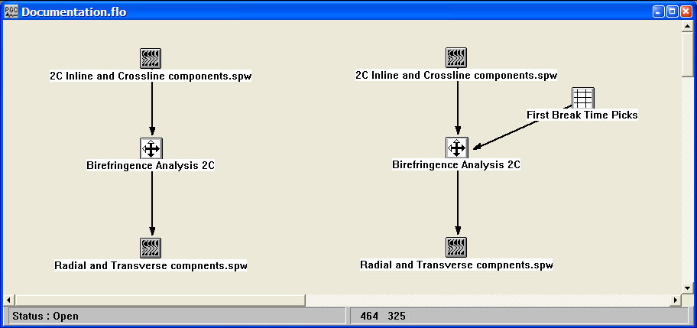
Example Flowchart:

Step Parameter Dialog:
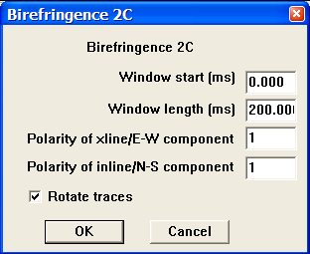

Parameter Description:
Window start (ms) — If a First Break Time Pick file is not linked to the Birefringence step, this value will indicate the start time of the analysis. If a First Break Time Pick file is linked to the Birefringence step, this value will indicate the start time of the analysis with respect to the first break time.

Window length (ms) — Length of birefringence analysis following start time.

Polarity of xline/E-W component — Defines polarity of crossline component.

Polarity of inline/N-S component — Defines polarity of inline component.

Rotate trace – If checked, the optimum rotation angle determined by the Birefringence analysis is applied to the output data. Otherwise, only the analysis is performed.

Birefringence Analysis - 4C

Usage:
The splitting of shear waves into fast and slow components is called Birefringence. Analysis of the split shear waves allow the data recorded in the acquisition, or inline-crossline coordinate system to be rotated into the frame of reference of the principal axes of the azimuthally anisotropic medium. The rotated data correspond to the radial and transverse components of motion. . The 4C Birefringence analysis requires as input the inline and crossline receiver components recorded by horizontal inline and crossline sources, respectively. The analysis computes the optimum rotation angle and time delay that maximizes the radial component energy of an inline source or the transverse component energy of a crossline source. The analysis also provides an estimate of the azimuth of anisotropy.

Input Links:
1) Seismic data in common receiver order (mandatory). The trace header must be updated with source-receiver azimuth and source- and receiver-component types. The common-receiver gathers should be sorted by (1) receiver number; (2) source-receiver offset; (3) receiver component.

Output Links:
1) Seismic data rotated into principal axis of the azimuthally anisotropic medium in common receiver order with strike angle of the principal axis in User Def 1 trace header (mandatory).

Reference:
Alford, R. M., 1986 Shear data in the presence of azimuthal anisotropy: Dilley, Texas: Presented at the 56th Annual SEG Meeting, Houston, Texas.

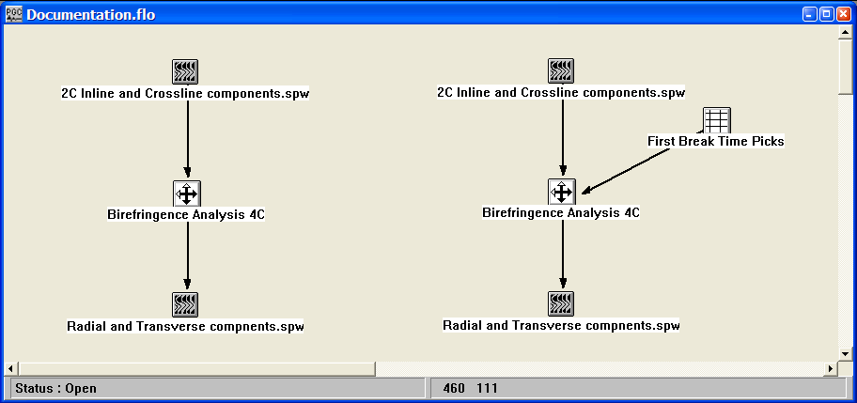
Example Flowchart:

Step Parameter Dialog:
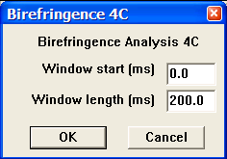

Parameter Description:
Window start (ms) — If a First Break Time Pick file is not linked to the Birefringence step, this value will indicate the start time of the analysis. If a First Break Time Pick file is linked to the Birefringence step, this value will indicate the start time of the analysis with respect to the first break time.

Window length (ms) — Length of birefringence analysis following start time.

CCP Binning

Usage: The Common-Conversion Point (CCP) binning step assigns CCP numbers to mode-converted PS data as a function of the source-receiver offset and a constant or time-variable V_{p}/V_{s} ratio (gamma).

Input Links:
- Converted wave data volume in any sort order (mandatory).
- PS Nhmo gamma function card (optional).

Output Links:
1) Converted wave data volume in any sort order (mandatory).

Reference:

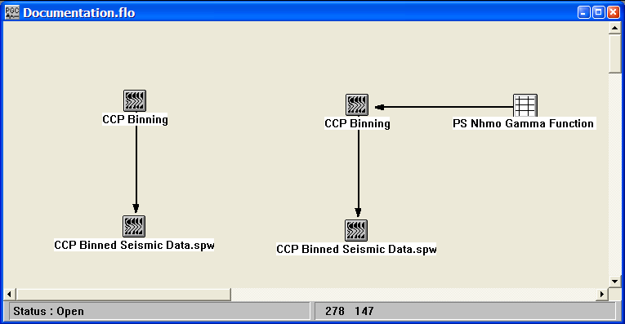
Example Flowchart:

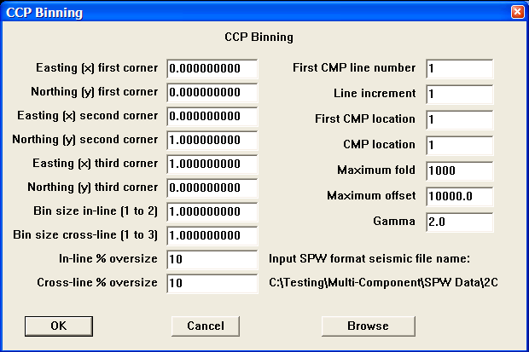
Step Parameter Dialog:

Parameter Description:
Easting (x) first corner — Enter the easting coordinate of the first corner of your survey.

Northing (y) first corner — Enter the northing coordinate of the first corner of your survey.

Easting (x) second corner — Enter the easting coordinate of the second corner of your survey.

Northing (y) second corner — Enter the northing coordinate of the second corner of your survey.

Easting (x) third corner — Enter the easting coordinate of the third corner of your survey.

Northing (y) third corner — Enter the northing coordinate of the third corner of your survey.

Bin size in-line (1 to 2) — Enter the size in distance units of the in-line side of each bin.

Bin size cross-line (1 to 3) — Enter the size in distance units of the cross-line side of each bin.
In-line % oversize — Enter the percent of the in-line bin dimension used to extend the bin in the in-line direction.

Cross-line % oversize — Enter the percent of the cross-line bin dimension used to extend the bin in the cross-line direction.

First CMP line number — Enter the first CMP line number. This line number is assigned to all the bins along the side of the survey from corner 1 to corner 2.

Line increment — Enter the increment in line numbers between adjacent CMP lines.

First CMP location number — Enter the first CMP location number. This location number is assigned to all the bins along the side of the survey from corner 1 to corner 3.

CMP location increment — Enter the increment in locations between adjacent CMP locations.

Maximum Fold – Enter the maximum allowable fold attainable after flex binning.

Maximum Offset – Enter the maximum allowable source-receiver offset among traces in neighboring bins used to increase fold.

Gamma – Enter the assumed Vp/Vs ratio (gamma) used to determine the offset to the P-to-S conversion point. If a PS Nhmo gamma function card file is not linked to the CCP Binning step, this is the constant gamma value used to determine the offset to the P-to-S conversion points.

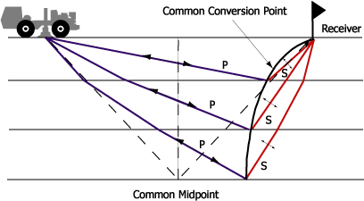

The above figure illustrates the difference between the location of the common-conversion point and the common midpoint.

CCP Fold - Geometry
Usage:
The CCP Fold – Geometry step extracts common asymptotic conversion point fold from the source, receiver, and cross-reference SPS card data files.

Input Links:
- Observers Notes – SPS Format cards (mandatory).
- Receiver Locations – SPS Format cards (mandatory).
- Source Locations – SPS Format cards (mandatory).

Output Links:
1) CCP Fold Image file (mandatory).

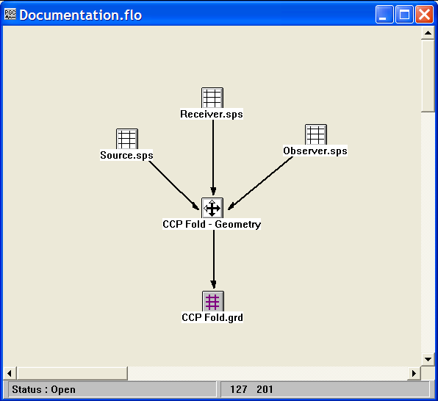
Example Flowchart:

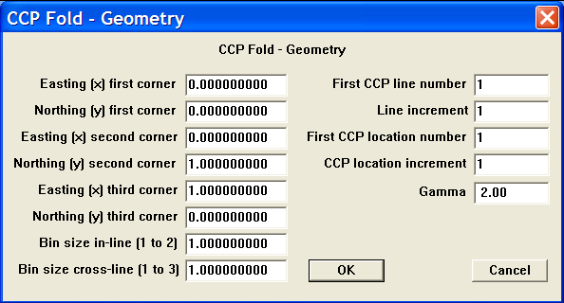
Step Parameter Dialog:

Parameter Description:
Easting (x) first corner — Enter the easting coordinate of the first corner of your survey.

Northing (y) first corner — Enter the northing coordinate of the first corner of your survey.

Easting (x) second corner — Enter the easting coordinate of the second corner of your survey.

Northing (y) second corner — Enter the northing coordinate of the second corner of your survey.

Easting (x) third corner — Enter the easting coordinate of the third corner of your survey.

Northing (y) third corner — Enter the northing coordinate of the third corner of your survey.

Bin size in-line (1 to 2) — Enter the size in distance units of the in-line side of each bin.

Bin size cross-line (1 to 3) — Enter the size in distance units of the cross-line side of each bin.

First CMP line number — Enter the first CMP line number. This line number is assigned to all the bins along the side of the survey from corner 1 to corner 2.

Line increment — Enter the increment in line numbers between adjacent CMP lines.

First CMP location number — Enter the first CMP location number. This location number is assigned to all the bins along the side of the survey from corner 1 to corner 3.

CMP location increment — Enter the increment in locations between adjacent CMP locations.

Gamma — Enter the constant gamma used to compute the asymptotic source-receiver conversion point.

Constant Gamma Stacks
Usage:
The Constant Gamma Stack step generates a file of constant gamma stack traces, where gamma is defined as the V_{p}/V_{s} ratio. A P-wave stacking velocity field must be supplied, and you choose the number of gammas with which to stack your data, the first gamma to apply, and the last gamma to apply. You have the option to apply a stretch mute, if you so desire. With the series of constant gamma stack traces, you page through these stacked panels in SeisViewer and interactively pick gamma functions that result in the most coherent stacked sections.

Input Links:
- Seismic data pre-stack, in CMP sort order (mandatory).
- Velocity card data file containing p-wave stacking velocity functions (mandatory).

Output Links:
None - This process writes directly to an output disk file.

Example Flowchart:
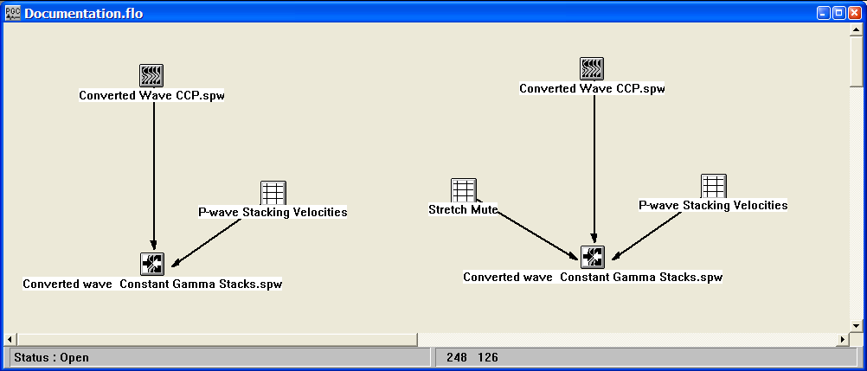

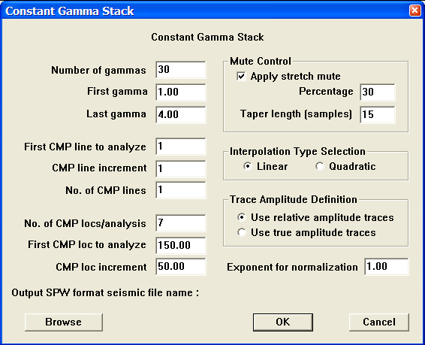
Step Parameter Dialog:

Parameter Description:
Number of gammas — Enter the number of gammas to use in the analysis. A stacked section is calculated for each gamma linearly interpolated between the starting and ending input gamma. The gamma increment will be:
G_{inc} = (last gamma – first gamma)/ (Number of gammas-1).

First gamma — Enter the starting gamma for the analysis. This gamma will be used for non-hyperbolic NMO on the first output stack. {>0.0}

Last gamma — Enter the ending gamma for the analysis. This gamma will be used for non-hyperbolic NMO on the last output stack. {>0.0}

First CMP line to analyze — Enter the first CMP line number to analyze.

CMP line increment — Enter the CMP line increment between lines to analyze.

No. of CMP lines — Enter the number of CMP lines to analyze.

No. of CMP locs/analysis — Enter the number of CMP locations in each analysis panel. At each CMP location a range of constant velocity stacks will be generated from the first velocity to the last velocity in increments of V_{inc}

First CMP loc to analyze — Enter the first CMP location to analyze.

CMP loc increment — Enter the CMP location increment between groups of CMP locations to analyze.

Mute Control
Apply stretch mute — If checked, a stretch mute will be applied to the NMO corrected data. Stretch muting restricts the stretching of the data due to the NMO correction. If not check, the stretch mute must be supplied by an Early Mute card linked to the Constant Gamma Stack step.

Percentage — Enter the percent stretch mute. The smaller the percent the more severe the mute function.

Taper length — Enter the mute taper length in samples. Longer taper lengths result in a smoother transition from the mute zone to the data zone.

Interpolation Type Selection — Select the interpolation type (linear or quadratic). The moveout function causes trace data samples to be moved in time to new locations. Since these new time locations of the data sample values are not exactly at the sample interval of the data, the data is interpolated to the correct sample interval.

Linear — Linear interpolation uses the equation of a line (y = mx + b) to interpolate data samples between or beyond existing data.

Quadratic — Quadratic interpolation uses the equation of a quadratic (y = ax^2 + bx + c) to interpolate data samples between or beyond existing data.

Trace Amplitude Definition — Select the trace amplitude definition.

Use relative amplitude traces — Relative amplitude traces will be summed in the stacking process. Relative amplitude traces are scaled independently of one another.

Use true amplitude traces — Selects the use of true amplitude scaled traces in the analysis. True amplitude traces are scaled by one common factor per record.

Exponent for normalization — Enter the scaling exponent. Traces are scaled by (fold ** EXP).

Browse — Select an existing SPW format seismic file or enter the name of a new SPW format seismic file to use for output from the process.

Convert PS Time Picks

Usage: The Convert PS Time Picks step maps P-wave event times to PS-wave event times using a user supplied gamma (Vp/Vs) function. Alternatively, the step can map PS-wave event times to P-wave event times.

Input Links:
- Horizon Picks file containing either P-wave event times or PS-wave event times (mandatory).
- PS Nhmo Gamma Function card (mandatory).

Output Links:
1) Horizon Picks file containing PS-wave event times or P-wave event times (mandatory).

Reference:

Example Flowchart:
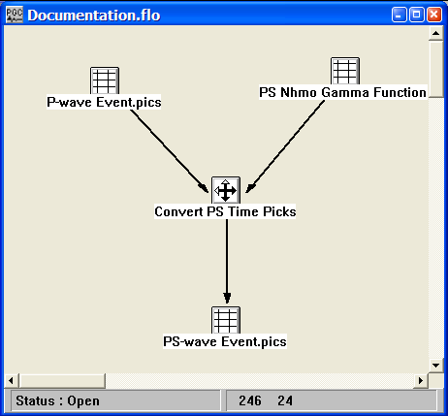
Step Parameter Dialog:
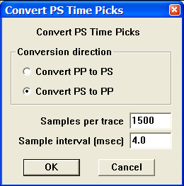

Parameter Description:
Conversion direction — Select the type of time pick conversion. If the input times were picked on P-wave data, select Convert PP to PS. If the input times were picked on PS-wave data, select Convert PS to PP.

Convert PP to PS — Maps P-wave event times to PS-wave event times.

Convert PS to PP — Maps PS-wave event times to P-wave event times.

Samples per trace — Enter the number of samples per trace in the seismic data from which the event times were picked.

Samples interval (ms) — Enter the sample interval of the seismic data from which the event times were picked.

Dual Summation

Usage: The Dual Summation step scales the pressure sensor data (hydrophone) to the same range as the co-located vertical-component geophone data. After scaling, the two recordings are summed so that the spectral notch resulting from the receiver water-surface ghost will be eliminated. If the input data are 4C, the Dual Summation step will output enhanced 3C data. If the input data are 2C, the Dual Summation step will output enhanced single-component data

Input Links:
1) Seismic data in common receiver order (mandatory). The trace header must be updated with the source- and receiver-component types. The common-receiver gathers should be sorted by (1) receiver number; (2) source-receiver offset; (3) receiver component.

Output Links:
1) 1C or 3C seismic data in common-receiver gather sort order (mandatory).

Reference:

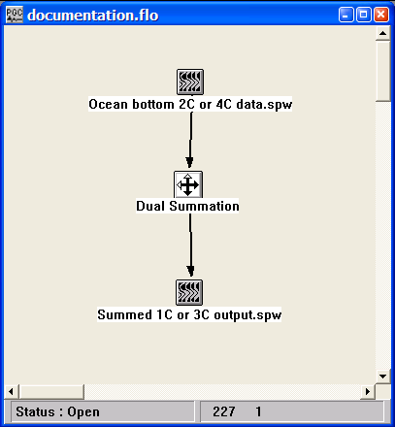
Example Flowchart:
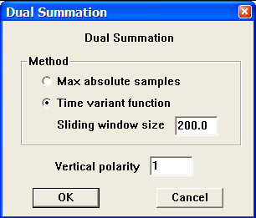
Step Parameter Dialog:

Parameter Description:
Method — Select the analysis method to determine the dual sensor summation factors.

Max absolute samples — If selected, the geophone scale factor will be equal to the ratio of the maximum absolute value of the geophone trace to the maximum absolute value of the hydrophone trace.

Time variant function — If selected, the geophone scale factor will be a time variant function controlled by a sliding window.

Sliding window size – size of the window, in ms, over which the dual sensor summation factors are calculated.

Vertical polarity - Defines polarity of the vertical component.

Horizontal Rotation

Usage:
The Horizontal Rotation step rotates the two horizontal components of a multi-component data volume through rotation angles determined by the (1) source-receiver azimuth, (2) the azimuth of the inline component, and (3) the azimuth of the crossline component. The step outputs a single data file consists of rotated radial (Receiver Component = 17) and transverse (Receiver Component = 16) component traces.

Input Links:
- Seismic data in common receiver order (mandatory). The trace header must be updated with source-receiver azimuth and source- and receiver-component types. The common-receiver gathers should be sorted by (1) receiver number; (2) source-receiver offset; (3) receiver component.

Output Links:
- Seismic data in common receiver order (mandatory).

Example Flowchart:
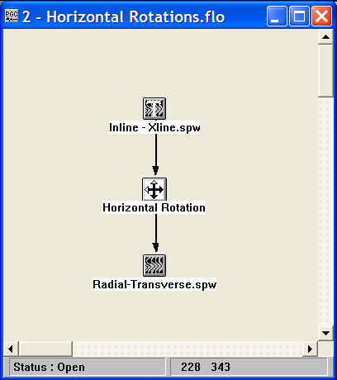

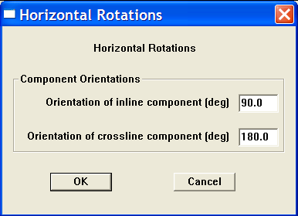
Step Parameter Dialog:

Parameter Description:

Orientation of inline component – Enter the azimuth of the field orientation of the inline component receiver.

Orientation of crossline component – Enter the azimuth of the field orientation of the crossline component receiver.

Select Component

Usage:
The Select Component step is used to extract source and receiver components from multi-component seismic data based on the trace header types described at the beginning of the Multi-Component section.

Input Links:
- Multi-component seismic data (mandatory). The trace header must be updated with the source- and receiver-component types.

Output Links:
1) Seismic data containing selected source or receiver component (mandatory).

Reference:

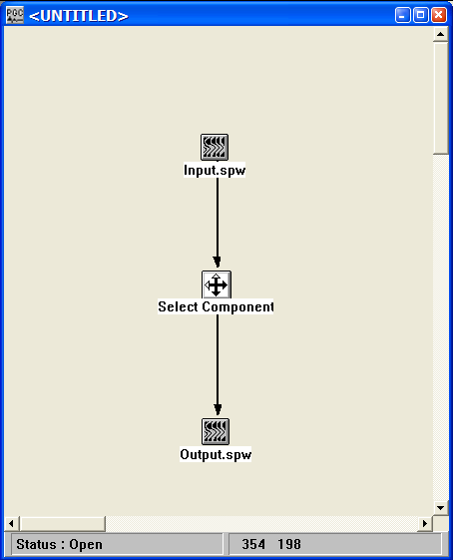
Example Flowchart:

Step Parameter Dialog:
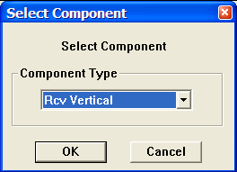

Parameter Description:

Component Type – Use the drop down menu to select a source or receiver component. Available components include:

Receiver Pressure
Receiver Vertical
Receiver Inline
Receiver Crossline
Receiver Rotated Vertical
Receiver Rotated Transverse
Receiver Rotated Radial

Source Vertical
Source Inline
Source Crossline
Source Rotated Vertical
Source Rotated Transverse
Source Rotated Radial
Source Summed Vertical

Three Component Rotations

Usage:
The Three Component Rotation step performs Euler rotations of three component data. Each rotation requires the specification of a rotation axis and a rotation angle. The rotation angles can be read from any of the trace header fields, or specified as a constant by the user.

Input Links:
- Seismic data sorted into three-component clusters (mandatory).

Output Links:
- Rotated seismic data (mandatory).

Example Flowchart:

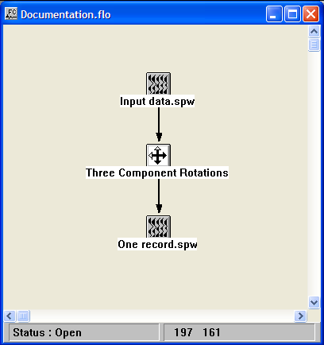

Step Parameter Dialog:

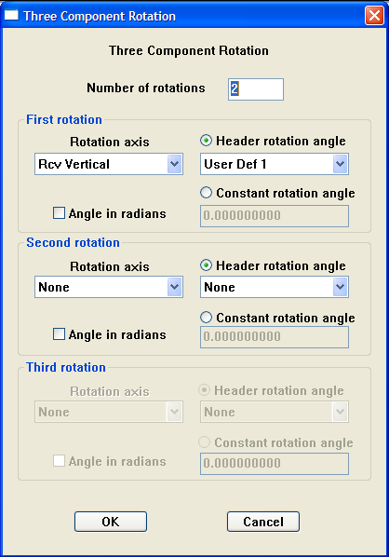

Parameter Description:

Number of rotations — Indicate the number of rotations to be performed.

First rotation (Number of rotations >= 1)

Rotation axis – Select the component axis about which to perform this rotation.

Header rotation angle – If the Header rotation angle radio button is selected, then the rotation angle will be read from the trace header field selected in the adjacent drop down menu.

Constant rotation angle – If the Constant rotation angle radio button is selected, then the rotation angle will be read from the user supplied value in the adjacent text entry box.

Angle in radians – If checked, the rotation angle will be read in units of radians. Otherwise, the rotation angle will be read in units of degrees.
Second rotation (Number of rotations >= 2)

Rotation axis – Select the component axis about which to perform this rotation.

Header rotation angle – If the Header rotation angle radio button is selected, then the rotation angle will be read from the trace header field selected in the adjacent drop down menu.

Constant rotation angle – If the Constant rotation angle radio button is selected, then the rotation angle will be read from the user supplied value in the adjacent text entry box.

Angle in radians – If checked, the rotation angle will be read in units of radians. Otherwise, the rotation angle will be read in units of degrees

Third rotation (Number of rotations = 3)

Rotation axis – Select the component axis about which to perform this rotation.

Header rotation angle – If the Header rotation angle radio button is selected, then the rotation angle will be read from the trace header field selected in the adjacent drop down menu.

Constant rotation angle – If the Constant rotation angle radio button is selected, then the rotation angle will be read from the user supplied value in the adjacent text entry box.

Angle in radians – If checked, the rotation angle will be read in units of radians. Otherwise, the rotation angle will be read in units of degrees

Two Component Horizontal Rotation

Usage:
The Two Component Horizontal Rotation step computes the rotation required to transform the horizontal components of a multi-component data volume recorded in the acquisition, or inline-crossline coordinate system into the vertical-radial-transverse frame of reference defined by the source-receiver azimuth. These rotations are then applied by the Apply Horizontal Rotation step. The rotation angles can be determined from (1) a covariance analysis of a user-defined portion of the seismic record, (2) a constant, user-specified angle, or (3) by scanning for the rotation angle that maximizes energy among the horizontal components. The analysis start time may be referenced to the first break wavelet using pick times stored in an Early Mute card file.

Input Links:
- Seismic data in common receiver order (mandatory). The trace header must be updated with source-receiver azimuth and source- and receiver-component types. The common-receiver gathers should be sorted by (1) receiver number; (2) source-receiver offset; (3) receiver component.
- Early Mute file containing time picks prior to the first breaks (optional).

Output Links:
- Rotations Card data file containing a list of the rotation estimates for each source-receiver pair (mandatory).

Example Flowchart:

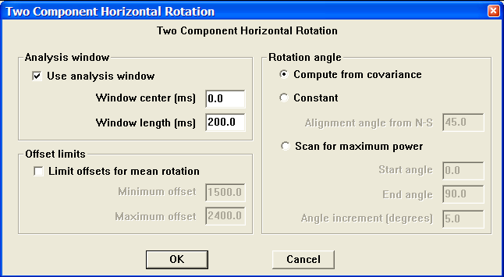
Step Parameter Dialog:

Parameter Description:

Analysis window
Use analysis window — If checked, the rotation analysis will be based on the specified window of data. If a First Break Pick Time card is linked to the Two-Component Horizontal Rotation step, then the analysis will be based on a window centered about the first break pick time.

Window center (ms) – The center of the rotation analysis window. If the analysis window is referenced to a first-break pick file, a time of 0 ms corresponds to the first-break pick time.

Window length (ms) – The length of the analysis window. The analysis window will extend from (window_center - window_length/2) to (window_center + window_length/2). If a First Break Pick Time card is linked to the step, these values will be with respect to the first break time.

Offset limits
Limit offsets for mean rotation – If checked, the rotation angle used to rotate receiver will be the mean value for that receiver determined from the analysis of all data within a specified offset range. Source-receiver azimuth for each of the traces used in the analysis is taken into account.

Minimum offset – The minimum absolute offset used to determine the rotation angle.

Maximum offset – The maximum absolute offset used to determine the rotation angle.

Rotation angle
Compute from covariance — If checked, a covariance analysis will be performed to determine the principal axes defined by the horizontal components. The azimuth of the principal axis will be output to the rotation card file.

Constant — If checked, the constant, user-specified rotation angle will be applied.

Scan for maximum power — If checked, the two horizontal components will be rotated through the user-specified range of angles. The angle that results in maximum power will be output to the Rotation card file.

Alignment angle from N-S – If the Compute rotation angle option is not checked (and the optimum rotation angle is not determined through analysis), allows rotation from a preferred azimuth.

Polarity
Polarity of xline/E-W component – Defines polarity of crossline component. Valid values are +/- 1.

Polarity of inline/N-S component – Defines polarity of inline component. Valid values are +/- 1.

Wavefield Separation

Usage:
The Wavefield Separation step is designed to extract the compressional and shear wavefield from three-component or full-vector recordings based on the polarization attributes of the P- and S- wavefield. The polarization attributes of a three-component recording are extracted through covariance analysis of a window of the recording.

Input Links:
- Seismic data in common receiver order (mandatory). The trace header must be updated with the source- and receiver-component types. The common-receiver gathers should be sorted by (1) receiver number; (2) source-receiver offset; (3) receiver component.
- Early Mute card file (mandatory).

Output Links:
1) Seismic data file containing the P-wave or the S-wave three-component wavefield (mandatory).

Reference:
Flinn, E. A., 1965, Signal analysis using rectilinearity and direction of particle motion: IEEE Proc., 12, 1874-1876.
Jurkevics, A., 1988, Polarization analysis of three-component array data: Bull. Seis. Am., 78, 1725-1743.
Jackson, G. M., Mason, I. M., and Greenhalgh, S. A., 1991, Principal component transforms of triaxial recording by singular value decomposition: Geophysics, 56, 528-533.

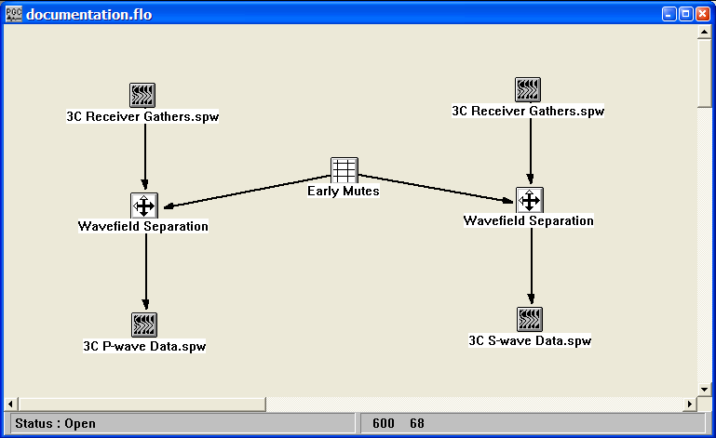
Example Flowchart:
Step Parameter Dialog:
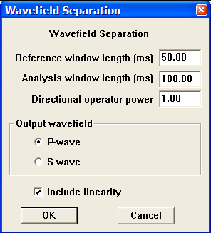

Parameter Description:
Reference window length (ms) – Length of reference time window.

Analysis window length (ms) – Length of the covariance analysis window.

Directional operator power – Weighting coefficients are raised to the directional operator power.

Output Wavefield – Select whether the P-wave or the S-wave wavefield will be output.

P-wave – Outputs the P-wave wavefield.

S-wave – Outputs the S-wave wavefield.

Include linearity – If checked, the linearity attribute is used to weight the input wavefield to generate the output wavefield.

Mutes

This section documents the processing steps available in the Mutes category.

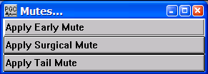
The types of mutes currently available are:

Apply Early Mute

Usage:
The Apply Early Mute step allows you to apply mute definitions in the Early Mute card to your data. You may choose to interpolate mute functions for the records between the picked mute records or to just mute the records associated with the picked mutes. You have a choice of applying a Hanning, Hamming, or Blackman type of mute taper. You may also specify the length of the mute taper. Early mutes may be interactively defined in SeisViewer using the Pick Traces tool located in the Picking menu.

Input Links:
1) Seismic data in any sort order (mandatory).
2) Early Mutes cards (mandatory).

Output Links:
1) Seismic data in any sort order (mandatory).

Example Flowchart:

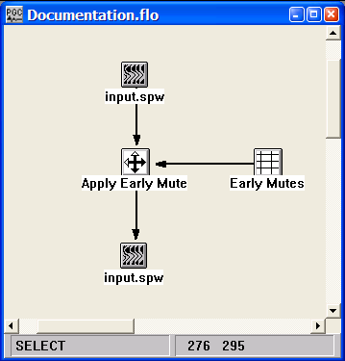
Step Parameter Dialog:
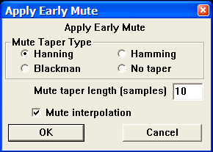

Parameter Description:
Mute Tape Type — Select the type of taper to use when applying the mute function.

Hanning — A Hanning taper is specified by the equation : x(n) = 0.5 - 0.5 * cos (2*pi*n/N).

Hamming — A Hamming taper is specified by the equation : x(n) = 0.54 - 0.46 * cos (2*pi*n/N).

Blackman — A Blackman taper is specified by the equation : x(n) = 0.42 - 0.5 * cos (2*pi*n/N)+ 0.08 * cos (4*pi*n/N).

No taper — No taper will be applied to the mute. This may result in problems in later processing steps due to Gibbs effect.

Mute taper length — Enter the mute taper length in samples. Longer taper lengths result in a smoother transition from the mute zone to the data zone.

Mute Interpolation — If checked, the early mutes will be interpolated between the control points where picks were made.

Apply Surgical Mute

Usage:
The Apply Surgical Mute step allows you to apply a set of picked mute cards to your data. You may choose to interpolate mute functions for the records between the picked mute records or to just mute the records associated with the picked mutes. You have a choice of applying a Hanning, Hamming, or Blackman type of mute taper. You may also specify the length of the mute taper. Surgical mutes may be interactively defined in SeisViewer using the Pick Traces tool located in the Picking menu.

Input Links:
1) Seismic data in any sort order (mandatory).
2) Surgical Mutes cards (mandatory).

Output Links:
1) Seismic data in any sort order (mandatory).

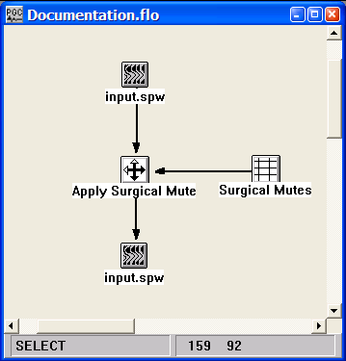
Example Flowchart:

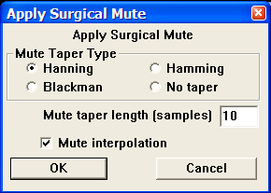
Step Parameter Dialog:

Parameter Description:
Mute Tape Type — Select the type of taper to use when applying the mute function.

Hanning — A Hanning taper is specified by the equation : x(n) = 0.5 - 0.5 * cos (2*pi*n/N).

Hamming — A Hamming taper is specified by the equation : x(n) = 0.54 - 0.46 * cos (2*pi*n/N).

Blackman — A Blackman taper is specified by the equation : x(n) = 0.42 - 0.5 * cos (2*pi*n/N)+ 0.08 * cos (4*pi*n/N)

No taper — No taper will be applied to the mute. This may result in problems in later processing steps due to Gibbs effect.

Mute taper length — Enter the mute taper length in samples. Longer taper lengths result in a smoother transition from the mute zone to the data zone.

Mute Interpolation — If checked, the surgical mutes will be interpolated between picked control points.

Apply Tail Mute

Usage:
The Apply Tail Mute step allows you to apply a set of picked mute cards to your data. You may choose to interpolate mute functions for the records between the picked mute records or to just mute the records associated with the picked mutes. You have a choice of applying a Hanning, Hamming, or Blackman type of mute taper. You may also specify the length of the mute taper. Tail mutes may be interactively defined in SeisViewer using the Pick Traces tool located in the Picking menu.

Input Links:
1) Seismic data in any sort order (mandatory).
1) Tail Mutes cards (mandatory).

Output Links:
1) Seismic data in any sort order (mandatory).

Example Flowchart:
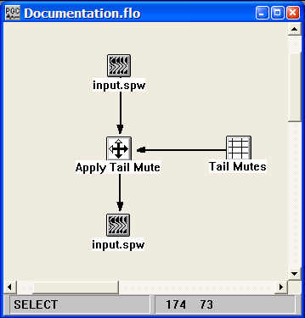

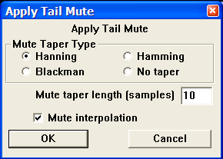
Step Parameter Dialog:

Parameter Description:
Mute Tape Type — Select the type of taper to use when applying the mute function.

Hanning — A Hanning taper is specified by the equation : x(n) = 0.5 - 0.5 * cos (2*pi*n/N).

Hamming — A Hamming taper is specified by the equation : x(n) = 0.54 - 0.46 * cos (2*pi*n/N).

Blackman — A Blackman taper is specified by the equation : x(n) = 0.42 - 0.5 * cos (2*pi*n/N)+ 0.08 * cos (4*pi*n/N)

No taper — No taper will be applied to the mute. This may result in problems in later processing steps due to Gibbs effect.

Mute taper length — Enter the mute taper length in samples. Longer taper lengths result in a smoother transition from the mute zone to the data zone.

Mute Interpolation — If checked, the tail mutes will be interpolated between picked control points.

Quality Analysis

This section documents the processing steps available in the Quality Analysis category.

The types of quality analysis currently available are:

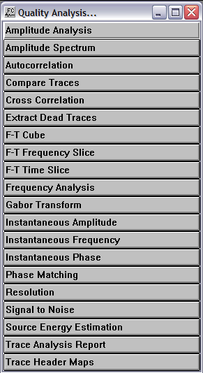

Amplitude Analysis
Usage:
The Amplitude Analysis step performs single- or multi-channel analysis of sample amplitudes and updates a user specified trace header with the results of the analysis. Attribute types include RMS value, Average Magnitude, Maximum Magnitude, Maximum Amplitude, Median Value, and Energy.

Input Links:
1) Seismic data in any order (mandatory).

Output Links:
1) Seismic data amplitude spectrum attribute traces (mandatory).

Example Flowchart:
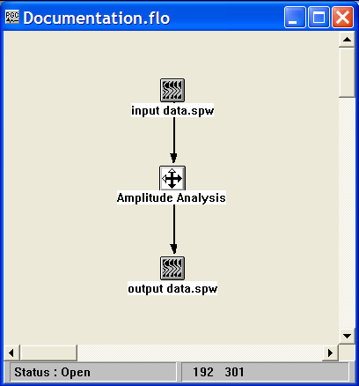

Step Parameter Dialog:

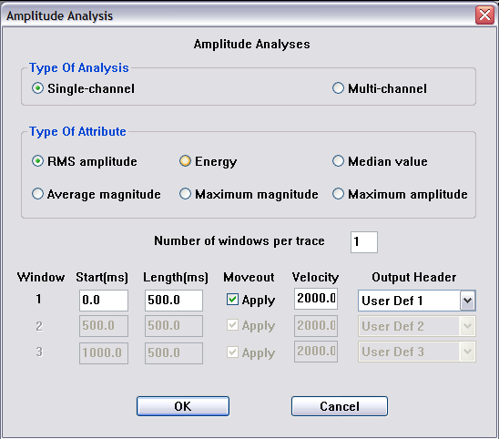

Parameter Description:
Type of Analysis — Specify whether the amplitude analysis will be single-channel or multi-channel. Single-channel attributes are calculated per trace. Multi-channel attributes are calculated from the ensemble of traces in an input gather.

Type of Attribute — Specify the type of amplitude attribute.

RMS – Calculate the root-mean-squared value in the analysis window.

Average magnitude – Calculate the average of the absolute values in the analysis window.

Maximum magnitude – Determine the maximum of the absolute values in the analysis window.

Energy – Calculate the sum of the squares of sample values in the analysis window.

Maximum amplitude – Determine the maximum value in the analysis window.

Median value – Determine the median value in the analysis window.

Number of windows per trace — Specify the number of analysis windows per trace for a single-channel analysis, or the number of analysis windows per record for a multi-channel analysis.

Start time (ms) — Enter the start time of the window to use.

Length (ms) — Enter the length of the window to use.

Apply moveout – Specify whether a linear moveout will be applied to the start time of the analysis window.

Velocity – If moveout is to be applied, specify the moveout velocity.

Output Header – Select the trace header that will be updated with the results of the analysis.

Amplitude Spectrum
Usage:
The Amplitude Spectrum step inputs seismic data and outputs the amplitude spectrum of each trace into the output seismic file.

Input Links:
1) Seismic data in any order (mandatory).

Output Links:
1) Seismic data amplitude spectrum attribute traces (mandatory).

References:
See Technical Note TN-AmpSpc.doc

Example Flowchart:

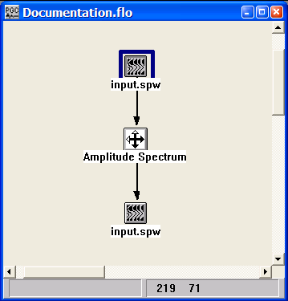
Step Parameter Dialog:
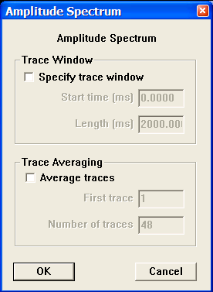

Parameter Description:
Specify Trace Window — If checked, the specified window will be used for calculating the amplitude spectrum.

Start time (ms) — Enter the start time of the window to use.

Length (ms) — Enter the length of the window to use.

Average Traces — If checked, the spectrums of the specified traces will be averaged.

First trace — Enter the first trace number in the window to be average.

Number of traces — Enter the number of traces to average.

Autocorrelation
Usage:
The Autocorrelation computes a single trace autocorrelation for each input data trace. The autocorrelation trace will have the same length as the input trace, and the zero lag value can be shift in time if you want to view both positive and negative lags.

Input Links:
1) Seismic data in any sort order (mandatory).

Output Links:
1) Seismic data in any sort order (mandatory).

Example Flowchart:
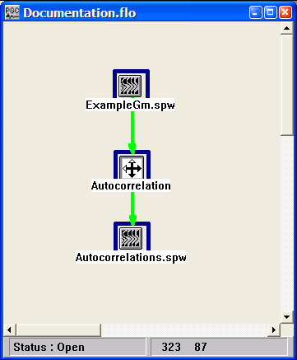

Step Parameter Dialog:

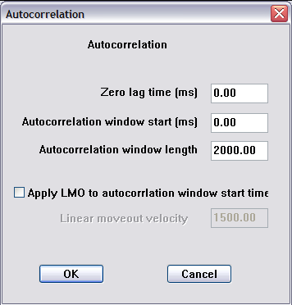

Parameter Description:
Zero lag time (ms) — Enter the time to display the zero lag value of the autocorrelation. If the value is zero, only the positive lags will be computed. If the value is equal to half the input trace length, a fully symmetric autocorrelation will be output.

Autocorrelation window start (ms) — Enter the start time in milliseconds for computing the trace autocorrelation.

Autocorrelation window length (ms) — Enter the length in milliseconds for computing the trace autocorrelation. The autocorrelation function will be generated from data samples between the start time and the start time + window length.

Apply LMO to autocorrelation window start time — If checked, the autocorrelation window start time will be a function of offset:

Start time = (source-receiver offset/ velocity) + Autocorrelation window start time.

Compare Traces
Usage:
The Compare Traces step allows you to compare two seismic data files and determine if they are identical within a user-specified tolerance. The results of the comparison are written to the console and the numeric differences of each trace are written to the output seismic file.

Input Links:
1) Seismic data in any sort order (mandatory).
2) Seismic data in the same sort order as input link #1 (mandatory).

Output Links:
1) Seismic data in the same sort order as the input (mandatory).

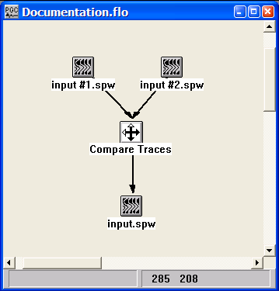
Example Flowchart:

Step Parameter Dialog:
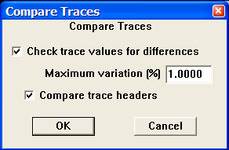

Parameter Description:
Check trace values for differences — If checked, the two input seismic trace data sets will be compared sample by sample and checked against the maximum allowed percent variation that is entered.

Max % variation — Enter the maximum allowable percentage variation for differences in the trace sample values.

Compare Trace Headers — If checked, the trace header fields for the data traces with are compared and a failure will occur if they do not match exactly.

Cross Correlation
Usage:
The Cross Correlation step computes the cross correlation function for each pair of corresponding input data traces. The length of the cross correlation trace is 2n –1 samples, where n is the number of samples in each of the input data traces. The zero lag value of the cross correlation trace occurs at sample n.

Input Links:
- Seismic data in any sort order (mandatory).
- Seismic data in any sort order (mandatory).

Output Links:
1) Seismic data in any sort order (mandatory).

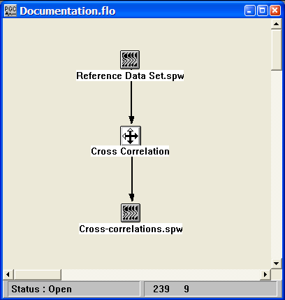
Example Flowchart:

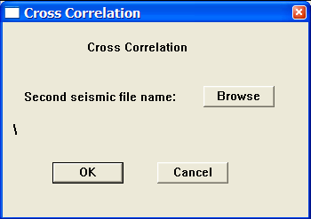
Step Parameter Dialog:

Parameter Description:
Second seismic file name – Use the Browse button to select the seismic file that will be cross-correlated with the input reference seismic file.

Extract Dead Traces
Usage:
The Extract Dead Traces step removes traces with a dead trace flag from the data stream prior to output.

Input Links:
1) Seismic data in any sort order (mandatory).

Output Links:
1) Seismic data in any sort order (mandatory).

Example Flowchart:

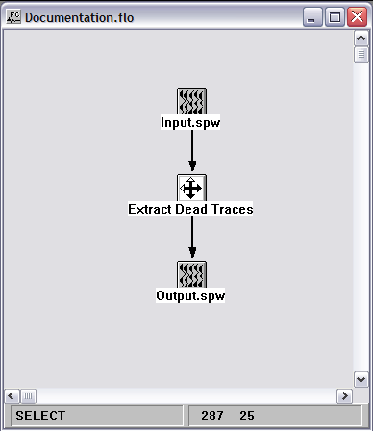

Step Parameter Dialog:

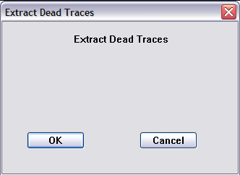

Parameter Description:
There are no parameters for the Extract Dead Traces step

F-T Cube
Usage:
The Frequency-Time Cube step converts a 2D seismic line into 3D F-T volume whose axis are CMP Location, Frequency, and Time.

Input Links:
1) Seismic data in any sort order (mandatory).

Output Links:
1) F-T Cube (mandatory).

Reference:

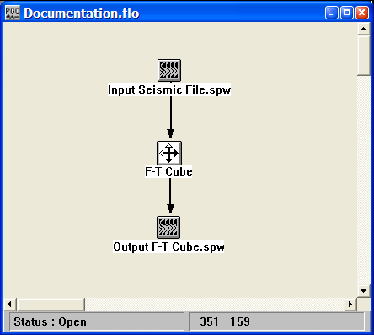
Example Flowchart:

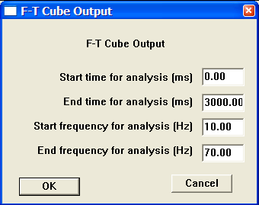
Step Parameter Dialog:

Parameter Description:
Start time for analysis (ms) — Enter the start time of the F-T cube.

End time for analysis (ms) — Enter the end time of the F-T cube.

Start frequency for analysis (Hz) — Enter the value of the first frequency slice to output.

End frequency for analysis (Hz) — Enter the value of the last frequency slice to output.

F-T Frequency Slice
Usage:
The Frequency-Time Frequency Slice step converts each trace in a data set into an F-T data set then outputs the selected constant frequency slices.

Input Links:
1) Seismic data in any sort order (mandatory).

Output Links:
1) F-T Frequency Slice Image (mandatory).

Reference:

Example Flowchart:

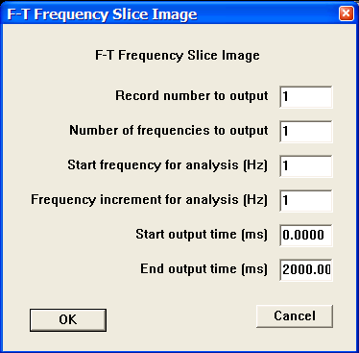
Step Parameter Dialog:

Parameter Description:
Record number to output — Enter the record number to use in the calculation.

Number of frequencies to output — Enter the number of frequency slices to output.

Start frequency for analysis — Enter the frequency in Hertz of the first slice to output.

Frequency increment for analysis — Enter the increment in Hertz between output slices.

Start output time — Enter the first time to use in the output.

End output time — Enter the last time to use in the output.

F-T Time Slice
Usage:
The Frequency-Time Time Slice step converts each trace in a data set into an F-T data set then outputs the selected constant time slices.

Input Links:
1) Seismic data in any sort order (mandatory).

Output Links:
1) F-T Time Slice Image (mandatory).

Reference:

Example Flowchart:

Step Parameter Dialog:
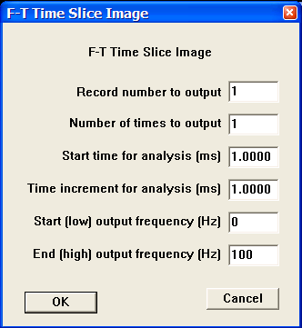

Parameter Description:
Record number to output — Enter the record number to use in the calculation.

Number of times to output — Enter the number of time slices to output.

Start time for analysis (ms) — Enter the time in milliseconds of the first slice to output.

Time increment for analysis (ms) — Enter the increment in milliseconds between output slices.

Start (low) output frequency (Hz) — Enter the first frequency in Hertz to use in the output.

End (high) output frequency (Hz) — Enter the last frequency in Hertz to use in the output.

Frequency Analysis

Usage:
The Frequency Analysis step performs single- or multi-channel spectral analysis of sample amplitudes and updates a user specified trace header with the results of the analysis. Analysis types include Dominant Frequency, Peak Amplitude at dominant frequency, Bandwidth, Average Frequency, Spectral Kurtosis, and Spectral Power.

Input Links:
1) Seismic data in any order (mandatory).

Output Links:
1) Seismic data amplitude spectrum attribute traces (mandatory).

Example Flowchart:

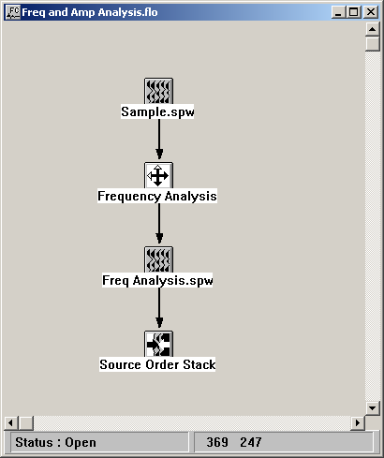

Note – The Stacking steps such as the Source Order Stack shown here will average the User Defined trace header fields where the attribute information is usually stored. This is a very useful feature as it very simply enables the calculation and display of the average attribute values for sources and receivers.
Step Parameter Dialog:

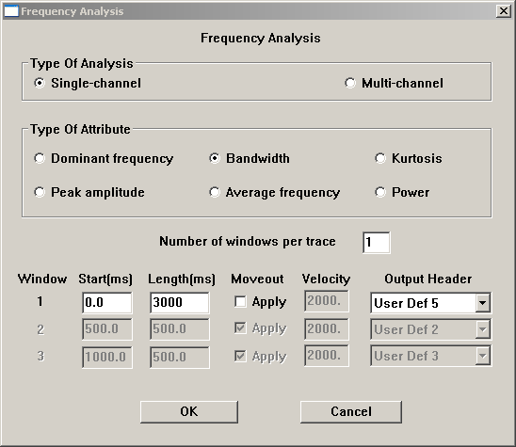

Parameter Description:
Type of Analysis — Specify whether the amplitude analysis will be single-channel or multi-channel. Single-channel attributes are calculated per trace. Multi-channel attributes are calculated from the ensemble of traces in an input gather.

Type of Attribute — Specify the type of amplitude attribute.

Dominant frequency – Calculate the the dominant frequency in the analysis window.

Peak amplitude – Determine the amplitude of the dominant frequency in the analysis window.

Bandwidth – Calculate the bandwidth of the frequency spectrum assuming Gaussian statistics. The width of the 1st standard deviation is calculated.

Average frequency – Calculate the average frequency in the analysis window.

Kurtosis – A statistical measure of the sharpness vs flatness of the frequency spectrum.

Power – Calculate the sum of the squares of spectral amplitudes in the analysis window.

Number of windows per trace — Specify the number of analysis windows per trace for a single-channel analysis, or the number of analysis windows per record for a multi-channel analysis.

Start time (ms) — Enter the start time of the window to use.

Length (ms) — Enter the length of the window to use.

Apply moveout – Specify whether a linear moveout will be applied to the start time of the analysis window.

Velocity – If moveout is to be applied, specify the moveout velocity.

Output Header – Select the trace header that will be updated with the results of the analysis.

Gabor Transform

Usage:
The Gabor Transform step performs spectral decomposition of the seismic trace data using the Gabor transform-like multifilter analysis technique. The number frequency traces in each time-frequency gather is equal to:

Number of traces = (EndFrequency-Start Frequency)/Filter Bandwidth traces

Each trace in the time-frequency gather represents a different frequency band in the original data.

Input Links:
1) Seismic data in any order (mandatory).

Output Links:
1) Seismic data in any order (mandatory).

References
Dziewonski, Bloch, and Landisman, 1969, A technique for the analysis of transient
seismic signals, Bull. Seism. Soc. Am., 1969, vol. 59, no.1, pp.427-444.
Taner, M., T., Koehler, F., and Sheriff, R., E., 1979, Complex seismic trace analysis,
Geophysics, vol. 44, pp.1041-1063.

Example Flowchart:

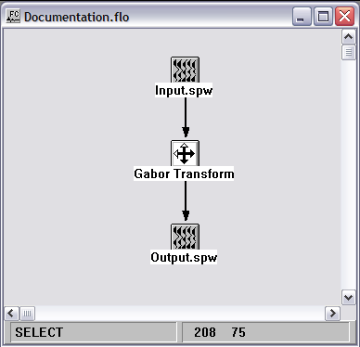

Step Parameter Dialog:

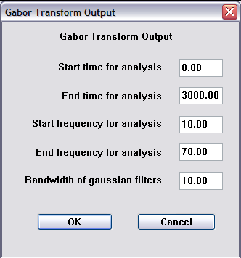

Parameter Description:
Start time for analysis — Specify the start time for time-frequency analysis.

End time for analysis — Specify the end time for time-frequency analysis.

Start frequency for analysis — Specify the start frequency for time-frequency analysis.

End frequency for analysis — Specify the end frequency for time-frequency analysis.

Bandwidth of Gaussian — Specify the bandwidth of each frequency analysis.

Instantaneous Amplitude
Usage:
The Instantaneous Amplitude step calculates instantaneous amplitude attributes for each trace and outputs each as a seismic trace in the output seismic file. Instantaneous amplitude is a measure of the reflectivity strength of events on a seismic section.

Input Links:
1) Seismic data in any sort order (mandatory).

Output Links:
1) Seismic attribute data in any sort order (mandatory).

Reference:
Taner, M.T., Koehler, F., Sheriff, R.E., 1979, Complex Seismic Trace Analysis: Geophysics, v. 44, no. 6, p. 1041-1063.

Example Flowchart:
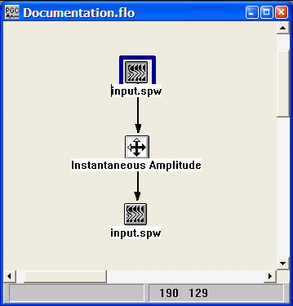

Step Parameter Dialog:
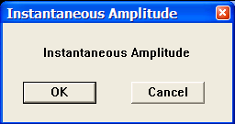

Parameter Description:
There are no parameters for this step.

Instantaneous Frequency
Usage:
The Instantaneous Frequency step calculates instantaneous frequency attribute for each trace and outputs each as a seismic trace in the output seismic file. This attribute is a measure of the frequency of events on a seismic section.

Input Links:
1) Seismic data in any sort order (mandatory).

Output Links:
1) Seismic attribute data in any sort order (mandatory).

Reference:
Taner, M.T., Koehler, F., Sheriff, R.E., 1979, Complex Seismic Trace Analysis: Geophysics, v. 44, no. 6, p. 1041-1063.

Example Flowchart:
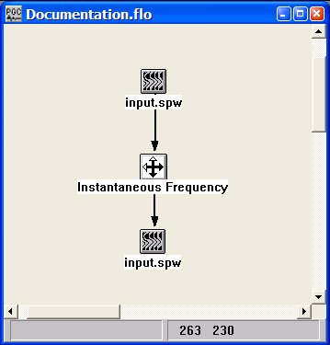

Step Parameter Dialog:
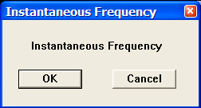

Parameter Description:
There are no parameters for this step.

Instantaneous Phase
Usage:
The Instantaneous Phase step calculates instantaneous phase attribute for each trace and outputs each as a seismic trace in the output seismic file. This attribute is a measure of the continuity of events on a seismic section.

Input Links:
1) Seismic data in any sort order (mandatory).

Output Links:
1) Seismic attribute data in any sort order (mandatory).

Reference:
Taner, M.T., Koehler, F., Sheriff, R.E., 1979, Complex Seismic Trace Analysis: Geophysics, v. 44, no. 6, p. 1041-1063.

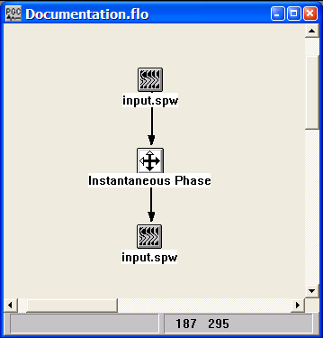
Example Flowchart:

Step Parameter Dialog:
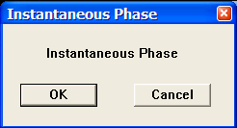
Parameter Description:
There are no parameters for this step.

Phase Matching
Usage:
The Phase Matching step computes the constant phase rotation and time shift between pairs of corresponding data traces contained in a reference and secondary data volume. The value of the average phase rotation and the average time shift between the two volumes is written to the execution console. The option exists to output the value of each phase rotation-time shift pair to a Phase Matching Statistics card data file.

Input Links:
- Seismic data in any sort order (mandatory).
- Seismic data in any sort order (mandatory).

Output Links:
1) Phase Matching Statistics card data (optional).

Example Flowchart:

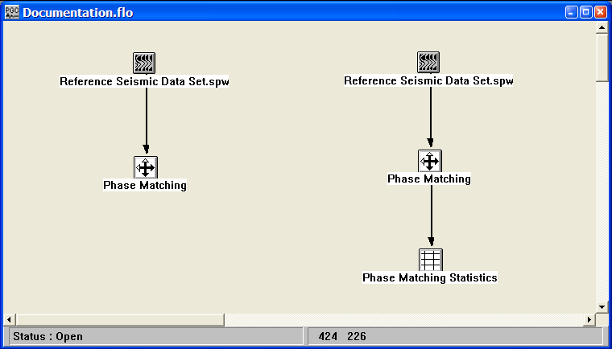
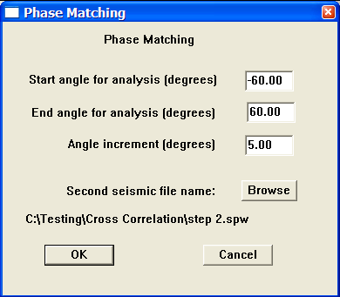
Step Parameter Dialog:

Parameter Description:
Start angle for analysis (degrees) – Enter the start angle used in the analysis. The step will analyze all angles from the Start angle to the End angle at increments specified by the Angle increment.

End angle for analysis (degrees) – Enter the end angle used in the analysis. The step will analyze all angles from the Start angle to the End angle at increments specified by the Angle increment.

Angle increment (degrees) – Enter the angle increment used in the analysis. The step will analyze all angles from the Start angle to the End angle at increments specified by the Angle increment.

Second seismic file name – Use the Browse button to select the seismic file that will be cross-correlated with the input reference seismic file.

Resolution
Usage:
The Resolution step provides a statistical estimate of the resolving power of the selected seismic data. The results of the process are output to the console file.

Input Links:
1) Seismic data in any sort order (mandatory).

Output Links:
None – The results of the process are output to the console file.

Reference:
Hatton, L., Worthington, M.H. and Makin, J. , Seismic Data Processing, Theory and Practice, 1986.

Example Flowchart:
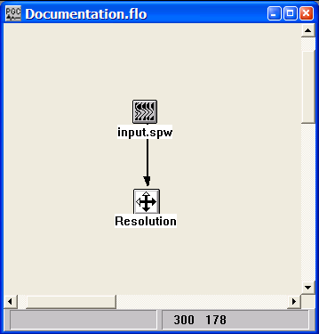

Step Parameter Dialog:

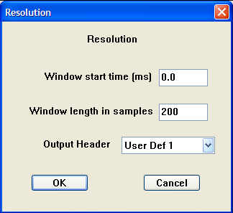

Parameter Description:
Window start time (ms) — Enter the starting time of the analysis window on the trace data.

Window length in samples — Enter the length of the analysis window in samples.

Output Header – Indicate the trace header field to store the results of the resolution calculation.

Signal to Noise
Usage:
The Signal to Noise step provides an statistical estimate of the signal to noise ratio of the selected seismic data. The results of the process are output to the console file.

Input Links:
1) Seismic data in any sort order (mandatory).

Output Links:
None – The results of the process are output to the console file.

Reference:
Hatton, L., Worthington, M.H. and Makin, J. , Seismic Data Processing, Theory and Practice, 1986.

Example Flowchart:
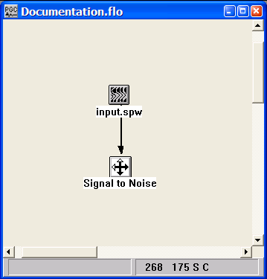

Step Parameter Dialog:

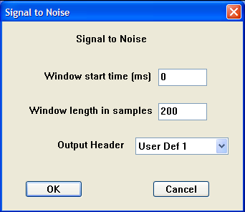

Parameter Description:
Window start time (ms) — Enter the starting time of the analysis window on the trace data.

Window length in samples — Enter the length of the analysis window in samples.

Output Header – Indicate the trace header field to store the results of the signal to noise calculation.

Source Energy Estimation
Usage:
The Source Energy Estimation computes an estimate of the source energy-to-noise ratio based on an analysis of samples values prior to and following the arrival of first break energy. A text file is output that contains, for each source location, an estimate of (1) the energy-to-noise ratio, (2) the average energy, and (3) the average noise

Input Links:
- Seismic data in source order (mandatory).
- An Early Mute card containing reference times to the start of analysis. Typically, these would be picked at the time of the first arrivals. (mandatory).

Output Links:
None. A text file of the source energy estimation is specified inside the step dialog.

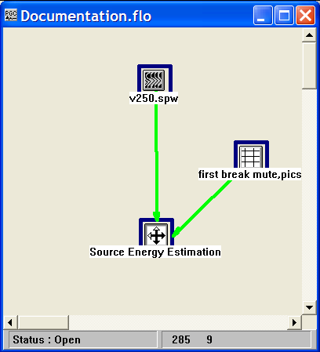
Example Flowchart:

Step Parameter Dialog:

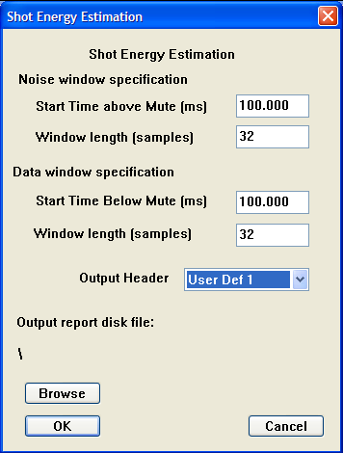

Parameter Description:
Noise window specification — Specify the window for the analysis of noise.

Start Time above mute (ms) – Specify the time above the mute to start the analysis.

Window length (samples) – Specify the number of samples used to determine the noise estimate.

Data window specification — Specify the window for the analysis of noise.

Start Time above mute (ms) – Specify the time above the mute to start the analysis.

Window length (samples) – Specify the number of samples used to determine the signal estimate.

Output report disk file — Specify the name of the text file (*.txt) that will contain the results of the analysis.

Output Header – Indicate the trace header field to store the results of the source-energy estimate.

Trace Analysis Report
Usage:
The Trace Analysis Report creates a text file that contains list bad records, and optionally, a list of traces that were killed in the geometry application step.

Input Links:
- Seismic data in any sort order (mandatory).

Output Links:
None. A text file for the trace report is specified inside the step dialog.

Example Flowchart:

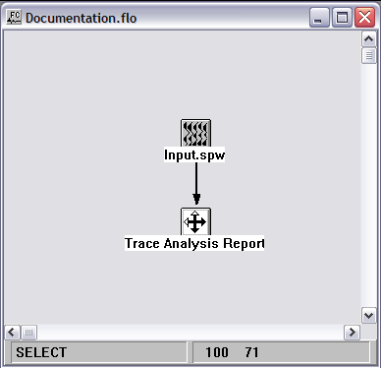
Step Parameter Dialog:

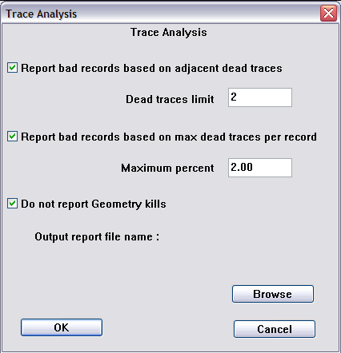

Parameter Description:
Report bad records based on adjacent dead traces – Check this option if bad records are to be identified according to the number of adjacent dead traces.

Dead traces limit – Enter the number of adjacent dead traces that will cause the record the be considered “bad”, and therefore listed in the trace analysis report.

Report bad records based on max dead traces per record – Check this option if bad records are to be identified according to the number of adjacent dead traces.

Maximum percent – Enter the maximum percentage of dead traces that will cause the record the be considered “bad”, and therefore listed in the trace analysis report.

Do not report Geometry Kills – Check this option if you DO NOT want traces killed in the geometry application step to appear in the trace analysis report.

Output report file name – Use the Browse… button to assign a file name to the trace analysis report.

Trace Header Maps
Usage:
The Trace Header Maps step is used to create image files from the trace header values in 3D seismic data .

Input Links:
- Seismic data in any sort order (mandatory).

Output Links:
- CMP Fold Image (mandatory).

Example Flowchart:

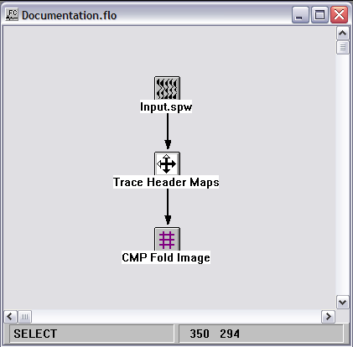

Step Parameter Dialog:

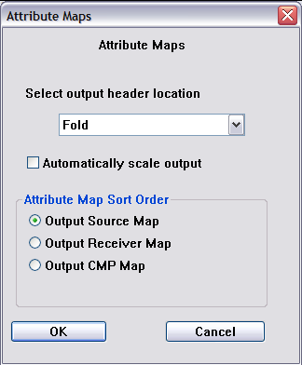

Parameter Description:
Select output header field – Use the drop down menu to select the trace header field that will be mapped into the CMP Fold Image.

Automatically scale output –

Attribute Map Sort Order – Select the output coordinate system – source, receiver, or CMP - for the image.

Seismic Data

This section documents the seismic data types in SPW and the processes currently available for creating those data types.

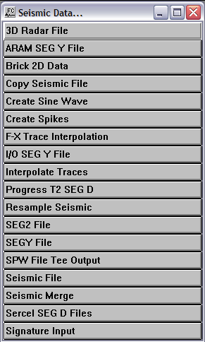

3D Radar File
Usage:
The 3D Radar File step is for the direct input of GPR data recorded in the 3D Radar format.

Input Links:
1) None. The radar file is selected inside the step dialog (mandatory).

Output Links:
1) Seismic data in any sort order (mandatory).

Example Flowchart:

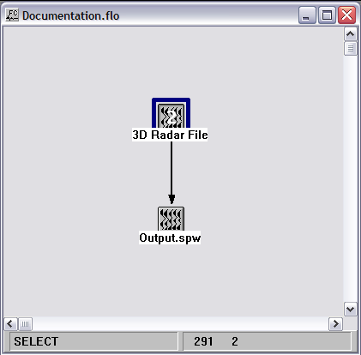

Step Parameter Dialog:

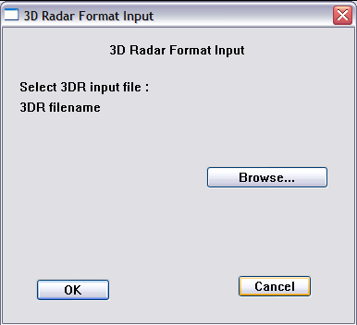

Parameter Description:
Select 3DR input file — Use the Browse button to locate the 3D Radar formatted file to be reformatted on input.

ARAM SEGY File
Usage:
The ARAM SEGY File step is for the direct input of SEGY data recorded with an ARAM Aries recording instrument.

Input Links:
1) None. The ARAM SEGY file is selected inside the step dialog (mandatory).

Output Links:
1) Seismic data in any sort order (mandatory).

Example Flowchart:

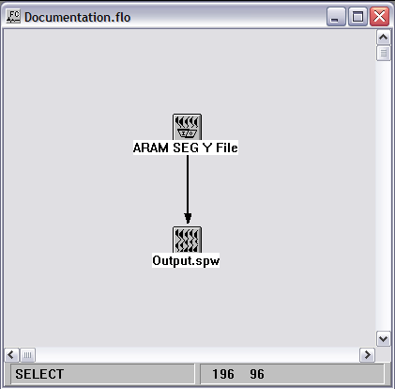

Step Parameter Dialog:

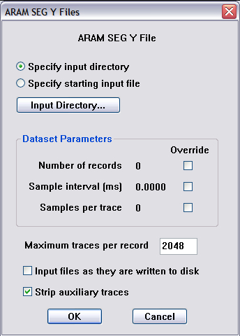

Parameter Description:
Specify input directory — With the radio button set to Specify input directory, the browse button toggles to Input Directory… Use the Input Directory button to specify the folder where the SEGY files are located.

Specify starting input file — With the radio button set to Specify starting input file, the browse button toggles to First Input File… Use the First Input File button to specify the first SEGY file, located inside the Input Directory, to be reformatted.

Number of records — By default, all records will be reformatted. Check the override box to specify the number of records, starting with the first input file.

Sample interval (ms) — By default the sample interval will be extracted from the binary header. If that value is absent or incorrect, check the override box and specify a sample interval in milliseconds.

Samples per trace —By default the number of samples per trace will be extracted from the binary header. If that value is absent or incorrect, check the override box and specify a the number of samples per trace

Brick 2D Data
Usage:
The Brick 2D Data step was design to modify the manner in which closely spaced 2D profiles – GPR or seismic - were stored on disk so that they could be view as time slices.

Input Links:
1) Post-stack seismic data in inline order (mandatory).

Output Links:
None – This process writes directly to an output disk file.

Example Flowchart:

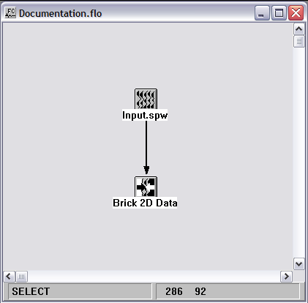

Step Parameter Dialog:

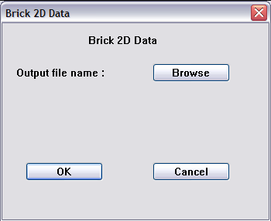

Parameter Description:
Output file name — Assign a file name for the bricked data file.

Copy Seismic File
Usage:
The Copy Seismic File step allows you to copy a portion of a seismic data file into a separate seismic file.

Input Links:
1) Seismic data in any sort order (mandatory).

Output Links:
1) Seismic data in any sort order (mandatory).

Example Flowchart:
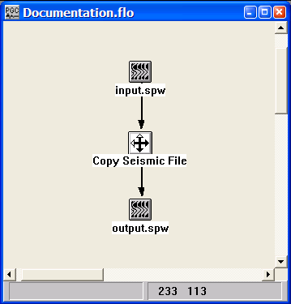
Step Parameter Dialog:

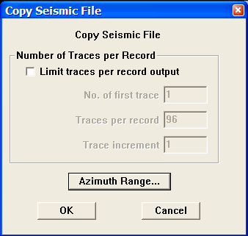
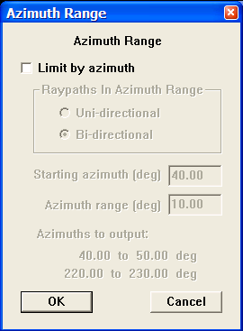

Parameter Description:
Limit traces per record output — If checked, the output records will be limited by the specified parameters.

No. of first trace — Enter the first trace to output per record.

Traces per record — Enter the number of traces per record to be output.

Traces increment — Enter the increment between traces in the record to be output.

Azimuth Range Dialog -

Limit by azimuth — If checked, the azimuth range limiting parameters will be applied to the copy of the data.

Uni-directional — If selected, the azimuth range will include only angles in one direction.

Bi-directional — If selected, the azimuth range will include both positive and negative angles.

Starting azimuth (deg) — Enter the starting angle for your range in degrees.

Azimuth range (deg) — Enter the number of degrees from the starting angle to include in the range.

Azimuths to output – The dialog will indicate the azimuths that will be output as specified by the above parameters.

Create Sine Waves
Usage:
The Create Sine Waves step is a utility for testing purposes. It creates a series of mono frequency sine waves with each trace being a different frequency from the start frequency to the end.

Input Links:
None.

Output Links:
1) Seismic data in any sort order (mandatory).

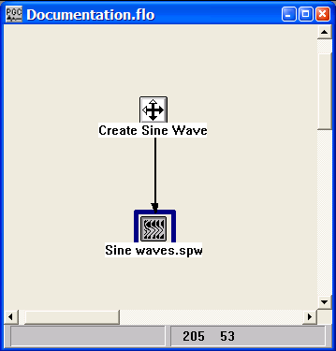
Example Flowchart:

Step Parameter Dialog:
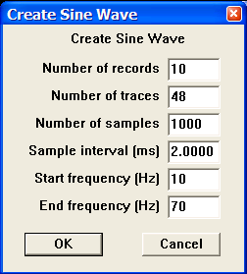

Parameter Description:
Number of records — Enter the number of records to create.

Number of traces — Enter the number of traces per record.

Number of samples — Enter the number of samples per trace.

Sample interval (ms) — Enter the sample interval of the traces in milliseconds.

Start frequency (Hz) — Enter the frequency of the first trace in Hertz.

End frequency (Hz) — Enter the frequency of the last trace in Hertz.

Create Spikes
Usage:
The Create Spikes step builds traces consisting of an impulse response series.

Input Links:
None.

Output Links:
1) Seismic data in any sort order (mandatory).

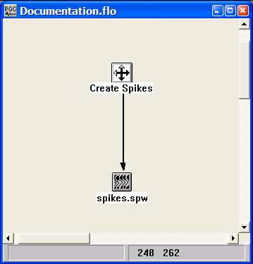
Example Flowchart:

Step Parameter Dialog:
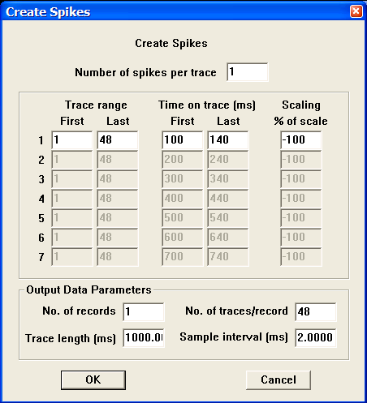

Parameter Description:
Number of spikes per trace — Enter the number of impulses to create on each trace.

Trace Range - First — Enter the first trace in the record that will contain a spike.

Trace Range - Last — Enter the last trace in the record that will contain a spike.

Time on Trace (ms) - First — Enter the time of the spike on the first trace.

Time on Trace (ms) - Last — Enter the time of the spike on the last trace.

Scaling % of scale — Enter the scale as a percentage of the maximum value of the trace for this spike.

Output Data Parameters:
No. of records — Enter the number of records to create.

No. of traces/record — Enter the number of traces per record.

Trace length (ms) — Enter the trace length in milliseconds.

Sample interval (ms) — Enter the sample interval of the traces in milliseconds.

F-X Trace Interpolation
Usage:
The F-X Trace Interpolation step performs a 2-to-1 f-x domain interpolation of the input gather. Trace headers of the interpolated traces are equal to the average of their two neighbors. The Trace Flag header field of the interpolated traces will be equal to 28 on output.

Input Links:
1) Seismic data in any sort order (mandatory).

Output Links:
- Seismic data with interpolated traces.

Reference:
Spitz, S., 1991 Seismic trace interpolation in the f-x domain, Geophysics, 56, p. 785.

Example Flowchart:

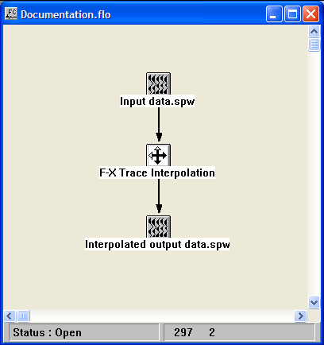
Step Parameter Dialog:

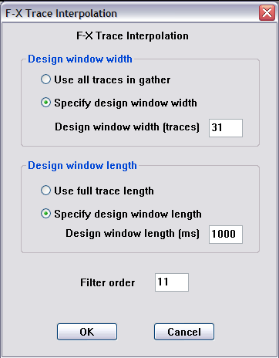

Parameter Description:
Design widow width
Use all trace in gather — Allows the window width to vary with changes in fold for pre-stack trace interpolation.

Specify design window width – Use this option to enter a fixed design width

Design window width (traces) – Enter the width of the design window in units of traces

Design widow length
Use full trace length — Use this option if the design length is to equal the record length.

Specify design window length – Use this option to enter a fixed design length

Design window length (ms) – Enter the length of the design window in units of milliseconds

Filter order — Number of terms in the prediction filter.

I/O SEGY File
Usage:
The I/O SEGY File step is for the direct input of SEGY data recorded with an I/O System IV recording instrument.

Input Links:
1) None. The I/O SEGY file is selected inside the step dialog (mandatory).

Output Links:
1) Seismic data in any sort order (mandatory).

Example Flowchart:

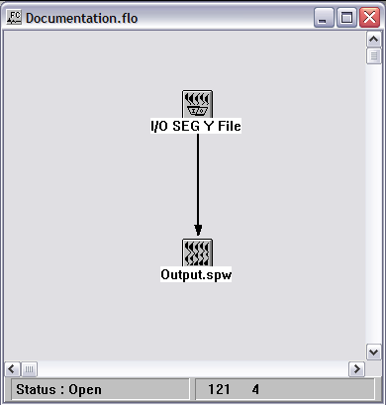

Step Parameter Dialog:

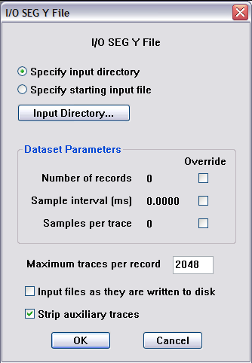

Parameter Description:
Specify input directory — With the radio button set to Specify input directory, the browse button toggles to Input Directory… Use the Input Directory button to specify the folder where the SEGY files are located.

Specify starting input file — With the radio button set to Specify starting input file, the browse button toggles to First Input File… Use the First Input File button to specify the first SEGY file, located inside the Input Directory, to be reformatted.

Number of records — By default, all records will be reformatted. Check the override box to specify the number of records, starting with the first input file.

Sample interval (ms) — By default the sample interval will be extracted from the binary header. If that value is absent or incorrect, check the override box and specify a sample interval in milliseconds.

Samples per trace —By default the number of samples per trace will be extracted from the binary header. If that value is absent or incorrect, check the override box and specify a the number of samples per trace

Interpolate Traces
Usage:
The Interpolate Traces step performs a 2-to-1 time domain interpolation of the input gather.

Input Links:
1) Seismic data in any sort order (mandatory).

Output Links:
None – This process writes directly to an output disk file.

Example Flowchart:

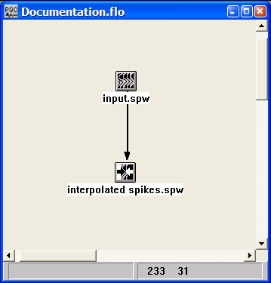
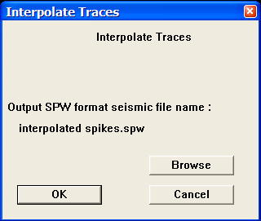
Step Parameter Dialog:

Parameter Description:
Output SPW format seismic file name — Use the Browse button to specify the output file containing the interpolated seismic file.

Progress T2 SEGD File
Usage:
The Progress T2 SEGD File step is for the direct input of SEGD.

Input Links:
1) None. The SEGD file is selected inside the step dialog (mandatory).

Output Links:
1) Seismic data in any sort order (mandatory).

Example Flowchart:

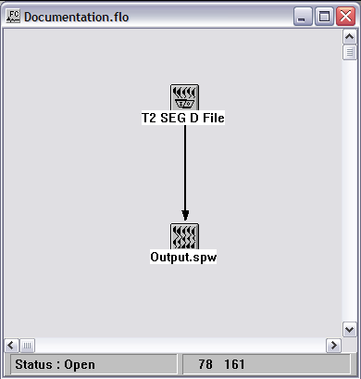

Step Parameter Dialog:

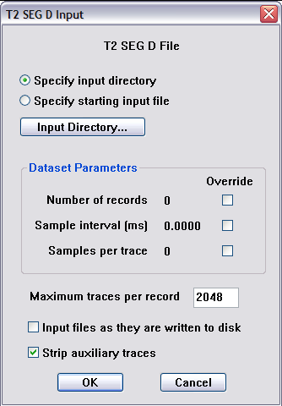

Parameter Description:
Specify input directory — With the radio button set to Specify input directory, the browse button toggles to Input Directory… Use the Input Directory button to specify the folder where the SEGD files are located.

Specify starting input file — With the radio button set to Specify starting input file, the browse button toggles to First Input File… Use the First Input File button to specify the first SEGD file, located inside the Input Directory, to be reformatted.

Number of records — By default, all records will be reformatted. Check the override box to specify the number of records, starting with the first input file.

Sample interval (ms) — By default the sample interval will be extracted from the general header. If that value is absent or incorrect, check the override box and specify a sample interval in milliseconds.

Samples per trace —By default the number of samples per trace will be extracted from the general header. If that value is absent or incorrect, check the override box and specify the number of samples per trace.

Resample Seismic

Usage:
The Resample Seismic step creates a copy of a data set with options to (1) resample to a specified sample interval, and (2) change the start time and trace length of the data on the fly.

Input Links:
1) Seismic data in any sort order (mandatory).

Output Links:
1) Seismic data in any sort order (mandatory).

Example Flowchart:

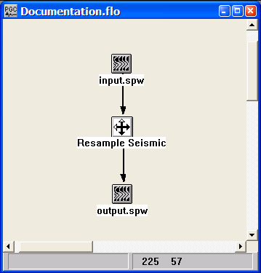
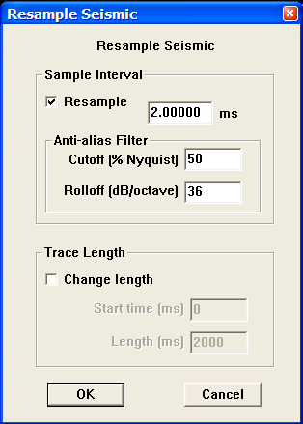
Step Parameter Dialog:

Parameter Description:
Resample — If checked, the traces will be resampled to the specified sample interval.

Anti-alias Filter –

Cutoff (%Nyquist) — Enter the percentage of the Nyquist frequency at which an anti-alias filter is applied.

Rolloff (db/Octave) — Enter the rolloff of the filter in dB/Octave.

Change Length — If checked, the traces will be truncated or extended to the specified length.

Start time (ms) — Enter the start time of the trace to output in milliseconds.

Length (ms) — Enter the length of the trace to output in milliseconds

SEG 2 File
Usage:
The SEG2 File step allows for direct input of SEG-2 formatted data from a disk file.

Input Links:
None. The SEG-2 disk file is selected in the SEG2 File dialog by means of a Browse button.

Output Links:
1) Seismic data file (mandatory).

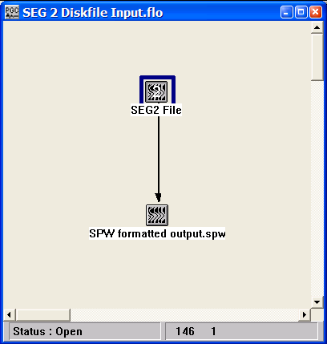
Example Flowchart:

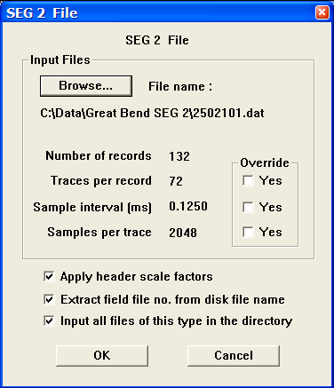
Step Parameter Dialog:

Parameter Description:
Input Files — Select the SEG-2 disk file and set the input parameters.

Browse – Click on the Browse button to select the SEG-2 disk file. Once the file has been selected, the values in the SEG-2 trace header indicating the number of records, the number of traces per record, the sample interval, and the number of samples per trace will be displayed in the SEG-2 File dialog. Be sure to confirm the verity of these values. If they are not as expected, an option exists to override these values so that the SEG-2 file may be successfully reformatted.

Number of records – Indicates the number of records in the SEG-2 disk file inferred from the SEG-2 file header.

Traces per record — Indicates the number of traces per record stored in bytes 6 and 7 of the SEG-2 file descriptor block.

Override – Click yes if the Traces per record value is not correct. Enter the correct value.

Sample interval (ms) — Indicates the sample interval stored in the appropriate sub-string of the SEG-2 file descriptor block.

Override – Click yes if the Sample interval value is not correct. Enter the correct value.

Samples per trace — Indicates the number of samples per trace stored in bytes 8-11 of the SEG-2 trace descriptor block.

Override – Click yes if the Samples per trace value is not correct. Enter the correct value.

Apply header scale factors — If checked, the scale factors written to the trace header will be applied to the output data file.

Extract field file number from disk file name – If checked, the field file number in the output data file will be extracted from the field file name. File extensions will be dropped.

Input all file of this type in the directory – If checked, all additional files of the type selected will be reformatted. Otherwise, only the file selected will be reformatted.

SEG Y File
Usage:
The SEGY File step allows for direct input of SEG Y formatted data from a disk file.

Input Links:
None. The SEG Y disk file is selected in the SEGY File dialog by means of a Browse button.

Output Links:
1) Seismic data file (mandatory).

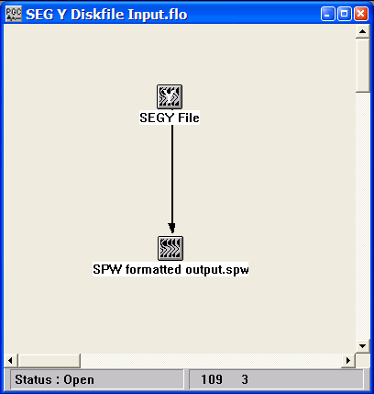
Example Flowchart:

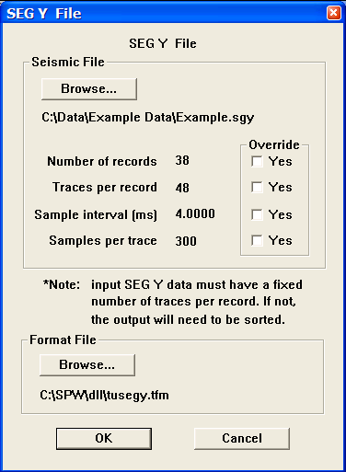
Step Parameter Dialog:

Parameter Description:
Seismic File — Select the SEG Y disk file and set the input parameters.

Browse – Click on the Browse button to select the SEG Y disk file. Once the file has been selected, the values in the SEG-Y trace header indicating the number of records, the number of traces per record, the sample interval, and the number of samples per trace will be displayed in the SEG Y File dialog. Be sure to confirm the verity of these values. If they are not as expected, an option exists to override each of these values so that the SEG-Y file may be successfully reformatted.

Number of records – Indicates the number of records in the SEG-Y disk file inferred from the SEG-Y file header.

Override – Click yes if the Number of records value is not correct. Enter the correct value.

Traces per record — Indicates the number of traces per record stored in bytes 13-14 of the SEG-Y binary file header.

Override – Click yes if the Traces per record value is not correct. Enter the correct value.

Sample interval (ms) — Indicates the sample interval stored in bytes 17-18 of the SEG-Y binary file header.

Override – Click yes if the Sample interval value is not correct. Enter the correct value.

Samples per trace — Indicates the number of samples per trace stored in bytes 21-22 of the SEG-Y binary file header.

Override – Click yes if the Samples per trace value is not correct. Enter the correct value.

Format file — Select the file that accurately describes the SEG-Y file header. A default SEG Y format file is provided that describes the accepted SEG-Y standard as published by the Society of Exploration Geophysics. If the file or trace header of the selected SEG-Y file is known to differ from the SEG standard, an alternate file may be selected that describes the header.

Seismic File
Usage:
The Seismic File step allows you to select or create a SPW format seismic file on disk. It is the input SPW seismic format file and/or the output SPW seismic format file for almost all the processing steps.

Input Links:
The Seismic File may receive input links from any processing step that requires an output seismic data file. In this case, execution of the flow will require that the user provides a file name for the Seismic File by left-clicking on the icon to open the Seismic File dialog and creating the output file name with the Browse button.

Output Links:
Output links from the Seismic File may be directed to any processing step that requires as input a seismic data file. In this case, execution of the flow will require that the user provides a file name for the Seismic File by left-clicking on the icon to open the Seismic File dialog and selecting the input file name with the Browse button.

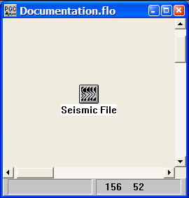
Example Flowchart:

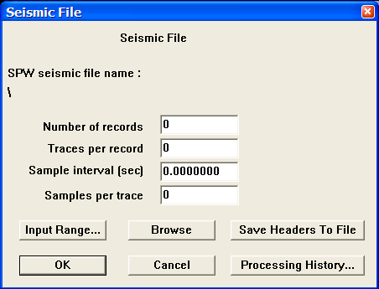
Step Parameter Dialog:

Data description – If the seismic file is linked to an existing file name, the four parameter boxes provide a brief description of the data volume:

Number of records — The number of sort ordered records in the seismic file.

Traces per record — The number of traces per sort ordered record in the seismic file.

Sample interval – The time sample interval of the seismic file in seconds.

Samples per trace – The number of data samples per trace in the seismic file.

Input Range — Select this button to set an input range of records to process.

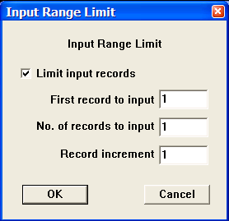
Limit input records — If checked, the input records will be limited to the specified records.

First record to input — Enter the first record to input into the processing flow.

No. of records to input — Enter the number of records to input into the processing flow.

Record increment – Enter the increment between records to input.

Browse — Select this button to set the seismic file name.

Save Headers to File — Select this button to export the seismic trace headers to an output text file. The output text file is a tab-delimited file that may be directly read into various text and spreadsheet applications.

Processing History — Select this button to display a history of all processing steps that have been performed on the data set from the first to the last process.

SPW Demo File
Usage:
The SPW Demo File is a seismic data file generated by the staff of the Parallel Geoscience Corporation that is designed to work with the SPW suite of software tools in Demo Mode. When operating in Demo Mode, the SPW suite of software tools does not require the use of a hardware key. As such, SPW Demo Files are meant to allow prospective users to evaluate the software without the need for a hardware key.

Input Links:
None. This file is created by the staff of the Parallel Geoscience Corporation.

Output Links:
Output links from the Seismic File may be directed to any processing step that requires as input a seismic data file. In this case, execution of the flow will require that the user provides the file name of the SPW Demo File by left-clicking on the icon to open the Seismic File dialog and selecting the input file name with the Browse button.

Example Flowchart:
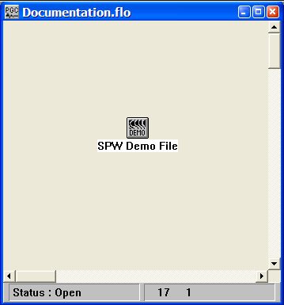

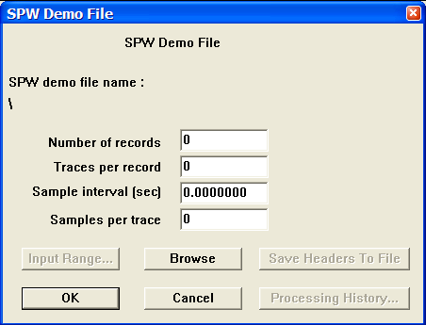
Step Parameter Dialog:

Data description – If the seismic file is linked to an existing file name, the four parameter boxes provide a brief description of the data volume:

Number of records — The number of sort ordered records in the seismic file.

Traces per record — The number of traces per sort ordered record in the seismic file.

Sample interval – The time sample interval of the seismic file in seconds.

Samples per trace – The number of data samples per trace in the seismic file.

Browse — Select this button to set the seismic file name.

Seismic Merge
Usage:
The Seismic Merge step allows you to merge up to a total of five seismic files into a single output seismic file.

Input Links:
- Seismic file in any sort order (mandatory).
- Seismic file in any sort order (mandatory).
- Seismic file in any sort order (optional).
- Seismic file in any sort order (optional).
- Seismic file in any sort order (optional).

Output Links:
1) Seismic data unsorted (mandatory).

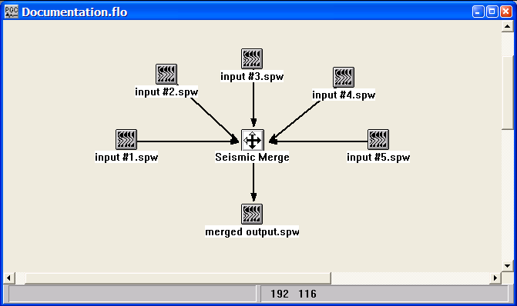
Example Flowchart:

Step Parameter Dialog:
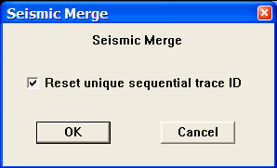

Parameter Description:
Reset unique sequential trace ID — If checked, the SPW unique trace ID will be reset. This is highly recommended, as merged data files will often have overlapping trace ID numbers.

Sercel SEGD File
Usage:
The Sercel SEGD File step is for the direct input of SEGD data files recorded with a Sercel recording instrument.

Input Links:
1) None. The SEGD file is selected inside the step dialog (mandatory).

Output Links:
1) Seismic data in any sort order (mandatory).

Example Flowchart:

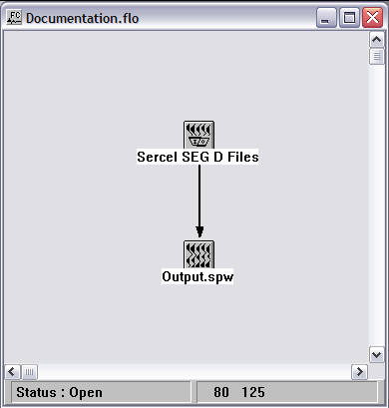

Step Parameter Dialog:

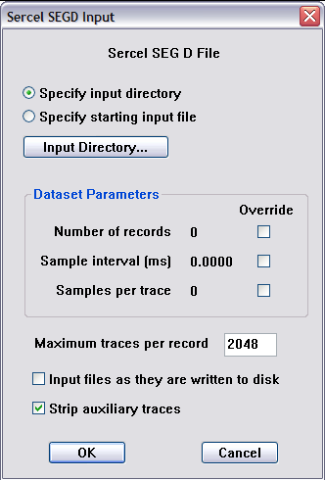

Parameter Description:
Specify input directory — With the radio button set to Specify input directory, the browse button toggles to Input Directory… Use the Input Directory button to specify the folder where the SEGD files are located.

Specify starting input file — With the radio button set to Specify starting input file, the browse button toggles to First Input File… Use the First Input File button to specify the first SEGD file, located inside the Input Directory, to be reformatted.

Number of records — By default, all records will be reformatted. Check the override box to specify the number of records, starting with the first input file.

Sample interval (ms) — By default the sample interval will be extracted from the general header. If that value is absent or incorrect, check the override box and specify a sample interval in milliseconds.

Samples per trace —By default the number of samples per trace will be extracted from the general header. If that value is absent or incorrect, check the override box and specify the number of samples per trace.

Signature Input
Usage:
The Signature Input step allows for direct input of seismic signatures stored in ASCII format. The signature is converted to an SPW formatted seismic file.

Input Links:
None. The signature file must be in a comma delimited format (e.g. -0.07451, ) at the rate of one sample per row. This file is selected in the Signature Input dialog by means of a Browse button.

Output Links:
1) Seismic data file (mandatory).

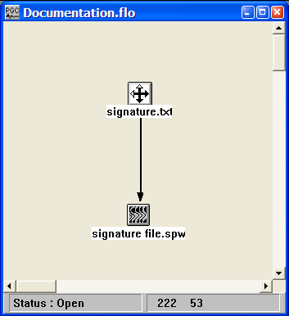
Example Flowchart:

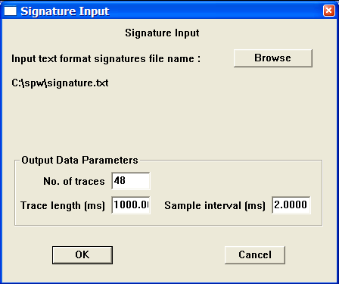
Step Parameter Dialog:

Parameter Description:

Browse — Use the browse button to select the signature file.

Output Data Parameters
Number of traces — The number of times to duplicate the signature file.

Trace length — The trace length of the signature file.

Sample interval (ms) – The time sample interval of the signature file.

Sorting Steps

This section documents the processing steps available in the Sorting Steps category. Each of the sort steps appears on the flow chart as a seismic icon. Therefore, compilation and execution of a seismic sort is performed by either of two methods. First, if the flow segment to be compiled only contains the sort step and the corresponding seismic output, the flow must be compiled and executed as a separate job. This is because the lack of an intermediate-processing step between the sort and the output will result in the compilation of all linked steps on the FlowChart canvas. Second, if the flow to be compiled contains an intermediate processing step (i.e. Copy Seismic Data) between the sort and the seismic output, the flow may be compiled and executed as the subset of a larger job flow on the FlowChart canvas.

Processing steps currently available are:
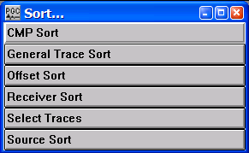

CMP Sort
Usage:
The CMP Sort step allows you to sort a seismic file into CMP ordered records. The CMP Sort step appears on the flow chart as a seismic icon. Therefore, compilation and execution of the CMP Sort is performed by either of two methods. First, if the flow segment to be compiled only contains the sort step and the corresponding seismic output, the flow must be compiled and executed as a separate job. This is because the lack of an intermediate-processing step between the sort and the output will result in the compilation of all linked steps on the FlowChart canvas. Second, if the flow to be compiled contains an intermediate processing step (i.e. Copy Seismic Data) between the sort and the seismic output, the flow may be compiled and executed as the subset of a larger job flow on the FlowChart canvas.

Input Links:
None – This process requires an input seismic disk file in any sort order.

Output Links:
- Seismic data in CMP sort order (mandatory).

References:
See Technical Note TN-Sort.doc

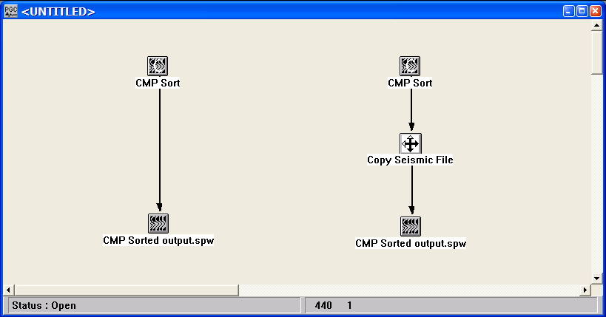
Example Flowchart:

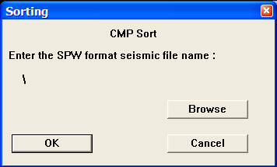
Step Parameter Dialog:

Parameter Description:
Browse — Select this button to set the input seismic file name.

General Trace Sort
Usage:
General Trace Sort allows you to sort your input seismic traces according to primary, secondary, and optional tertiary keys. The keys are trace header fields: Source location, receiver location, CMP location, stack record number (i.e. for data sets containing several stacked sections), offset, field file number, etc... You may select sub-ranges of any key, and choose to bin, or group together, several traces having adjacent sort keys, and omit traces between these bins.

The Primary Sort Key controls the sort type of the records you output. The Secondary Sort Key controls the sort type of the traces of these output records. These two sort keys are mandatory. The Tertiary Sort Key is optional and controls sorting of duplicate trace types such as two traces in a CMP bin at identical offsets.

For each sort key, you control the bin interval and bin size. A bin defines how the sorted data type is grouped. A bin consists of one or more adjacent locations sorted into the same output location. You must specify the size of the bin and the interval between bins. A bin size can be as small as one and as large as the number of locations in your data set. The bin interval is the number of locations to skip to reach the next location for output. The range limits allow you to limit the location in the output to the specific range of location your require for further analysis and processing.

The General Trace Sort step appears on the flow chart as a seismic icon. Therefore, compilation and execution of the General Trace Sort is performed by either of two methods. First, if the flow segment to be compiled only contains the sort step and the corresponding seismic output, the flow must be compiled and executed as a separate job. This is because the lack of an intermediate-processing step between the sort and the output will result in the compilation of all linked steps on the FlowChart canvas. Second, if the flow to be compiled contains an intermediate processing step (i.e. Copy Seismic Data) between the sort and the seismic output, the flow may be compiled and executed as the subset of a larger job flow on the FlowChart canvas.

Input Links:
None – This process requires an input seismic disk file in any sort order.

Output Links:
- Seismic data in the selected sort order (mandatory).

References:
See Technical Note TN-Sort.doc

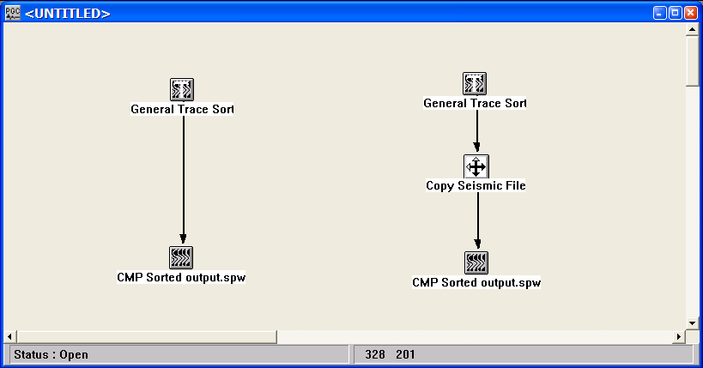
Example Flowchart:

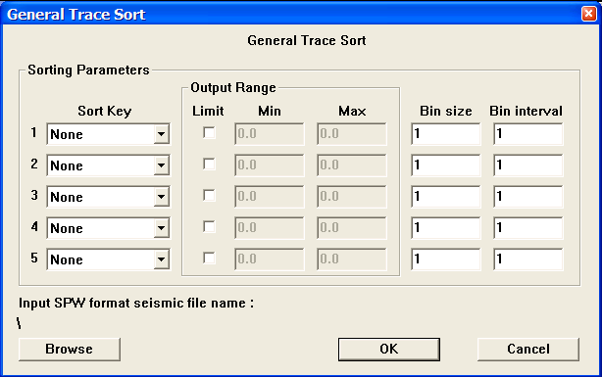
Step Parameter Dialog:
Parameter Description:
Sort Key — Specify the sort key. (i.e. Source, Receiver, CMP Record No., Field File No., Offset etc...)

Output Range limit — If checked, this will set a range limit for the sort key.

Min — Enter the minimum value in the range limit of the sort key.

Max — Enter the minimum value in the range limit of the sort key.

Bin size — Specify a grouping of locations with adjacent sort keys.

Bin interval — Specify the increment between adjacent bins.

Browse — Select this button to set the input seismic file name.

General Sort Examples:

Example # 1 : If you want to sort for output of every third shot record in your data set, you would define the General Trace Sort parameters as follows:

Primary Sort Type: Source
Bin Size: 1
Bin Interval: 3

Secondary Sort Type: Offset
Bin Size: 1
Bin Interval: 1

Your output data set would consist of every third shot record with the traces in each record sorted by increasing offset distance.

Example # 2 : If you want to sort for output of every tenth CMP record in your data set with three adjacent CMP's in each bin (i.e. a CMP super gather for velocity semblance analysis), you would define the General Trace Sort parameters as follows:

Primary Sort Type: CMP
Bin Size: 3
Bin Interval: 10

Secondary Sort Type: Offset
Bin Size: 1
Bin Interval: 1

Your output data set would consist of every tenth CMP record with the traces in each record sorted by increasing offset distance. You could use the Range limits to select a specific range of CMP's and offsets to include in the output data set.

Example # 3 : If you want to sort for output of every shot record in your data set with only every third trace output, you would define the General Trace Sort parameters as follows:

Primary Sort Type: Source
Bin Size: 1
Bin Interval: 1

Secondary Sort Type: Offset
Bin Size: 1
Bin Interval: 3

Your output data set would consist of every shot record with only one-third the input traces present in each output record sorted by increasing offset distance.

Offset Sort
Usage:
The Offset Sort step allows you to sort a seismic file into offset ordered records. The Offset Sort step appears on the flow chart as a seismic icon. Therefore, compilation and execution of the Offset Sort is performed by either of two methods. First, if the flow segment to be compiled only contains the sort step and the corresponding seismic output, the flow must be compiled and executed as a separate job. This is because the lack of an intermediate-processing step between the sort and the output will result in the compilation of all linked steps on the FlowChart canvas. Second, if the flow to be compiled contains an intermediate processing step (i.e. Copy Seismic Data) between the sort and the seismic output, the flow may be compiled and executed as the subset of a larger job flow on the FlowChart canvas.

Input Links:
None – This process requires an input seismic disk file.

Output Links:
- Seismic data in offset sort order (mandatory).

References:
See Technical Note TN-Sort.doc

Example Flowchart:

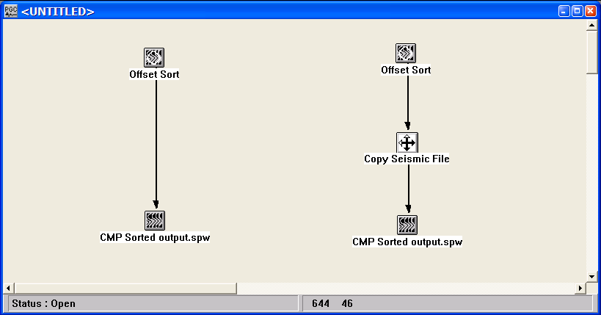
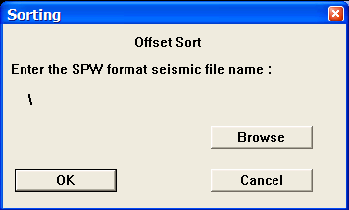
Step Parameter Dialog:

Parameter Description:
Browse — Select this button to set the input seismic file name.

Receiver Sort
Usage:
The Receiver Sort step allows you to sort a seismic file into receiver ordered records. The Receiver Sort step appears on the flow chart as a seismic icon. Therefore, compilation and execution of the Receiver Sort is performed by either of two methods. First, if the flow segment to be compiled only contains the sort step and the corresponding seismic output, the flow must be compiled and executed as a separate job. This is because the lack of an intermediate-processing step between the sort and the output will result in the compilation of all linked steps on the FlowChart canvas. Second, if the flow to be compiled contains an intermediate processing step (i.e. Copy Seismic Data) between the sort and the seismic output, the flow may be compiled and executed as the subset of a larger job flow on the FlowChart canvas.

Input Links:
None – This process requires an input seismic disk file.

Output Links:
- Seismic data in receiver sort order (mandatory).

References:
See Technical Note TN-Sort.doc

Example Flowchart:
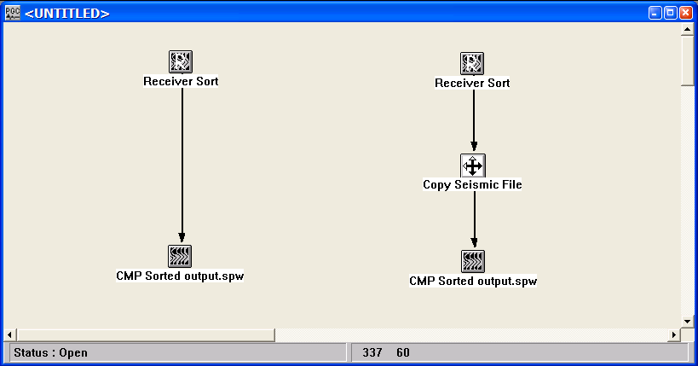

Step Parameter Dialog:
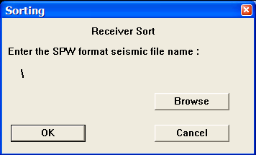

Parameter Description:
Browse — Select this button to set the input seismic file name.

Select Traces
Usage:
The Select Traces step allows you to select seismic data on the basis one or two header words.

Input Links:
1) Seismic data in any sort order (mandatory).

Output Links:
1) Seismic data in any sort order (mandatory).

Example Flowchart:
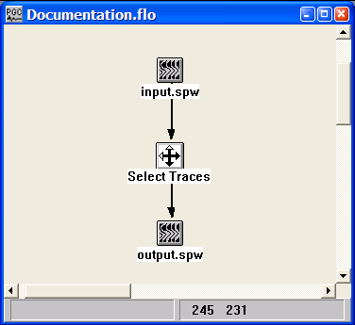
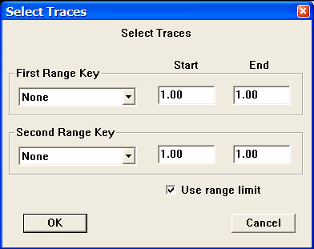
Step Parameter Dialog:

Parameter Description:
Use range limit – If checked, allows selection of minimum and maximum values of the range keys.

First Range Key — Specify the sort key. (i.e. Source, Receiver, CMP Record No., Field File No., Offset etc...).

Start – Enter the first value in the range limit of the first sort key.

End – Enter the last value in the range limit of the first sort key.

Second Range Key — Specify the sort key. (i.e. Source, Receiver, CMP Record No., Field File No., Offset etc...)

Start – Enter the first value in the range limit of the second sort key.

End – Enter the last value in the range limit of the second sort key.

Source Sort
Usage:
The Source Sort step allows you to sort a seismic file into source ordered records. The Source Sort step appears on the flow chart as a seismic icon. Therefore, compilation and execution of the Source Sort is performed by either of two methods. First, if the flow segment to be compiled only contains the sort step and the corresponding seismic output, the flow must be compiled and executed as a separate job. This is because the lack of an intermediate-processing step between the sort and the output will result in the compilation of all linked steps on the FlowChart canvas. Second, if the flow to be compiled contains an intermediate processing step (i.e. Copy Seismic Data) between the sort and the seismic output, the flow may be compiled and executed as the subset of a larger job flow on the FlowChart canvas.

Input Links:
None – This process requires an input seismic disk file.

Output Links:
- Seismic data in receiver sort order (mandatory).

References:
See Technical Note TN-Sort.doc

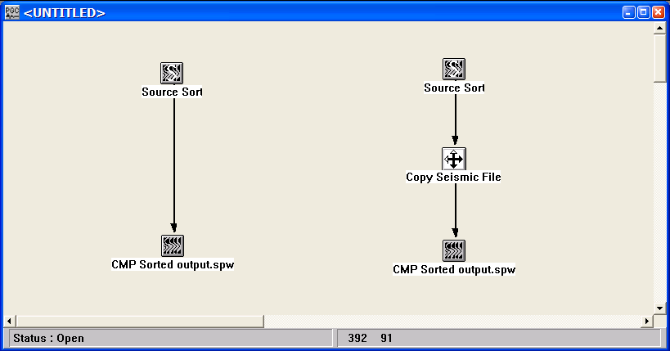
Example Flowchart:

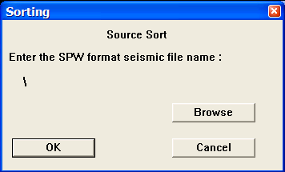
Step Parameter Dialog:

Parameter Description:
Browse — Select this button to set the input seismic file name.

Stacking and Summing Steps
This section documents the processing steps available in the Stacking and Summing Steps category.

Processing steps currently available are:

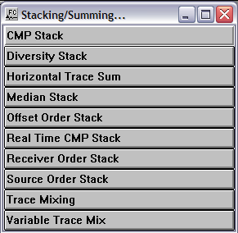
CMP Stack
Usage:
The CMP Stack step generates a CMP stack seismic file from CMP sorted input data. You may choose among stacking all offsets, the near 1/3 offsets, or the mid 1/3 offsets, the far 1/3 offsets. You may also choose to stack signed (positive and negative) or unsigned (absolute value of positive and negative) offsets. For the signed or unsigned offset cases you specify the minimum and maximum offsets to stack. You may apply a scaling exponent for scaling of your traces. Traces are scaled by the fold of your data raised to the power of the chosen exponent (i.e. fold ** EXP). You also specify whether you want to sum relative or absolute amplitude traces.

Input Links:
1) Seismic data in any CMP order (mandatory).

Output Links:
None – This process writes directly to an output disk file.

Example Flowchart:
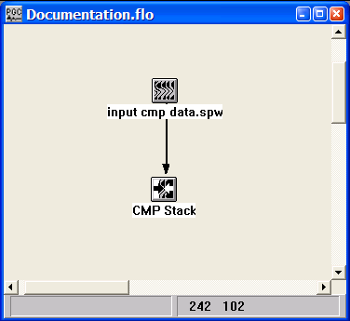

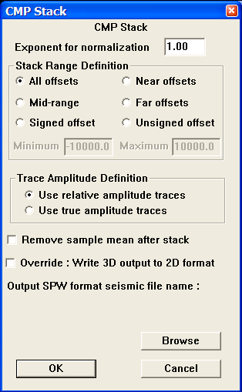
Step Parameter Dialog:

Parameter Description:
Exponent for normalization — Enter the scaling exponent. Traces are scaled by (fold ** EXP).

Stack Range Definition — Set the offset range to stack.

All offsets — All offsets will be stacked.

Near offsets — The near 1/3rd offsets will be stacked.

Mid-range — The mid 1/3rd offsets will be stacked.

Far offsets — The far 1/3rd offsets will be stacked.

Signed offset — Offsets in the signed (both positive and negative offsets) range will be stacked. Specify the minimum and maximum offsets to be used.

Unsigned offset — Offsets in the unsigned (absolute value of positive and negative offsets) range will be stacked. Specify the minimum and maximum offsets to be used.

Minimum — Set the minimum offset range to stack.

Maximum — Set the maximum offset range to stack.

Trace Amplitude Definition — Amplitude summing selection.

Use relative amplitude traces — Relative amplitude traces will be summed in the stacking process. Relative amplitude traces are scaled independently of one another.

Use true amplitude traces — Absolute amplitude traces will be summed in the stacking process. True amplitude traces are scaled by one common factor per record.

Remove sample mean after stack – If checked, removes the average DC bias from each stacked trace.

Override: Write 3D output to 2D format –

Browse — Select this button to set the output seismic file name.

Diversity Stack
Usage:
The Diversity Stack step performs a sample by sample horizontal stack using a specified percent of the samples centered on the median sample.

Input Links:
1) Seismic data in any sort order (mandatory).

Output Links:
None – This process writes directly to an output disk file.

Example Flowchart:

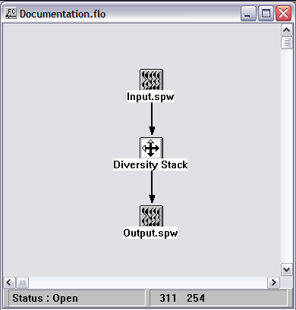

Step Parameter Dialog:

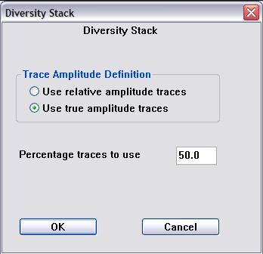

Parameter Description:
Trace Amplitude Definition — Amplitude summing selection.

Use relative amplitude traces — Relative amplitude traces will be summed in the stacking process. Relative amplitude traces are scaled independently of one another.

Use true amplitude traces — Absolute amplitude traces will be summed in the stacking process. True amplitude traces are scaled by one common factor per record.

Percent of traces to use — Enter the percentage of traces to sum into each resulting output diversity stacked trace. A number such as 50 indicates that 50 % of the samples centered on the median sample value will be used in the diversity summed sample.

Horizontal Trace Sum
Usage:
The Horizontal Trace Sum step is used to perform a horizontal sum of multiple input traces into a single output trace on the basis of either the sequential or the offset order of the input traces.

Input Links:
1) Seismic data in any sort order (mandatory).

Output Links:
1) Seismic data in any sort order (mandatory).

Example Flowchart:
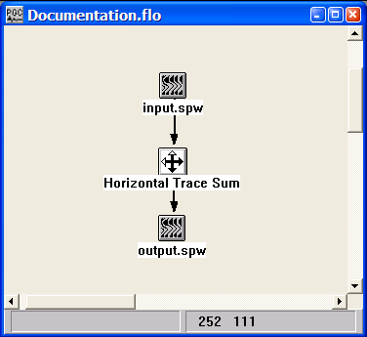
Step Parameter Dialog:
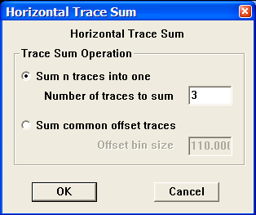

Parameter Description:
Trace Sum Operation – Select whether to sum traces sequentially or by common offset bin.

Sum n traces into one – Enter the number of sequential input traces to sum into a single output trace.

Sum common offset traces – Enter the offset bin size over which input traces will be summed into a single output trace. All input trace offsets falling between (n) * offset bin size and (n+1) * offset bin size will be summed into a single output trace.

Median Stack
Usage:
The Median Stack step performs a sample by sample horizontal stack using a specified percent of the samples centered on the median sample.

Input Links:
1) Seismic data in any sort order (mandatory).

Output Links:
None – This process writes directly to an output disk file.

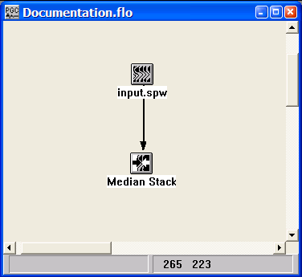
Example Flowchart:

Step Parameter Dialog:
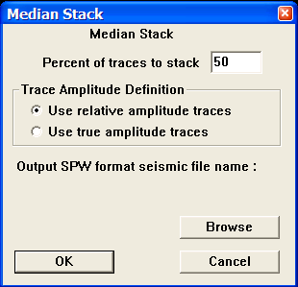
Parameter Description:
Percent of traces to stack — Enter the percentage of traces to sum into each resulting output trace. A number such as 50 indicates that 50 % of the samples centered on the median sample value will contribute to the summed output sample.

Trace Amplitude Definition — Amplitude summing selection.

Use relative amplitude traces — Relative amplitude traces will be summed in the stacking process. Relative amplitude traces are scaled independently of one another.

Use true amplitude traces — Absolute amplitude traces will be summed in the stacking process. True amplitude traces are scaled by one common factor per record.

Browse — Select this button to set the output seismic file name.

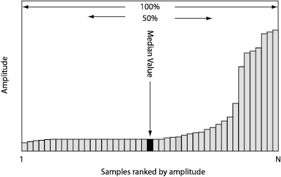
Offset Order Stack
Usage:
The Offset Order Stack step allows you to input data sorted in common offset order and output a common offset stack seismic file. You may apply a scaling exponent for scaling of your traces. Traces are scaled by the fold of your data raised to the power of the chosen exponent (i.e. fold ** EXP). You also specify whether you want to sum relative or absolute amplitude traces.

Input Links:
1) Seismic data in common offset sort order (mandatory).

Output Links:
None – This process writes directly to an output disk file.

Example Flowchart:
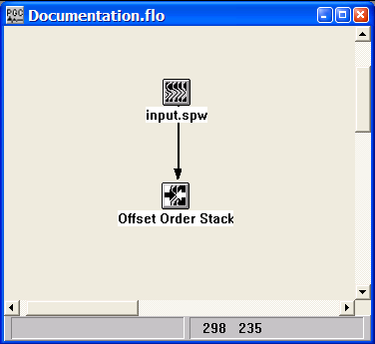

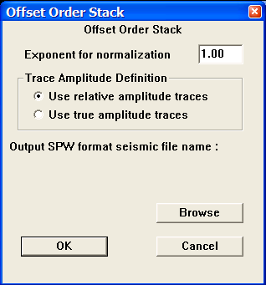
Step Parameter Dialog:

Parameter Description:
Exponent for normalization — Enter the scaling exponent. Traces are scaled by (fold ** EXP).

Trace Amplitude Definition — Amplitude summing selection.

Use relative amplitude traces — Relative amplitude traces will be summed in the stacking process. Relative amplitude traces are scaled independently of one another.

Use true amplitude traces — Absolute amplitude traces will be summed in the stacking process. True amplitude traces are scaled by one common factor per record.

Browse — Select this button to set the output seismic file name.

Receiver Order Stack
Usage:
The Receiver Order Stack step allows you to input data sorted in common receiver order and output a common receiver stack seismic file. You may apply a scaling exponent for scaling of your traces. Traces are scaled by the fold of your data raised to the power of the chosen exponent (i.e. fold ** EXP). You also specify whether you want to sum relative or absolute amplitude traces.

Input Links:
1) Seismic data in common receiver sort order (mandatory).

Output Links:
None – This process writes directly to an output disk file.

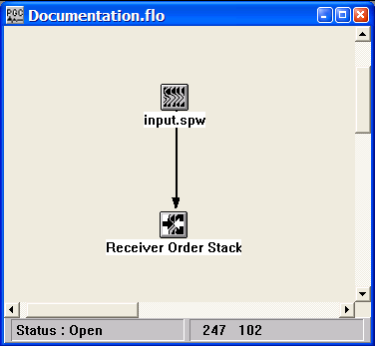
Example Flowchart:

Step Parameter Dialog:
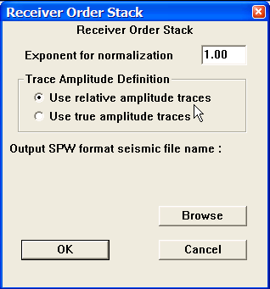

Parameter Description:
Exponent for normalization — Enter the scaling exponent. Traces are scaled by (fold ** EXP).

Trace Amplitude Definition — Amplitude summing selection.

Use relative amplitude traces — Relative amplitude traces will be summed in the stacking process. Relative amplitude traces are scaled independently of one another.

Use true amplitude traces — Absolute amplitude traces will be summed in the stacking process. True amplitude traces are scaled by one common factor per record.

Browse — Select this button to set the output seismic file name.

Source Order Stack
Usage:
The Source Order Stack step allows you to input data sorted in common source order and output a common source stack seismic file. You may apply a scaling exponent for scaling of your traces. Traces are scaled by the fold of your data raised to the power of the chosen exponent (i.e. fold ** EXP). You also specify whether you want to sum relative or absolute amplitude traces.

Input Links:
1) Seismic data in common source sort order (mandatory).

Output Links:
None – This process writes directly to an output disk file.

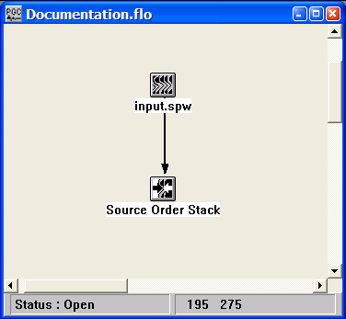
Example Flowchart:

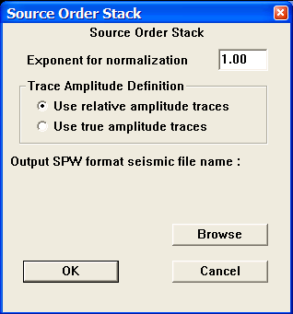
Step Parameter Dialog:

Parameter Description:
Exponent for normalization — Enter the scaling exponent. Traces are scaled by (fold ** EXP).

Trace Amplitude Definition — Amplitude summing selection.

Use relative amplitude traces — Relative amplitude traces will be summed in the stacking process. Relative amplitude traces are scaled independently of one another.

Use true amplitude traces — Absolute amplitude traces will be summed in the stacking process. True amplitude traces are scaled by one common factor per record.

Browse — Select this button to set the output seismic file name.

Trace Mixing
Usage:
The Trace Mixing step is used to perform a weighted horizontal sum of up to fifteen (15) sequential input traces into a single output trace.

Input Links:
1) Seismic data in any sort order (mandatory).

Output Links:
1) Seismic data in any sort order (mandatory).

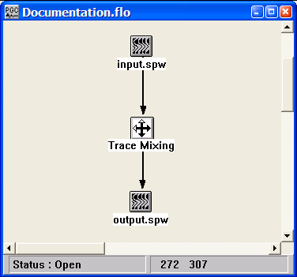
Example Flowchart:

Step Parameter Dialog:
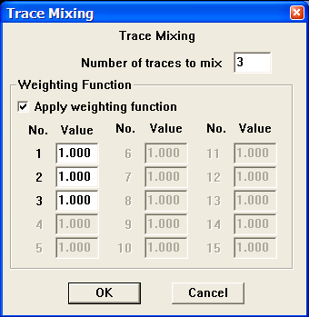

Parameter Description:
Number of traces to mix — Enter the number of traces to mix (blend) into each output trace.

Apply weighting function — If checked, the specified weighting function will be used. Otherwise, each trace contributing to the mix will be equally weighted.

Value — The relative value of the weight for each trace in the mix.

Variable Trace Mix
Usage:
The Variable Trace Mix step is used to perform an unweighted horizontal trace mix of sequential input traces into a single output trace. The number of traces in the mix may vary as a function of trace number in the gather.

Input Links:
1) Seismic data in any sort order (mandatory).

Output Links:
1) Seismic data in any sort order (mandatory).

Example Flowchart:
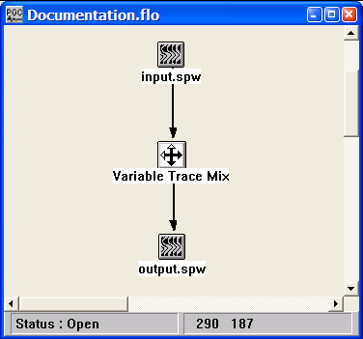

Step Parameter Dialog:
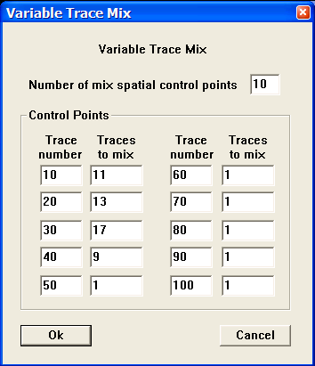
Parameter Description:
Number of mix spatial control points — Enter the number of variable spatial control points to be specified for the mix.

Trace number — Enter a trace number where the number of traces to mix will change.

Traces to mix — Enter the number of traces to mix for this segment of the data.

Statics Steps
This section documents the processing steps available in the Statics Steps category.
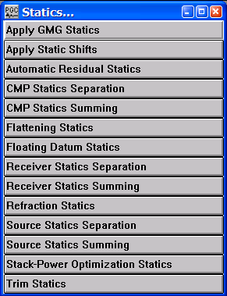
Processing steps currently available are:

Apply GMG Statics
Usage:
The Apply GMG Statics step allows you to apply datum statics, refraction statics, and relative statics calculated by Green Mountain Geophysics third party software. The static shift values can be applied in a coarse grain mode or fine grain mode. The coarse grain mode applies static shifts by shifting to the nearest sample in the time domain. The fine grained mode phase shifts your data in the frequency domain, allowing an efficient method of shifting your data in increments less than the sample interval. Finally, the negative of the static values in the card data can be applied.

Input Links:
1) Seismic data in any sort order (mandatory).
2) GMG Source File (optional).
3) GMG Receiver File (optional).

Output Links:
1) Seismic data in any sort order (mandatory).

Example Flowchart:

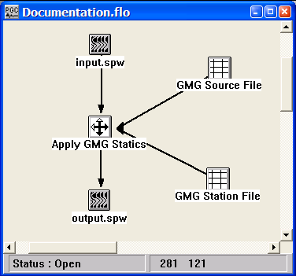
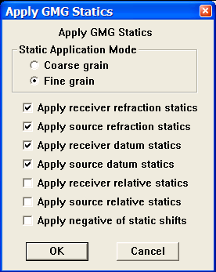
Step Parameter Dialog:

Parameter Description:
Static Application Mode — Select the mode of statics application.

Coarse grain — Statics shifts are applied to the nearest discrete sample position.

Fine grain — Statics shifts are applied as a precise phase shift operator in the Fourier domain.

Apply receiver refraction statics — If checked, the receiver refraction statics in the GMG Station file will be applied.

Apply source refraction statics — If checked, the source refraction statics in the GMG Source file will be applied.

Apply receiver datum statics — If checked, the receiver datum statics in the GMG Station file will be applied.

Apply source datum statics — If checked, the source datum statics in the GMG Source file will be applied.

Apply receiver relative statics — If checked, the receiver relative statics in the GMG Station file will be applied.

Apply source relative statics — If checked, the source relative statics in the GMG Source file will be applied.

Apply negative of static shifts — If this is checked, the negative of the static values will be applied.

Apply Static Shifts
Usage:
The Apply Static Shifts step allows you to apply source, receiver, CMP, and trace statics calculated by any of the various statics processing steps. The static shift values can be applied in a coarse grain mode or fine grain mode. The coarse grain mode applies static shifts by shifting to the nearest sample in the time domain. The fine grained mode phase shifts your data in the frequency domain, allowing an efficient method of shifting your data in increments less than the sample interval.

Input Links:
1) Seismic data in any sort order (mandatory).
2) CMP Statics cards (optional).
3) Receiver Statics cards (optional).
4) Source Statics cards (optional).
5) Trace Statics cards (optional).

Output Links:
1) Seismic data in any sort order (mandatory).

Example Flowchart:

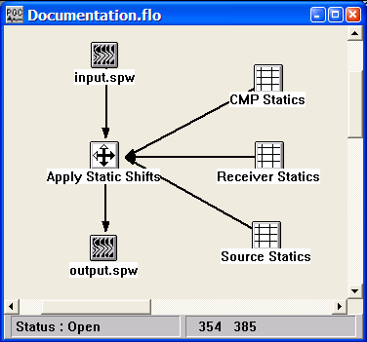
Step Parameter Dialog:
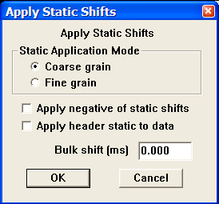

Parameter Description:
Static Application Mode — Select the mode of statics application.

Coarse grain — Statics shifts are applied to the nearest discrete sample position.

Fine grain — Statics shifts are applied as a precise phase shift operator in the Fourier domain.

Apply negative of static shifts — If this is checked, the negative of the static values will be applied.

Apply header statics — If this is checked, the value in the Static Time field in the trace header spreadsheet will be applied to the seismic trace.

Bulk shift in ms — Enter a constant statics shift in milliseconds to apply to all the seismic data traces.

Automatic Residual Statics

2-D Only
Usage:
The Automatic Residual Statics step uses a least-squares linear inversion routine to decompose traveltime equations into source, receiver, CMP, and offset related terms. The pick times input to the inversion are picked automatically using cross correlation in a specified time window. You control the window of data for analysis as well as the maximum allowable static that can be computed. A damping filter can be applied to suppress any long period effects associated with the residual statics solution. Options exist for removing either or both the residual normal moveout (RNMO) term and a linear trend from the statics solution. Surface consistent source and receiver statics are generated and output for later application using the Apply Statics step.

Input Links:
1) Seismic data - NMO corrected CMP gathers (mandatory).

Output Links:
1) Source Statics cards (mandatory).
2) Receiver Statics cards (mandatory).

Reference:
Wiggins, R. A., et al., 1976, Residual statics analysis as a general linear inverse problem: Geophysics, vol. 50, no. 11, p. 2172ff.
See Technical Note TN-ResSt.doc

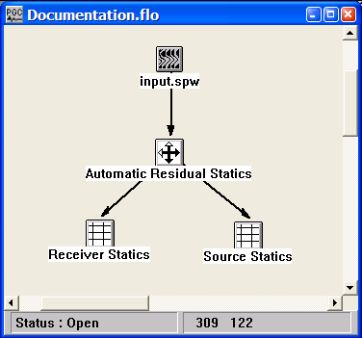
Example Flowchart:

Step Parameter Dialog:

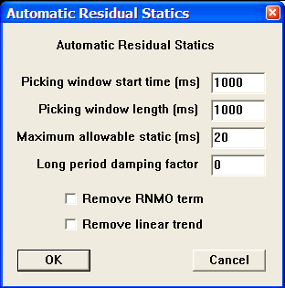

Parameter Description:
Picking window start time (ms) — Enter the time in milliseconds of the start of the cross correlation window for picking the times for use in the residual statics calculation.

Picking window length (ms) — Enter the length of the correlation window in milliseconds for picking the times for use in the residual statics calculation. {>0}

Maximum allowable static (ms) — Enter the maximum allowable static shift pick (number of correlation lags) in milliseconds. {>0}

Long period damping factor — This parameter controls the degree the periodic components in the statics solution longer than a spread length will be damped. {-8,8}

Remove RNMO term — If checked, residual normal moveout (RNMO term) will be included in the matrix calculations of the solution. If this term is not included in the matrix, then the RNMO will affect the source and receiver static solutions.

Remove linear trend — If checked, a least squares linear fit will be removed from the final statics solution.

CMP Statics Separation
Usage:
The CMP Statics Separation step inputs CMP Statics card data and separates the statics into long and short period components. The operator is currently a 2-D operator which operates in the in-line direction.

Input Links:
1) CMP Statics cards (mandatory).

Output Links:
1) CMP Statics cards (mandatory).
2) CMP Statics cards (mandatory).

Example Flowchart:
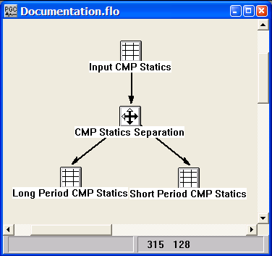
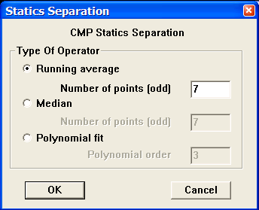
Step Parameter Dialog:

Parameter Description:
Type Of Operator - defines the type of function to use for defining the fit to the long period statics solution.

Running Average — This selects an averaging smoothing operator.

Number of points (odd) — Enter the number of points in the running average smoother.

Median — This selects a median smoothing operator.

Number of points (odd) — Enter the number of points in the median smoother.

Polynomial fit — This selects a polynomial fitting operator to approximate the long period statics.

Polynomial order — Enter the order of the orthogonal polynomials to fit to the data.

CMP Statics Summing
Usage:
The CMP Statics Summing step will sum together two input CMP Statics card data files into a single output CMP Statics card data file.

Input Links:
1) CMP Statics cards (mandatory).
2) CMP Statics cards (mandatory).

Output Links:
1) CMP Statics cards (mandatory).

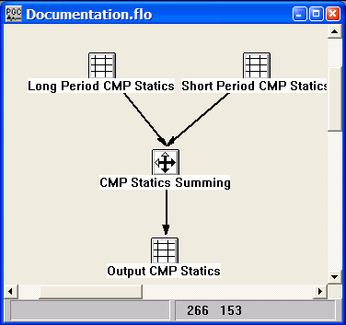
Example Flowchart:

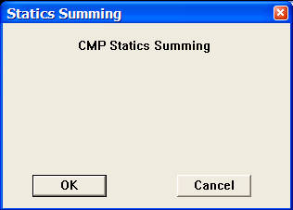
Step Parameter Dialog:

Parameter Description:
There are no parameters for this step.

Flattening Statics

Usage:
The Flattening Statics step inputs a seismic data file and a corresponding Horizon File pick card, and outputs a set of CMP Static cards. You can then apply these CMP statics using the Apply Statics step to flatten the picked horizon on a stack to the datum you specify. You have the option of applying a smoothing operation to the set of CMP static time shifts using a running average, median, or polynomial smoothing operator.

Input Links:
- Seismic File (mandatory).
- Horizon File cards (mandatory).

Output Links:
1) CMP Statics cards (mandatory).

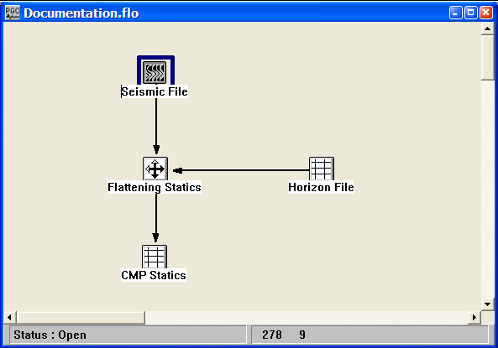
Example Flowchart:

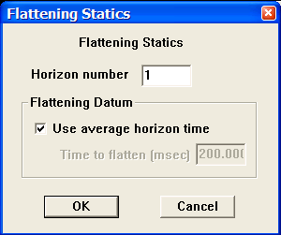
Step Parameter Dialog:

Parameter Description:
Horizon number – Enter the number of the horizon in the Horizon File card used to determine the static shifts.

Flattening Datum – Statics can be computed that will flatten the chosen horizon to the average horizon time or to a specified constant time.

Use average horizon time – If checked, the CMP statics card will contain statics that flatten the chosen horizon to a time that is the average of all times defining the horizon.

Time to flatten (msec) – If chosen, the CMP statics card will contain statics which flatten the chosen horizon to the specified constant time.

Floating Datum Statics
Usage:
The Floating Datum Statics step inputs the trace headers from a Seismic Data file and outputs a set of Source and Receiver static files that adjust the data to a floating datum, and CMP static file that asdjusts the data from the floating datum to a flat datum. Alternatively, the Source and Receiver statics can be computed that adjust the surface data directly to a flat datum. In both cases, the statics are applied using the Apply Statics step.

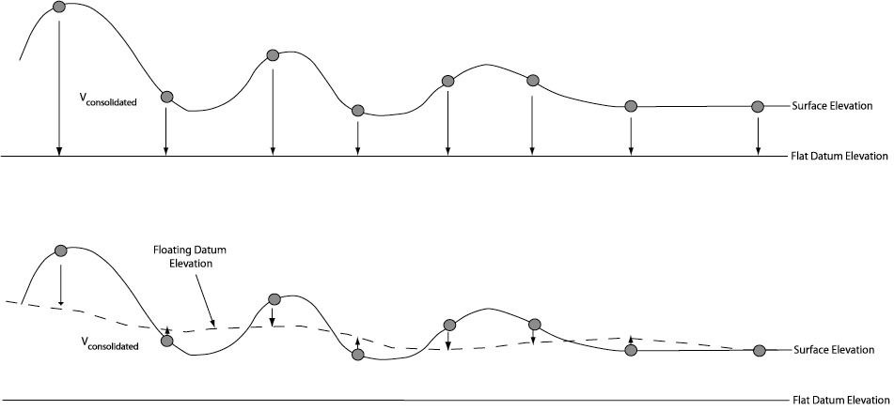

Input Links:
1) Seismic data file in any sort order (mandatory).

Output Links:
1) Source Statics cards (mandatory).
2) Receiver Statics cards (mandatory).
3) CMP Statics cards (optional, in the case of correction to a Floating Datum).

Example Flowcharts:
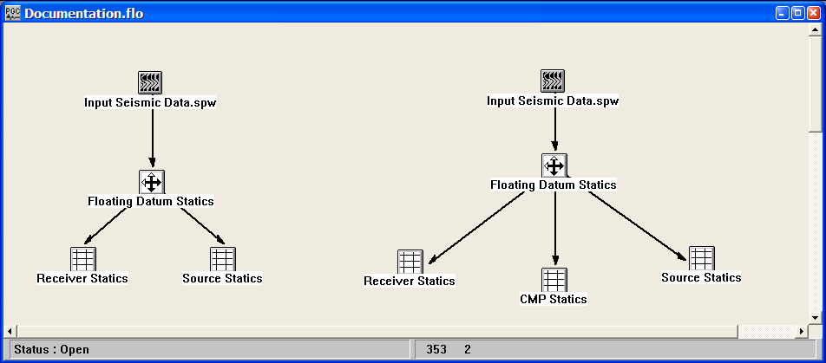
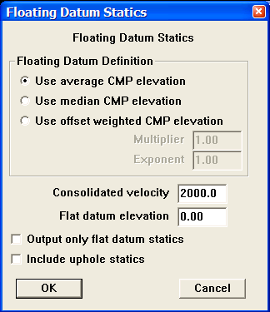
Step Parameter Dialog:

Parameter Description:
Floating Datum Definition - defines the type of function to use for defining the floating datum.

Average — This selects an average operator.

Median — This selects a median smoothing operator.

Offset weighted CMP Elevation — If selected, a weighted CMP elevation function of the form weight = multiplier*(offset **exponent ) will be used to define the datum.

Multiplier — Enter the multiplier of the weighting function.

Exponent — Enter the exponent of the weighting function.

Consolidated velocity — Enter the consolidated, or replacement velocity.

Flat datum elevation — Enter the elevation of the flat datum to use.

Output only flat datum statics — If checked, only the flat datum statics will be output. Source and receiver statics will be from the surface to the flat datum. The CMP statics will be output as 0.

Include uphole static — If checked, the uphole static will be included.

Receiver Statics Separation
Usage:
The Receiver Statics Separation step inputs Receiver Statics card data and separates the statics into long and short period components. The current separation operator is a 2-D operator that operates in the in-line direction. The first output link will contain the long period statics, and the second output link will contain the short period statics.

Input Links:
1) Receiver Statics cards (mandatory).

Output Links:
1) Receiver Statics cards (mandatory). The first link contains the long period statics.
2) Receiver Statics cards (mandatory). The second link contains the short period statics.

Example Flowchart:
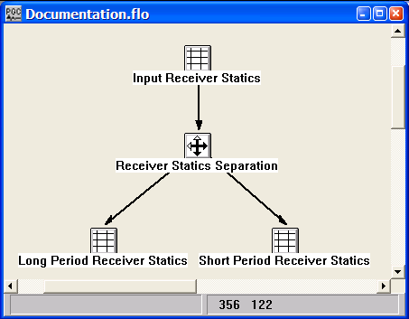
Step Parameter Dialog:
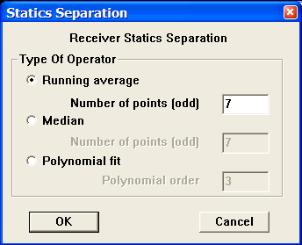

Parameter Description:
Type Of Operator - defines the type of function to use for defining the fit to the long period statics solution.

Running Average — This selects an averaging smoothing operator.

Number of points (odd) — Enter the number of points in the running average smoother.

Median — This selects a median smoothing operator.

Number of points (odd) — Enter the number of points in the median smoother.

Polynomial fit — This selects a polynomial fitting operator to approximate the long period statics.

Polynomial order — Enter the order of the orthogonal polynomials to fit to the data.

Receiver Statics Summing
Usage:
The Receiver Statics Summing step will sum together two input Receiver Statics card data files into a single output Receiver Statics card data file.

Input Links:
1) Receiver Statics cards (mandatory).
2) Receiver Statics cards (mandatory).

Output Links:
1) Receiver Statics cards (mandatory).

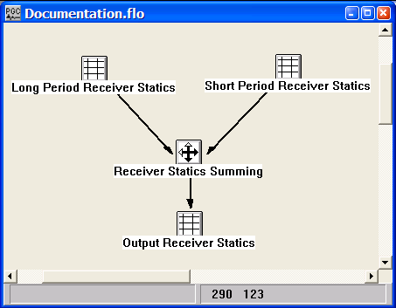
Example Flowchart:

Step Parameter Dialog:
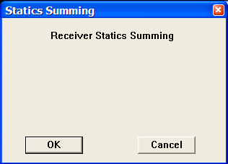

Parameter Description:
There are no parameters for this step.

Refraction Statics
(2D Only)
Usage:
The Refraction Statics step generates 2D Source and Receiver Statics card data files based on a one or two layer refraction statics solution. The step requires as input a seismic data file with complete geometry header information and a First Break Time Picks card.

Input Links:
1) Seismic data in any sort order (mandatory).
2) First Break Time Pick card (mandatory).

Output Links:
- Receiver Statics cards (mandatory).
- Source Statics cards (mandatory).

Reference:
Farrell, R. C., and Euwema, R. M., 1984, Refraction Statics, IEEE, 72, no.10, p 1316-1329.

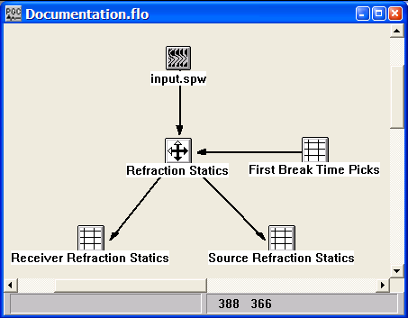
Example Flowchart:

Step Parameter Dialog:
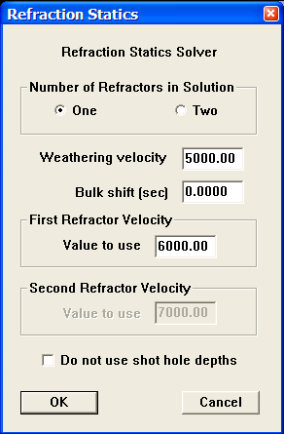

Parameter Description:
Number of Refractors in Solution – Select whether to compute a one- or a two-layer refraction static solution.

Weathering velocity – Enter the value of the weathering (i.e. overburden) velocity.

Bulk Shift – Enter a constant statics shift in milliseconds to apply to all the seismic data traces.

First Refractor Velocity – Enter the constant value to be used for the first refractor velocity.

Second Refractor Velocity – Enter the constant value to be used for the second refractor velocity.

Do not use shot hole depths – If checked, the value in the Source Depth field of the trace header spreadsheet will not be used when computing the refraction static solution.

Source Statics Separation
Usage:
The Source Statics Separation step inputs Source Statics card data and separates the statics into long and short period components. The current separation operator is a 2-D operator that operates in the in-line direction. The first output link will contain the long period statics, and the second output link will contain the short period statics.

Input Links:
1) Source Statics cards (mandatory).

Output Links:
1) Source Statics cards (mandatory). The first link contains the long period statics.
2) Source Statics cards (mandatory). The second link contains the short period statics.

Example Flowchart:
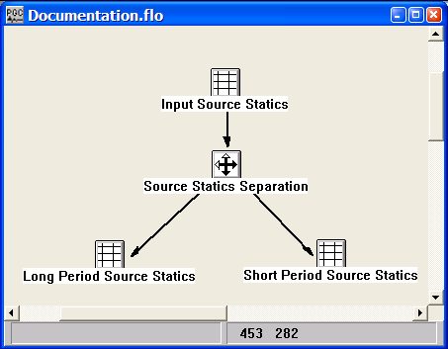
Step Parameter Dialog:
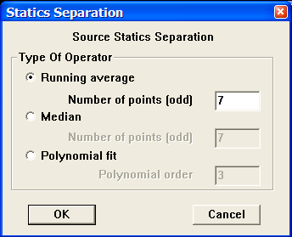

Parameter Description:
Type Of Operator - defines the type of function to use for defining the fit to the long period statics solution.

Running Average — This selects an averaging smoothing operator.

Number of points (odd) — Enter the number of points in the running average smoother.

Median — This selects a median smoothing operator.

Number of points (odd) — Enter the number of points in the median smoother.

Polynomial fit — This selects a polynomial fitting operator to approximate the long period statics.

Polynomial order — Enter the order of the orthagonal polynomials to fit to the data.

Source Statics Summing
Usage:
The Source Statics Summing step will sum together two input Source Statics card data files into a single output Source Statics card data file.

Input Links:
1) Source Statics cards (mandatory).
2) Source Statics cards (mandatory).

Output Links:
1) Source Statics cards (mandatory).

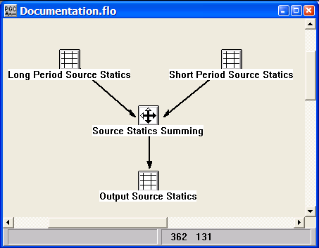
Example Flowchart:

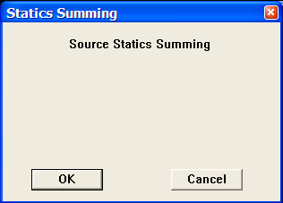
Step Parameter Dialog:

Parameter Description:
There are no parameters for this step.

Stack-Power Optimization Statics

2-D/3-D
Usage:
The Stack-Power Optimization Statics step calculates surface consistent residual static time corrections by maximizing the power in the stack. Source and receiver super traces are cross-correlated with corresponding CMP super traces to determine a surface consistent static correction.

For 3-D, the input seismic file is required to be a CMP binned seismic volume. For 2-D, the input seismic file can be in any sort order, as long as Geometry Definition has been applied. Binning geometry for 3-D surveys should include all shot and receiver locations. Set the bin origin at the minimum source, receiver or CMP location.

Output stacks may be generated to evaluate the quality of the statics. The stacks show the sorted input file stacked in the analysis window with static corrections applied. The stacks are accumulated in the frequency domain and back transformed for the final stack trace. Numerical round off may cause slight variations when compared with stacks from the CMP Stack processing step. Stack type may be source, receiver or CMP.

Analysis stacks at specified intervals may be created to evaluate optimal convergence. The analysis stacks are a selected subset of source, receiver or CMP lines output to a specified directory. A unique filename suffix is assigned automatically for each iteration. Small subsets are recommended to reduce disk storage requirements. Full volume source, receiver and CMP stacks with user specified filename may be output for the final iteration.

An option exists to output to the console a summary of the static corrections generated at the end of each iteration. The source and receiver statics output by the Stack-Power Optimization Statics Step are applied with the Apply Statics step.

Input Links:
- Seismic data, 3-D binned or 2-D in any sort order with geometry applied (mandatory).

Output Links:
- Source statics cards (mandatory).
- Receiver statics cards (mandatory).
- Selected stack analysis files (optional).
- Selected stack volume (optional).

Reference:
Ronen J., and Claerbout, J., 1985, Surface-consistent residual statics estimation by stack-power maximization, Geophysics, vol. 50, no. 12, p. 2759-2767.
Example Flowcharts:
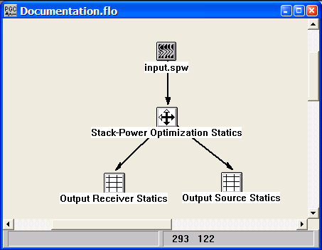

Step Parameter Dialog:

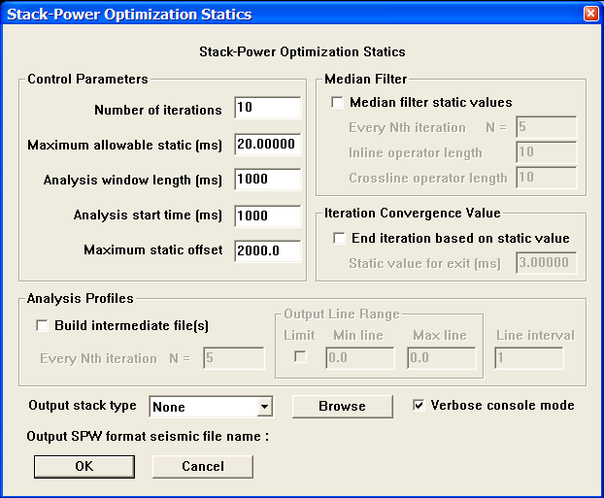

Parameter Description:
Control Parameters -
Number of iterations — Maximum number of iterations for the processing step.

Maximum allowable static — Static shifts for each iteration are not allowed to exceed this value in ms. The final static is the sum of statics at each iteration. The total static may exceed the maximum allowable static per iteration.

Analysis window length — Correlation window size for stack-power evaluation in ms. The window starts at ‘Analysis start time’.

Analysis start time — Start time for correlation window in ms.

Maximum static offset — Offsets greater than this value in feet or meters are not included in the stacked sections. A warning appears in the console window if the maximum-static offset criteria results in the removal of more than 95% of the stack trace fold

Median filter static values — If checked, a running median spatial filter is applied to each sample. The filter is an effective way to remove spikes. The operator size is specified along inline and crossline directions. The crossline operator size is restricted to 1 for 2-D seismic data.

Every Nth iteration — Apply the median filter at this iteration interval. A value of 1 applies the filter every iteration.

Inline operator length — Spatial size of median filter along the inline direction in samples.

Crossline operator length — Spatial size of median filter along the crossline direction in samples. Restricted to 1 for 2-D seismic data.

End iteration based on static value — If checked, stop the process when the maximum static shift for the iteration is less than the specified value.

Static value for exit — Maximum static in ms.

Build intermediate files — If checked, intermediate analysis profiles are written to the directory specified by the ‘Output SPW format seismic file name’ selection. Suffices are appended automatically based on iteration number. The naming convention appends _tmp[iteration number] to the output seismic file name, where [iteration number] is an integer from 1 to the number of iterations. Files are overwritten on subsequent iterations. Intermediate files are output only over the analysis window and are used to judge section quality for the output iteration. The analysis files are recommended to be a subset of the full volume to reduce disk storage requirements. A full volume stack is output for the final iteration.

Iteration interval — Intermediate files are output for every Nth iteration.

Output Line Range — If the limit box is checked, analysis files are built for lines between the min/max line values at the line interval. Min/Max line and line interval is restricted to be 1 for 2-D seismic. If the limit box is unchecked, only the line interval is applied to the output stack starting at the first line.

Output Stack Type —Select the output stack type. Stack type may be CMP, source, receiver or none.

Verbose console mode — If this box is checked, static shifts for each unique line and location number are summarized for each iteration in the console window.

Output SPW format seismic file name— The output file name for the final stack. The file name is specified using the Browse button.

Surface Consistent Statics

Usage:
The Surface Consistent Statics step calculates source and receiver residual statics using a Gauss-Seidel iterative method to solve for the source static, receiver static, structure term, and residual NMO) that provide a best fit to the linear traveltime equations in a least-squares sense. linear inversion routine to decompose traveltime equations into source, receiver, CMP, and offset related terms. The pick times input to the inversion are picked automatically using cross correlation in a specified time window. You control the window of data for analysis as well as the maximum allowable static that can be computed. A damping filter can be applied to suppress any long period effects associated with the residual statics solution. Options exist for removing either or both the residual normal moveout (RNMO) term and a linear trend from the statics solution. The source and receiver statics output by the Surface Consistent Residual Statics Step are applied with the Apply Statics step.

Input Links:
1) Seismic data - NMO corrected CMP gathers (mandatory).

Output Links:
1) Source Statics cards (mandatory).
2) Receiver Statics cards (mandatory).

Reference:
Wiggins, R. A., et al., 1976, Residual statics analysis as a general linear inverse problem: Geophysics, vol. 50, no. 11, p. 2172ff.
See Technical Note TN-ResSt.doc

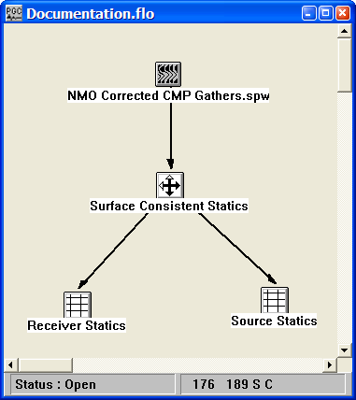
Example Flowchart:

Step Parameter Dialog:
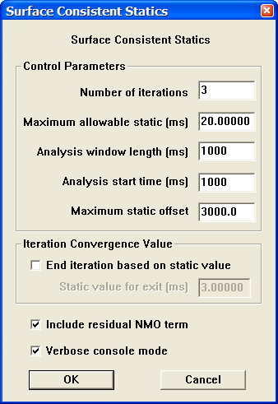

Parameter Description:
Control Parameters

Number of iterations — Enter the number of iterations performed to calculate final source and receiver statics. The value must be greater than zero, and it is suggested that the value be no larger than 5.

Maximum allowable static (ms) — Enter the maximum allowable static shift in milliseconds. {>0}

Analysis window length (ms) — Enter the length of the analysis window. The trace data used for cross correlation with the pilot trace will extend from the start time to (start time + window length).

Analysis start time (ms) — Enter the start time for statics analysis.

Maximum static offset – Enter the largest offset used during analysis to generate source and receiver residual statics.
Iteration Convergence Value – The option exists end the Gauss-Seisdel iterative scheme based on a maximum static supplied by the user.

End iteration based on static value — If checked, the Gauss-Seidel iterative scheme will end if maximum static computed in the previous iteration does not exceed a user-specified value.

Static value for exit (ms) – Enter the maximum static.

Include residual NMO term — If checked, a least squares linear fit will be removed from the final statics solution.

Verbose console mode — If checked, a least squares linear fit will be removed from the final statics solution.

Trim Statics
Usage:
Trim Statics calculates small CMP statics shifts for the data based on alignment of events within the specified window. You specify the start time and the length of the analysis window for calculation and the maximum allowed static shift. The step finds the static shift within these limits using automatic picking of the peak of the cross-correlation amplitude between the trace and the stacked trace for the gather.

Input Links:
1) Seismic data in CMP sort order (mandatory).

Output Links:
1) Seismic data in CMP sort order (mandatory).
2) Trace Statics (optional)

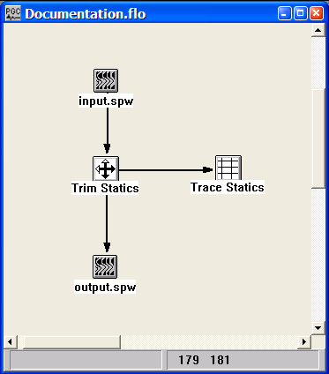
Example Flowchart:

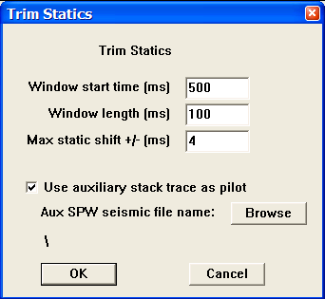
Step Parameter Dialog:

Parameter Description:
Window start time (ms) — Enter the window start time in milliseconds for trim statics analysis.

Window length (ms) — Enter the length of the window in milliseconds for trim statics analysis.

Max static shift +/- (ms) — Enter the largest allowable static shift in milliseconds for trim statics analysis.

Use auxiliary stack trace as pilot – If checked, an auxiliary stack file may be selected and the stack traces in that file will serve as the trim static pilot traces.

Aux SPW seismic file name – Use the Browse button to select the auxiliary stack file.

Velocities
This section documents the processing steps available in the Velocity Steps category.

Processing steps currently available are:

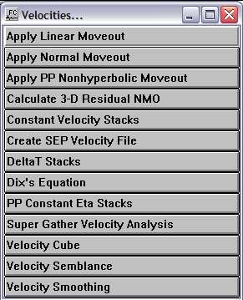

Apply Linear Moveout
Usage:
The Apply Linear Moveout step allows you to apply a linear moveout function in either the forward or inverse direction. You specify the moveout velocity. You may also apply a constant static shift to your data. The moveout correction may be applied in a coarse or fine-grained application mode. A coarse grained static shift is applied to the nearest sample. Fine-grained static shifts are applied in the frequency domain by phase shifting your data.

Input Links:
1) Seismic data in any sort order (mandatory).

Output Links:
1) Seismic data in any sort order (mandatory).

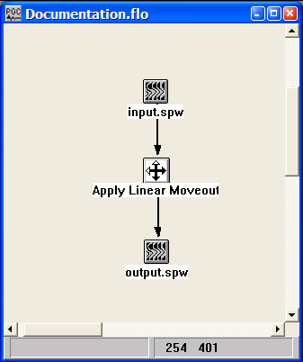
Example Flowchart:

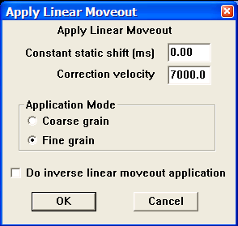
Step Parameter Dialog:

Parameter Description:
Constant static shift (ms) — Enter a constant static shift in milliseconds.

Correction velocity — Enter the constant moveout velocity.

Static Application Mode — Select the statics application mode.

Coarse grain — This specifies the statics shifts will be applied to the nearest discrete sample position.

Fine grain — This specifies the statics shifts will be applied as a precise phase shift operator in the Fourier domain.

Do inverse linear moveout application — If checked, inverse linear moveout will be applied to your data.

Apply NMO
Usage:
The NMO Correction step allows you to apply normal moveout corrections to your pre-stack data using a single velocity or a set of velocity function cards. You choose between a linear or quadratic interpolation method for interpolating trace sample values back to even sample intervals after applying the moveout. You may also apply a stretch mute to your NMO corrected data. A constant velocity moveout may be accomplished by inputting a correction velocity in the dialog and not connecting any velocity function cards to the step. The NMO process automatically spatially interpolates the velocity over the entire range of CMPs in the line.

In the case of 3D data, the velocity functions are interpolated using a 2-D Delaunay triangulation weighting of evaluation points. Velocity function CMP locations are triangulated, then barycentric coordinates are used to compute weights between velocity functions. The interpolation is done laterally. No allowance is made for structure. An option allows for the application of a non-hyperbolic moveout correction.

Input Links:
1) Seismic data in any sort order (mandatory).
2) Velocity Function cards (optional).

Output Links:
- Seismic data in any sort order (mandatory).

References:
See Technical Note TN-NonHyperbolicMoveout.doc

Example Flowchart:
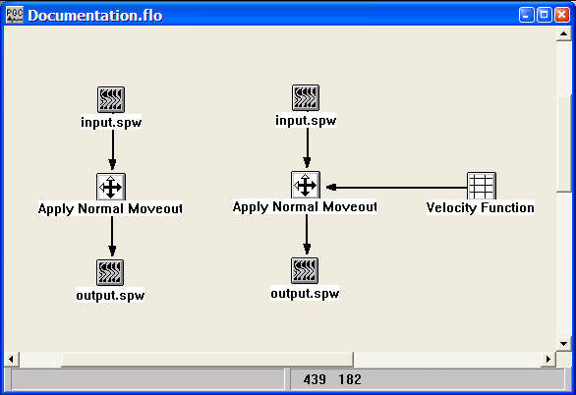
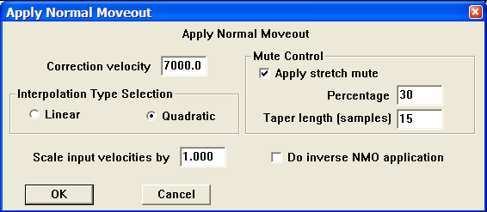
Step Parameter Dialog:

Parameter Description:
Correction velocity — Enter the NMO velocity. This constant velocity that will be used if a set of velocity function cards is NOT linked to the NMO correction step.

Interpolation Type Selection — Select the interpolation type (linear or quadratic). The moveout function causes trace data samples to be moved in time to new locations. Since these new time locations of the data sample values are not usually exactly at the sample interval of the data, the data is interpolated to be evenly sampled at the correct sample interval.

Linear — Linear interpolation uses the equation of a line (y = mx + b) to interpolate data values between or beyond existing data.

Quadratic — Quadratic interpolation uses the equation of a quadratic (y = ax^2 + bx + c) to interpolate data values between or beyond existing data.

Mute Control — Set the parameters for the stretch mute definition.

Apply stretch mute — If checked, a stretch mute will be applied to the NMO corrected data. Stretch muting removes the stretching of the data due to the NMO correction.

Percentage — Enter the percent stretch mute. The smaller the percent the more severe the mute function.

Taper length — Enter the mute tape length in samples. Longer taper lengths result in a smoother transition from the mute zone to the data zone.

Scale input velocities by – Enter the amount by which the input velocities are scaled up or down. A value of 1.0 does not alter the velocity field.

Do inverse NMO application — If checked, the inverse NMO correction will be applied, instead of the usual forward NMO.

Apply PP Non-hyperbolic Moveout

Usage:
Non-hyperbolic P-wave moveout may become significant when source-receiver offsets are approximately equal to or greater than the depth of reflection. The resulting deviations from the hyperbolic traveltime equation may be attributed to one or more phenomena: (1) The standard hyperbolic travel-time equation is only a two-term, short-offset approximation of the full travel-time equation for P-wave reflections in layered media; (2) the earth media may be anisotropic. The Apply PP Non-hyperbolic Moveout step uses the travel-time equation for transversly isotropic (TI) media described by Alkhalifah and Tsvankin (1997). The resulting moveout is a function of the zero-offset time, the source-receiver offset, P-wave short-spread stacking velocity, and η (eta), where eta is an effective anisotropy parameter that measures the ratio of horizontal to vertical P-wave velocity. The Apply PP Non-hyperbolic Moveout step uses the combination of P-wave stacking velocities and Eta functions to correct for non-hyperbolic moveout.

Input Links:
- Seismic data in any sort order (mandatory).
2) PP Nhmo Eta Function card containing eta pics (mandatory).

Output Links:
1) Seismic data in any sort order (mandatory).

Reference:
Alkhalifah, Tariq, 1997, Velocity analysis using nonhyperbolic moveout in transversely isotropic media: Geophysics, 62, 1839-1854.
Alkhalifah, Tariq, and Tsvankin, Ilya, 1995, Velocity analysis for transversely isotropic media: Geophysics, 60, 1550-1566.

Example Flowchart:
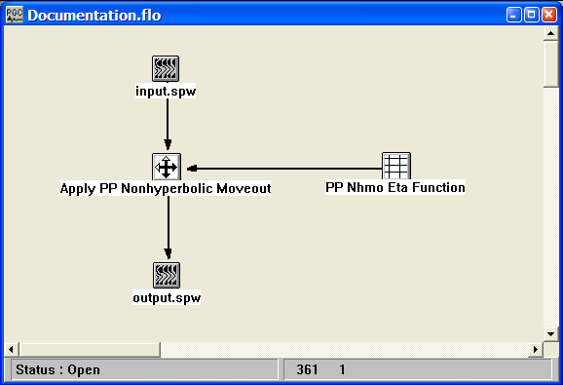
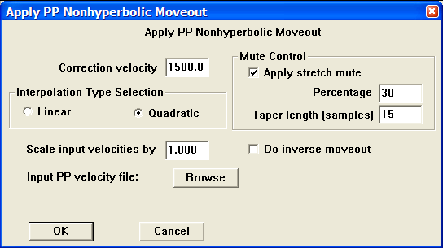
Step Parameter Dialog:

Parameter Description:
Correction velocity — Enter the short-spread P-wave NMO velocity. This constant velocity will be used if a P-wave stacking velocity function is NOT selected with the Browse button.

Interpolation Type Selection — Select the interpolation type (linear or quadratic). The moveout function causes trace data samples to be moved in time to new locations. Since these new time locations of the data sample values are not usually exactly at the sample interval of the data, the data is interpolated to be evenly sampled at the correct sample interval.

Linear — Linear interpolation uses the equation of a line (y = mx + b) to interpolate data values between or beyond existing data.

Quadratic — Quadratic interpolation uses the equation of a quadratic (y = ax^2 + bx + c) to interpolate data values between or beyond existing data.

Mute Control — Set the parameters for the stretch mute definition.

Apply stretch mute — If checked, a stretch mute will be applied to the NMO corrected data. Stretch muting removes the stretching of the data due to the NMO correction.

Percentage — Enter the percent stretch mute. The smaller the percent the more severe the mute function.

Taper length — Enter the mute tape length in samples. Longer taper lengths result in a smoother transition from the mute zone to the data zone.

Scale input velocities by – Enter the amount by which the input velocities are scaled up or down. A value of 1.0 does not alter the velocity field.

Do inverse NMO application — If checked, the inverse NMO correction will be applied, instead of the usual forward NMO.

Azimuth Velocity Analysis
Usage:
The Azimuth Velocity Analysis step creates azimuth restricted velocity semblance displays from the input CMP records. Azimuthal stacking velocities may be picked interactively from these semblance displays in SeisViewer. For semblance display generation, you designate the number of azimuth groups, the number of velocities, the starting velocity, and the velocity increment. The resulting output will contain one semblance panel for each user defined azimuth group (see figure below). An option exists to restrict the azimuthal semblance analysis to a time window of the input data.

Input Links:
- Seismic data in CMP sort order (mandatory).

Output Links:
1) Seismic File (mandatory).

Reference:
Taner, M. and Kohler, 1969, Velocity spectra — digital computer derivation and applications of velocity functions, Geophysics, v. 34, no. 6, p. 859ff.

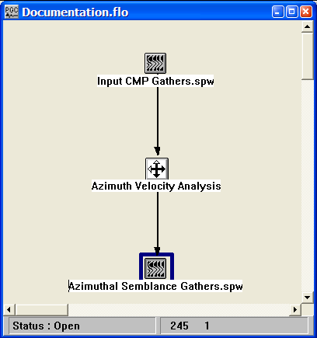
Example Flowchart:

Step Parameter Dialog:
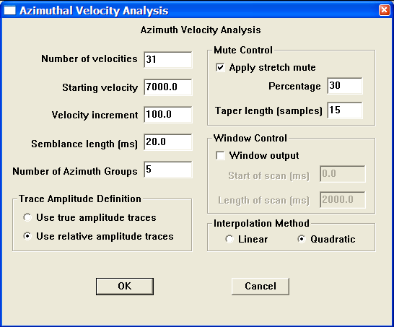

Parameter Description:
Number of velocities — Enter the number of velocities to use in the analysis. A semblance value is calculated for each velocity linearly interpolated between the starting and ending input velocities.

Starting velocity — Enter the first velocity to scan.

Velocity increment — Enter the value by which the velocity is incremented.

Semblance length (ms) — Enter the length of the semblance calculation window in milliseconds.

Number of Azimuth Groups — Enter the number of azimuth groups to use in the analysis. The input CMP gathers sorted into source-receiver azimuth groups covering angles from 0 to 180 degrees. The first group will contain all source-receiver azimuths in the range 0 to (180/Number of Groups). The second group will contain all source-receiver azimuths in the range (180/Number of Groups) to 2* (180/Number of Groups), and so on (see figure below). At time increments of (Semblance Length/2), a semblance value is calculated for each velocity linearly interpolated between the starting and ending input velocities.

Interpolation Method — Select the interpolation type (linear or quadratic). The moveout function causes trace data samples to be moved in time to new locations. Since these new time locations of the data sample values are not exactly at the sample interval of the data, the data is interpolated to even sampling at the correct interval.

Linear — Linear interpolation uses the equation of a line (y = mx + b) to interpolate data values between or beyond existing data.

Quadratic — Quadratic interpolation uses the equation of a quadratic (y = ax^2 + bx + c) to interpolate data values between or beyond existing data.

Trace Amplitude Definition — Amplitude summing selection.

Use relative amplitude traces — Selects the use of relative amplitude scaled traces in the analysis. Relative amplitude traces are scaled independently of one another.

Use true amplitude traces — Absolute amplitude traces will be summed in the stacking process. True amplitude traces are scaled by one common factor per record.

Mute Control — Set the stretch mute control parameters.

Apply stretch mute — If checked, a stretch mute will be applied to the NMO corrected data. Stretch muting restricts the stretching of the data due to the NMO correction prior to one second.

Percentage — Enter the percent stretch mute. The smaller the percent the more severe the mute function.

Taper length — Enter the mute tape length in samples. Longer taper lengths result in a smoother transition from the mute zone to the data zone.

Window Control — If checked, only a window of the scan will be output.

Start of scan (ms) — Enter the starting time of the semblance scan window.

Length of scan (ms) — Enter the scan window length.
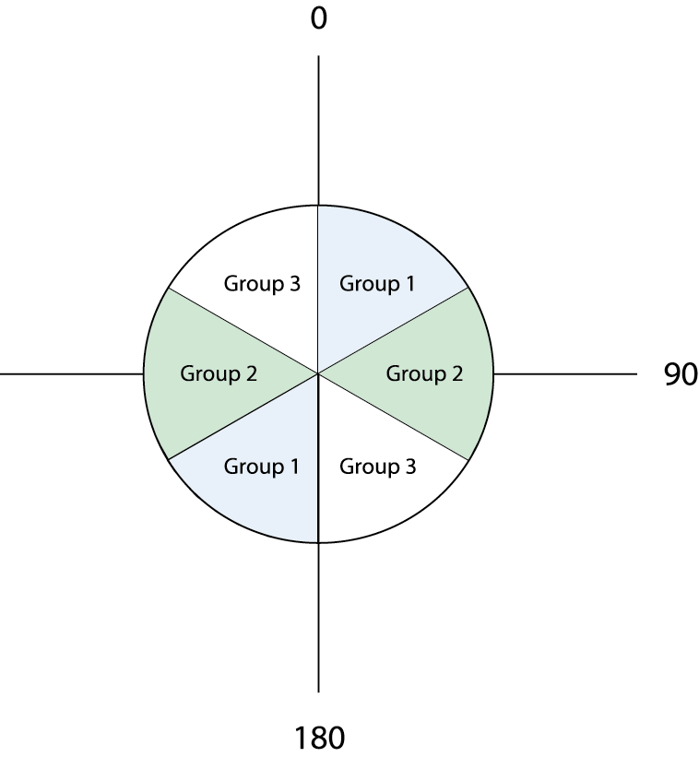

Azimuth Velocity Analysis for the case of three azimuth groups: 0-60, 60-120, and 120-180.

Calculate 3-D Residual NMO
Usage:
Calculate residual NMO time shifts.

Input Links:
- NMO corrected seismic data in bin sorted order (mandatory).
- Horizon Pick cards (mandatory).
- Velocity Function cards (optional).

Output Links:
1) Residual NMO Analysis card data (mandatory).

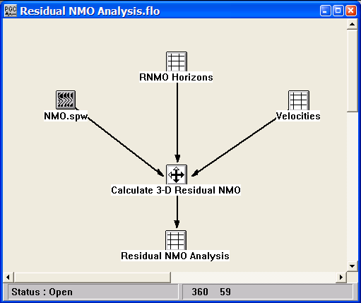
Example Flowchart:

Step Parameter Dialog:
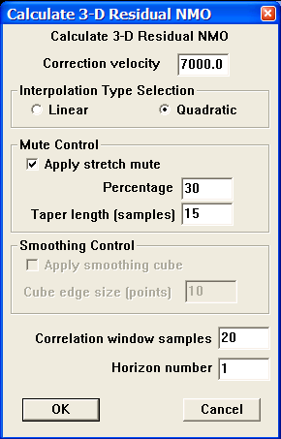
Parameter Description:
Correction velocity — Enter the NMO velocity. This is the constant velocity that will be used if a set of velocity function cards is NOT linked to the NMO correction step.

Interpolation Type Selection — Select the interpolation type (linear or quadratic). The moveout function causes trace data samples to be moved in time to new locations. Since these new time locations of the data sample values are not usually exactly at the sample interval of the data, the data is interpolated to be evenly sampled at the correct sample interval.

Linear — Linear interpolation uses the equation of a line (y = mx + b) to interpolate data values between or beyond existing data.

Quadratic — Quadratic interpolation uses the equation of a quadratic (y = ax^2 + bx + c) to interpolate data values between or beyond existing data.

Mute Control — Set the parameters for the stretch mute definition.

Apply stretch mute — If checked, a stretch mute will be applied to the NMO corrected data. Stretch muting removes the stretching of the data due to the NMO correction.

Percentage — Enter the percent stretch mute. The smaller the percent the more severe the mute function.

Taper length — Enter the mute tape length in samples. Longer taper lengths result in a smoother transition from the mute zone to the data zone.

Correlation window samples — Length of the correlation window (in number of samples), centered on the horizon time, used in the computation of residual NMO time shifts.

Horizon number – Indicate the horizon number in the horizon file for which the residual NMO time shifts will be calculated.

Constant Velocity Stacks
Usage:
The Constant Velocity Analysis step generates a file of constant velocity stack traces. You choose the number of velocities with which to stack your data, the first velocity to apply, and the last velocity. You have the option to apply a stretch mute, if you so desire. With the series of constant velocity stack traces, you may page through these stacked panels in SeisViewer and interactively pick velocity functions that result in the most coherent stacked sections.

Input Links:
1) Seismic data pre-stack, in CMP sort order (mandatory),

Output Links:
None - This process writes directly to an output disk file.

Example Flowchart:
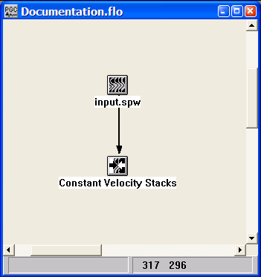

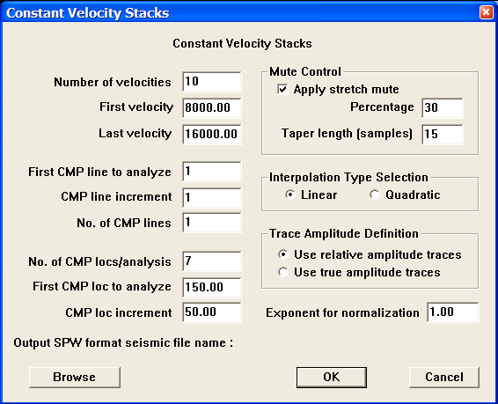
Step Parameter Dialog:

Parameter Description:
Number of velocities — Enter the number of velocities to use in the analysis. A stacked section is calculated for each velocity linearly interpolated between the starting and ending input velocities. The velocity increment will be:
V_{inc} = (last velocity – first velocity)/ (Number of velocities-1).

First velocity — Enter the starting velocity for the analysis. This velocity will be used for NMO on the first output stack. {>0.0}

Last velocity — Enter the ending velocity for the analysis. This velocity will be used for NMO on the last output stack. {>0.0}

First CMP line to analyze — Enter the first CMP line number to analyze.

CMP line increment — Enter the CMP line increment between lines to analyze.

No. of CMP lines — Enter the number of CMP lines to analyze.

No. of CMP locs/analysis — Enter the number of CMP locations in each analysis panel. At each CMP location a range of constant velocity stacks will be generated from the first velocity to the last velocity in increments of V_{inc}

First CMP loc to analyze — Enter the first CMP location to analyze.

CMP loc increment — Enter the CMP location increment between groups of CMP locations to analyze.

Mute Control — Select the stretch mute definition.
Apply stretch mute — If checked, a stretch mute will be applied to the NMO corrected data. Stretch muting restricts the stretching of the data due to the NMO correction.

Percentage — Enter the percent stretch mute. The smaller the percent the more severe the mute function.

Taper length — Enter the mute taper length in samples. Longer taper lengths result in a smoother transition from the mute zone to the data zone.

Interpolation Type Selection — Select the interpolation type (linear or quadratic). The moveout function causes trace data samples to be moved in time to new locations. Since these new time locations of the data sample values are not exactly at the sample interval of the data, the data is interpolated to the correct sample interval.

Linear — Linear interpolation uses the equation of a line (y = mx + b) to interpolate data samples between or beyond existing data.

Quadratic — Quadratic interpolation uses the equation of a quadratic (y = ax^2 + bx + c) to interpolate data samples between or beyond existing data.

Trace Amplitude Definition — Select the trace amplitude definition.

Use relative amplitude traces — Relative amplitude traces will be summed in the stacking process. Relative amplitude traces are scaled independently of one another.

Use true amplitude traces — Selects the use of true amplitude scaled traces in the analysis. True amplitude traces are scaled by one common factor per record.

Exponent for normalization — Enter the scaling exponent. Traces are scaled by (fold ** EXP).

Browse — Select an existing SPW format seismic file or enter the name of a new SPW format seismic file to use for output from the process.

Delta-T Stacks
Usage:
The Delta-T Stacks step generates a series of constant delta-T stack traces. The delta-T is measured from a user supplied reference velocity field. As such, the Delta-T Stacks step is designed to refine previously picked velocity fields. You choose the number first delta-T stack, the last delta-T stack, and the number of delta-T stacks to generate. You have the option to apply a stretch mute to the NMO corrected data, if you so desire. With the series of constant delta-T stack traces, you may page through these stacked panels in SeisViewer and interactively pick velocity functions that result in the most coherent stacked sections.

Input Links:
- Seismic data pre-stack, in CMP sort order (mandatory),

Output Links:
None - This process writes directly to an output disk file.

Example Flowchart:
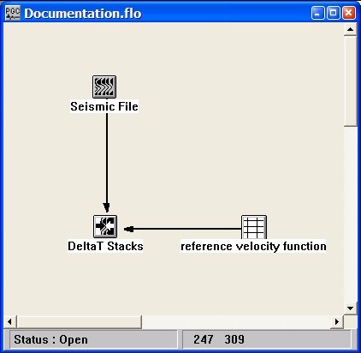

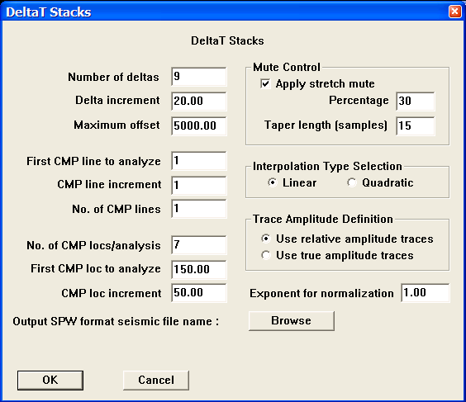
Step Parameter Dialog:
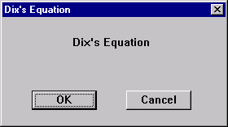

Parameter Description:
Number of deltas — Enter the number of deltas to use in the analysis. A stacked section is calculated for each delta between the starting and ending d eltas.

Delta increment — Enter the delta increment for the analysis. This velocity will be used for NMO on the first output stack. {>0.0}

Maximum offset — Enter the ending velocity for the analysis. This velocity will be used for NMO on the last output stack. {>0.0}

First CMP line to analyze — Enter the first CMP line number to analyze.

CMP line increment — Enter the CMP line increment between lines to analyze.

No. of CMP lines — Enter the number of CMP lines to analyze.

No. of CMP locs/analysis — Enter the number of CMP locations in each analysis panel.

First CMP loc to analyze — Enter the first CMP location to analyze.

CMP loc increment — Enter the CMP location increment between groups of CMP locations to analyze.

Mute Control — Select the stretch mute definition.
Apply stretch mute — If checked, a stretch mute will be applied to the NMO corrected data. Stretch muting restricts the stretching of the data due to the NMO .

Percentage — Enter the percent stretch mute. The smaller the percent the more severe the mute function. A value of zero will mute everything prior to one second.

Taper length — Enter the mute taper length in samples. Longer taper lengths result in a smoother transition from the mute zone to the data zone.

Interpolation Type Selection — Select the interpolation type (linear or quadratic). The moveout function causes trace data samples to be moved in time to new locations. Since these new time locations of the data sample values are not exactly at the sample interval of the data, the data is interpolated to the correct sample interval.

Linear — Linear interpolation uses the equation of a line (y = mx + b) to interpolate data samples between or beyond existing data.

Quadratic — Quadratic interpolation uses the equation of a quadratic (y = ax^2 + bx + c) to interpolate data samples between or beyond existing data.

Trace Amplitude Definition — Select the trace amplitude definition.

Use relative amplitude traces — Relative amplitude traces will be summed in the stacking process. Relative amplitude traces are scaled independently of one another.

Use true amplitude traces — Selects the use of true amplitude scaled traces in the analysis. True amplitude traces are scaled by one common factor per record.

Exponent for normalization — Enter the scaling exponent. Traces are scaled by (fold ** EXP).

Browse — Select an existing SPW format seismic file or enter the name of a new SPW format seismic file to use for output from the process.
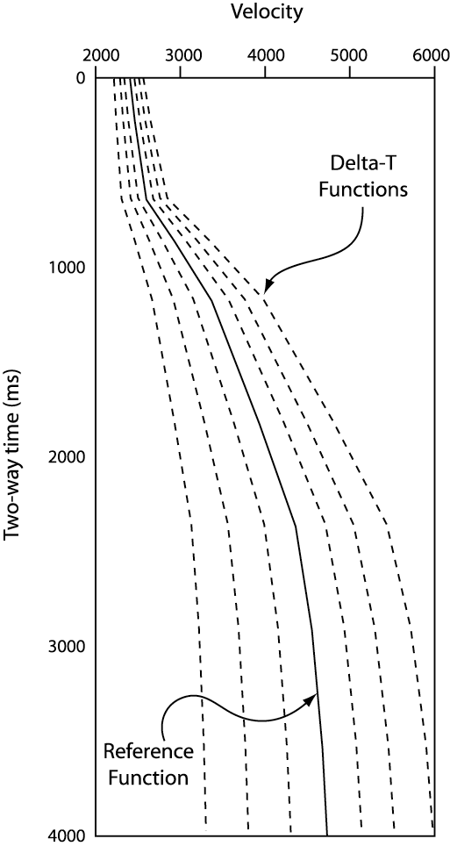

Delta-T Velocities

Dix’s Equation
Usage:
The Dix’s Equation step will convert a set of RMS velocity function cards to interval velocity cards. The interval velocity cards are suitable for input into a migration process.

Input Links:
1) Velocity Function cards containing RMS stacking velocities (mandatory).

Output Links:
1) Velocity Function cards containing interval velocities (mandatory).

Reference:
Dix, C.H., 1955, Seismic velocities from surface measurements, Geophysics vol. 20, no. 1, p. 68ff.

Example Flowchart:
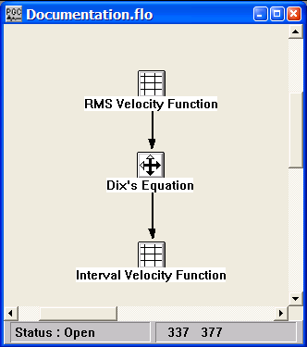

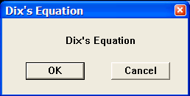
Step Parameter Dialog:

Parameter Description:
There are no parameters for this step.

PP Constant Eta Stacks
Usage:
The PP Constant Eta Stacks step generates a file of constant eta stack traces, where eta is defined as 0.5 ( V²_{h}/ V²_{nmo} – 1). A P-wave stacking velocity field must be supplied, and you choose the number of eta with which to stack your data, the first eta to apply, and the last eta to apply. You have the option to apply a stretch mute, if you so desire. With the series of constant eta stack traces, you page through these stacked panels in SeisViewer and interactively pick eta functions that result in the most coherent stacked sections.

Input Links:
- Seismic data pre-stack, in CMP sort order (mandatory).
- Velocity card data file containing p-wave stacking velocity functions (mandatory).

Output Links:
None - This process writes directly to an output disk file.

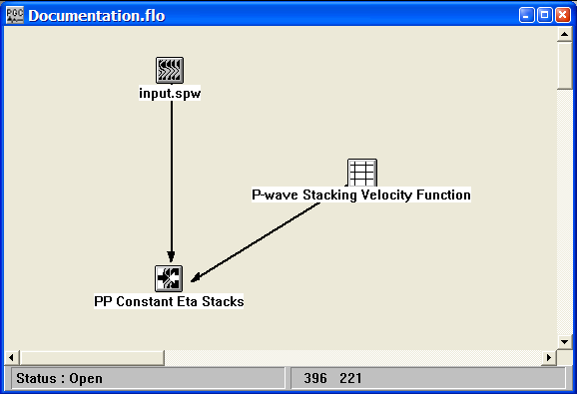
Example Flowchart:

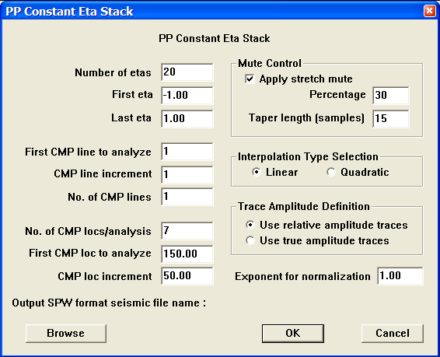
Step Parameter Dialog:

Parameter Description:
Number of etas — Enter the number of gammas to use in the analysis. A stacked section is calculated for each eta linearly interpolated between the starting and ending input gamma. The eta increment will be:
Eta_{inc} = (last eta – first eta)/ (Number of eta-1).

First eta — Enter the starting eta for the analysis. This eta will be used for non-hyperbolic NMO on the first output stack. {>0.0}

Last eta — Enter the ending eta for the analysis. This eta will be used for non-hyperbolic NMO on the last output stack. {>0.0}

First CMP line to analyze — Enter the first CMP line number to analyze.

CMP line increment — Enter the CMP line increment between lines to analyze.

No. of CMP lines — Enter the number of CMP lines to analyze.

No. of CMP locs/analysis — Enter the number of CMP locations in each analysis panel. At each CMP location a range of constant velocity stacks will be generated from the first velocity to the last velocity in increments of V_{inc}

First CMP loc to analyze — Enter the first CMP location to analyze.

CMP loc increment — Enter the CMP location increment between groups of CMP locations to analyze.

Mute Control — Select the stretch mute definition.
Apply stretch mute — If checked, a stretch mute will be applied to the NMO corrected data. Stretch muting restricts the stretching of the data due to the NMO correction.

Percentage — Enter the percent stretch mute. The smaller the percent the more severe the mute function.

Taper length — Enter the mute taper length in samples. Longer taper lengths result in a smoother transition from the mute zone to the data zone.

Interpolation Type Selection — Select the interpolation type (linear or quadratic). The moveout function causes trace data samples to be moved in time to new locations. Since these new time locations of the data sample values are not exactly at the sample interval of the data, the data is interpolated to the correct sample interval.

Linear — Linear interpolation uses the equation of a line (y = mx + b) to interpolate data samples between or beyond existing data.

Quadratic — Quadratic interpolation uses the equation of a quadratic (y = ax^2 + bx + c) to interpolate data samples between or beyond existing data.

Trace Amplitude Definition — Select the trace amplitude definition.

Use relative amplitude traces — Relative amplitude traces will be summed in the stacking process. Relative amplitude traces are scaled independently of one another.

Use true amplitude traces — Selects the use of true amplitude scaled traces in the analysis. True amplitude traces are scaled by one common factor per record.

Exponent for normalization — Enter the scaling exponent. Traces are scaled by (fold ** EXP).

Browse — Select an existing SPW format seismic file or enter the name of a new SPW format seismic file to use for output from the process.

Supergather Velocity Analysis
Usage:
The PP Constant Eta Stacks step generates a file of constant eta stack traces, where eta is defined as 0.5 ( V²_{h}/ V²_{nmo} – 1). A P-wave stacking velocity field must be supplied, and you choose the number of eta with which to stack your data, the first eta to apply, and the last eta to apply

Input Links:
- Seismic data output from the Build Super Gathers processing step (mandatory).

Output Links:
1) Seismic File (mandatory).

Example Flowchart:

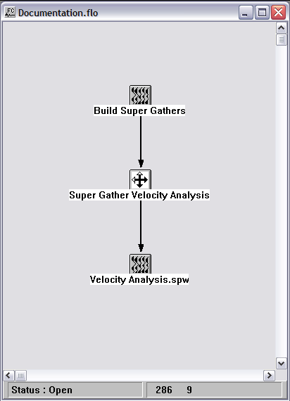

Step Parameter Dialog:

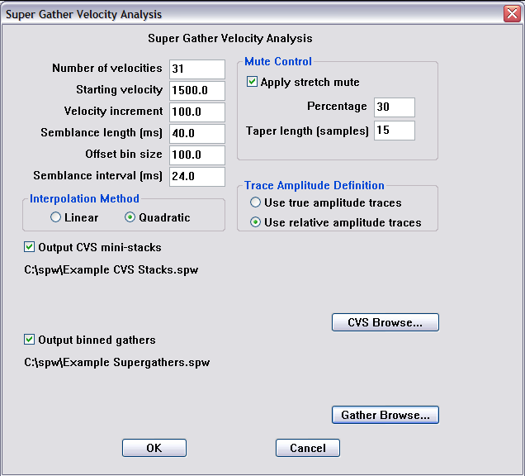

Parameter Description:
Number of velocities — Enter the number of velocities to use in the analysis. A stacked section is calculated at each velocity increment from Starting velocity to Starting Velocity + Velocity increment * (Number of velocities-1).

Starting velocity — First velocity to scan.

Velocity increment – Increment of velocity scans.

Semblance length (ms) — Length over which semblance is calculated.

Offset bin size —

Semblance interval — Time increment for calculating semblance.

Apply stretch mute — If checked, a stretch mute will be applied to the NMO corrected data. Stretch muting restricts the stretching of the data due to the NMO correction.

Percentage — Enter the percent stretch mute. The smaller the percent the more severe the mute function.

Taper length — Enter the mute taper length in samples. Longer taper lengths result in a smoother transition from the mute zone to the data zone.

Interpolation Type Selection — Select the interpolation type (linear or quadratic). The moveout function causes trace data samples to be moved in time to new locations. Since these new time locations of the data sample values are not exactly at the sample interval of the data, the data is interpolated to the correct sample interval.

Linear — Linear interpolation uses the equation of a line (y = mx + b) to interpolate data samples between or beyond existing data.

Quadratic — Quadratic interpolation uses the equation of a quadratic (y = ax^2 + bx + c) to interpolate data samples between or beyond existing data.

Trace Amplitude Definition — Select the trace amplitude definition.

Use relative amplitude traces — Relative amplitude traces will be summed in the stacking process. Relative amplitude traces are scaled independently of one another.

Use true amplitude traces — Selects the use of true amplitude scaled traces in the analysis. True amplitude traces are scaled by one common factor per record.

CVS Browse — Assign a file name to the output CVS panels.

Gather Browse — Assign a file name to the output supergathers.

Velocity Cube
Usage:
The Velocity Cube step inputs a 3D seismic volume, the corresponding stacking velocity cards, and outputs a velocity cube with a velocity function defined at each bin position.

Input Links:
- Seismic data in CMP sort order (mandatory).
2) Velocity Function card (mandatory).

Output Links:
1) Seismic File (mandatory).

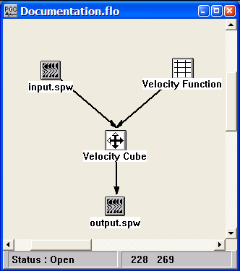
Example Flowchart:

Step Parameter Dialog:
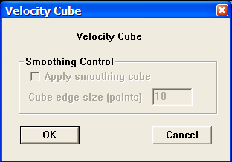

Parameter Description:
Smoothing Control — The smoothing options are not active.

Velocity Semblance
Usage:
The Velocity Semblance step creates velocity semblance displays for the input CMP records. Stacking velocities may be picked interactively from this semblance display in SeisViewer. For semblance display generation, you designate the velocity range for semblance calculation by choosing the number of velocities, the starting velocity for this range, and the velocity increment. You may generate only one CMP semblance display for each input CMP gather. You may also control the time gate length around hyperbolic velocity paths for CMP summing in the semblance calculation using the “Semblance length” input parameter. Finally, the output semblance display may be windowed, and a stretch mute may be applied if so desired.

Input Links:
- Seismic data in CMP sort order (mandatory).

Output Links:
1) Seismic File (mandatory).

Reference:
Taner, M. and Kohler, 1969, Velocity spectra — digital computer derivation and applications of velocity functions, Geophysics, v. 34, no. 6, p. 859ff.

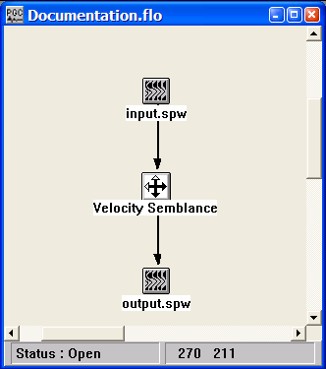
Example Flowchart:

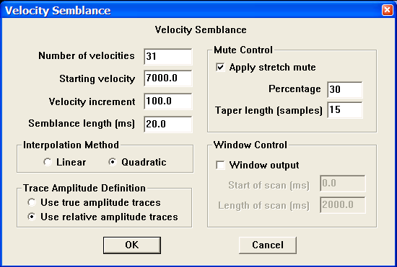
Step Parameter Dialog:

Parameter Description:
Number of velocities — Enter the number of velocities to use in the analysis. At time increments of (Semblance Length/2), a semblance value is calculated for each velocity linearly interpolated between the starting and ending input velocities.

Starting velocity — Enter the first velocity to scan.

Velocity increment — Enter the value by which the velocity is incremented.

Semblance length (ms) — Enter the length of the semblance calculation window in milliseconds.

Interpolation Method — Select the interpolation type (linear or quadratic). The moveout function causes trace data samples to be moved in time to new locations. Since these new time locations of the data sample values are not exactly at the sample interval of the data, the data is interpolated to even sampling at the correct interval.

Linear — Linear interpolation uses the equation of a line (y = mx + b) to interpolate data values between or beyond existing data.

Quadratic — Quadratic interpolation uses the equation of a quadratic (y = ax^2 + bx + c) to interpolate data values between or beyond existing data.

Trace Amplitude Definition — Amplitude summing selection.

Use relative amplitude traces — Selects the use of relative amplitude scaled traces in the analysis. Relative amplitude traces are scaled independently of one another.

Use true amplitude traces — Absolute amplitude traces will be summed in the stacking process. True amplitude traces are scaled by one common factor per record.

Mute Control — Set the stretch mute control parameters.

Apply stretch mute — If checked, a stretch mute will be applied to the NMO corrected data. Stretch muting restricts the stretching of the data due to the NMO correction prior to one second.

Percentage — Enter the percent stretch mute. The smaller the percent the more severe the mute function.

Taper length — Enter the mute tape length in samples. Longer taper lengths result in a smoother transition from the mute zone to the data zone.

Window Control — If checked, only a window of the scan will be output.

Start of scan (ms) — Enter the starting time of the semblance scan window.

Length of scan (ms) — Enter the scan window length.

Velocity Smoothing
Usage:
The Velocity Smoothing step generates a smoothed version of a velocity field.

Input Links:
- Velocity Function card file (mandatory).

Output Links:
1) Velocity Function card file (mandatory).

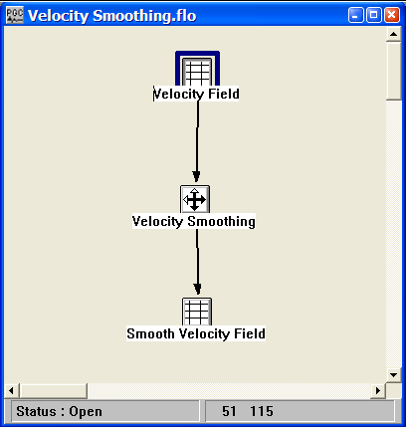
Example Flowchart:

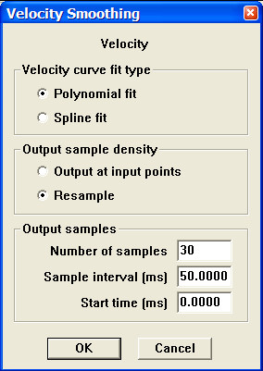
Step Parameter Dialog:

Parameter Description:
Velocity curve fit type —

Polynomial fit —

Spline —

Output sample density —

Output at input points — The time-velocity pairs in the smoothed output velocity funcition will be located at the same times present in the input velocity function.

Resample — The time of the time-velocity pairs will be specified by the user.

Output samples — If the output samples are being resampled, select the sampling interval.

Number of samples — Enter the number of time-velocity pairs in each output velocity function.

Sample interval (ms) — Enter the interval – in ms – between each time-velocity pair.

Start time (ms) — Enter the time of the first time-velocity pair.

Wavelet Shaping Steps

This section documents the processing steps available in the Wavelet Shaping Steps category.

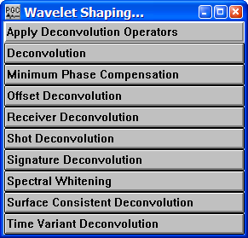
Processing steps currently available are:

Apply Deconvolution Operators
Usage:
The Apply Deconvolution Operators step is used to apply deconvolution operators output by either the Deconvolution step or the Surface Consistent Deconvolution step. In each case the file of operators is a SPW formatted seismic data file.

Input Links:
- Seismic data in any sort order (mandatory).
- Auxiliary data file containing the operators to be applied (mandatory).

Output Links:
- Seismic data in any sort order (mandatory).

Example Flowchart:
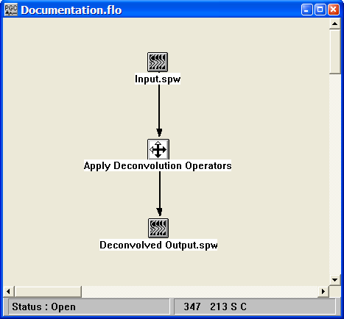

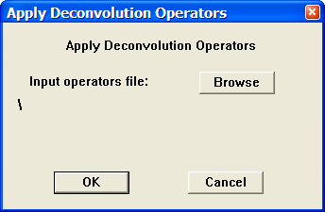
Step Parameter Dialog:

Parameter Description:
Input operators file — Use the Browse button to locate the SPW formatted file of deconvolution operators that will be applied to the input data.

Deconvolution
Usage:
The Deconvolution step is a Wiener-Levinson algorithm for applying either spiking or predictive deconvolution to your data. You choose the percent pre-whitening, filter length, number of operators, the overlap of the operator design windows, start time of the first operator design window, and the design window lengths. For the predictive deconvolution method, you must specify the predictive length of your wavelet. You may also apply a linear moveout to your deconvolution design windows to allow a sliding window whose start time varies with offset. An option exists to output the computed deconvolution operators for subsequent use with the Apply Deconvolution Operators step.

Input Links:
- Seismic data in any sort order (mandatory).
- Horizon card data containing water bottom time picks (optional).

Output Links:
1) Seismic data in any sort order (mandatory).

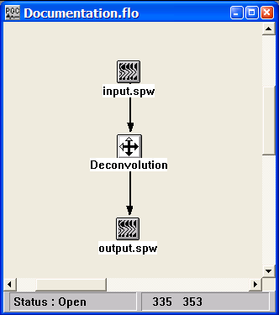
Example Flowchart:

Step Parameter Dialog:
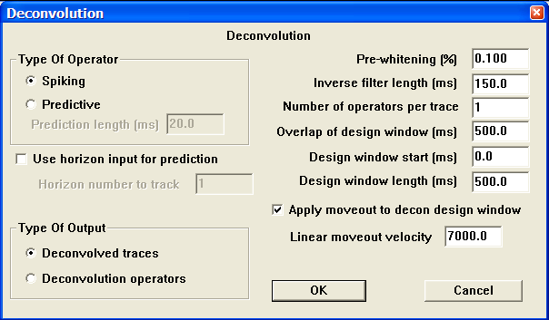
Parameter Description:
Type of Operator — Select type of deconvolution to perform: Spiking or Predictive.

Spiking — Weiner-Levinson spiking deconvolution.

Predictive — Weiner-Levinson predictive or gapped deconvolution.

Prediction length (ms) — Enter the prediction length in milliseconds.

Use horizon input for prediction – If checked, allows the input of times (e.g. water bottom) from a Horizon card data file to establish the prediction distance on a record- by-record basis.

Horizon number to track – Enter the horizon number in the Horizon card data file that will by used to establish the prediction distance.

Type of Output — By default, the Devonvolution step outputs deconvolved traces. However, the option exists to output the computed deconvolution operators for subsequent use with the Apply Deconvolution Operators step.

Deconvolved traces — Output deconvolved traces.

Deconvolution operators — Output deconvolution operators.

Pre-whitening percent — Enter the amount of white noise to add. The zero lag of the autocorrelation function is increased by this amount to induce stability in the matrix solution.

Inverse filter length (ms) — Enter the length of the inverse filter to be calculated and applied in milliseconds.

Number of operators per trace — Enter the number of separate deconvolution inverse filters to calculate per trace. If more than one, then the trace is divided into this number of windows and each window has an inverse filter individually calculated and applied.

Overlap of design window (ms) — Enter the overlap in milliseconds of the trace windows. This is the amount of the previous and/or next window to include in the calculation of the inverse filter for the current window.

Design window start (ms) — Enter the start time in milliseconds of the deconvolution design window.

Design window length (ms) — Enter the length in milliseconds of the deconvolution design window.

Apply moveout to decon design window — If checked, a linear moveout will be applied to the deconvolution design window. The window start time will shift by: delta time = offset / velocity.

Linear moveout velocity — Enter the linear moveout of the deconvolution design window.

Minimum Phase Compensation
Usage:
Minimum Phase Compensation allows you to compensate for the non-minimum phase nature of some seismic sources, such as Vibroseis™. The step calculates the minimum phase equivalent of a supplied source signature trace and then filters the data with a filter which converts the supplied signature to it’s minimum phase equivalent.

Input Links:
1) Seismic data in any sort order (mandatory).
2) Seismic data — recorded source signatures (optional).

Output Links:
1) Seismic data in any sort order (mandatory).

Example Flowchart:
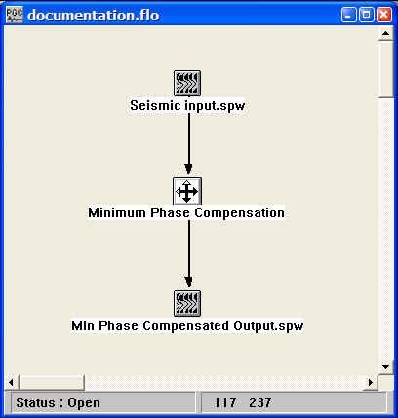

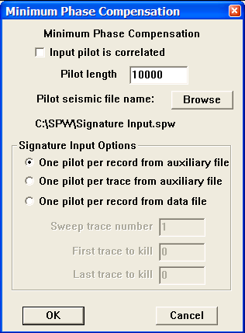
Step Parameter Dialog:

Parameter Description:
Input pilot is correlated – If checked, indicates that the pilot trace containing the source signature used to design the minimum phase compensation filter is a correlated seismic trace.

Pilot length (ms) — Enter the length of the pilot in milliseconds.

Pilot seismic file name – Use the Browse button to select the auxilairy file contains the pilot/signature traces.

Signature Input Options — Select the method of accessing the signature.

One pilot per record from an auxiliary file — This option inputs one pilot trace in sequential order from an auxiliary file and crosscorrelates that pilot signature with the respective sequential record. Therefore, number of pilot traces should equal the number of input records.

One pilot per trace from an auxiliary file — This option inputs one pilot trace in sequential order from an auxiliary file and crosscorrelates that pilot signature with the respective sequential trace. Therefore, number of pilot traces should equal the number of input traces.

One pilot per record in the data file — This option uses one trace from each record as the pilot trace for that record.

Sweep trace number — Enter the trace number to use as the pilot.

First trace to kill — If you demultiplexed the data set with the auxiliary traces to recover the pilot sweep, you may wish to kill the these auxiliary traces. Enter the first trace number to kill.

Last trace to kill — If you demultiplexed the data set with the auxiliary traces to recover the pilot sweep, you may wish to kill the these auxiliary traces. Enter the last trace number to kill.

Offset Deconvolution
Usage:
The Offset Deconvolution step is a Wiener-Levinson based algorithm that allows you to decompose the offset response to account for changes in wavelet shape due to offset variable conditions. Both spiking and predictive deconvolution operators are available. You choose the amount of pre-whitening, the inverse filter length, the start time of you operator design window, and the design window length. You may also apply a linear moveout to your deconvolution design windows to allow a sliding window whose start time varies with offset. For the predictive deconvolution method, you must choose a predictive length for your wavelet. You also have the option of range limiting, by offset distance, the traces used in the design of the deconvolution operator.

Input Links:
1) Seismic data in offset sort order (mandatory).

Output Links:
1) Seismic data in offset sort order (mandatory).

Example Flowchart:
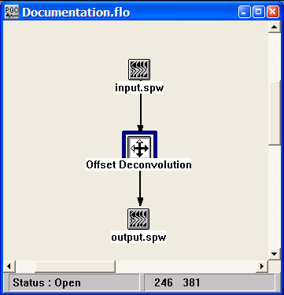

Step Parameter Dialog:

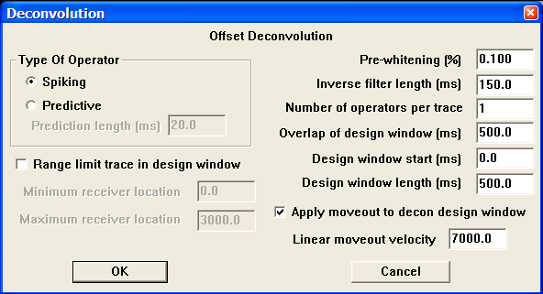

Parameter Description:
Type of Operator — Select type of deconvolution to perform: Spiking or Predictive.

Spiking — Weiner-Levinson spiking deconvolution.

Predictive — Weiner-Levinson predictive or gapped deconvolution.

Prediction length (ms) — Enter the prediction length in milliseconds.

Pre-whitening percent — Enter the prewhitening multiplier. The zero lag of the autocorrelation function is increased by this amount to induce stability in the matrix solution.

Inverse filter length (ms) — Enter the length of the filter to be calculated and applied in milliseconds.

Design window start (ms) — Enter the start time of the decon design window in milliseconds.

Design window length (ms) — Enter the length of the decon design window in milliseconds.

Apply moveout to decon design window — If checked, a linear moveout will be applied to the deconvolution design window. The window start time will shift by: delta time = offset / velocity.

Linear moveout velocity — Enter the linear moveout of the deconvolution design window.

Range limit trace in design window — If checked, the range of traces used to design the deconvolution operator may be limited by offset.

Minimum absolute offset — Enter the minimum absolute receiver trace to use in the design of the deconvolution operator.

Maximum absolute offset — Enter the maximum absolute receiver trace to use in the design of the deconvolution operator.

Receiver Deconvolution
Usage:
The Receiver Deconvolution step is a Weiner-Levinson based algorithm that allows you to decompose the receiver response to account for changes in wavelet shape due to near-receiver conditions. Both spiking and predictive deconvolution operators are available. You choose the amount of pre-whitening, the inverse filter length, the start time of you operator design window, and the design window length. You may also apply a linear moveout to your deconvolution design windows to allow a sliding window whose start time varies with offset. For the predictive deconvolution method, you must choose a predictive length for your wavelet. You also have the option of range limiting, by offset distance, the traces used in the design of the deconvolution operator.

Input Links:
1) Seismic data in receiver sort order (mandatory).

Output Links:
1) Seismic data in receiver sort order (mandatory).

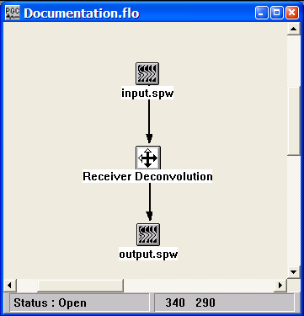
Example Flowchart:

Step Parameter Dialog:

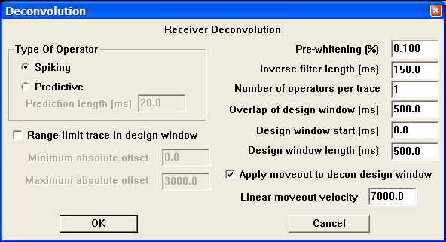

Parameter Description:
Type of Operator — Select type of deconvolution to perform: Spiking or Predictive.

Spiking — Weiner-Levinson spiking deconvolution.

Predictive — Weiner-Levinson predictive or gapped deconvolution.

Prediction length (ms) — Enter the prediction length in milliseconds.

Pre-whitening percent — Enter the pre-whitening multiplier. The zero lag of the autocorrelation function is increased by this amount to induce stability in the matrix solution.

Inverse filter length (ms) — Enter the length of the filter to be calculated and applied in milliseconds.

Design window start (ms) — Enter the start time of the decon design window in milliseconds.

Design window length (ms) — Enter the length of the decon design window in milliseconds.

Apply moveout to decon design window — If checked, a linear moveout will be applied to the deconvolution design window. The window start time will shift by: delta time = offset / velocity.

Linear moveout velocity — Enter the linear moveout of the deconvolution design window.

Range limit trace in design window — If checked, the range of traces used to design the deconvolution operator may be limited by offset.

Minimum absolute offset — Enter the minimum absolute offset trace to use in the design of the deconvolution operator.

Maximum absolute offset — Enter the maximum absolute offset trace to use in the design of the deconvolution operator.

Source Deconvolution
Usage:
The Source Deconvolution step is a Wiener-Levinson based algorithm that allows you to decompose the source response to account for changes in wavelet shape due to near-source conditions. Both spiking and predictive deconvolution operators are available. You choose the amount of pre-whitening, the inverse filter length, the start time of you operator design window, and the design window length. You may also apply a linear moveout to your deconvolution design windows to allow a sliding window whose start time varies with offset. For the predictive deconvolution method, you must choose a predictive length for your wavelet. You also have the option of range limiting, by offset distance, the traces used in the design of the deconvolution operator.

Input Links:
1) Seismic data in source (shot) sort order (mandatory).

Output Links:
1) Seismic data in source (shot) sort order (mandatory).

Example Flowchart:
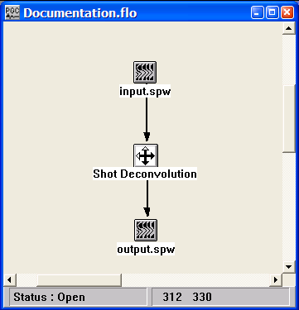

Step Parameter Dialog:

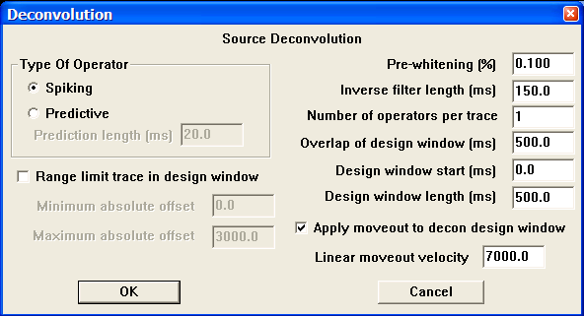
Parameter Description:
Type of Operator — Select type of deconvolution to perform: Spiking or Predictive.

Spiking — Weiner-Levinson spiking deconvolution.

Predictive — Weiner-Levinson predictive or gapped deconvolution.

Prediction length (ms) — Enter the prediction length in milliseconds.

Pre-whitening percent — Enter the prewhitening multiplier. The zero lag of the autocorrelation function is increased by this amount to induce stability in the matrix solution.

Inverse filter length (ms) — Enter the length of the filter to be calculated and applied in milliseconds.

Design window start (ms) — Enter the start time of the decon design window in milliseconds.

Design window length (ms) — Enter the length of the decon design window in milliseconds.

Apply moveout to decon design window — If checked, a linear moveout will be applied to the deconvolution design window. The window start time will shift by: delta time = offset / velocity.

Linear moveout velocity — Enter the linear moveout of the deconvolution design window.

Range limit trace in design window — If checked, the range of traces used to design the deconvolution operator may be limited by offset.

Minimum absolute offset — Enter the minimum absolute offset trace to use in the design of the deconvolution operator.

Maximum absolute offset — Enter the maximum absolute offset trace to use in the design of the deconvolution operator.

Signature Deconvolution
Usage:
Signature Deconvolution allows you to remove a seismic signature from your data traces by calculating the inverse of a supplied signature trace and then filtering your data by this signature inverse. This is a common technique for use in processing marine data to remove the signature of the airguns.

Input Links:
1) Seismic data in any sort order (mandatory).

Output Links:
- Seismic data in any sort order (mandatory).

Example Flowchart:
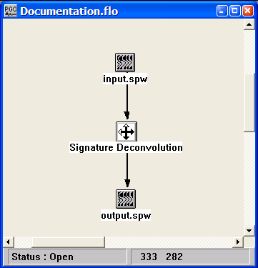

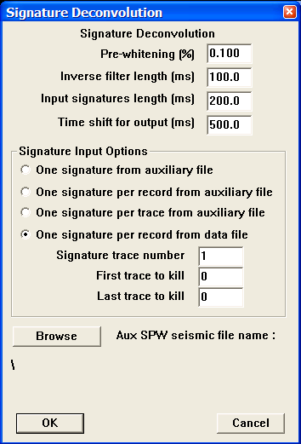
Step Parameter Dialog:

Parameter Description:
Pre-whitening percent — Enter the prewhitening multiplier. The zero lag of the autocorrelation function is increased by this amount to induce stability in the matrix solution.

Inverse filter length (ms) — Enter the length of the filter to be calculated and applied in milliseconds.

Input signature length (ms) — Enter the length of the input signatures in milliseconds.

Time shift for output (ms) – Enter the time shift for the output trace following signature deconvolution

Signature Input Options — Select the data input source of the signature trace or traces.

One signature from an auxiliary file — This option inputs one signature trace from an auxiliary input data and uses that trace as the signature trace for the entire data set.

One signature per record from an auxiliary data file — This option inputs one signature trace per record from an auxiliary input data set and uses that trace as the signature trace for all traces in the record in the signature deconvolution calculation.

One signature per trace from an auxiliary data file — This option inputs one signature trace from an auxiliary input data set per data trace and uses that trace as the signature trace for the corresponding data trace in the signature deconvolution calculation.

One signature per record in the data file — This option uses one trace from each data record and uses that trace as the signature trace for all seismic traces in the record in the signature deconvolution calculation.

Signature trace number — Enter the trace number to use as the signature trace.

First trace to kill — If you demultiplexed the data set with the auxiliary traces to recover the signature trace, you may wish to kill the these auxiliary traces. Enter the first trace number to kill.

Last trace to kill — If you demultiplexed the data set with the auxiliary traces to recover the signature trace, you may wish to kill the these auxiliary traces. Enter the last trace number to kill.

Browse — Select this button to set the input auxiliary file containing the signatures.

Spectral Whitening
Usage:
The Spectral Whitening step is a multi-banded spectral whitening method for balancing the energy of the selected frequency bands of your data. You specify the beginning and ending frequencies in the pass zone, the number of bands within this zone, and the length of the AGC operator. The individual band-pass filter cut off values are linearly interpolated based on the low and high pass frequencies and the number of bands that you choose. Each band is given a Butterworth third order slope with the midpoints of each slope being the half power points. Within each band every trace is AGC’ed with respect to the maximum amplitude in the window. All AGC’ed bands are then summed. Optionally, you may specify the Low Cut / Low Pass / High Pass / High Cut (LC,LP,HP,HC) filter points and associated weights for summing of up to ten filter bands. For optimal balancing of the energy of your frequency bands, your filters should be designed such that the slopes of your filters exactly overlap as is illustrated below. Such a design optimally flattens the spectrum of your data without distorting the spectrum.

Input Links:
1) Seismic data in any sort order (mandatory).

Output Links:
1) Seismic data in any sort order (mandatory).

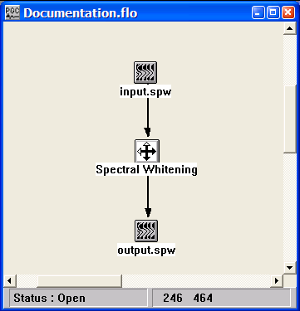
Example Flowchart:

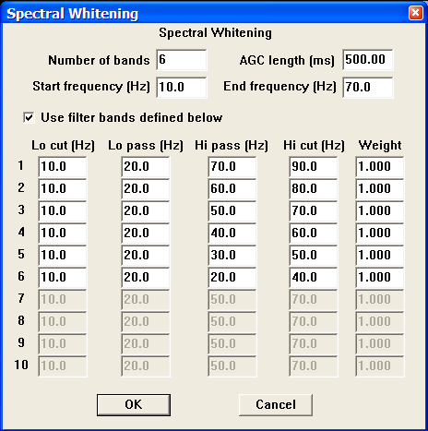
Step Parameter Dialog:

Parameter Description:
Start pass frequency (Hz) — Enter the low frequency pass band limit in hertz (Hz). This is the lowest frequency in the pass band.

End pass frequency (Hz) — Enter the high frequency pass band limit in hertz (Hz). This is the highest frequency in the pass band. It may not exceed one-half the Nyquist frequency.

Number of spectral bands — Enter the number of frequency bands. Each trace is split into this number of frequency bands which are AGC'ed and then summed to create the output trace.

Length of AGC operator (ms) — Enter the AGC operator length. This is the length of the AGC operator, which is applied to each frequency band.

Use filter bands defined below — If checked, the entered filter bands specified by the low cut, low pass, high pass, high cut and filter weight will be used.

Lo Cut — Enter the filter low frequency cutoff point in hertz (Hz).

Lo Pass — Enter the filter low frequency pass point in hertz (Hz).

High Pass — Enter the filter high frequency pass point in hertz (Hz).

High Cut — Enter the filter high frequency cutoff point in hertz (Hz).

Weight — Enter the filter band relative weight.

Surface Consistent Deconvolution
Usage:
The Surface Consistent Deconvolution step uses a Gauss-Seidel iterative method to perform a four-component surface-consistent decomposition of the amplitude spectra of the input seismic data into source, receiver, offset, and CMP components. Deconvolution operators are constructed from the source and receiver components of this decomposition. These operators are applied with the Apply Deconvolution Operators step. The user specifies whether the deconvolution will be of the spiking or predictive type, the design window, operator length, and percent white noise.

Input Links:
- Seismic data in any sort order (mandatory).

Output Links:
1) None. The surface-consistent deconvolution operators are output to an auxiliary disc file.

Reference:
Cary, P. M., and Lorentz, G. A., 1993, Four-component surface-consistent deconvolution: Geophysics, 58, 383-392.

Example Flowchart:
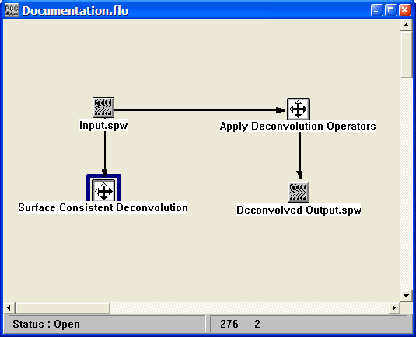
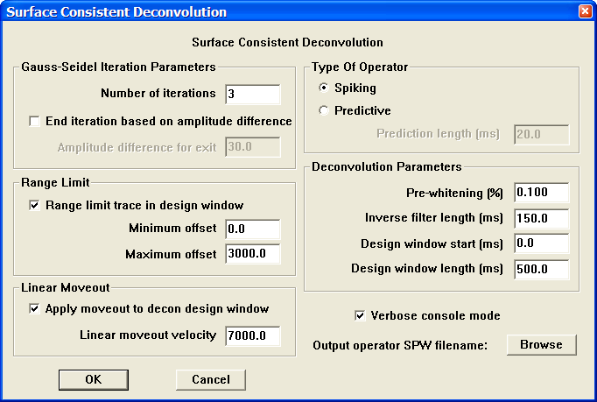
Step Parameter Dialog:

Parameter Description:
Gauss-Seidel Iteration Parameters

Number of iterations — Specify the number of iterations performed in the Gauss-Seidel decomposition of the amplitude spectra.

End iteration based on amplitude difference — If checked, the step will continue until changes in component amplitudes from one iteration to the next do not exceed a user specified value.

Amplitude difference for exit - Specify the value.

Type of Operator — Select type of deconvolution to perform: Spiking or Predictive.

Spiking — Spiking deconvolution.

Predictive — Predictive or gapped deconvolution.

Prediction length (ms) — Enter the prediction length in milliseconds.

Range Limit

Range limit trace in design window — If checked, the range of traces used to design the deconvolution operator may be limited by offset.

Minimum absolute offset — Enter the minimum absolute offset trace to use in the design of the deconvolution operator.

Maximum absolute offset — Enter the maximum absolute offset trace to use in the design of the deconvolution operator.

Linear moveout velocity — Enter the linear moveout of the deconvolution design window.

Deconvolution Parameters

Pre-whitening percent — Enter the pre-whitening multiplier. The zero lag of the autocorrelation function is increased by this amount to induce stability in the matrix solution.

Inverse filter length (ms) — Enter the length of the filter to be calculated and applied in milliseconds.

Design window start (ms) — Enter the start time of the deconvolution design window in milliseconds.

Design window length (ms) — Enter the length of the deconvolution design window in milliseconds.

Time-Variant Deconvolution
Usage:
The Deconvolution step is a Wiener-Levinson algorithm for applying either spiking or predictive multi-gate deconvolution to your data. You choose the percent pre-whitening, filter length, number of operators, the overlap of the operator design windows, start time of each operator design window, and the design window lengths. For the predictive deconvolution method, you must specify the predictive length of your wavelet. You may also apply a linear moveout to your deconvolution design windows to allow a sliding window whose start time varies with offset.

Input Links:
- Seismic data in any sort order (mandatory).

Output Links:
1) Seismic data in any sort order (mandatory).

Example Flowchart:

Step Parameter Dialog:
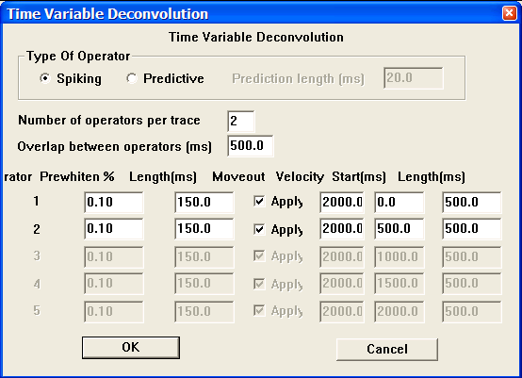

Parameter Description:
Type of Operator — Select type of deconvolution to perform: Spiking or Predictive.

Spiking — Weiner-Levinson spiking deconvolution.

Predictive — Weiner-Levinson predictive or gapped deconvolution.

Prediction length (ms) — Enter the prediction length in milliseconds.

Number of operators per trace — Enter the number of separate deconvolution inverse filters to calculate per trace.

Overlap of design window (ms) — Enter the overlap in milliseconds between operators. This is the amount of the previous and/or next window to include in the calculation of the inverse filter for the current window.

For each design gate, enter:

Pre-whitening percent — Enter the amount of white noise to add. The zero lag of the autocorrelation function is increased by this amount to induce stability in the matrix solution.

Inverse filter length (ms) — Enter the length of the inverse filter to be calculated and applied in milliseconds.
Apply moveout to decon design window — If checked, a linear moveout will be applied to the deconvolution design window. The window start time will shift by: delta time = offset / velocity.

Linear moveout velocity — Enter the linear moveout of the deconvolution design window.

Design window start (ms) — Enter the start time in milliseconds of the deconvolution design window.

Design window length (ms) — Enter the length in milliseconds of the deconvolution design window.

Wavelet Estimation – Seismic Only
Usage:
The Wavelet Estimation – Seismic Only step estimates the seismic source wavelet from the input seismic data. The amplitude spectrum of the source wavelet is derived from the averaged autocorrelations of the input data, while the minimum-phase spectrum of the source wavelet is derived from the Hilbert transform of the logarithmic amplitude spectrum. The input data are assumed to be minimum phase. You set the wavelet length and choose the data window from which the wavelet is extracted. A small amount of white noise can be added to the computed amplitude spectrum to stabilize the results.

Input Links:
- Seismic data in any sort order (mandatory).

Output Links:
- Seismic data (mandatory).

Reference:
White, R. E., and O’Brien, P. N. S., 1993, Estimation of the primary seismic pulse: Geophysical Prospecting, 22, 627-651.

Example Flowchart:
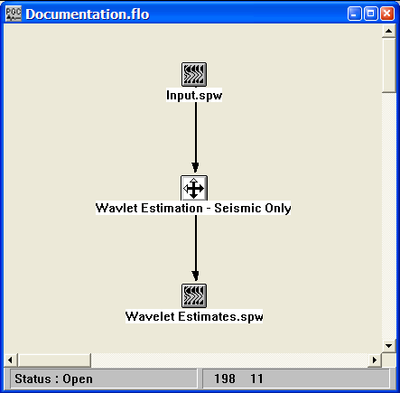
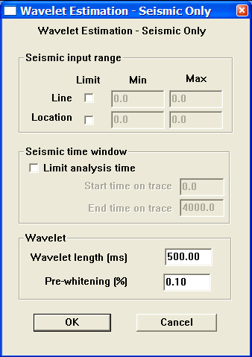
Step Parameter Dialog:

Parameter Description:
Seismic input range – Allows the wavelet to be extracted from a limited spatial zone of the input data.

Line – If checked, allows you to limit the range of CMP lines used to extract the wavelet.

Min – Minimum CMP line number to input.

Max – Maximum CMP line number to input.

Location – If checked, allows you to limit the range of CMP locations used to extract the wavelet.

Min – Minimum CMP location number to input.

Max – Maximum CMP location number to input.

Seismic time window – If checked, allows the wavelet to be extracted from a limited temporal zone of the input data.

Start time on trace – Enter the start time for analysis.

End time on trace – Enter the end time for analysis.

Wavelet length (ms) – Enter the length of the output seismic wavelet.

Pre-whitening (%) – Enter the percent pre-whitening that will be used to stabilize the computation of the phase spectrum.

Wavelet Estimation – Seismic + Well
Usage:
The Wavelet Estimation – Seismic + Well step estimates the seismic source wavelet from the combination of a well log derived reflectivity sequence and the adjacent post-stack seismic data. The step allows the wavelet to be derived by either the Fourier Division or the Wiener Filtering methods. The input data are assumed to be minimum phase. You set the wavelet length and choose the data window from which the wavelet is extracted. A small amount of white noise can be added to the computed amplitude spectrum to stabilize the results.

Input Links:
- Seismic data in any sort order (mandatory).

Output Links:
- Seismic data (mandatory).

Reference:
Danielsen, V., and Karlsson, T. V., 1984, Extraction of signatures from seismic and well data: First Break, 2.

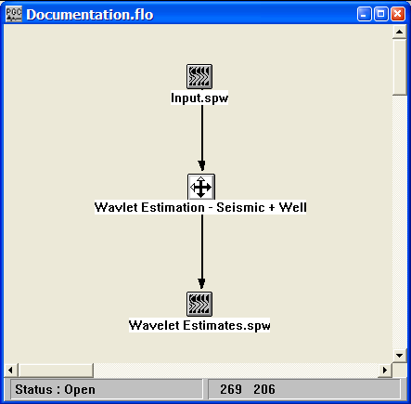
Example Flowchart:

Step Parameter Dialog:
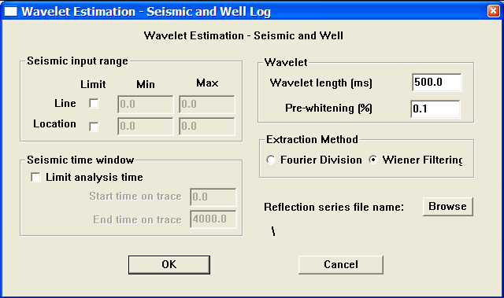

Parameter Description:
Seismic input range – Allows the wavelet to be extracted from a limited spatial zone of the input data.

Line – If checked, allows you to limit the range of CMP lines used to extract the wavelet.

Min – Minimum CMP line number to input.

Max – Maximum CMP line number to input.

Location – If checked, allows you to limit the range of CMP locations used to extract the wavelet.

Min – Minimum CMP location number to input.

Max – Maximum CMP location number to input.

Seismic time window – If checked, allows the wavelet to be extracted from a limited temporal zone of the input data.

Start time on trace – Enter the start time for analysis.

End time on trace – Enter the end time for analysis.

Wavelet length (ms) – Enter the length of the output seismic wavelet.

Pre-whitening (%) – Enter the percent pre-whitening that will be used to stabilize the computation of the phase spectrum.

Extraction Method – Select the method used to extract the source wavelet from the seismic and well log.

Fourier – The amplitude spectrum of the source wavelet is computed as the quotient of the Fourier transform of the seismic trace(s) at the well location and the Fourier transform of the reflectivity series derived from appropriate well-log data. The phase spectrm

Wiener – A least-square Wiener filter is computed that transforms the reflectivity series derived from appropriate well-log data into the seismic trace(s) at the well location.

